# **Cotton Harvest File Download Utility – Setup Guide**

Date: 12/29/2016

## Application Overview

The Cotton Harvest File Download Utility may be used to automate the download of Harvest ID files from MyJohnDeere.

### Download process

The application download process will download all harvest id zip files, extract the files, and find the Harvest ID file in the archive. For each harvest id file an output file is created. Output files are named using the Machine ID and the timestamp that the file was downloaded. All output files are written to a single folder selected by the user.

The application maintains a row count for each unique file downloaded. This is used on subsequent downloads to only output newly appended records. The application identifies a file by the first data line instead of the filename, it is possible for the same file data to go into MyJohnDeere under different file names. Therefore, matching on the first data line is a more accurate way of matching datasets.

## System Pre-requisites and Recommendations

* PC running Microsoft® Windows® version 7, 8.1, or 10
* At least 100MB storage space to install the application. More space will be needed to store downloaded files. Total storage required will depend on the number of files being received.
* Access to an active MyJohnDeere account and appropriate subscriptions and/or licenses to receive files from trusted partners.
* Microsoft .NET Framework 4.6.1. If it does not already exist on your system, the setup installer will acquire and install this package for you.
* Microsoft SQL Express Local DB 2014 - This is lightweight and free database engine from Microsoft. If it does not already exist on your system, the setup installer will acquire and install this package for you.

## Installing the application

### Step 1 – Obtain the setup package

The application installer is packaged in a ZIP archive named *CottonHarvestFileDownloadUtilityProductionV1_0.zip*. Download and extract this file to your computer

### Step 2 – Run the automated setup

The ZIP file you extracted in Step 1 will contain two files as shown below.

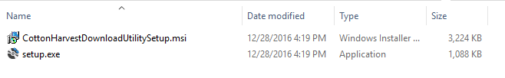

Double click the file named *setup.exe*. It is recommended that you run *setup.exe*, and not the .msi file. Running the *setup.exe* ensures that any pre-requisite Windows components are installed before launching the application install. The setup program will guide you through the installation.

## Configuring the Application

Once the application is installed, it will open automatically if you opted for the application to launch at the end of the installer (the default.) If you opted not to launch the application when the installer completed, browse to your desktop and click the *Cotton Harvest File Download Utility* icon.

This will launch the application and you will see a screen like the one below:

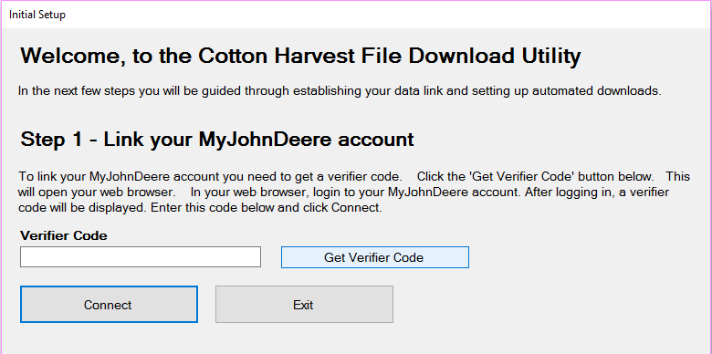

Click the *Get Verifier Code* button - this opens a separate web browser window and will require you to login to your MyJohnDeere account. After logging in, you should see a code of random characters. Copy it and return to the Cotton Harvest File Download Utility screen and paste it into the Verifier Code box.

If you see a 403 error instead of a verifier code, then return to the Cotton Harvest File Download Utility screen and click the *Get Verifier Code* button a second time. This appears to be an occasional issue with the John Deere website in some versions of Internet Explorer and Firefox.

Once you have obtained and copied in your verifier code, click connect. You should then be taken to a screen like the one below:

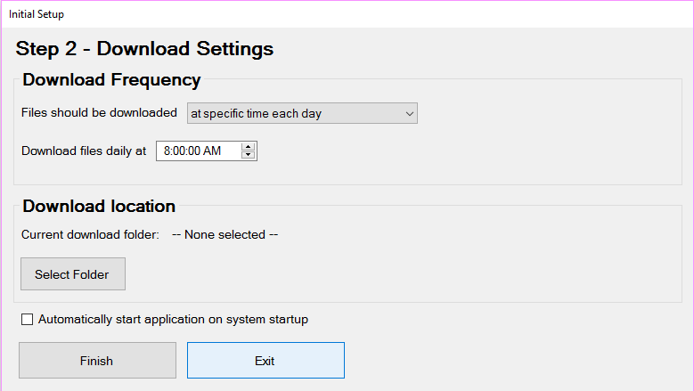

From this screen choose your preferred download frequency and a download location. Check the ‘*Automatically start application on system startup’* box if you want to run the application automatically each time you startup and login to Windows. Click finish and your setup should be complete. When the application is running, it will be visible in the System Tray. See the illustrations below for examples of the system tray on Windows 10 (appearance will be slightly different on Windows 7 and 8.1).

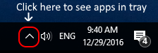 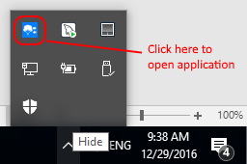

### Importing Partner Organizations

With the application open click on the *Manage Partners* tab. Then click *Import Partners*. See illustration below:

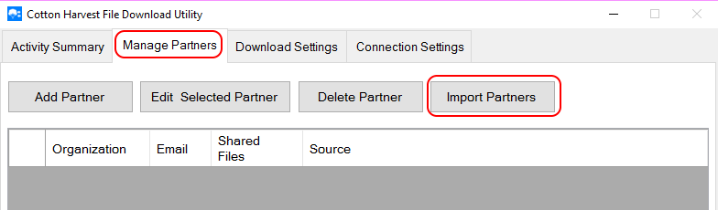

After clicking import partners a confirmation will appear, click yes and the import should start. Once the import completes, you should see a list of organizations that have you setup as a Trusted Partner similar to what is shown below:

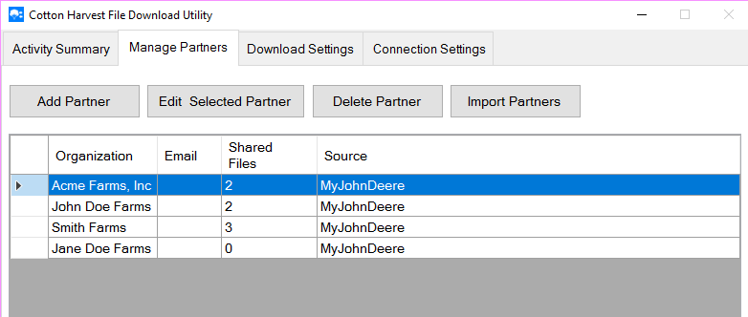

If you do not see any partners listed after importing, this means you need to setup the appropriate Trusted Partner relationships with your producers in the MyJohnDeere website. You may initiate a request to be added as a trusted partner by clicking the *Add Partner* button and entering the organization name and the producer’s email. You may re-send the request again later by using the ‘Edit Selected Partner’ button. Trusted partnerships may also be setup in the MyJohnDeere website.

If organizations appear in your list that you do not want to download files for, then select that organization row and click *Delete Partner*. This does not remove them from your MyJohnDeere account, but will prevent the application from downloading their files.

## The Activity Summary

The activity summary provides a snapshot of application activity.

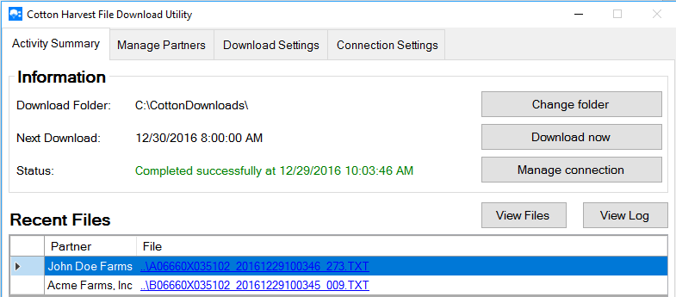

### Information box

The information box shows current settings and status. The *Download now* button can be used to manually start a download as opposed to waiting for the next scheduled download.

### Recent Files

The recent files list shows the files downloaded the last time a download occurred. Clicking the file link will open that file in the default Windows text editor (usually Notepad).

The View Files button will open the folder containing all download files, in Windows File Explorer.

The View Log button opens a log of application activity, this log contains diagnostic information.

### Notifications

When new files are downloaded a notification message like the one below will be shown to alert the user. Appearance may vary on different versions of Windows.

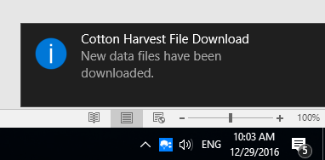

## Managing Download Settings

Download settings may be changed and updated at any time using the Download settings tab as shown below:

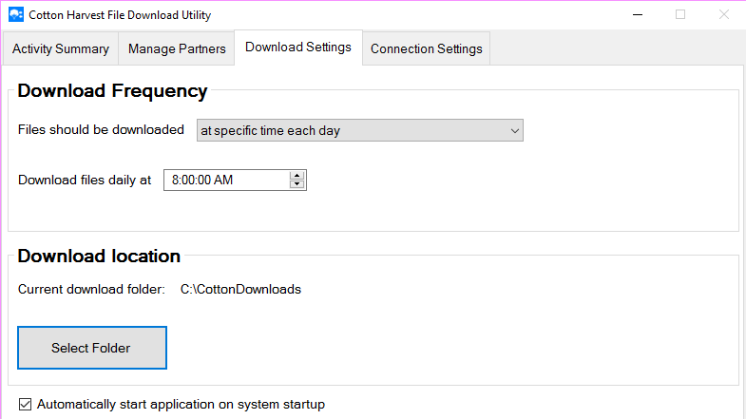

Download settings are automatically saved as they are changed.

## Managing Connection Settings

The connection settings screen can be used to update the link to MyJohnDeere by clicking the *Change connection* button.

