Lab 1: design a DFA that accepts any string with substring 101.
STATE TRANSITION DIAGRAM:

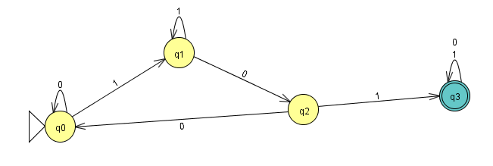
SOURCE CODE:
#include <stdio.h>

int main() {
char str[100];
int state = 0;

printf("Enter a binary string: ");
scanf("%s", str);

for (int i = 0; str[i] != '\0'; i++) {

switch (state) {
case 0:
if (str[i] == '1')
state = 1;
break;

case 1:
if (str[i] == '0')
state = 2;
else
state = 1;
break;

case 2:
if (str[i] == '1')
state = 3;
else
state = 0;
break;

case 3:
state = 3; // Stay in accept state
break;
}
}

if (state == 3)
printf("Accepted (contains 101)\n");
else
printf("Rejected (does not contain 101)\n");

return 0;
}
OUTPUT:
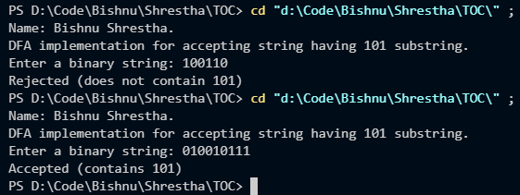

JFLAP SIMULATION:
REJECTED
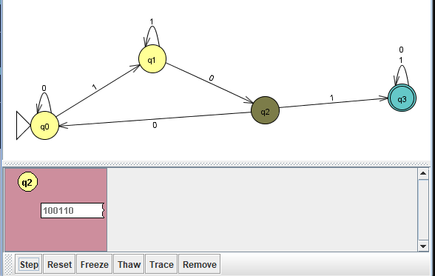

TRACE STATES:
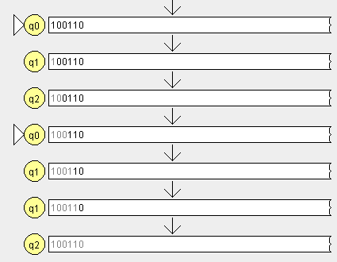

ACCEPTED SIMULATION
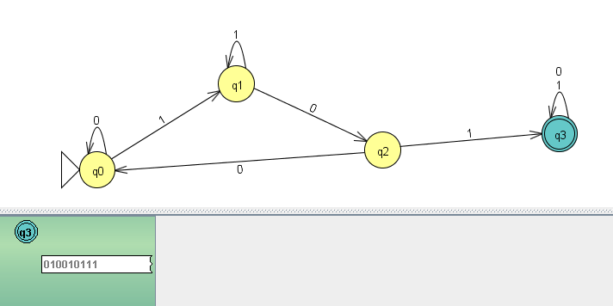

TRACE STATES:
