**Degrees of Freedom: GDP per Capita vs Press Freedom**

**H. Akkaraju, N. Bohra, S. Kaul, A. Rafiq**

[akkarh@uw.edu](mailto:akkarh@uw.edu), [nicolebohra@gmail.com](mailto:nicolebohra@gmail.com), [sk2019@uw.edu](mailto:sk2019@uw.edu), [aliar97@gmail.com](mailto:aliar97@gmail.com)

**ABSTRACT**

It is commonly believed that countries with higher GDP and economic prosperity allow for greater freedoms within their citizens. This research explores if a nation’s GDP per capita has a relationship with the amount of press freedom that exists. We performed a linear regression model and found no correlation with GDP per capita and a country’s Press Freedom Index.  After a linear regression analysis, it was deemed that the results were inconclusive as the correlation was not significant enough to suggest that GDP per capita had a large effect on the freedoms of a country. After a test of correlations between difference of differences, there was more of a significance but still not enough to render the results as conclusive.

**INTRODUCTION**

Economically prosperous countries are generally perceived to have a higher standard of living, lower poverty rates, and general happiness and freedom of citizens, than countries that are not as economically prosperous. However, countries with the highest GDP’s, like China for example, can have staggeringly high poverty rates due to wealth disparity, political regimes, and civil justice violations (Economic Development and Cultural Change, University of Chicago). This raises the question of whether the prosperity of a country’s citizens is heavily based in its’ monetary prosperity, and shifts the weight towards the role the country’s political regime and other variables can play.

One type of freedom that plays a pivotal role in democracy particularly is freedom of the press. Freedom of Press is the mere principal in communicating information and expression through electronic or printed mediums freely. It is vital in informing citizens of a country about public affairs and holding actions of powerful governments accountable at all levels. Not only does this freedom allow citizens to gain insight on government actions, but it empowers the people to express themselves, their opinions, and gain exposure to a wide variety of information. Freedom of the press is essential to society today to keep citizens protected and informed about those in power.

Amidst all the “fake news”, press freedom has actually had the biggest decline for the first time in 13 years in the United States (Freedom of the Press 2017). In this generation, we have leveraged new technology and social media dominance to make information sharing easier to protect our basic fundamental rights. We acknowledge that some countries don’t have enough resources to access to these technologies or social media, so we decided to broaden our scope to see how press freedom plays a role globally. This decline in press freedom poses a threat to our nation’s First Amendment of the Constitution which sparked our curiosity in exploring the relationship between a country’s GDP status and their Press Freedom Index (provided by the Reporters Without Borders [RSF] non-profit organization). Through our research, we would like to find explore if a correlation exists between GDP per capita and the nation’s Press Freedom Index.

**DATA SOURCE**

**World Press Freedom Index**

We used several datasets in this analysis from two different organizations to analyze the relationship between freedom of press with the GDP of a country.  
We used the “World Press Freedom Index” from Reporters without Borders (Reporters Sans Frontières). RSF in an international non-profit organization headquartered in Paris, France that has consultant status for the United Nations. Their dataset reports scores regarding press freedoms in of 188 countries, and has archives back to 2002. These scores are an Abuse Score, an Underlying Situation Score, and a difference in scores and position from the previous year.

The criteria evaluated in the questionnaire are abuse, pluralism, media independence, media environment and self-censorship, legislative framework, transparency, and the quality of the infrastructure that supports the production of news and information. This data is compiled from a robust questionnaire sent to media professionals, lawyers, and sociologists in 20 languages. The Underlying Situation score encompasses data from the 7 criteria formerly described. The Abuse Score indicates the mistreatment of reporters in form of violence, persecution, and other such slander towards reporters.

**GDP and GDP Per Capita**

We also used datasets of GDP and GDP Per Capita from The World Bank. The World Bank Group is a financial institution that facilitates loaning money to developing countries for capital projects. It is headquartered in Washington D.C.

**RELATED WORK**

There has been prior discussion and research on the topic of countries’ GDP and the effects it has on different types of freedoms. One study that was quite similar to our topic of research was evaluating the role of press freedom (data also provided by RSF) in economic development for 115 countries [1]. This paper focuses primarily on how an increase in press freedom can contribute to a country’s economic growth/foreign direct investment and prosperity whereas we are exploring the impact of press freedom index based on a country’s economic status. A bidirectional relationship between press freedom and economic growth was found using a generalized method of the ‘moments technique’ which is a method in estimating population means. Using integration and causality tests, it was concluded that there was a causal relationship between a country’s press freedom and its’ economic growth/foreign direct investment. The study concluded that policy makers in governments should take the significance of free and fair press into consideration to increase economic success in a country.

The Heritage Foundation, an American conservative think tank, is focused on creating laws that encourage economic freedom [7]. Much of their research focuses on Economic freedom in correlation with other freedoms. One article demonstrates the potential relationship between a country’s economic freedom index based on GDP status using visualizations. Although they did not use a statistical model to assert their hypothesis in this particular article, it is depicted in their data visualizations that that GDP doesn’t have a strong correlation with economic freedom. A study by Eastern Michigan University also explored how freedom correlates with economic success in terms of GDP per capita [6]. While an increase in GDP doesn’t have a relationship with an increase of economic freedom, this research discovers that the more economic freedom there is, the higher economic success there is (data provided by Freedom House non-profit organization). The study used a bivariate linear regression, simple linear regression and t-tests to analyze economic freedom index and GDP per capita. The results obtained indicated that freedom is important for GDP and economic growth.

Researchers have had an interest in the topic of how economic status in a country influences citizen freedoms. So far, there has been more research focusing in on how economic freedoms have been impacted by GDP in a country whereas only one study has examined the relationship between press freedom and GDP. The variables of interest are the same, however our team was more interested in exploring the correlation between GDP and press freedom index (along with other interesting indices regarding reporting) to examine how freedom varies by countries’ economic statuses.

**METHODS**

**Data Transformation**

Since we primarily wanted to compare freedom indices for different countries, we focused on GDP per capita data so it is already normalized for comparisons. We did not have GDP per capita data for all the 265 countries. Thus, we had to omit a couple of rows of GDP data from our analysis. Doing so allowed us to produce a GDP and GDP per capita data frame for about 264 countries.

The RSF data we obtained from Reporters without borders has about 30 fewer rows of data compared to the GDP data; we did not have access to freedom scores for all 264 countries. Therefore, to obtain a one-to-one correspondence, we omitted GDP data for 84 countries.

Lastly, to we used Pandas backfill function to replace “NaN” values in our raw dataframe. Since we were working with a European dataset, there were a few extraneous columns (country names in multiple languages, geographic zone etc.) which we excluded from our analysis.

**Analysis**

After the data was processed, we used a linear regression model to find if there was any statistical significance between a country's GDP data and its’ a country's freedom overall score. We got the GDP per capita data for all the countries in our data set for the year 2017 and compared it to the overall score of the freedom index of 2018 for every country. We then used the r-squared values to determine if there was a 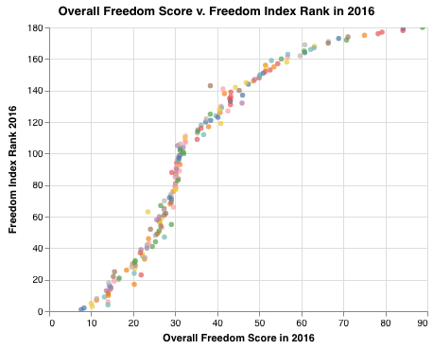good correlation between the two columns of data. We then randomly selected two low GDP countries and two high GDP countries. We then conducted a difference of differences model by comparing the r-squared values versus the overall freedom score. There was a slightly larger correlation.

**RESULTS**

We used a Gapminder chart (**Figure 1)** to visualize the correlation between GDP per capita and the Overall Freedom Scores in 2016; each bubble represents a country. As can be seen in the chart, there is no strong correlation between these two variables. The size of the bubble in the following chart indicates the Abuse score which indicates the levels of mistreatment of media centers/reporters in form of violence, persecution, and other such slander towards media, reporters, and organizations. Having a high GDP per capita does not correlate with low abuse scores; there are several countries with low-mid GDP per capita that have a lower abuse score. In addition, countries with the highest overall freedom score in 2016, do not have higher values GDP per capita.

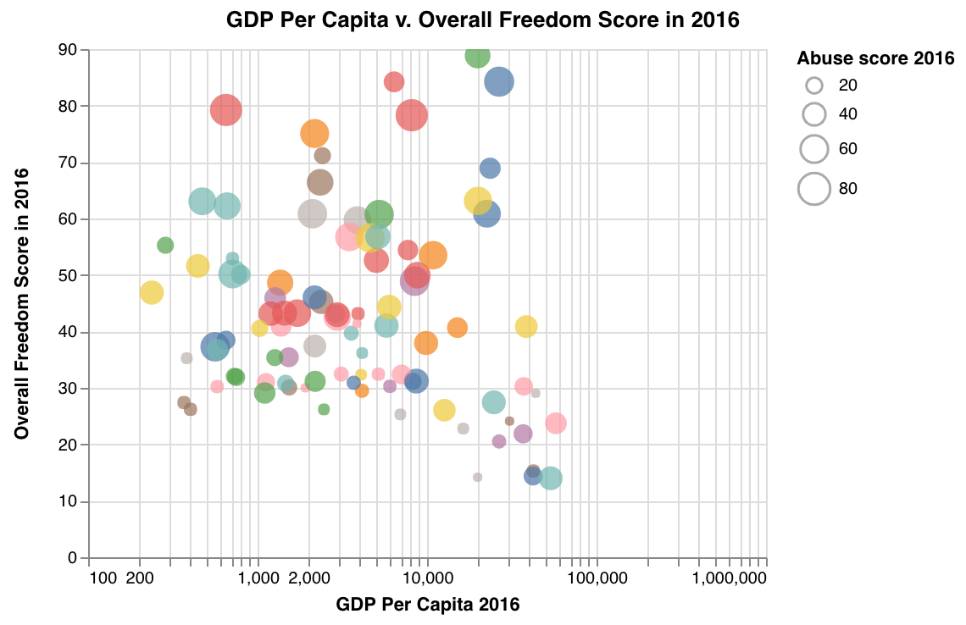

*Figure 1*

We also plotted the overall freedom score in 2016 against the freedom index rank in 2016 (**Figure 2)**. We discovered that Norway has the lowest freedom score consequently has the best rank for Freedom Index in 2016. Norway has a GDP per capita of $70890.04 which is significantly higher than the mean GDP per capita $12898.97. On the other end of the spectrum, we have North Korea which has a GDP per capita $19871.72 (also higher than the mean GDP per capita) but has the lowest Freedom Index rank in 2016. Lastly, the Freedom Index Rank is not the best metric to understand the differences between countries with similar overall freedom score; as can be seen in the chart, the curve flattens when the overall scores are close to each other.

*Figure 2*

Lastly, from our linear model, we found that while there was a small correlation, but the model only

explained around 17% of the variance in the data (**Figure 3**). Therefore, we fail to reject the null hypothesis, that there is no strong correlation between a country’s GDP and it’s Press Freedom score).

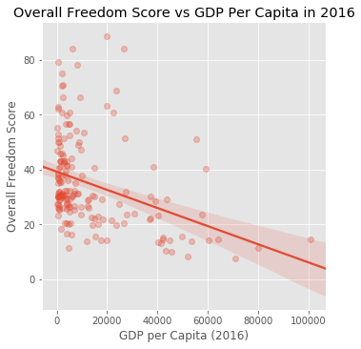

*Figure 3*

**FUTURE WORK**

In this research, we explored the relationship between GDP and Press Freedoms through a linear model. We found in our exploratory analysis that GDP and GDP per capita weren’t the best indicators of Press Freedom via graphical correlations. The linear model also showed that the relationship did not prove to explain all the variance in the data, though there was a small visible correlation. From this, we can gather that it is unlikely that just one variable alone dictates the freedom of press. Linear modeling with normalization could be used in the future to explore the correlations between press freedoms and other variables like political regime, and grow to become a multivariate model. This model could also be expanded beyond freedom of the press to encompass other civic freedoms like voting accessibility.

**REFERENCES**

1. Alam, Abdullah & Shah, Syed. (2013). The Role of Press Freedom in Economic Development: A Global Perspective. Journal of Media Economics. 26. 4-20. 10.1080/08997764.2012.755986.
2. Beresford, Peter, and David Green. “Income and Wealth: An Opportunity to Reassess the UK Poverty Debate.” Critical Social Policy, vol. 16, no. 46, Feb. 1996, pp. 95–109, doi:10.1177/026101839601604605.
3. Dunham, Jennifer. “Freedom of the Press 2017.” *Freedom House*, 9 Nov. 2017, freedomhouse.org/report/freedom-press/freedom-press-2017.
4. Fan, et. al. “Reforms, Investment, and Poverty in Rural China” University of Chicago Journal of Economic Development and Change, University of Chicago, Jan. 2006.
5. “Finance-Growth-Poverty Nexus in South Africa: A Dynamic Causality Linkage.” NeuroImage, Academic Press, 24 Dec. 2008.
6. Harrold, Trevis, "International Political Economy: How Does Freedom Correlate with Economic Success?" (2014). Senior Honors Theses. 378.

<http://commons.emich.edu/honors/378>

1. Raul. “These Maps Show How Economic Freedom Around the World Enriches/Impoverishes People.” *HowMuch*, howmuch.net/articles/economic-freedom-gdp-per-capita.