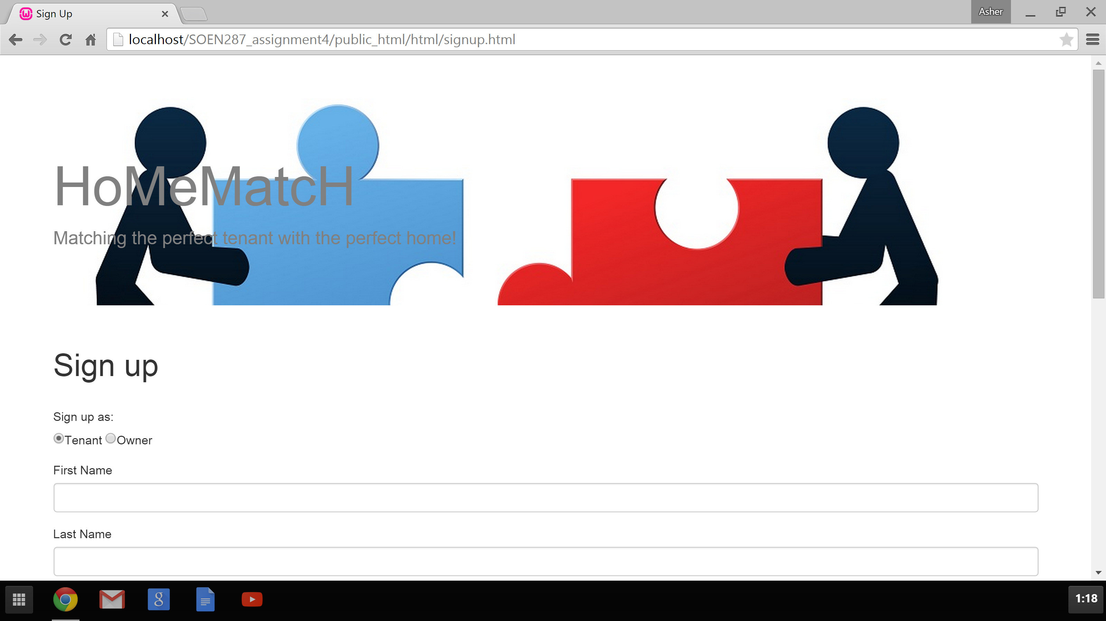

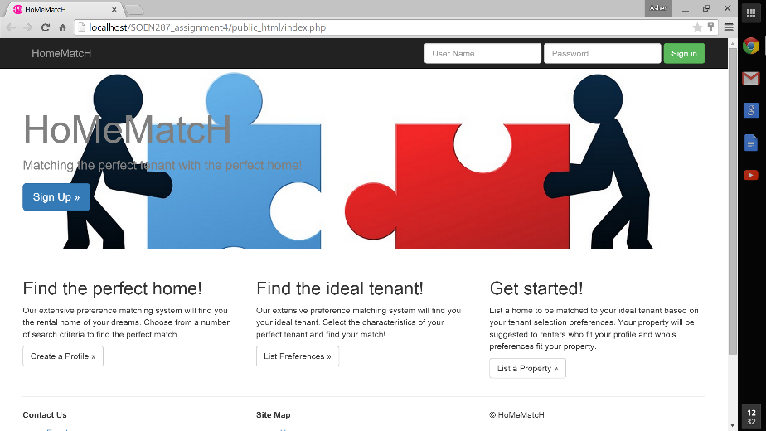This website matches potential tenants with property owners based on a two sided matching algorithm.

Upon arriving at the sites home page, users can sign up, sign in, or access any relevant forms they may need.

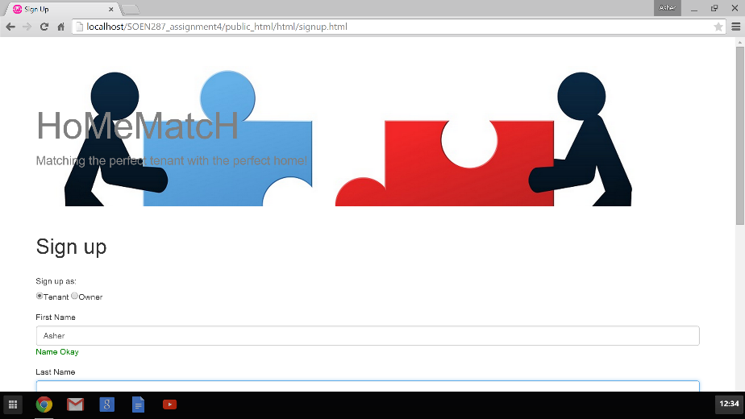New users will click the Sign Up button, and be directed to the /html/signup.html page, which will post their information to /php/new_user.php, which will add their information to the database.

Upon submitting their sign up information, the user will be directed to /php/personal_page.php, a page that displays the user’s information, as well as the forms the user still needs to submit.

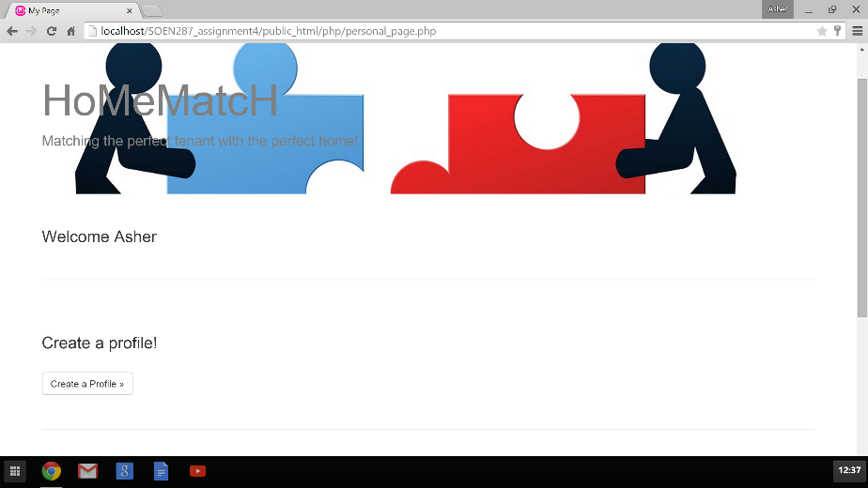Upon clicking the link to the appropriate form from the personal page or the home page, the user will be directed to that form.

Tenants must fill out a profile, which informs the prospective owners about themselves, and a rental preferences form describing the property they 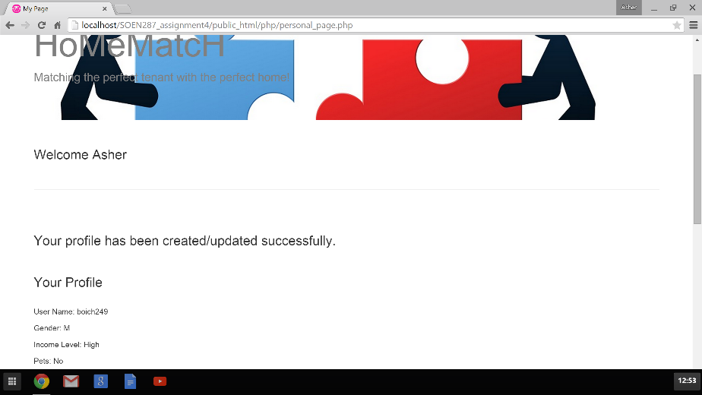would like to rent, which will be matched against the property info.

Owners must fill out a tenant selection form, which describes their ideal tenant, which is matched against the tenant’s profile.

Once a tenant has filled in the appropriate forms, he may request a match.

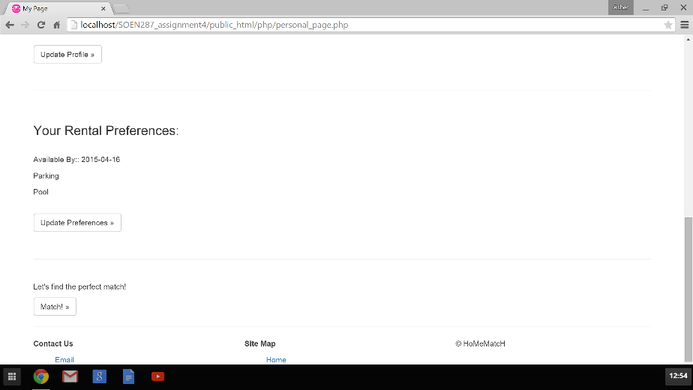The website will process the matching algorithm and display the information of the best two sided match.

Once signed in, the hompage offers a link to sign out, as well as a link to the user’s personal page.

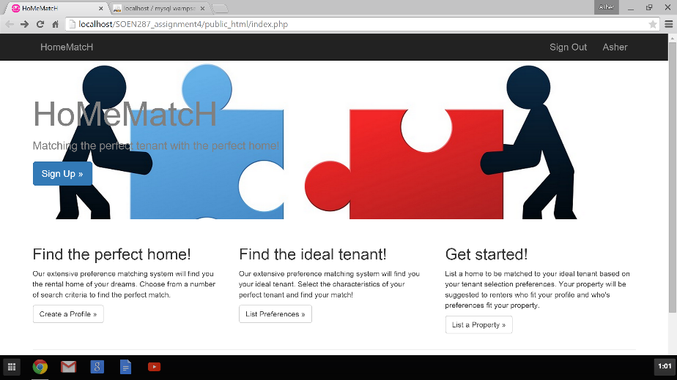

Site Map

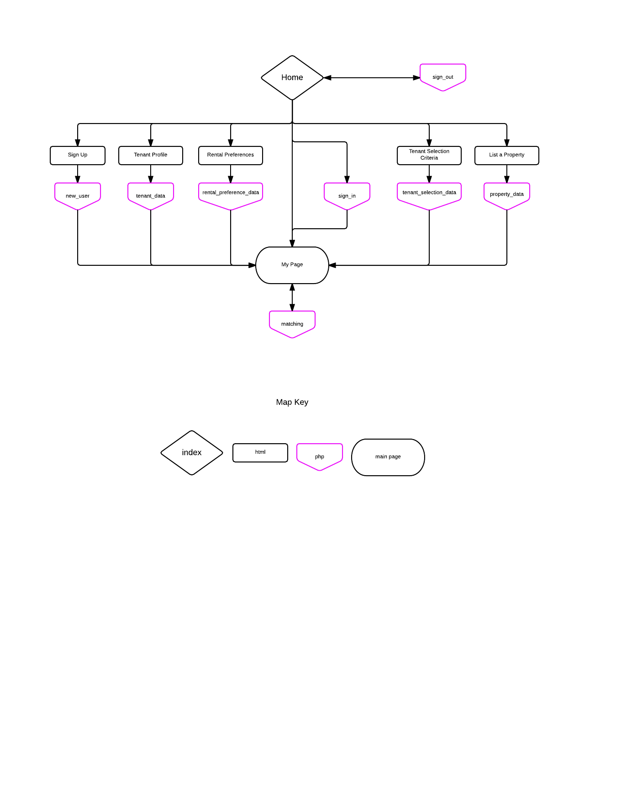

Model of mySQL database rental_7262442

