# **DATA - SQL**

Following ERD of the user events database:

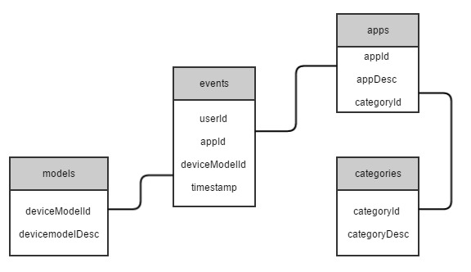

Tables Description:

Events – main events table, 5B daily events for the last 30 days.

Apps – source applications that provide us the user events. ~300K apps dimension table.

Categories – applications categories (For example - Music, Games…) ~50 different categories

Models – phone device models (For example – Samsung S7, iPhone 6, HTC 10) 50K devices dimension table

*\* Pay attention – There might be some apps without any category attached to*

Based on this database, please answer the following questions:

## Question 1:

In a single query, please find for each category it's top 3 apps - apps with the largest number of events during the last 7 days. The output should include the following fields – categoryDesc, appDesc, numEvent

## Question 2:

Hypothesis: 'HTC 10' device users have a much higher affinity to use Games then a 'Samsung S7' users. Please provide a query (1 or more) that will check this hypothesis. After each query, sketch the desired result data structure, and explain how it can help you to succeed the task.