SIM UOW CSCI251
ASSIGNMENT 2
Last updated: 31 January 2024
Timothy Mah
10258663
Lecture Group L01

Contents
Introduction 2
Usage 2
Program flow 2
Extra features 3
Input validation 3
Main menu 3
Sorting menu 3
All shape data input 3
Data visualisation 4
Dynamic shape range 4
Limitations 4
Learnings 4
Override 4
Virtual functions 5
Abstract functions 5
Unique_ptr 5
static variable vs static function vs static variables in a class 5
ternary conditional operator 5
Thoughts and reflections 5
Purpose? 5
Assignment difficulty 5

Introduction
Hello this is my documentation for SIM UOW CSCI251 ASSIGNMENT 2.

Usage
The final program file can only be run in Ubuntu because of the makefile. However, the main file can be compiled to support Windows by compiling as .exe.
To run,
./ csci251_a2.app
To compile,
make
In same directory as makefile. Makefile should be in same directory as main file and the other helper files.

Program flow
This is my program structure. shapetwod.h holds the parent class declaration. The 4 child classes have their declaration in their corresponding .h files. Functions.h is the holds the function prototypes of all my functions. The implementation of the child classes is in their corresponding .cpp files. The implementation of all my functions is in functions.cpp. Main() is in assn2.cpp. The compiled program is in csci251_a2.app.
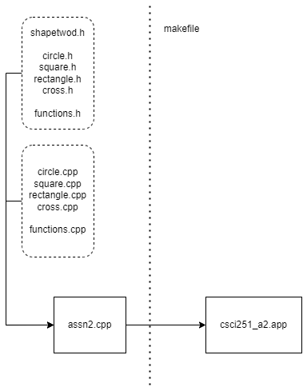

This is my program flowchart
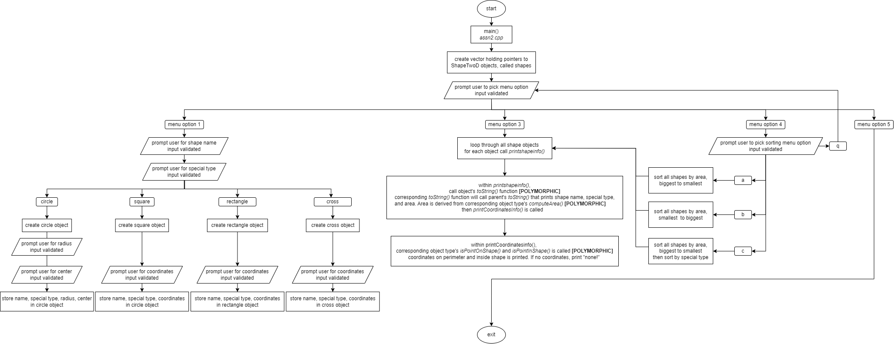

Extra features
Please may I have more marks ☺

Input validation

Main menu
User can only input 1,2,3,4, or 5. All else will be rejected and the program will not continue until valid user input is received. Program will continuously prompt for valid user input.

Sorting menu
User can only input a,b,c, or q. All else will be rejected and the program will not continue until valid user input is received. Program will continuously prompt for valid user input.

All shape data input
For all input that require numbers, only integers are allowed. All else will be rejected and the program will not continue until valid user input is received. Program will continuously prompt for valid user input.
Only exception is radius must be positive.
For special type input, only ws or ns is accepted.
For shape name, only square, rectangle, cross, or circle is accepted.

Dynamic shape range
The shape coordinates can be any range the compiler can handle. It is limited by numeric_limits<int>::max() and min().
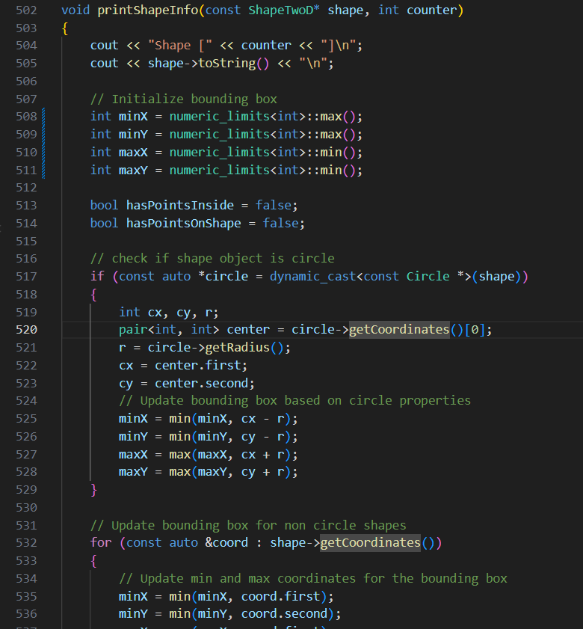

Learnings
Some cool stuff I learnt

Override
I understood from the lectures what is function overriding. Essentially function call of same name can invoke different behaviour based on the object type. However, I don’t remember this Override syntax being used. Maybe it’s a new C++ feature. Regardless, it’s something I had learnt while doing this assignment. This override keyword explicit signals that the specified function is being overridden. The code would work as per normal even if the override keyword is not used. It’s more for ease of understanding.
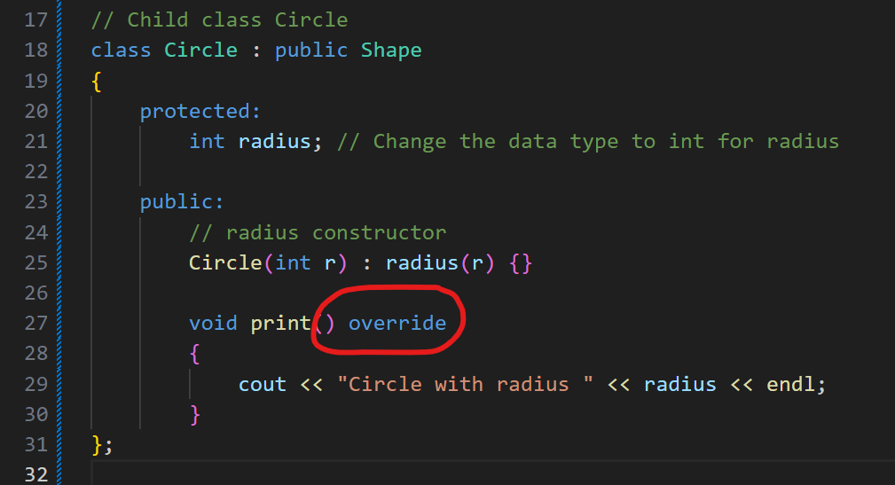

Virtual functions
I think I did not understand fully in class but after writing out the code and taking reference from online sources, I have a better understanding of what virtual functions are. In the following context, basically print() in parent class shape does nothing, but declaring this virtual function means that all children classes must have a print() function. This also enables polymorphism because if there’s no print() in parent class Shape, then shape -> print() would not work.
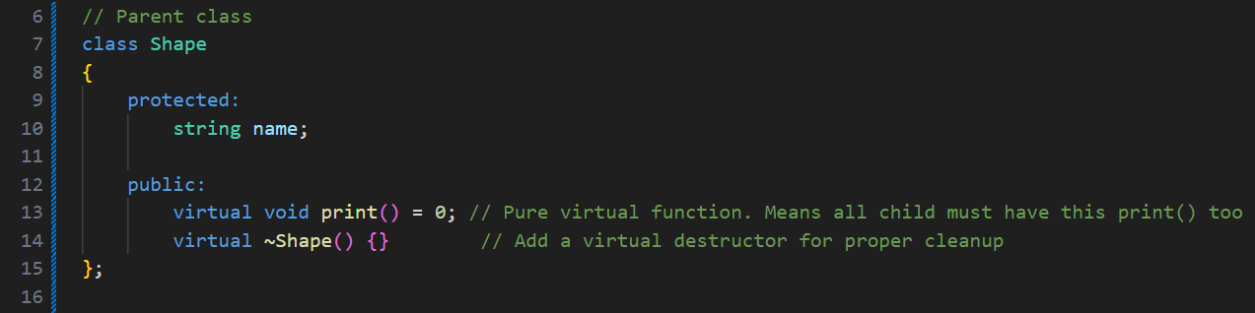

Abstract functions
Abstract function means that I cannot create an instance of it. In my context it means I cannot create an object of ShapeTwoD type directly.

Unique_ptr
Smart pointers! It’s basically a pointer pointer but used with vectors.

static variable vs static function vs static variables in a class
I discovered that actually the single keyword static has multiple meanings depending on where it is used. If used simply in a function when declaring a variable, aka static variable, it means that the value of the variable is not destroyed when the function ends. The value remains persistent between function calls.
Meanwhile, when used while declaring a function, it has several characteristics. First, static functions in a class can be called without creating an object of the class. Second, static functions in a class cannot interact with non-static variables or functions.
Lastly, static variables in a class share its value among all derived objects.
Apparently when static is used correctly, it can save memory and optimise performance but upon further reading, it seems modern compilers can optimise the code in the background already thus making the use of static to save memory a bit redundant.

ternary conditional operator
basically the ? operator. It’s a quick way to write an if statement in a single line. I would not use often since it is not very easily readable but it is useful in my assignment because it made the compareShapesByArea() function much cleaner. And the whole purpose of creating this function was to make my code cleaner.
The syntax is
return value ? (A < B) : (A> B);
If value is true, it will return the expression on the left of the : . if value is false, it will return the expression on the right of the : .

Thoughts and reflections

Purpose?
What is the purpose of function overriding and polymorphism? Perhaps for optimising games code for more fps? This feature of OOP seems so specific and niche I can’t foresee myself using this feature often unless I have a specific problem that requires it.

Assignment difficulty
I don’t even need to hide this, I relied on online sources EXTENSIVELY for all logic. I could apply what I had learnt about classes, inheritance and polymorphism in class, however logic for is point in shape, is point on shape, and all the other logic for cross, these were extremely difficult to create on my own. Moreover, the goal of this assignment is to test understanding of classes and polymorphism so why is the logic segment so difficult? The goal is not to test algorithms and maths right? I don’t even understand some of the algorithms I used. I treated them like a black box.

