

**Source Code Management**

**Lab Record**

**NAME: Abhipsha Jena**

**ENROLLMENT NUMBER: A866175124002**

**FACULTY: Dr. Monit Kapoor**

**COURSE CODE: CSE2015**

**SLOT: L15+L16**

**GIT INSTALLATION**

* Navigate to the official Git downloads pageand click the download link for the latest Git version

for Windows:

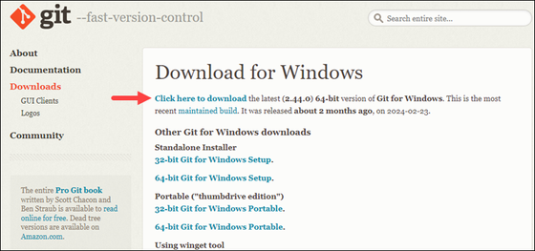

* Double-click the downloaded file to extract and launch the installer
* Review the GNU General Public License, and when you are ready to install, click Next.

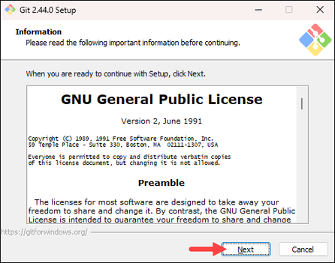

* The installer prompts you for an installation location. Leave the default one unless you want to change it and click Next.

* In the component selection screen, leave the defaults unless you need to change them and click Next.

* The installer offers to create a start menu folder. Click Next to accept and proceed to the next step.

* Select a text editor you want to use with Git. Use the drop-down menu to select Notepad++ (or whichever text editor you prefer) and click Next.
* If you prefer to use a CLI text editor in Git Bash, select nanoor Vimfrom the list.

* The next step allows you to choose a different name for your initial branch. The default is master.
* Unless you are working in a team that requires a different name, leave the default option and click Next.

* The next step allows you to change the PATH environment. The PATHis the default set of directoriesincluded when you run a command from the command line. Keep the middle selection and click Next.

* The installer prompts you to select the SSH client for Git to use. Git already comes with its own SSH client, so if you don't need a specific one, leave the default option and click Next**.**

* The next option relates to server certificates. The default option is recommended for most users. If you work in an Active Directory environment; you may need to switch to Windows Store certificates.
* Select your preferred option and click Next.

* The following selection configures line-ending conversion, which relates to the way data is formatted. The default selection is recommended for Windows. Click Nextto proceed.

* Choose the terminal emulatoryou want to use. The default MinTTY is recommended for its features. Click Nextto continue.

* The next step allows you to choose what the git pullcommand will do. The default option is recommended unless you specifically need to change its behaviour. Click Nextto continue with the installation.

* The next step is to choose which credential helper to use. Git uses credential helpers to fetch or save credentials. The default option is the most stable one. Select your preferred credential manager and click Next.

* The next step lets you decide which extra options to enable. If you use symbolic links, which represent shortcuts for the command line, tick the box. Keep file systemcaching checked and click Next.

* Depending on which Git version you are installing, it may offer to install experimental features. At the time this article was written, the installer offered options to include support for pseudo controls and a built-in file system monitor. For the most stable operation, do not install experimental features and click Install.

* Once the installation is complete, tick the boxes to view the Release Notes or launch Git Bash if you want to start using Git right away and click Finish.
* A screenshot of a computer

  AI-generated content may be incorrect.

**COMMANDS**

* **pwd**

(Presenting work directory)

It is used to view the current directory working on



* **cd <directory name>**

(change directory)

It is used to change the directory

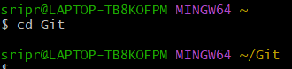

* **cd ..**

It is used to change the directory to the parent directory

* **ls**

It is used to list all the folders



* **vi <file name>**

(vim mode/vi editor)

It is used to create a file and edit it



Click the key “I” to insert or edit your file.

Then press esc key to return from insert mode

Enter :wq (write and quit) to return

* **cat <file name>**

It is used to view the file contents.

* **ls -l**

It is used to list all files

* **ls -ah**

It is used to list all the files including the hidden files

* **history**

It is used to view history of commands

* **mkdir <folder name>**

It is used to create folder



:ls nameoffolder

confirmation to check if the folder is created

:cd folder/

It is used to change the present directory as the folder

also after this create one new file by using vi (then insert i)

* **git init**

It is used to initialize the repository

(working directory to empty repository)

* **git status**

It is used to display the current status of the working directory.

* **git add <file name>**

It is used to add the file

After this edit the file (using vi, insert i)



* **git add .**

It is used to add all the files in the folder



* **git commit -m “<message>”**

It is used to commit a change

* **git config**

It is used to configure username and email

git config --global user.mail “mail”

git config --global user.name “username”



* **git log**

It is used to view status/entries of commits

* **git diff**

It shows the changes made in the working directory since the last commit

* **git branch<branch name>**

It is used to create a new branch



* **git branch**

It lists all the branches in the repository

* **git log --oneline**

It views a concise commit history

* **git checkout<branch name>**

It switches to the given branch

* **git merge <branch name>**

It is used to combine changes from one branch to your current branch

* **git branch -M <branch name>**

It is used to rename your current branch to a new name

* **git remote add origin <url>**

It is used to connect your local repository to a remote Git repository and gives it the name origin



* **git push -u origin <branch name>**

It is used to upload your local commits into the connected remote repository

* **git clone <url>**

It is used to download an existing Git repository from a remote server to your local machine

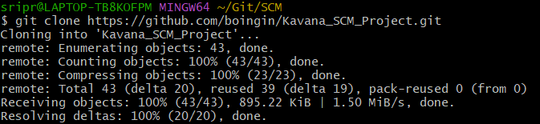

* **git pull**

It is used to download changes from the remote repository and integrate them into your current local branch

**HOW TO FORK A REPOSITORY**

* Open the repository you want to fork and click on the fork option on the top right corner



* You will come to the page which says to create a new fork
* You can select the owner from the list and type on the desired name you want the repository to be forked on
* By unticking the “Copy the main branch only” might help you to fork all the branches from the person’s repository which might help you in the contributing better to the projects as you will have access to all their previous codes

* After forking the repository will appear in your profile

* Now you can make contribution to their project by cloning it.
* To clone the repository, tap on the code option
* With the url provided you can copy it and use the git clone command to clone the forked repository into your system to work on the contribution

* After cloning, open their repository (cd <the file name you saved their repository as>)
* Create a separate branch and then make your contribution