**DESCRIPTION AND TEST OF REMOTE CONTROL**

**Description:**

Remote control is home appliance that helps people easier way to control their appliance (in this case TV). Its square shape and has buttons on one side that controls the appliance. On the bottom side there is a space for batteries for the energy of a remote control. The space for battery’s is covered with plastic cover that can be removed in case of a changing battery. Battery’s that are usable on this specified remote are “AA type” standard batteries. On the front side of a remote there is an infrared sensor that communicate with specific TV appliance on different frequencies.

On front size are button with different shape and function. Each button has one or more function. On top side of a remote there are buttons for ON/OFF television, SOURCE button. Below these top buttons there are 12 buttons in form 3x4 that control number of channels for TV. In the middle there are different shape and color buttons that each control one function of TV and they are standard shape and rounded shape buttons for easier control. On the bottom there are buttons for other functions of a TV in form 4x3.

**Screenshots:**

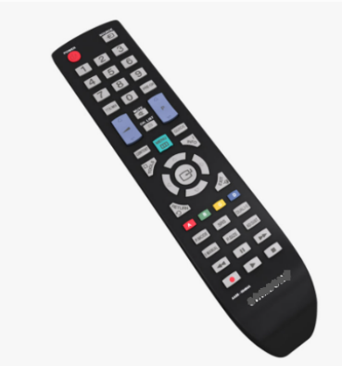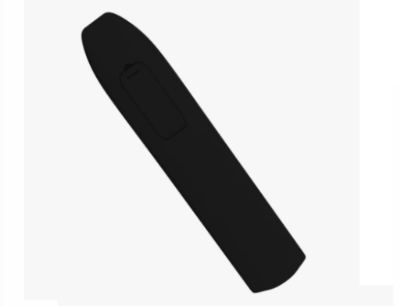

**Tests:**

**Preconditions:**

Before testing check the batteries in remote control are working properly.

*To check if batteries are working properly point to TV frond side and press ON/OFF button pointing to TV directly.

Before pressing buttons on remote control front side must be pointed to TV direction to work correctly or if its specifically sad in test otherwise.

**Test:**

1.Press On/OFF button ones and validate is TV on.

2.Press ON/OFF button twice and validate is TV off.

3.Try to turn on TV by pressing different buttons on TV and validate.

4.Press ON/OFF button and then check by pressing are all buttons working properly on TV and validate.

5.Try to press ON/OFF button with another one button and validate.

6.Try to press simultaneously two different buttons and validate.

7.Hold and press VOLUME UP and DOWN button to see if TV is responding correctly and validate.

8.Hold and press VOLUME UP button up longer than usual and see if TV is responding correctly and validate.

9.Hold and press PROGRAM UP button longer than usual and see if TV is responding correctly and validate.

10.Press MENU button on remote and then press NAVIGATION buttons UP, DOWN, LEFT, RAIGHT and validate if it’s working correctly.

11.Point remote control on other side opposite to TV and press ON/OFF button and validate is it working.

12.Put a physical obstacle in front of a remote control, point remote control to TV direction and press ON/OFF button and validate.

13.Remove only one battery form back side of a remote control and press ON/OFF button and validate if its working correctly.

14.Add different type of butteries (if possible) and press ON/OFF button and validate