DPM 2.1.0 - Metamodel Documentation

  - Metamodel Version: 2.1.0-PWD1
  - Metamodel Diagrams Date: 31/07/2026
  - Document Version and Status: v.2.1.0, Public Working Draft 1
  - Document Date: 31/07/2026

Contents
1 Introduction 4
1.1 Status 4
1.2 Document history 4
1.3 Abbreviations and glossary 4
1.4 Target audience 5
1.5 Out of scope of this document 5
2 Metamodel overview 6
3 Metamodel, ownership and supportive documentation 8
3.1 Metamodel metadata, ownership, and supportive documentation 8
3.2 Historisation 22
3.3 Derivation 27
3.4 Conventions 27
4 Metamodel components 29
4.1 Glossary 29
4.2 Grouping, rendering, and packaging of information requirements 39
4.3 Identification and description of each reported value 50
4.4 Operations on data 53
5 APPENDIX 1: Changes applied on DPM 2.1.0 56

Introduction
This document contains a description of the Data Point Metamodel, a common initiative of the EBA, EIOPA, ECB and SRB.

Status
PWD

Abbreviations and glossary
Term | Description
Data Point | Each distinct quantitative or qualitative reportable unit of information which is represented in the DPM and it corresponds to the DPM metamodel artifact Fact Variable.
DPM | Data Point Model - structured, metadata-driven methodology used to define, organise, and describe reporting requirements in a systematic and machine-readable way. It represents the relationships between data points, validation rules, transformations, and the hierarchical structure of datasets.
DPM Metamodel | Data Point Metamodel – in this abbreviation it refers to a metamodel (a model of the model – statements and structures that hold definition of information requirements) and a methodology (understood as a set of standardised methods used to solve certain problem).
DPM database | Database whose structure follows the DPM metamodel and stores metadata describing reporting requirements or other phases of the data management lifecycle.
DPM XL | DPM eXpression Language – formal syntax and grammar for representing operations (data quality checks and data transformations rules).
EBA | European Banking Authority
ECB | European Central Bank
EIOPA | European Insurance and Occupational Pensions Authority
Modeller | A person (usually a subject matter expert) responsible for defining and maintaining the metadata that describes reporting requirements or other phases of the data management lifecycle.
NCA | Regulatory body on the national level; in context of the EU and financial market these are typically Central Banks and Financial Services Authorities.
Report | data to be exchanged by reporting entities to regulators
Reporting entity/agent | Reporting entity/agent whose data is submitted in a report, e.g. financial institutions such as commercial banks, insurance undertakings, investment firms, etc
SDMX | Statistical Data and Metadata eXchange – standard facilitating exchange of statistical metadata and data.
SMEs | Subject Matter Experts – persons knowledgeable in certain area; in this document typically in regulatory reporting domain i.e. understanding content of information requirements.
SRB | Single Resolution Board
XBRL | eXtensible Business Reporting Language – open technical standard enabling metadata and data exchange.

Target audience
This document is aimed at all potential users of the DPM among all the stakeholders involved in processing regulatory data - from the initial data definition of reporting requirements by regulators, through the preparation and submission of reports by reporting institutions and the subsequent storage, validation, analysis and dissemination to all recipients of regulatory data. The target audience includes people with different roles, including SMEs, policy regulators, data architects and designers/developers of IT solutions. The document supports the design and implementation of DPM-based reporting, encompassing the related data collection and storage systems, validation and calculation engines, data exploration and dissemination platforms.

Out of scope of this document
This document focuses on the explanation of the DPM metamodel, touching also on its impact on the DPM methodology. This document does not cover the following topics that will be addressed by separate documentation in due time:
- The xBRL Architecture, including the mapping of DPM artefacts to XBRL specifications and the XBRL taxonomy architecture (e.g. applied for the serialissation of already published DPM models in XBRL, already published);
- the APIs supporting metadata exchange and approaches for standardisation of definitions (e.g. introduction of a single wide common dictionary on EU level) including technological solutions that could be leveraged for these purposes (e.g. registries driven by APIs), processes and approaches related to the extension of the DPM model which will be published in due time;
- the governance of the DPM metamodel, which aims to ensure collaboration between authorities on the maintenance of the common DPM Standard metamodel, promoting its adoption by different stakeholders, supporting digital processes, and helping people to better understand regulatory data. This documentation will be published in due time.

Metamodel overview
The DPM metamodel consists of four main components, each serving a dedicated purpose:
- A glossary of terms (4.1) organised into Categories (4.1.1), Properties (4.1.4) and Items (4.1.2) used to describe information requirements.
- Rendering (4.2.1) of information requirements in Tables (4.2.1.1) that can be Grouped (4.2.1.4) and Related (4.2.1.5 and 4.2.1.6). These are packaged (4.2.2) in Frameworks (4.2.2.1) and Modules (4.2.2.2) which represent data sets (subsets of information requirements) broken down by subject, scope, etc. This component supports the process of definition of information requirements and what is expected to be reported. It may serve data entry/presentation purposes.
- The identification and description (using glossary terms) of each individual information requirement (4.3) for which a value is to be reported. These are referred to as Variables (4.3.1) and facilitate data exchange by providing a single unique reference for each reported value, while also enabling the tracking of changes in definitions resulting from fixes or other modelling updates, thereby supporting data lineage. Variables typically originate from Table Headers (4.2.1.2) or Table Cells (4.2.1.3).
- The definition of operations on data (4.4) i.e., data quality checks (validations) and data transformation/derivations rules. Operations comprise of Operators (e.g. =, +, -) and Operands that may refer to glossary terms, rendering structures or Variables.
The DPM metamodel serves as the blueprint or abstract schema that defines the structure, components, and relationships specifying how metadata elements such as entities (3.1.1), attributes (3.1.1.1), associations (3.1.4), and validation rules (4.4) are organised and described. The metadata content for a given reporting framework, once hosted in the DPM, represents the DPM-driven implementation of that framework’s reporting requirements. In essence, the DPM metamodel provides the rules for the structured representation of reporting requirements hosted within it.
Metamodel entities identified as Concepts (3.1.2) are associated with an Owner (i.e. maintaining organisation), either directly or by inheriting it from another Concept, and may be provided with supportive documentation such as references to legal acts, regulations, standards, etc. (3.1.3.2). Concepts are identified by their unique ConceptGUID (3.4). Attributes that describe Concepts (e.g., Name, Description, etc) can be translatable (3.1.3.1).
Certain metamodel entities can be (re)used across components, e.g. Context and its Composition (4.1.5) can apply to glossary, rendering and Variables entities.
Metamodel entities or relationships between entities (e.g., associations between various types of Concepts) can be modified in time and are therefore subject to historisation by means of having Versions relating to Releases.
Figure 1 below presents an overview of the DPM metamodel described in detail in the next section of this document.
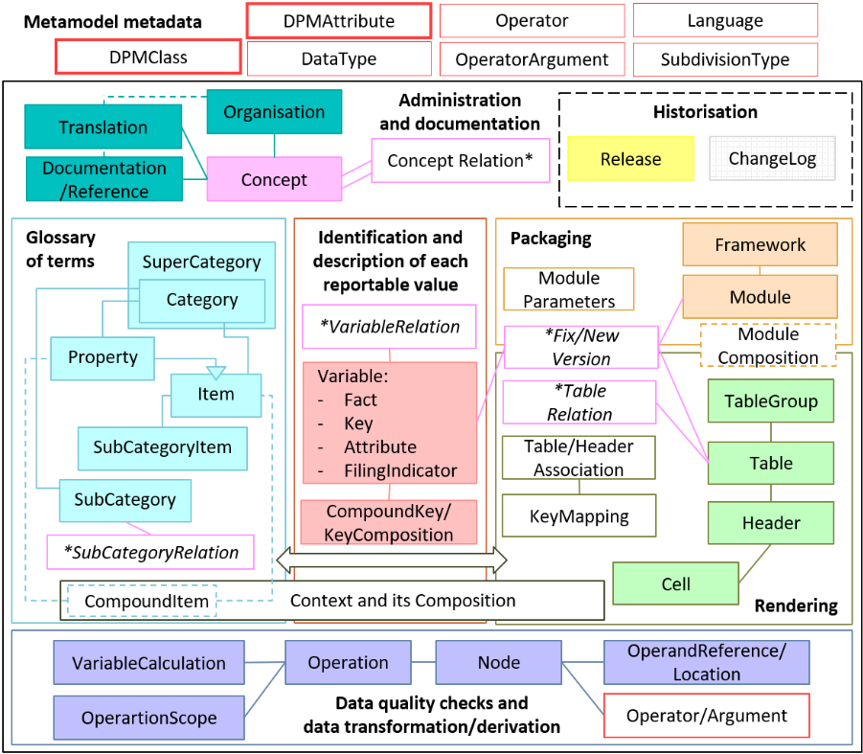
Figure 1. DPM metamodel overview.

Metamodel, ownership and supportive documentation

Metamodel metadata, ownership, and supportive documentation

Metamodel metadata entities
As presented on the left-hand side of Figure 1, the DPM defines a few entities that provide information about the metamodel itself. These entities comprise of:
- DPMClass,
- DPMAttribute,
- DataType,
- SubdivisionType,
- Language,
- Operator,
- OperatorArgument
and are presented in Figure 2.
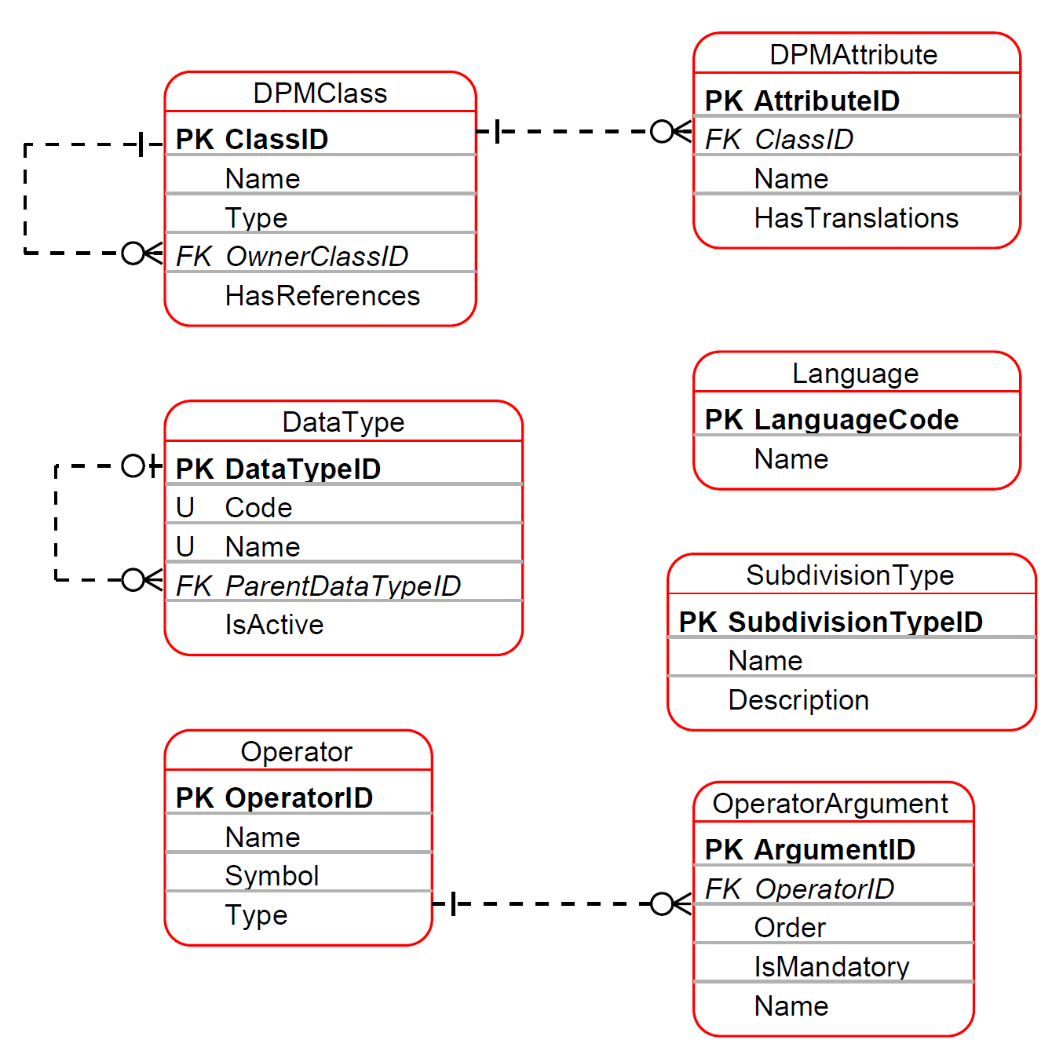
Figure 2. Metamodel metadata entities.
Content of the metamodel metadata entities is predefined as described in the next sections of this document, hence any changes can be introduced only by the DPM metamodel authors.
From the Modellers’ perspective these entities are fixed and must not be edited.

DPM Class and Attribute
The DPMClass entity lists all entities of the DPM metamodel.
DPMClass.Name corresponds to the name of each entity in the metamodel.
Some entities listed in DPMClass are Concepts (3.1.2), i.e. these model entities that:
- can be identified with an Owner or inherit Owner from other Concepts,
- may have references (3.1.3.2),
- contain attributes that are translatable (3.1.3.1).
Most DPM metamodel entities are Concepts. Still there are some entities that are not qualified as Concepts, since they are usually derived as a breakdown of other Concepts (e.g. OperationNodes are a technical breakdown of an operationversion).
DPMClasses whose DPMClass.HasReferences equals TRUE can be provided with references (as described in 3.1.3.2).
DPMClasses which are Concepts may include the DPMClass.OwnerClassID, identifying another Concept class from which their Owner is inherited (as described in 3.1.2).
DPMClasses are of four different types:
- Independent: A self-sustained class.
- Attributive: A class that refers to another class, either through containment (the referring class is part of the other, e.g. a Header is part of a Table) or through versioning (the referring class represents another over time, e.g. a TableVersion is a version of a Table).
- Subtype: A class is a specific subtype of another class (e.g. a Property is a subtype of an Item).
- Associative: This class is an association of two or more other classes. E.g. a SubCategoryItem is an association between a SubCategory and an Item.

Table 1 lists DPMClasses which are Concepts.
Name | Type | OwnerClass (inherited from) | HasReferences
Organisation | Independent |  | Yes
Category | Independent |  | Yes
Subcategory | Independent |  | Yes
SubcategoryVersion | Attributive |  | Yes
Item | Independent |  | Yes
PropertyCategory | Associative |  | Yes
ItemVersion | Associative |  | Yes
Framework | Independent |  | Yes
Module | Attributive | Framework | Yes
ModuleVersion | Attributive | Module | Yes
TableGroup | Independent |  | Yes
Table | Independent |  | Yes
TableVersion | Attributive | Table | Yes
TableAssociation | Associative |  | Yes
Header | Attributive | Table | Yes
HeaderVersion | Attributive | Header | Yes
Cell | Associative | Table | Yes
Variable | Independent |  | Yes
VariableVersion | Attributive | Variable | Yes
CompoundKey | Independent |  | Yes
Context | Independent |  | Yes
Operation | Independent |  | Yes
OperationVersion | Attributive | Operation | Yes
OperationScope | Associative | Operation | Yes
Document | Independent |  | No
DocumentVersion | Attributive | Document | No.
Subdivision | Attributive | DocumentVersion | No
Release | Independent |  | Yes
SubCategoryItem | Associative | SubCategory | Yes
Table 1. List of DPMClasses that are Concepts, along with their attributes.
The DPMAttribute entity lists attributes of each metamodel entity from a DPMClass. DPMAttribute.Name corresponds to the name of an attribute of an entity in the metamodel.
The default national language applied to all applicable entity attributes (such as Name, Description, etc.) in the DPM modelsis English. Attributes whose DPMAttribute.HasTranslation equals TRUE (e.g. Name, Description, etc.) can be provided with translations to other national languages (3.1.3.1).

The list of translatable attributes for each DPMClass is presented in Table 2.
Name | DPMClass | HasTranslations
Name | Category | Yes
Description | Category | Yes
Name | SubCategory | Yes
Description | SubCategory | Yes
Name | ItemVersion | Yes
Description | ItemVersion | Yes
Label | SubCategoryItem | Yes
Name | Framework | Yes
Description | Framework | Yes
Name | ModuleVersion | Yes
Description | ModuleVersion | Yes
Name | TableGroup | Yes
Description | TableGroup | Yes
Name | TableVersion | Yes
Description | TableVersion | Yes
Label | HeaderVersion | Yes
Name | TableAssociation | Yes
Description | TableAssociation | Yes
Name | VariableVersion | Yes
Description | OperationVersion | Yes
Expression | OperationVersion | Yes
Name | Document | Yes
TextExcerpt | Subdivision | Yes
Name | Organisation | Yes
Acronym | Organisation | Yes
Description | Release | Yes
Table 2. List of translatable DPMAttributes.
Relationship between DPMClass, DPMAttribute and Concept is presented in Figure 3.
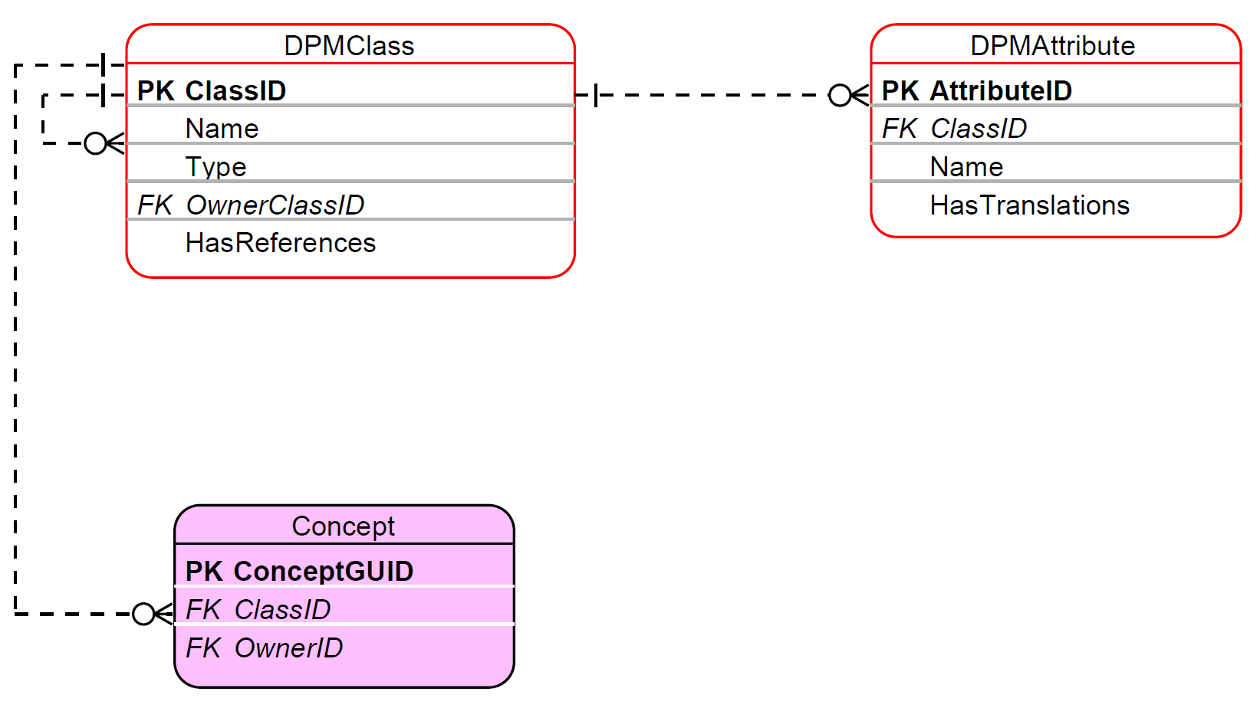
Figure 3. Concept, DPMClass and DPMAttribute entities.

Data Type
The DataType entity provides the list of data types that can be used on the Property entity (4.1.4).
As presented in Figure 2, each DataType is identified by Code and explained by Name.
The list of available data types is presented in see Table 3.
Code | Name | Parent Data Type
i | integer
r | decimal
s | string (non empty)
b | boolean
t | true | boolean
dt | date time
d | date | date time
e | enumeration | string
m | monetary
p | percentage
u | URI
o | ordinals
es | string (including empty string)
Table 3. List of data types.
Data types can be derived (by restriction) from one another. For example, True data type is a restriction of a Boolean data type to only one value (i.e. Boolean TRUE).
The DataType can be deactivated (3.2.3) by setting IsActive to FALSE which indicates that such deactivated data type can no longer be used in the modelling of metadata. Data types listed in Table 3 are all active at the moment of the release of this documentation.

Subdivision Type
SubdivisionType is used for structuring references to documentation (3.1.3.2) and, as presented in Figure 4, is referred to by Subdivision.
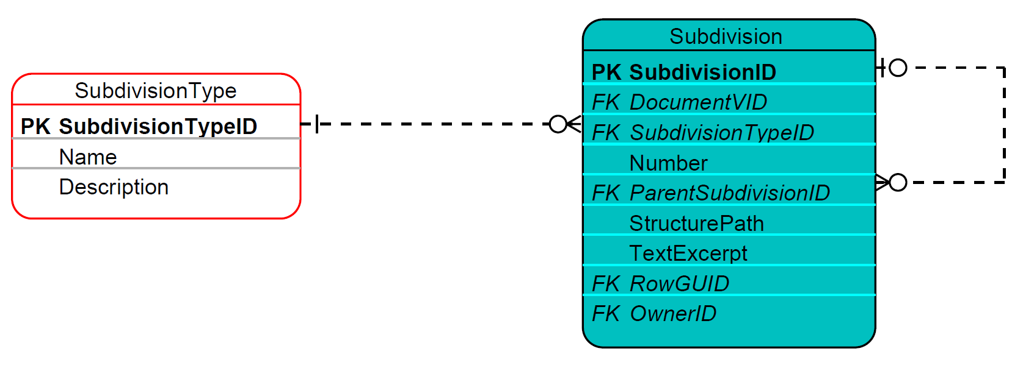
Figure 4. SubdivisionType entity.
SubdivisionType is identified by its Name and further explained by its Description. The list of SubdivisionTypes is presented in Table 4.
Name | Description
Chapter | For a publication that uses chapters, this part should be used to capture this information. Because chapters are not necessarily numbers, this is a string.
Article | Article refers to a statutory article in legal material.
Section | Section is used to capture information typically captured in sections of legislation or reference documents.
Subsection | Subsection is a subsection of the section part.
Paragraph | Paragraph is used to refer to specific paragraphs in a document.
Subparagraph | Subparagraph of a paragraph.
Clause | Subcomponent of a subparagraph.
Subclause | Subcomponent of a clause.
Appendix | Refers to the name of an Appendix, which could be a number or text.
Example | Example captures examples used in reference documentation; there is a separate element for Exhibits.
Page | Page number of the reference material.
Exhibit | Exhibit demonstrates an instance case in reference documentation; examples could also contain a separate element.
Footnote | Footnote is used to reference footnotes that appear in reference information.
Sentence | In some reference material individual sentences can be referred to.
URI | Full URI of the reference such as "http://www.fasb.org/fas133".
Requirement | A suggestion of a new model entry for consideration / to be addressed in the next releases.
Table 4. List of subdivision types.

Language
The Language entity enables the translation of a Concept’s translatable attribute to different national languages (3.1.3) based on the ISO 639-1 alpha-2 language codes and names.
Language is identified by LanguageCode and its Name as presented in Figure 5.
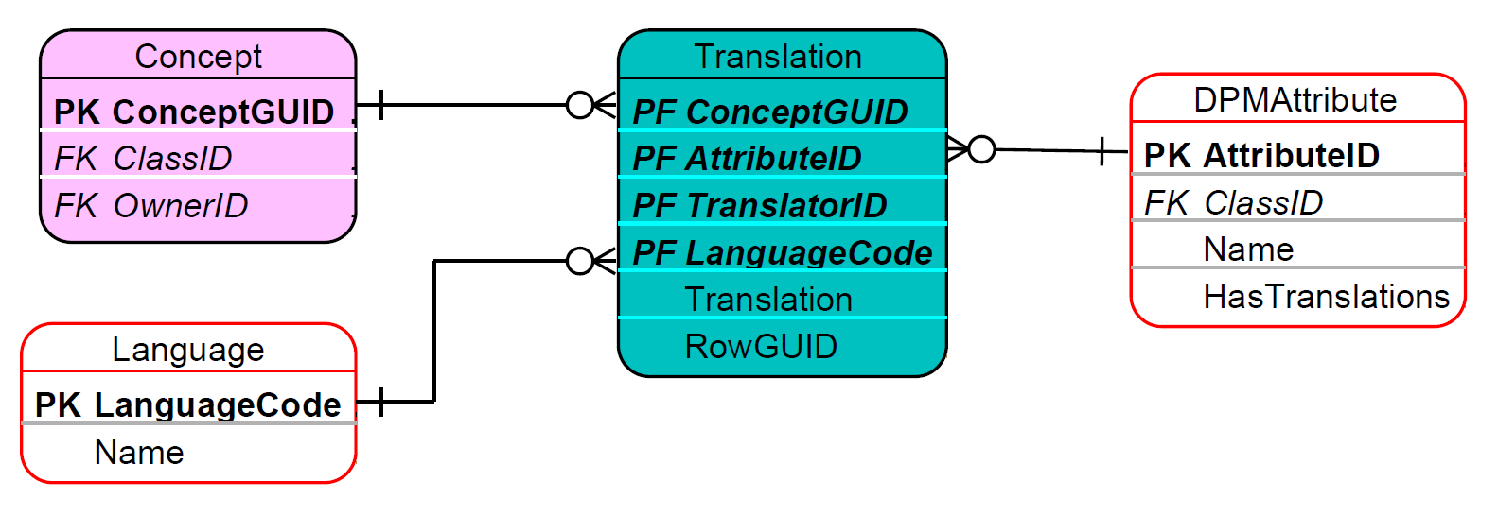
Figure 5. Language entity.

Operator and Operator Argument
Operators (as presented in Figure 6) can be applied by:
- SubCategoryItem (to indicate arithmetic operations between Items in a SubCategory, see 4.1.3),
- OperationNode (in which case Operators may be more complex and include multiple OperatorArguments, see 4.4.1, with each argument represented by a separate OperationNode linked to the same Operator and its own OperatorArgument).
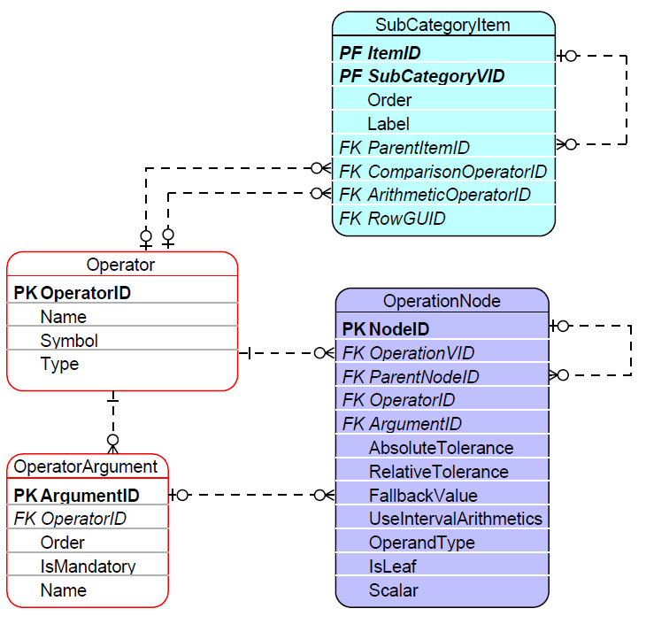
Figure 6. Operator and OperatorArgument entities.
The list of Operators is presented in Table 5.
Name | Symbol | Type
Unary plus | + | Numeric
Addition | + | Numeric
Division | / | Numeric
Unary minus | - | Numeric
Subtraction | - | Numeric
Absolute value | abs | Numeric
Numeric minimum | min | Numeric
Multiplication | * | Numeric
Numeric maximum | max | Numeric
Square root | sqrt | Numeric
Aggregate maximum | max_aggr | Aggregate
Aggregate minimum | min_aggr | Aggregate
Equal to | = | Comparison
Less than equal to | <= | Comparison
Greater than equal to | >= | Comparison
Element of | in | Comparison
Is null | isnull | Comparison
Greater than | > | Comparison
Less than | < | Comparison
Not equal to | != | Comparison
Match characters | match | Comparison
And | and | Logical
Or | or | Logical
Not | not | Logical
Exclusive or | xor | Logical
Sum | sum | Aggregate
Count | count | Aggregate
Where | where | Clause
Get | get | Clause
If then else | if-then-else | Conditional
Filter | filter | Conditional
Time shift | time_shift | Time
Rename | rename | Clause
RenameNode | node | Clause
Grouping clause | group by | Clause
Persistent assignment | <- | Assignment
Parenthesis Expression | () | Logical
Sub | sub | Clause

Table 5. List of Operators.
As presented in Figure 6, more complex Operators are composed of multiple arguments. The list of OperatorArguments is provided in Table 6.
Operator (FK) | Order | IsMandatory | Name
Unary plus | 1 | 1 | operand
Addition | 1 | 1 | left
Addition | 2 | 1 | right
Division | 1 | 1 | left
Division | 2 | 1 | right
Unary minus | 1 | 1 | operand
Subtraction | 1 | 1 | left
Subtraction | 2 | 1 | right
Absolute value | 1 | 1 | operand
Numeric minimum | 1 | 1 | operand
Multiplication | 1 | 1 | left
Multiplication | 2 | 1 | right
Numeric maximum | 1 | 1 | operand
Square root | 1 | 1 | operand
Aggregate maximum | 1 | 1 | operand
Aggregate maximum | 2 | 1 | grouping_clause
Aggregate maximum | 3 | 1 | component
Aggregate minimum | 1 | 1 | operand
Aggregate minimum | 2 | 1 | grouping_clause
Aggregate minimum | 3 | 1 | component
Equal to | 1 | 1 | left
Equal to | 2 | 1 | right
Less than equal to | 1 | 1 | left
Less than equal to | 2 | 1 | right
Greater than equal to | 1 | 1 | left
Greater than equal to | 2 | 1 | right
Element of | 1 | 1 | operand
Element of | 2 | 1 | set
Is null | 1 | 1 | operand
Greater than | 1 | 1 | left
Greater than | 2 | 1 | right
Less than | 1 | 1 | left
Less than | 2 | 1 | right
Not equal to | 1 | 1 | left
Not equal to | 2 | 1 | right
Match characters | 1 | 1 | operand
Match characters | 2 | 1 | pattern
And | 1 | 1 | left
And | 2 | 1 | right
Or | 1 | 1 | left
Or | 2 | 1 | right
Not | 1 | 1 | operand
Exclusive or | 1 | 1 | left
Exclusive or | 2 | 1 | right
Sum | 1 | 1 | operand
Sum | 2 | 1 | grouping_clause
Sum | 3 | 1 | component
Count | 1 | 1 | operand
Count | 2 | 1 | grouping_clause
Count | 3 | 1 | component
Where | 1 | 1 | operand
Where | 2 | 1 | condition
Get | 1 | 1 | operand
Get | 2 | 1 | component
If then else | 1 | 1 | condition
If then else | 2 | 1 | then
If then else | 3 | 1 | else
Filter | 1 | 1 | selection
Filter | 2 | 1 | condition
Time shift | 1 | 1 | operand
Time shift | 2 | 1 | period_indicator
Time shift | 3 | 1 | shift_number
Time shift | 4 | 1 | dimension
Rename | 1 | 1 | operand
Rename | 2 | 1 | node
RenameNode | 1 | 1 | old_name
RenameNode | 2 | 1 | new_name
Grouping clause | 3 | 1 | component
Persistent assignment | 1 | 1 | left
Persistent assignment | 2 | 1 | right
Parenthesis Expression | 1 | 1 | expression
Sub | 1 | 1 | operand
Sub | 2 | 1 | condition
Table 6. List of OperatorArguments.

Concept and Ownership
As explained in the previous section, information requirements and hence data models are developed by various authorities. It is therefore necessary to identify an Organisation that defined a given classification, business term, data set, table, etc, and is responsible for its maintenance.
For this purpose the DPM defines a Concept entity that represents identifiable objects in the model meeting specific criteria (i.e. receiving Code/Name assigned by a modeller). In technical terms – all metamodel entities that have a single primary key are Concepts (it is important to note though, that some of such entities are merely versions of another object in time like TableVersions). As Concepts are also prescribed by the metamodel for managing references (3.1.3.2) and translations (3.1.3.1), all DPMClasses (3.1.1.1) who have HasReferences set to TRUE or of which at least one attribute has HasTranslations set to TRUE, are also represented in the model as Concepts.
The ConceptGUID for the Concept is generated using a universally unique identifier (UUID). Most metamodel entities include a globally unique RowGUID attribute, which references the corresponding ConceptGUID. This approach prevents duplication and conflicts across entities, even across organisations.

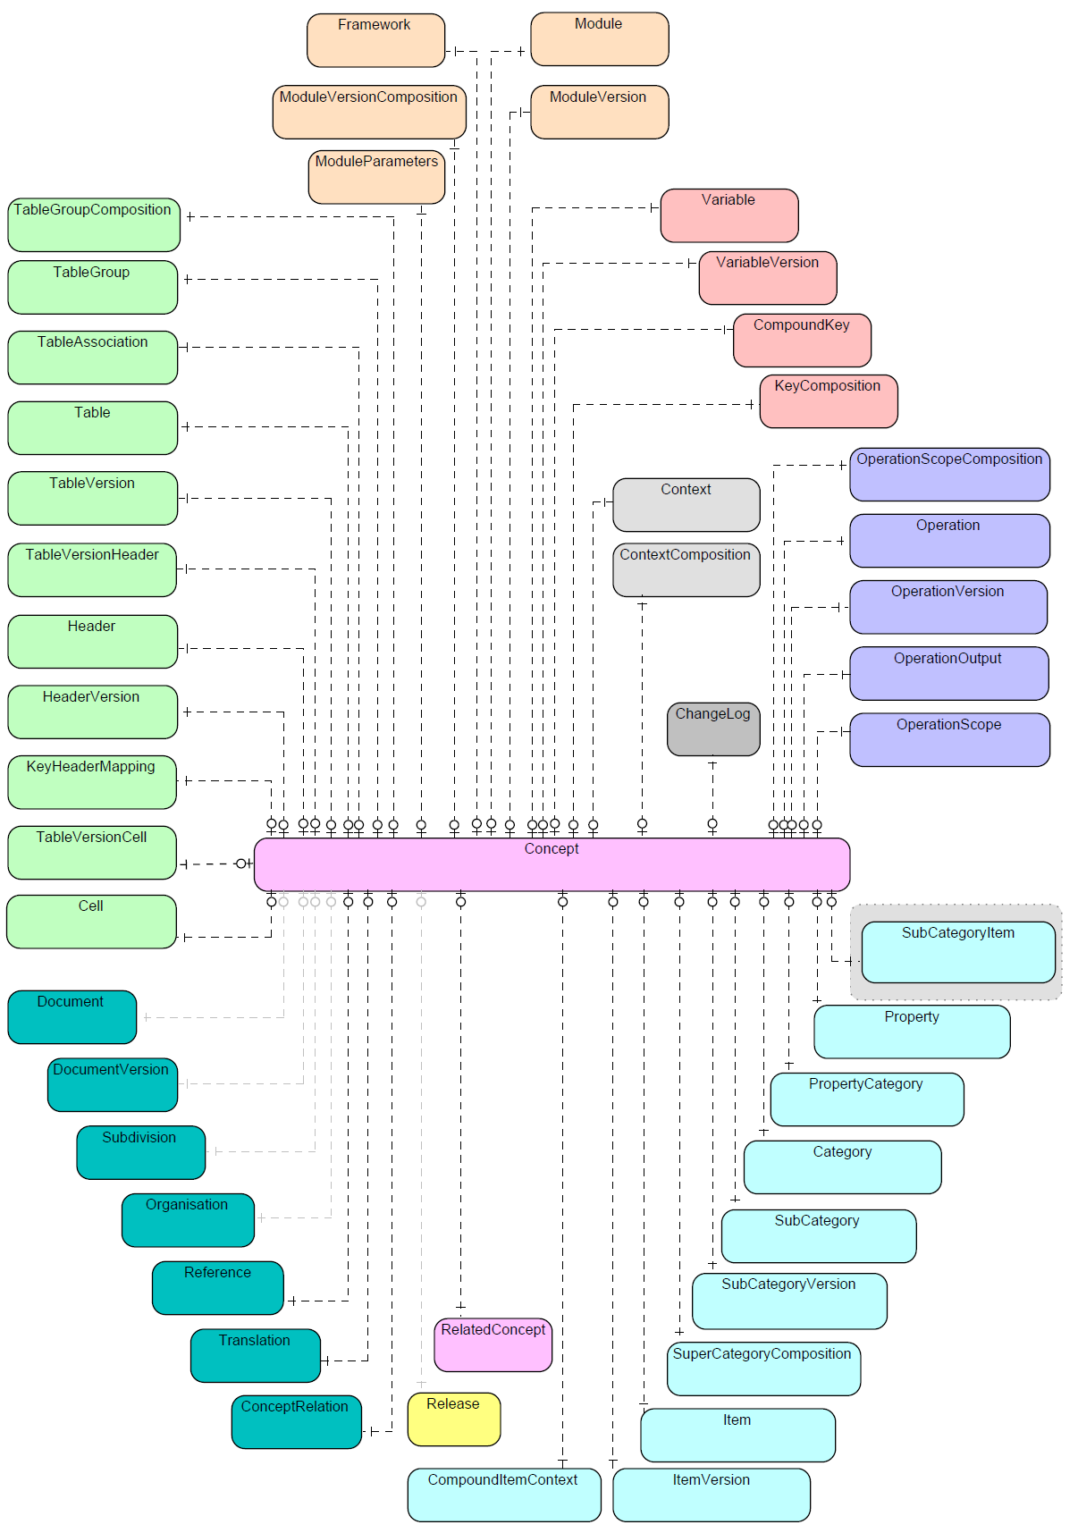
Figure 7. Concepts
As presented in Figure 8, Concept can be assigned with an Owner indicating Organisation that has defined and manages it. DPM metamodel restricts each Concept to have one and only one Owner.
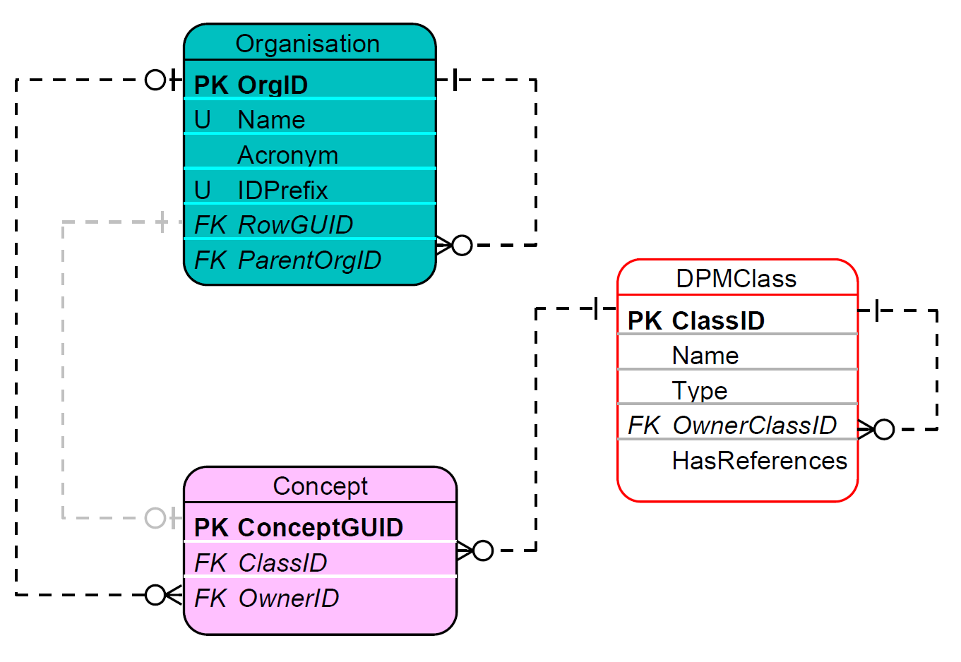
Figure 8. Concept as DPMClass and its Owner Organisation.
For some Concepts information about the Owner is inherited from other Concepts. This is achieve via the DPMClass.OwnerClassID and documented in Table 1. Modellers are therefore enabled to assign an Owner only for Concepts not having an OwnerClassID while any children of an upper-level class inherit this information from their parent (i.e. their Owner is the same as the Owner of the Concept identified by their parent DPMClass).
Owner Organisations are described by their Name and Acronym (e.g. “European Banking Authority” and “EBA” respectively; in fact Acronym is employed in the role of “Code”). An Organisation is a Concept itself and therefore its applicable attributes (i.e. Name and Acronym) are translatable (3.1.3.1).
The ParentOrgID attribute of an Organisation serves to differentiate between various domains within the same Organisation by including the OrgID of the parent Organisation. This enables the establishment of hierarchical relationships between organisations and facilitates a more granular management of Concepts by distinct Owners operating within the Organisation.
For technical reasons all identifiers (primary key IDs of all metamodel entities) in the physical database implementation are unique for each Concept. This shall simplify the process of merging models from various databases maintained individually by different Organisations. To achieve this, the first three digits of any ID indicate the Owner (as prescribed by Organisation.IDPrefix) while the other digits ensure uniqueness for each DPMClass for that Owner (e.g. sequential numbers).
DPM Metamodel contains predefined Organisations as illustrated in Table 7.
Name | Acronym | IDPrefix
DPM Metamodel | DPMM | 100
European Banking Authority | EBA | 101
European Insurance and Occupational Pensions Authority | EIOPA | 102
European Central Bank | ECB | 103
Table 7. DPM Metamodel predefined Organisations.
The “DPM Metamodel” Organisation hosts the definitions of the Categories (5.1.1) “Properties”, “Not applicable” and “Templates” which are structural Categories used by the metamodel itself. As they belong to the metamodel and are shared across all authorities, they are owned centrally rather than by any individual authority.

Supportive documentation

Translations
English is the main reference language for modelling in the DPM. Therefore, all attributes like Name, Description, Label, Value, etc across all DPM metamodel entities are provided in English, with the possibility of having translations into other languages where there is the business need.
Attributes that are expected or enabled to be translatable are marked with DPMAttribute.HasTranslation equals TRUE (4.2.1.1).
As presented in Figure 9, a Translation identifies the Concept (Translation.ConceptGUID, 4.2.2), with the translated attribute of this Concept (Translation.AttributeID, 4.2.1.1), the national language of the translation (Translation.LanguageCode, 4.2.1.4) and the Organisation that provided and manages this translation (Translation.TranslatorID, 4.2.2). It is therefore possible for an attribute of a Concept to have more than one translation, defined by different Organissations, in the same language.
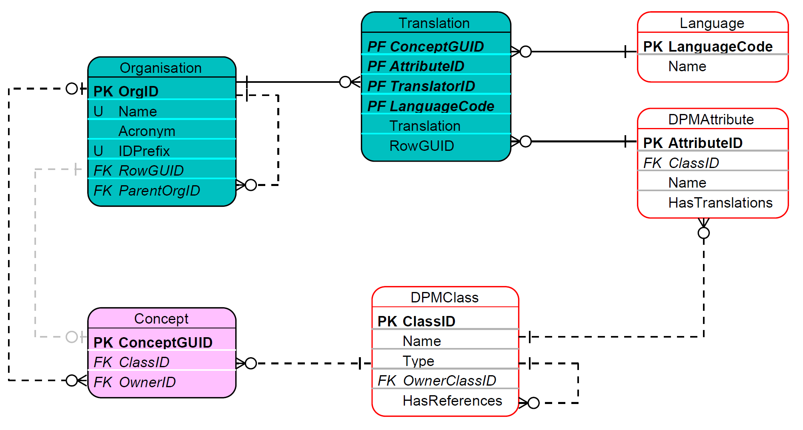
Figure 9. Concepts' attributes translations.

References to documentation
Information requirements result from various documents: legal acts, regulations, standards, change requests, requirements, etc. Concepts (3.1.2) belonging to DPMClasses whose HasReferences equals TRUE (3.1.1.1) can be associated with references containing their definitions, guidelines, or other explanations.
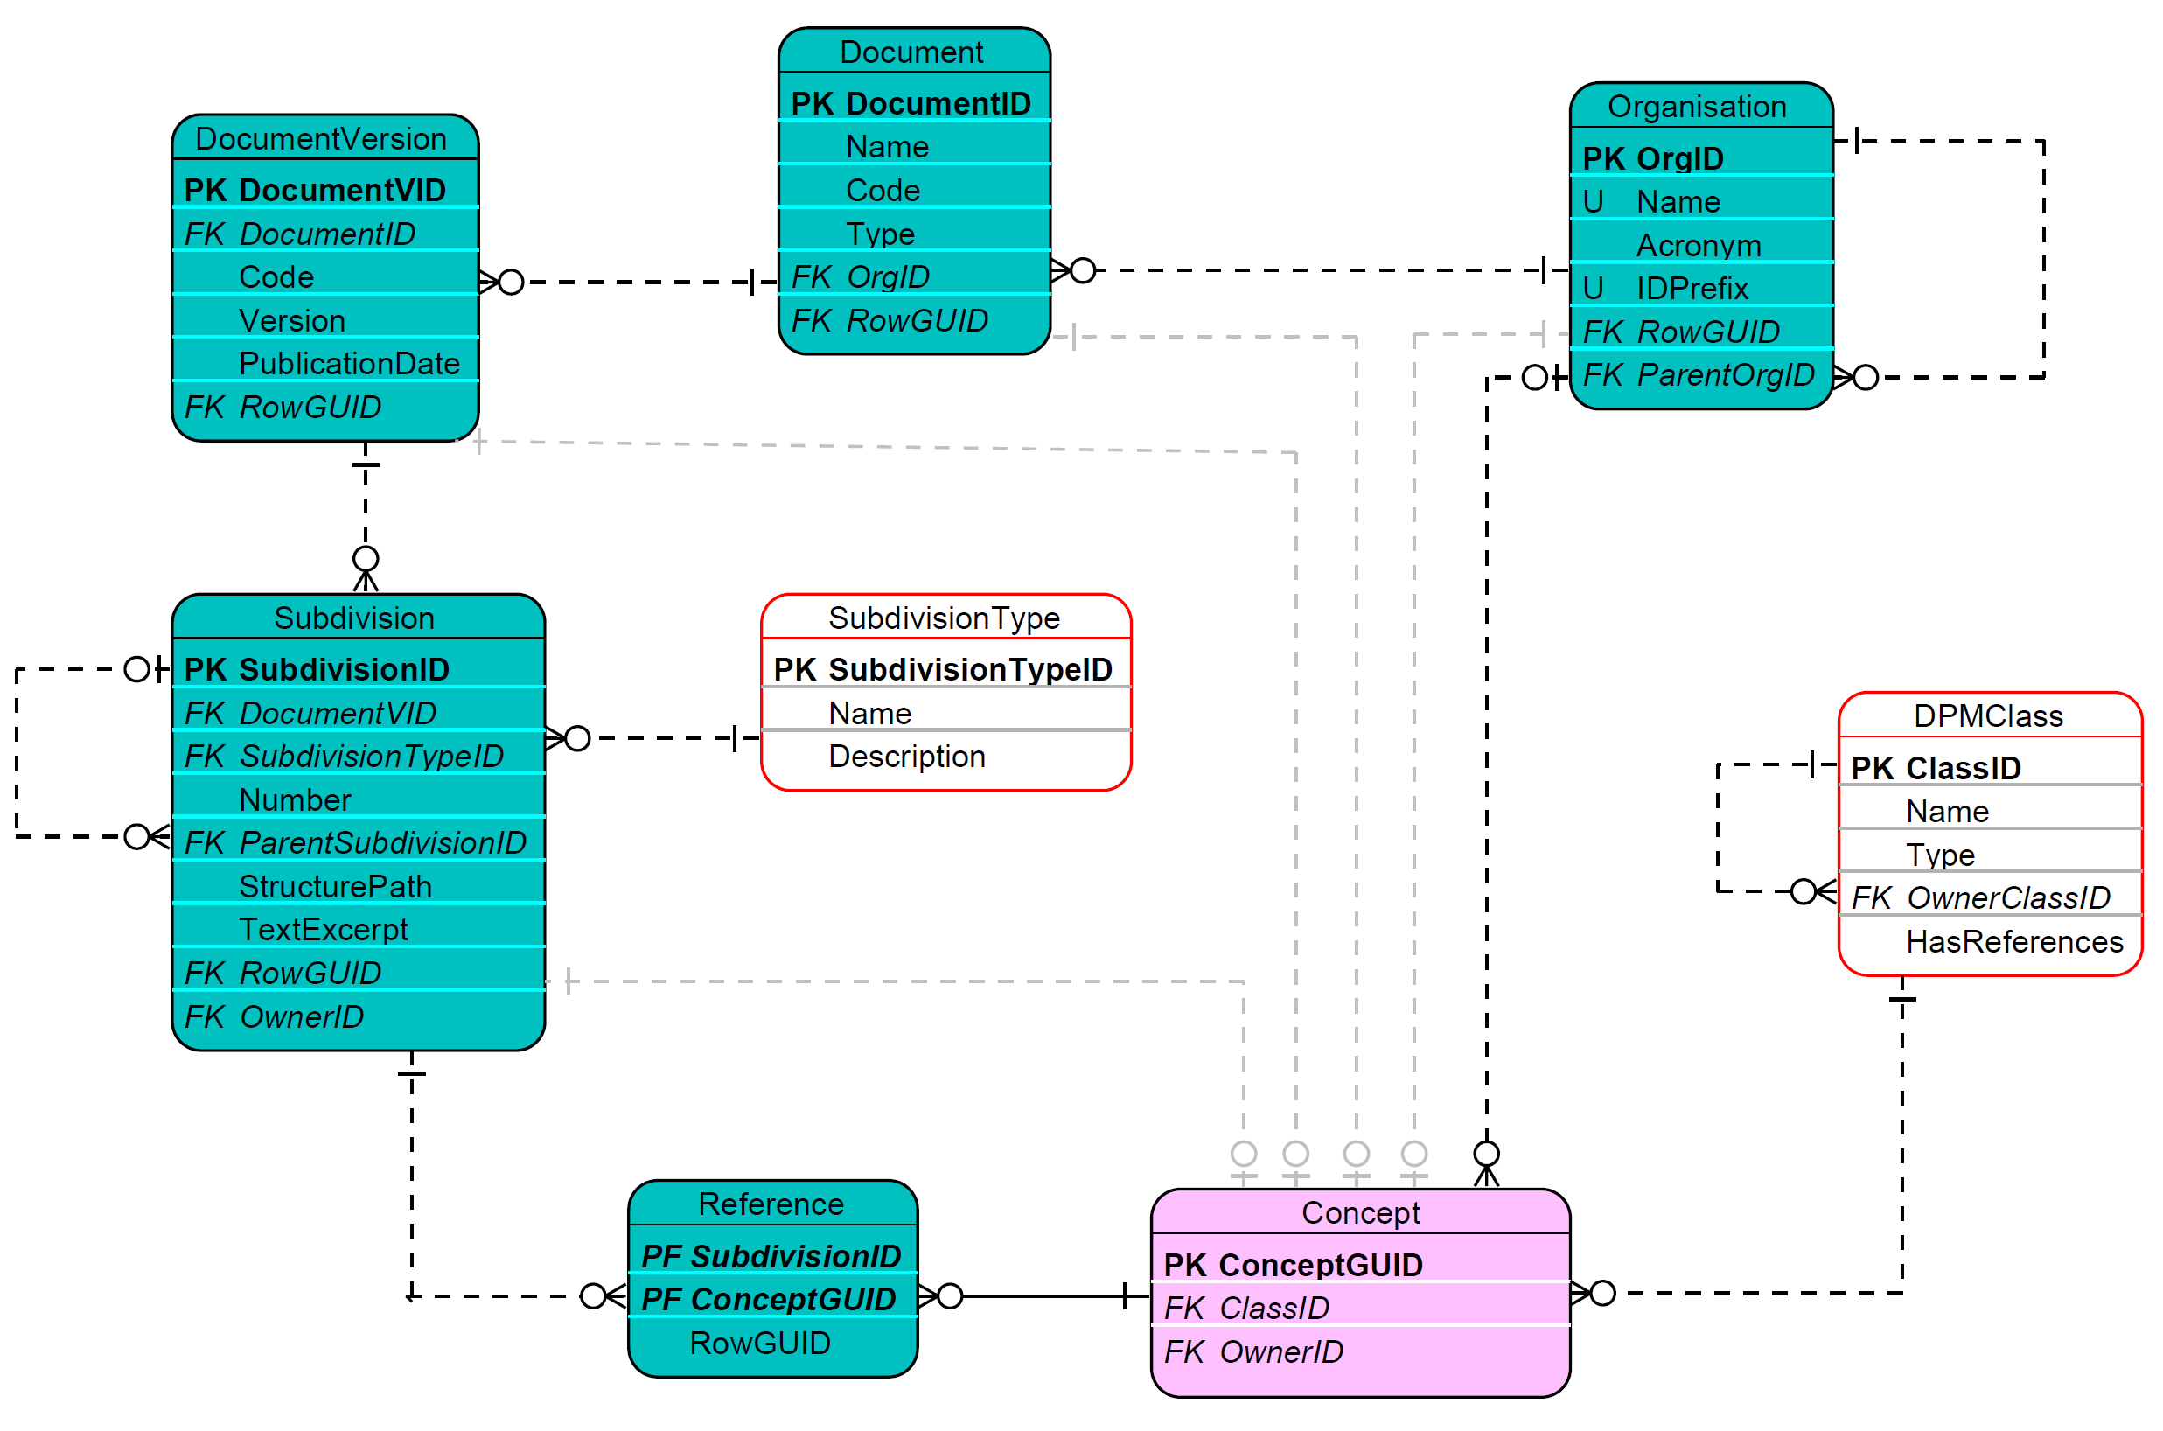
Figure 10. References.
As presented in Figure 10, a Document identifies a piece of legislation (e.g. EU Directive, ITS, etc) or other report by its Name and (optionally) its Code. Type indicates the kind of Document (e.g. “legal_document”, “change_request”). DocumentVersion serves for historisation purposes and indicates PublicationDate and Version information of the Document along with its Code which may also vary in time.
As explained in section 3.1.1, SubdivisionType provides a list of typical parts that structure a piece of a legislation or other report. They are used in Subdivision to mirror the arrangement and structure of a Document by providing the ability to refer to any individual Subdivision by its Number and providing means of nesting them in higher-level Subdivisions (hence the hierarchical structure of Subdivision.ParentSubdivisionID). The complete address of a Subdivision position in the document is also provided by Subdivision.StructurePath.
A Subdivision (typically leaf-level) may contain the actual wording of the document fragment it represents (Subdivision.TextExcerpt).
Subdivisions are linked to Concepts via Reference (one Concept can have References to many Subdivisions and one SubDivision may provide References for many Concepts).
Document, DocumentVersion and Subdivision are Concepts and therefore have an Owner (DocumentVersion and Subdivision inherit the Owner from the Document as per ) and some of their attributes (e.g. TextExcerpt) can have translations (see Table 2 and section 3.1.3.1).

Concept relation
The DPM metamodel provides the means for Concepts to be related to one another via ConceptRelation that can link all RelatedConcepts as presented in Figure 11.
This generic approach enables linking Concepts within and across Owners and/or representing various DPMClasses (3.1.1.1). For example, it can be used to connect identical Concepts defined by different Owners, or to identify the same Concept but modelled differently or even at different modelling levels (e.g. in logical and physical implementation).
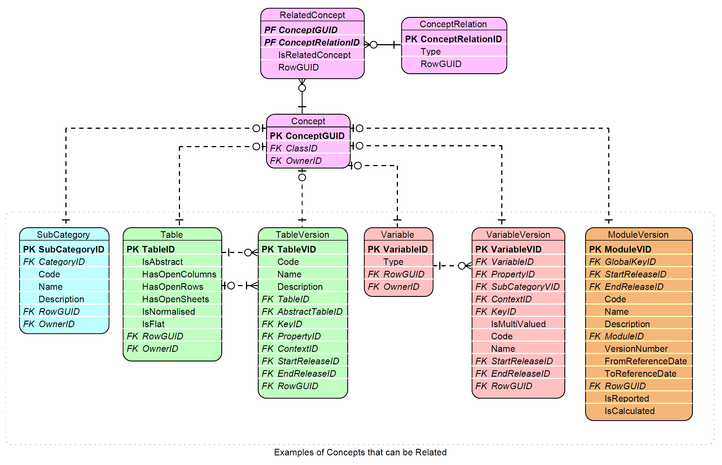
Figure 11. Concept and ConceptRelation.
If a relation has a direction, RelatedConcept.IsRelatedConcept equals TRUE identifies a Concept at the target of this relation, otherwise it is FALSE (default value) for relation’s source Concept or in case relation has no direction/is bidirectional.
ConceptRelation.Type identifies the type of relation. There are some generic relation types (i.e. that can be applied to various classes of Concepts - 3.1.1.1):
- “equivalent_concept” indicates that Concepts linked through such relation type (whatever DPMClass they represent) are semantically the same. This relation is bidirectional hence IsRelatedConcept is FALSE for all RelatedConcepts,“version_fix” and “version_new” apply typically to Versions of various Concepts (e.g. ModuleVersions, TableVersions or HeaderVersions) and informs that the target of the relation is created:
  - to correct a modelling problem (“version_fix”) of the source Concept or
  - as an evolution of the source Concept (“version_new”) due to e.g. revision of information requirements;
This information along with Releases is essential in determining applicability of glossary (4.1) Concepts in modelling of rendering (4.2.1) and Variables (4.3.1) in time.
In addition to the above three generic relation types, the DPM metamodel predefines also relation types that can be used to relate specific Concepts, i.e.:
- SubCategories – “subCategoryMaster_version” and “subCategoryRendering_restriction” (4.1.3),
- Variables – “factVariable_keyVariable” and “variable_attributeVariable” (4.3.1),
- Tables – “table_variant” (4.2.1.1),
- Headers - “header_attributeHeader” (4.2.1.2)

Detailed semantics of these relation types are explained in the referred sections.
Modellers can extend ConceptRelation.Type with other options that they need or find useful.

Historisation
Information requirements may change over time. Updates can be published by their authors in a scheduled or ad hoc manner.
Moreover, Modellers may decide to modify the way they represent glossary terms or information requirements (e.g. due to bug fixes or to improve the model during periodic revisions). Some Concepts (3.1.2) can therefore become obsolete over time. However, to enable resubmissions of data for past periods or to support time series analysis, Concepts of published models are never deleted as it shall always be possible to understand the modelling and information requirements applicable at any moment in time.

Releases
A Release is a snapshot of information requirements hosted in the DPM at a specific point in time. It serves as a publication package that coordinates the state of all artefacts (such as Modules, Tables, and glossary content) for the regulatory reporting. A Release includes specific ModuleVersions and their dependent artefacts (Tables, Headers, SubCategories, etc.).
The DPM metamodel distinguishes two approaches on how changes are treated:
- Structural Versioning: New versions of artefacts, such as Modules, Tables, Headers, and Operations, or Glossary artefacts, such as Categories, Properties are created whenever changes occur to the artefact itself or its underlying hierarchy. These changes may include updates to glossary items or modifications to related structural components, such as Tables.
- Operation scope deactivation and severity status: these changes are tracked using release-based logs.
Release represents each publication of an information requirements. Each Release is identified by a Code and a publication Date.
As indicated in Figure 12, a Release is applied to metamodel entities which can be:
- versions of certain classes of Concepts such as:
  - SubCategoryVersion,
  - TableVersion,
  - HeaderVersion,
  - VariableVersion,
  - ModuleVersion,
  - OperationVersion,
- connections between Concepts:
  - ItemVersion,
  - PropertyCategory,
  - SuperCategoryComposition,
  - TableGroupComposition,
  - CompoundItemContext,
  - TableAssociation
- individual Concepts life cycle: TableGroup.
The purpose of a Release is to document the evolution of Concepts or their composition and to help identify how a glossary term, a table content or a variable was represented at a point in time.
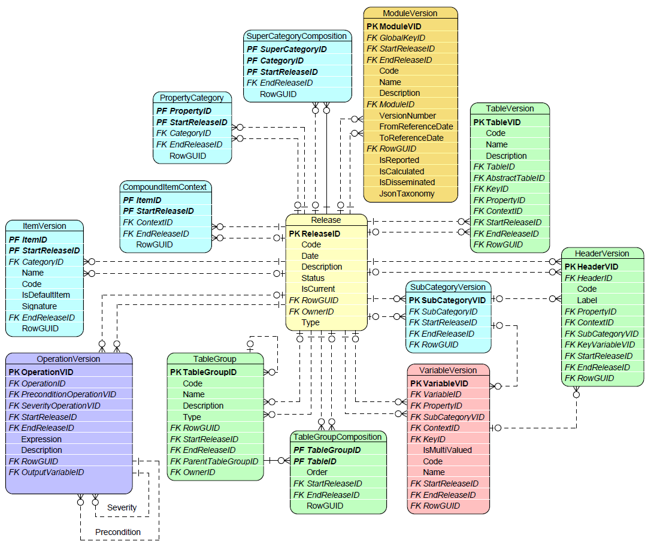
Figure 12. Metamodel entities whose historisation is supported by reference to Release.
On all entities where it applies, a Release is referenced twice, mandatorily with the DPMAttribute StartReleaseID and optionally via the EndReleaseID. Additionally, in ItemVersion and PropertyCategory, StartReleaseID is part of their primary key. Where StartReleaseID is not part of the primary key, the metamodel instead uses as Primary Key a single ID for this specific concept version. Alternatively, this Primary Key could be the combination of the version-invariant ID and the StartReleaseID. For example, in TableVersion the Primary Key is TableVID but it could also be TableID and StartReleaseID instead. TableVersion and HeaderVersion use an autonomous surrogate key because their relationship to Table and Header respectively is Attributive (3.1.1.1), a version over time of a single parent. ItemVersion and PropertyCategory instead use a composite key, reflecting their original conception as an Associative relationship, connecting Item/Property to Category. To make it explicit on the DPM implementation level, one can define a Unique Index on the alternate key (i.e. the combination of the Concept’s ID and StartRelease ID) whenever this uniqueness guarantee is required. Note that TableGroup is an exception as it has TableGroupID rather than a version identifier, its StartReleaseID is informational only, recording when the TableGroup came into use and is not part of any key or uniqueness constraint.
A Release is a concept and has to be assigned to an Owner, and can be linked to a Reference (3.1.3.2) while its Name and Description attributes are translatable (3.1.3.1).
The IsCurrent flag indicates a Release that in a given publication of the model is the most recent one.
There also exists the Type attribute that indicates the reason for which this release was created. The most frequent values are ‘module’ for releases created to include module updates and ‘deactivation’ for releases created in order to deactivate some validation rules. Other types of Releases could also be added to serve any arising requirements.
The DPM does not impose any specific semantic versioning approach on release. Instead, how releases are specified and coded is be driven by the individual requirements of Modellers, their Organisations and the life cycle of information requirements represented in the model. In case subsequent Releases introduce changes to the past Releases (not necessarily the directly preceding), and Modellers decide to track this information explicitlyinstead of correcting/updating these past Release, the “version_fix” and “version_new” Concept relation types (3.1.4) may additionally be used. Reference and submission dates (3.2.2) also play an important role in determining a Concepts’ applicability.
Releases are not intended to serve model administration purposes such as storing creation or modification timestamps, or reflecting workflow stages of the development process (e.g. internal and public working drafts). Nor are Releases intended to capture temporary metadata such as work-in-progress modelling or internal comments. Where this kind of information needs to be tracked, it is instead reflected in the log of changes (3.2.5).

Application dates
The life cycle of certain metamodel Concepts does not necessarily follow publication timelines or the dates indicated by Release. This applies in particular to Modules (4.2.2.2) that may be indicated as applicable for reporting from a point of time in the future or until a specified date, independent from the release. For this reason, the ModuleVersion definition contains the FromReferenceDate attribute and the optional ToReferenceDate attribute as presented in Figure 13.
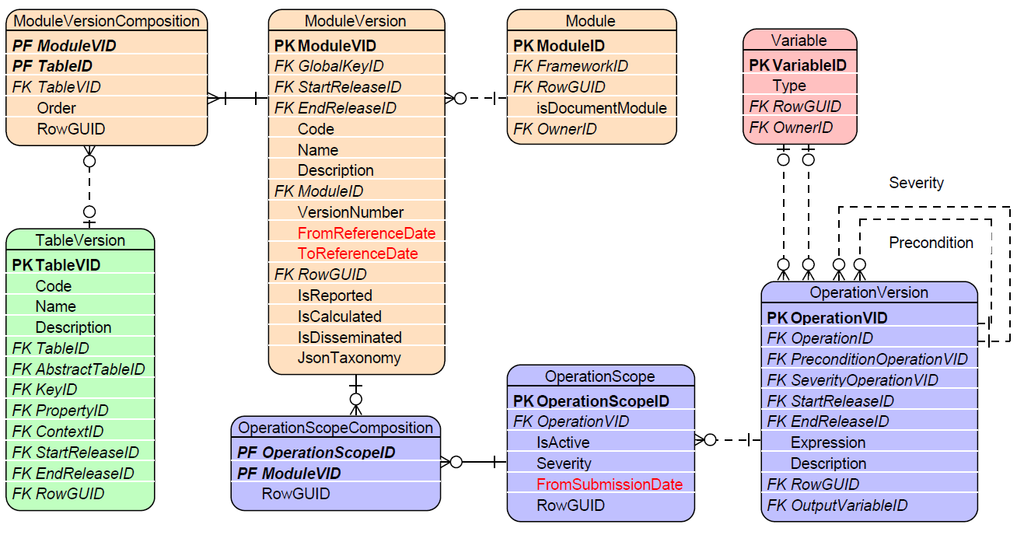
Figure 13. Metamodel entities with “from” and “to” application dates.
A similar independence from the model publication date applies to Operations (4.4.1). A version of a data quality check can be indicated as applicable for reports submitted after a certain date (OperationScope.FromSubmissionDate).
These dates support model users in understanding the scope of reportable information at any point in time: any date falls in some reference period of a ModuleVersion and hence the applicable TableVersions and OperationVersions are those attached to it via ModuleVersionComposition and OperationScopeComposition respectively. In case of the latter, users shall also consider the status of the OperationScope (which can be deactivated via IsActive, see 4.3.3) and if a report is to be sent after the OperationScope.FromSubmissionDate.
Historisation based on FromReferenceDate and ToReferenceDate ensures that each ModuleVersion, Operation is applied within a precise calendar window, supporting regulatory compliance and preventing ambiguity in reporting. A consequence of this is that glossary Concepts (such as Items or Properties) do not carry reference dates of their own; their applicability at a given date is derived from the ModuleVersion in which they are used. So the question "which version of glossary item X applies on date D for which module?" is resolved through the ModuleVersion that references X and is valid for date D.

Deactivations
As presented in Figure 14, the following metamodel entities: DataType, Category and Item (hence indirectly also Property) can be marked as deactivated by setting the IsActive attribute to FALSE. This deactivation implies that they must not be used in modelling of any future information requirements. It continues to apply, however, to reporting periods for which it was active, so that resubmissions of past data remain possible.
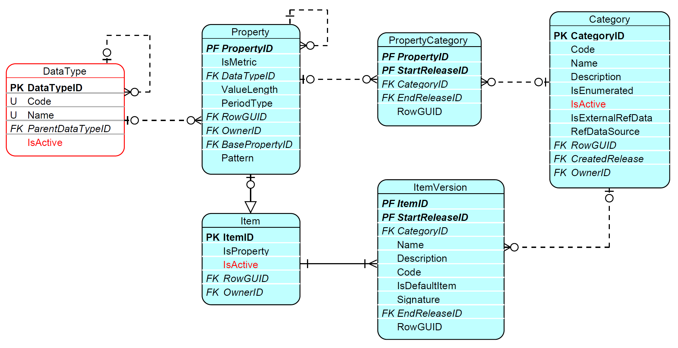
Figure 14. Metamodel metadata and glossary entities containing IsActive attribute enabling their deactivation.
The IsActive attribute is also present for an OperationScope (see Figure 13) where it determines if an OperationVersion (referred from the respective OperationScope) applies to a ModuleVersion (linked to OperationScope via OperationScopeComposition) for any reports sent after the OperationScope.FromSubmissionDate.
Moreover, OperationScope allows an OperationVersion to be reactivated for a ModuleVersion.

Dependencies

Historisation dependencies follow the dependencies between entities in the metamodel (identified, for example, by Ownership inheritance, see 3.1.1.1, 3.1.2). For example, deactivating a Category results in deactivation of all Items, SubCategories and Properties associated with it (unless they are reassigned to another Category). It is also expected that assigning an EndRelease to a Concept should impact the EndRelease of all dependent Concepts. For example, Property (represented as an Item) with EndRelease for a given Category must not be used with Items of that Category on any TableVersion or HeaderVersion in any subsequent release. The same applies to StartRelease which indicates the first published version starting from which a glossary Concept can be used in the description of Tables or Variables. Log of changes (non-normative)
A non-normative (i.e., not aimed to become part of the DPM standard) component was introduced in the DPM metamodel to store information about changes made to information requirements.
The ChangeLog entity contains information about modifications made to the content of metamodel entities or their attributes. In case this information is released externally, it may contain all alterations (including temporary modelling) or be limited only to final changes (e.g., differences between published Releases).
As presented in Figure 15, the ChangeLog indicates a Timestamp for each modification made and an individual User who introduces this modification via the UserEmail attribute. This latter information is aimed at internal use only, not to be shared in the public releases.
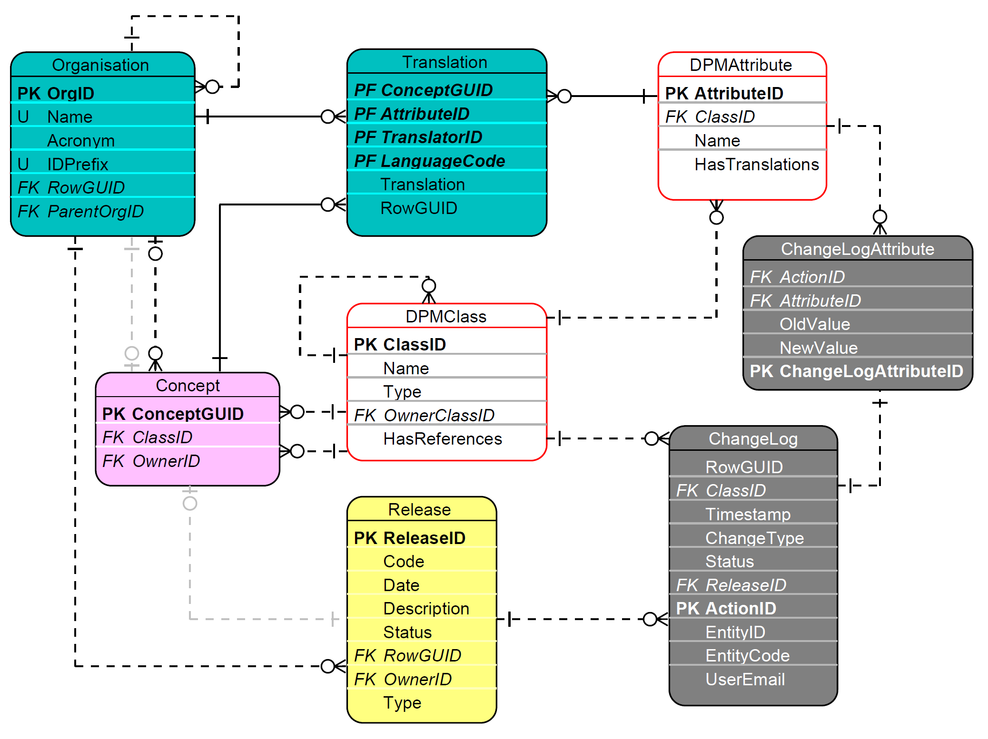
Figure 15. Change log component (non-normative).
In order for the ChangeLog to contain modifications to all DPM metamodel entities and refer to them using a single identifier, most entities in the physical implementation of the metamodel contains a RowGUID attribute which is a unique identifier referenced by ChangeLog.RowGUID.
Moreover, whilst a ChangeLog record refers to one DPM object (DPMClass), it may itself contain several DPMAttributes (attributes of that DPM object) whose values also change and all such changes are recorded accordingly. The changes for each individual attribute are recorded in the table ChangeLogAttribute.

Derivation
It is assumed that the majority of the metamodel entities are populated by Modellers, most likely with the support of dedicated tooling (e.g., DPM Studio). Several entities, however, depending on the modelling process applied, can be computed based on entries from other entities. This concerns, for example, the generation (and suggestion for reuse) of Variables (4.3.5) for Table Headers or Cells, the assembling Property-Item pairs in Contexts when defining Table Headers, as well as the automated reuse of existing ContextCompositions (4.1.5).

Conventions
The majority of metamodel entities that are Concepts are referred to by Modellers by their Code and Name..

Naming conventions
The name is a short, but at the same time meaningful and distinguishable human readable description of a given Concept. The name shall be unique in the context of a given DPMClass and Owner. Additionally, the ItemVersion.Name shall be unique within the Category it belongs to but not necessarily across all Categories to allow for homonyms. For additional details on the naming conventions, please refer to the Naming Conventions, which is itself a separate publication of the DPM Alliance
A description may also be assigned to many Concepts, providing a fuller explanation of the Concept's name. HeaderVersion and SubCategoryItem use a Label rather than a Name (the HeaderVersion.Label and the SubCategoryItem.Label respectively). A Name is not used in this case because these value are not required to be unique.

Code conventions
Codes can be meaningless and take an alphanumeric sequence unless they are clearly defined in underlying information requirements (e.g. Tables and their row/column codes) or in cases where, according to some convention, they can be abbreviations of Name (e.g., capitalised starting letters of each word of Name) or follow commonly applied codes (e.g. ISO codes for countries, currencies, NACE codes, etc). Codes shall be unique within a given DPMClass for a given Owner. Additionally, one Category must not have two or more Items with the same Code, unless these Items are defined by different Owners.
Specific implementations may restrict the length or format of Codes to comply with database type constraints, or replace characters that are not supported by a given technology (e.g., XML).

Metamodel components
As described in Chapter 2, the DPM metamodel consists of four main components. The sections of this chapter explain each of these components in detail, with cross-references throughout.

Glossary
The purpose of the Glossary component is to enable the definition and management of terms and notions that are later used to describe information requirements.
As presented in Figure 16 and explained in the next sections, the Glossary consists of Categories (4.1.1) that in turn comprise Items (4.1.2). The Items of a Category can be grouped in SubCategories (4.1.3) belonging to this Category. Items in SubCategories can be arranged in hierarchies (SubCategoryItem.ParentItemID). SubCategories may be related to one another (by means of ConceptRelations - 3.1.4). A Property (4.1.4) may be associated with a Category, and in doing do determines the specific role, or angle, from which Items of that Category re used when describing information requirements (in Tables - 4.2.1.1, their Headers - 4.2.1.2, or Cells - 4.2.1.3, and in Variables - 4.3.3). Each Property is also an Item, belonging to a dedicated Category. This allows Properties to be grouped into SubCategories for further use as restrictions of information requirements. A Category can comprise other categories (SuperCategoryComposition - 4.1.7). Compound Items (4.1.6) are constructed by combining Property-Item pairs (Context and ContextComposition - 4.1.5).
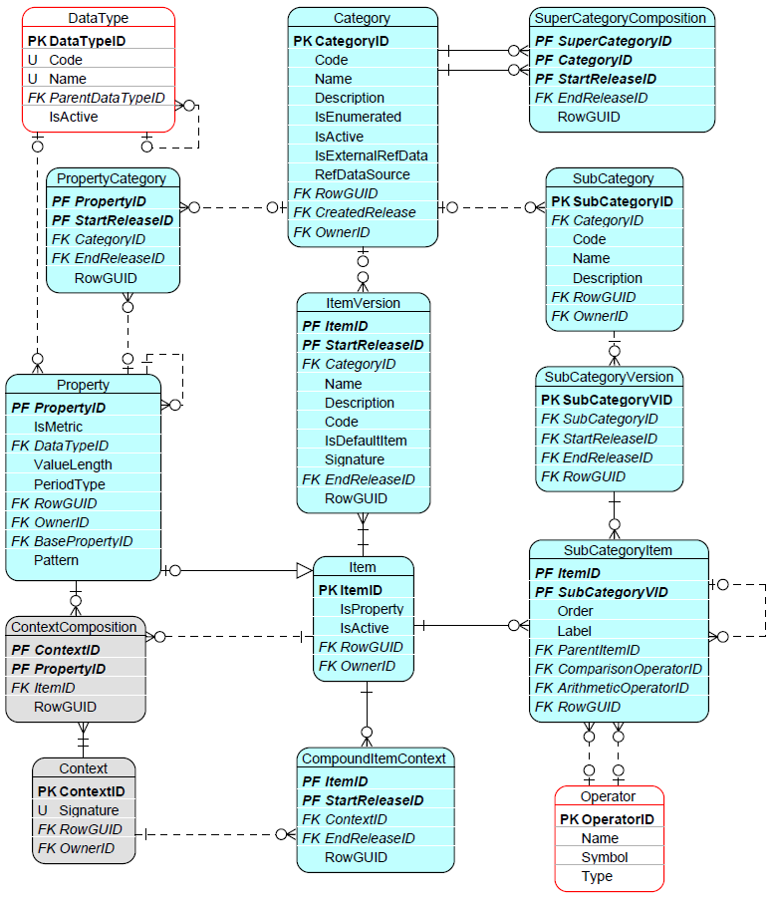
Figure 16. Glossary component entities and relations.

Category
Categories typically represent (code) lists of items sharing common semantics or grouped based on their similar nature. These Items (5.1.2) can be defined in the DPM, one-by-one, in which case Category is enumerated (IsEnumerated set to TRUE). Alternatively, a Category can serve only as a “placeholder” for such values, without listing them individually, which results in a non-enumerated Category (IsEnumerated set to FALSE). The content of non-enumerated Category is either not known to Modellers (as it can be for example reporting-entity-specific) or it is impractical to list all its values due to their large number of Items or to the high and frequent volatility of the Category’s composition. The CreatedRelease attribute of a Category indicates the ReleaseID at which the Category was created.
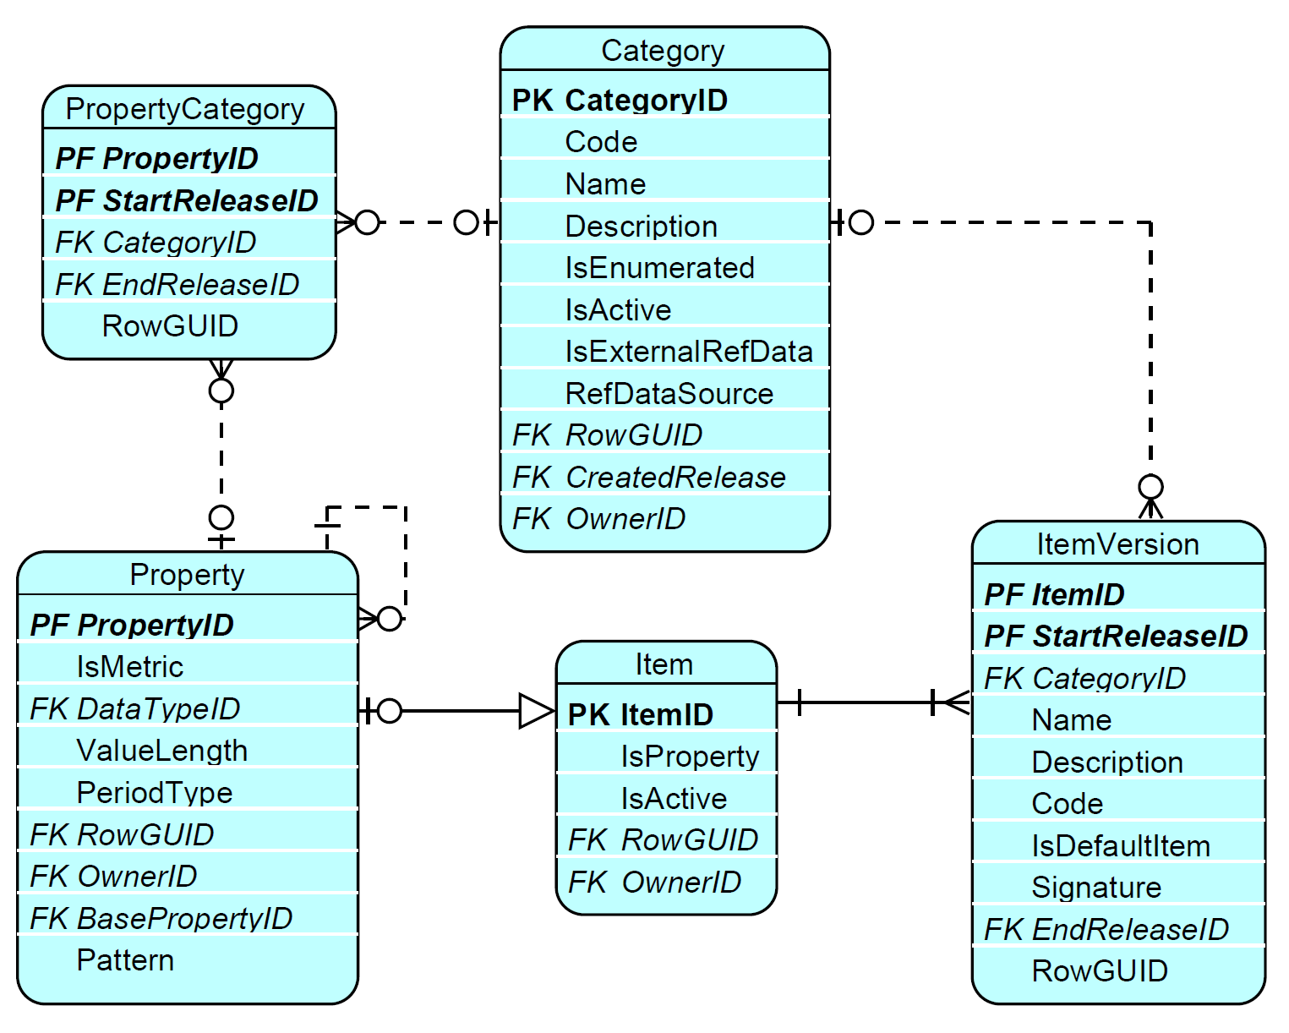
Figure 17. Category, Property and Item.
As presented in Figure 17, Categories are also associated with Properties (4.1.4) via the PropertyCategory entity.
In case of an enumerated Category, Properties related to it determine the specific role, or angle, from which Items of that Category are used when describing information requirements. For example, the Item “Spain” under the Category “Countries” can be associated with the Property “Issuer residence”, or alternatively with “Broker residence” or “Location of stock exchange” when describing a single piece of reportable information (a Variable – see 4.3.1).
A non-enumerated Category may gather Properties sharing a similar type of characteristic when used in the description of information requirements such as different types of codes identifying instruments (e.g. ISIN, SEDOL, CUSIP, etc) or entities (e.g. LEI, Tax Identification Numbers, etc). A non-enumerated Category may also gather quantitative Properties.
There are three Categories predefined in the DPM Metamodel, owned by the DPM Metamodel Organisation (Table 8).
Code | Name | Description
_PR | Properties | Contains Items (4.1.2) which are counterparts of Properties (4.1.4) in the physical implementation of the DPM metamodel.
_NA | Not applicable | Contains Items which do not belong to any specified Category such as those that are typically used only in dropdowns on Headers or Variables. It is also linked by Properties that do not belong to any real Category. Such enumerated Properties can refer to Items from Categories: "Not applicable", "Properties" and in such case they can also use Items of other Categories, in particular by being linked to such mixed SubCategory (5.1.3). It is not a semantically meaningful Category.
_TE | Templates | Contains Items which represent Templates (TableGroups - 4.2.1.4 or Tables - 4.2.1.1) for purposes of resembling Filing indicator Variables (4.3.2).
Table 8. Predefined DPM Metamodel Categories.
A Category can refer to external data (IsExternalRefData set to TRUE) identified in such case by RefDataSource. This could be, for example, the so called ‘master’ data (e.g. information about reporting entities and their reporting obligations) or reference data (registries of companies, information associated with LEI, list of instruments by ISIN codes, etc.). Such information can be used by Operations that handle external data (4.4.1).
Modellers identify Categories by their Code and Name and may provide Description (3.4).
A Category is a Concept and must be assigned to an Owner (3.1.2). It can be linked to a Reference (3.1.3.2) and its Name and Description attributes are translatable (3.1.3.1).
A Category can be deactivated (3.2.3).

Item
An Item represents each value of a Category (5.1.1) and is linked to it through the ItemVersion, as illustrated in Figure 17. This association is versioned by referencing the respective Release (4.3.1), allowing an Item to change its associated Category, Name, Code and Description over time, for example, due to bug fixes or model revisions aimed at improvements.
Modellers refer to Items using a ItemVersion.Code and ItemVersion.Name, and they may also provide a Description (4.5). The ItemVersion.Code is assigned in relation to a specific Category, ensuring its uniqueness within the context of that Category. By assigning a Code, Name, and Description to an ItemVersion, the versioning mechanism further supports the consistent tracking and management of Items across different releases.
Each enumerated Category can have one Item assigned as its default value (ItemVersion.IsDefaultItem set to TRUE).
A default Item can be assigned directly to a Super Category (4.1.7) with a dedicated default Item (i.e. one of the Items belonging to Super Category’s ownCategory). If no such dedicated default is assigned, the default Item of any of its constitutent Categories could be assumed to serve as the Super Category’s default Item.
In the physical implementation of the DPM metamodel, Items whose Item.IsProperty is set to TRUE are counterparts of Properties (4.1.4) and belong to a dedicated Category (see Table 8).
Depending on the implementation, ItemVersion.Signature can be a concatenation of the Codes or IDs of the respective Category and Item prefixed with their Owners (Codes or IDs). This is derived data that helps referring to Items or Properties in a unique and compact manner from Operations (4.4.1). The Signature pattern for Properties applied in the EBA and EIOPA models is as follows: {Organissation.Acronym}_{ItemVersion.Code} (e.g. “eba_SE”) while for other Items that are not Properties: {Organisation.Acronym}_{Category.Code}:{Organissation.Acronym}_{ItemVersion.Code} (e.g. “eiopa_BL:eiopa_x2”) where Organissation.Acronym refers to the Owner (3.1.2) of the Category or Item it prefixes.
Items can be deactivated (3.2.3).
Item is a Concept and must be assigned to an Owner (3.1.2).
Item and ItemVersion can be linked to References (3.1.3.2).
The attributes ItemVersion.Name and ItemVersion.Description are translatable (3.1.3.1).

SubCategory
A SubCategory is a (sub)set of Items (4.1.2) belonging to a Category (4.1.1). Subcategories can be used to group and further arrange Items (which - in case of some Categories - can be numerous), in smaller thematical or otherwise related groups, for easier management, navigation and browsing of information requirements.
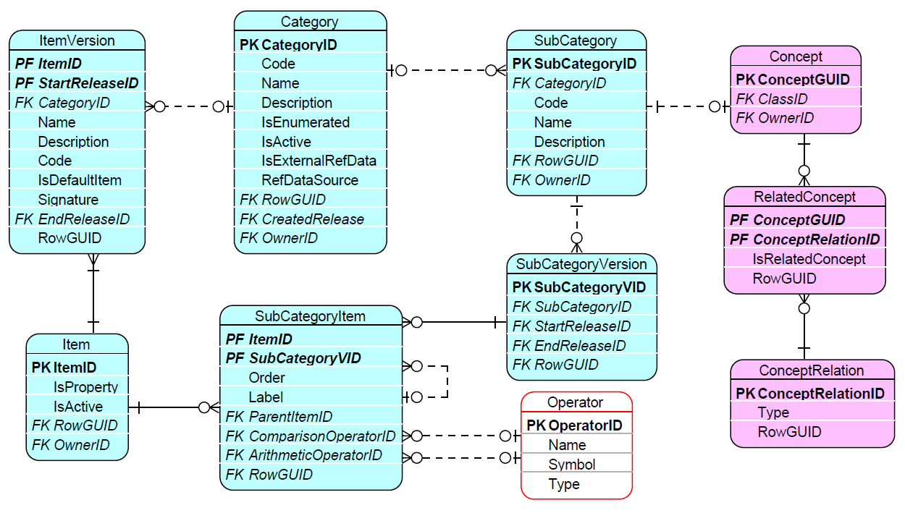
Figure 18. SubCategory composition of Items and its versioning.
Modellers refer to a SubCategory by its Code and Name and may provide a Description (3.4).
SubCategories are versioned as SubCategoryVersion referring to a Release.
As presented in Figure 18, Items are assigned to a SubCategoryVersion via SubCategoryItem, which enables the representation of hierarchical dependencies between Items (by means of SubCategoryItem.ParentItemID) and optionally provides information about arithmetical relations. The latter is achieved by setting a SubCategoryItem.ComparsionOperator (one of: “>”, “>=”, “=”, “=<”, “<”) indicating whether the children SubCategoryItems (i.e. identified via the SubCategoryItem.ParentItemID) contribute to a given SubCategoryItem completely (equal), as a subset (less than or equal) or a superset (greater than or equal). The positive or negative contribution of each child SubCategoryItem is indicated with the SubCategoryItem.ArithmeticOperator which can take the values “+” or “-” respectively. Note that only selected Operators (3.1.1.5) are allowed for the SubCategoryItem.ComprarisonOperator and the SubCategoryItem.ArithmeticOperator.
The order of Items within a SubCategory forms a single sequence across the entire SubCategory and it is not restarted, egardless of how deeply nested it is or which parent branch it belongs to.
Beyond arranging and documenting the glossary, SubCategories can provide enumeration options (a list of available/selectable values in the form of subsets of Items) for table Headers (4.2.1.2) and the Variables that result from them (4.3.3). In this application, an Item appearing as a dropdown option can be given a different label for that specific SubCategory (by means of SubCategory.Label) than its globally applied ItemVersion.Name. Consuming applications should use this SubCategoryItem.Label when rendering dropdown options, so the wording matches what is prescribed in the underlying regulations,instructions, or other business need. The definition of such dropdown Headers (and Variables) must still identify the relevant Property and SubCategory; the consuming application reassembles these into ordinary Property-Item pairs for the actual data exchange, regardless of which label was displayed.
SubCategories that are related to each other can be linked though a ConceptRelation (3.1.4). ConceptRelation.Type includes by design the following options (subject to extension by Modellers) dedicated to defining relationships between SubCategories:
- “subCategoryMaster_version” – indicates that the SubCategory identified as a source of the relation (RelatedConcept.IsRelatedConcept equals to FALSE) is a “master” (i.e. complete set of Items for specific classicisation e.g. list of all countries in the World) while the SubCategory identified as a target (RelatedConcept.IsRelatedConcept equals to TRUE) some ‘version’ of this ‘master’ (e.g. list of countries in Europe); such linking shall help maintaining of ‘version’ when composition of a related ‘master’ is changed (e.g. automatically apply modification in both when any is changed by the Modeller),
- “subCategoryRendering_restriction” - indicates that the target SubCategory (pointed by RelatedConcept.IsRelatedConcept equals to TRUE) shall be used by consuming application for rendering purposes (e.g. presentation in Table Cells - 4.2.1.3) whenever another SubCategory indicated by the source of the relationship (i.e. pointed by RelatedConcept.IsRelatedConcept equals to FALSE) is identified on a SubCategory of HeaderVersion (4.2.1.2) and/or VariableVersion (4.3.5) that defines/corresponds to this Cell; this mechanism enables displaying to users hierarchically structured dropdowns when not all options (e.g. only leaves and/or certain branches) are actually ‘selectable’ and thus reportable.
SubCategoryVersions can also be linked using the ConceptRelation types “version_fix” and “version_new” to distinguish between patches and evolutionary changes respectively, in case it cannot be achieved by means of Releases.
A SubCategory is a Concept and must be assigned to an Owner (3.1.2), which is inherited by its corresponding SubCategoryVersion.
A SubCategory and a SubCategoryVersion can be linked to References (3.1.3.2).
SubCategory.Name, SubCategory.Description and SubCategoryItem.Label are translatable (3.1.3.1).

Property
Properties can be quantitative or qualitative which is indicated in the metamodel (Figure 17) by the IsMetric attribute taking values TRUE or FALSE respectively.
Quantitative Properties characterise the nature and expected format of the measured value itself: they specify the expected data type of the reported value (by referring to Data Type, 3.1.1) and indicate whether the value applies at a specific point in time (PeriodType set to Instant) or over a period of time (PeriodType set to Duration).
Qualitative Properties are instead used to charachterise descriptive and qualitative aspects of a reported value. They are often applied alongside quantitative Properties to add further detail to information requirements: either by determining the role or angle an Item has when paired with it (in Context 4.1.5), or by forming the basis of separate Key or Attribute Variables attached to a Fact Variable (4.3.2).
A Property must be explicitly indicated on every Variable (4.1.8, 4.3.3). Additional Properties may also be introduced indirectly thought a Context (4.1.5) that the Variable refers to. For Table Headers (4.2.1.2) and Variables that offerenumerated (dropdown) options, the relevant Propertyis use together with a SubCategory (4.1.3) which supplies the list of selectable options.
Properties may refer to Categories (e.g. for the purpose of their grouping or to indicate applicable Items). Properties that do not belong to any natural Category can be applied to the “Not applicable” Category (see Table 8).
When used in rendering or in the definition of Variables, a Property can provide perspective only to Items of the Category (or Super Category 4.1.7 that this Category is part of) it is linked to via PropertyCategory for the specific Release (3.2.1) for which the renderingor variable is defined. For patches to past Releases, the “version_fix” ConceptRelation type (3.1.4) may be applied where required, to help identifying the glossary state applicable to the fix (e.g., by linking the corrected TableVersion back to the original one so that the Release of the original TableVersion can be determined, and with it, the PropertyCategory or ItemVersion assignment applicable for that Release).
The DataType (3.1.1.2) for Properties that refer to enumerated Categories (i.w. whose IsEnumerated attribute equals TRUE) is “Enumeration”.
The Pattern attribute for Properties enables the enforcement of constraints on a given DataType (4.2.1.2). These constraints are specified using a regular expression (Regex), which defines the permissible values within the data type. This ensures that only values matching the defined pattern are allowed.
When multiple keys in a table can be derived from the same underlying conceptual Property (e.g., different types of codes such as “ISIN” and “CUSIP”), the basePropertyID attribute can be used to reference a shared base Property via its identifier. In this example, the base Property could be “Code”. If the attribute BasePropertyID is assigned, the Property is classified as composite and its specific meaning can be specified depending on the ContextComposition (4.1.5) through the CompoundItemContext.ContextID for the Item that is corresponding to this PropertyID (i.e. has Item.ItemID=Property.PropertyID).
In the physical implementation of the DPM metamodel, each Property has a counterpart Item (4.1.2) whose IsProperty equals TRUE and that belongs to a dedicated Category (see Table 8). Therefore, a Property receives several of its characteristics from that Item: its Owner (3.1.2), Code, Name, Description (3.4), deactivation information (3.2.3), translations (3.1.3.1) and references (3.1.3.2).

Context and ContextComposition
The Context serves various roles in the metamodel and can also be used by components other than the Glossary, namely Rendering (4.2.1) and Variables (4.3). As presented in Figure 19 the main role of the Context is to gather Property-Item pairs.
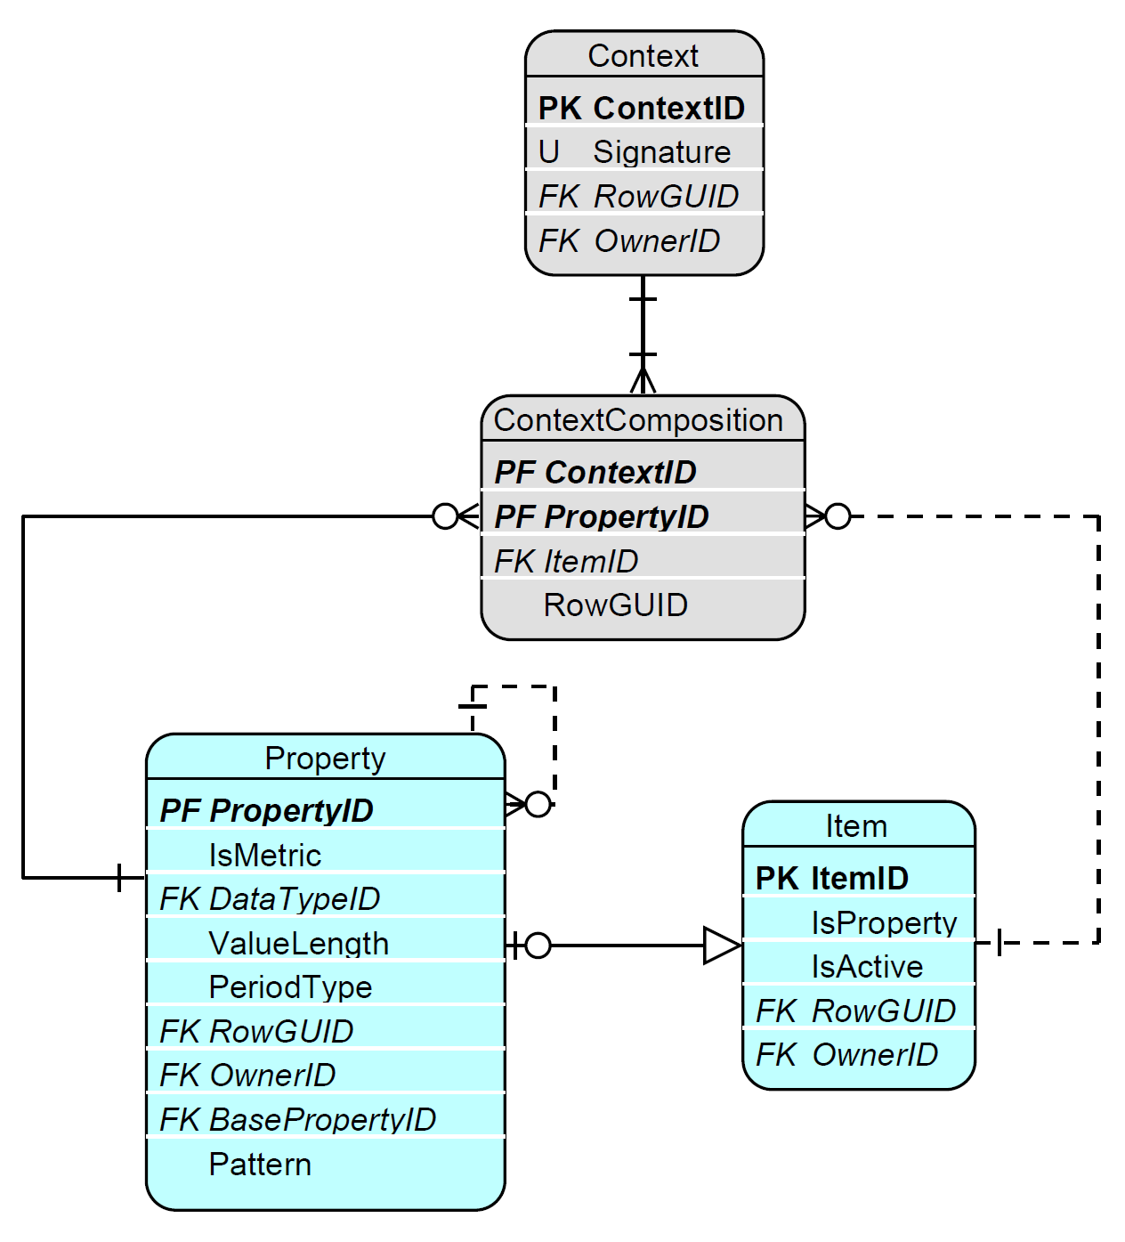
Figure 19. Context and ContextComposition.
Context, through ContextComposition, identifies at least one Property-Item pair. Typically, a given enumerated Property (4.1.4) can be used within a Context at most once, paired only with one Item (4.1.2). This Item needs to belong to the same Category (4.1.1) that the Property is linked to (via PropertyCategory) for a given Release .
The ContextSignature is formed by concatenating the Codes or IDs of the Properties and Items (including the identification of their Owners - 3.1.2) from a Context’s ContextComposition. In the case of the EBA and EIOPA models, the signature is based on IDs according to the following pattern: {PropertyID_ItemID}, separated with # and ordered by PropertyID(e.g. 117_2375#251_1528#326_5216#). This approach supports the identification and reuse of Contexts.
The Context is a Concept and has an Owner, which must be the same as the Owner of whichever entity this Context was created for:
- Compound Item (4.1.6),
- Table – for TableVersion and HeaderVersion (4.2.1.1), or
- Variable – for VariableVersion (4.3.1).

Compound Items
Compound Items are used to simplify the representation of complex terms in a model, where a single Item stands for a combination of underlying Property-Item pairs. The definition of a Compound Item consists of two or more such Property-Item pairs, each identified in a ContextComposition entry and gathered together in a Context (4.1.5). A Compound Item links to its Context via CompoundItemContext, which itself relates to a Release, allowing the composition to be versioned over time, as presented in Figure 20.
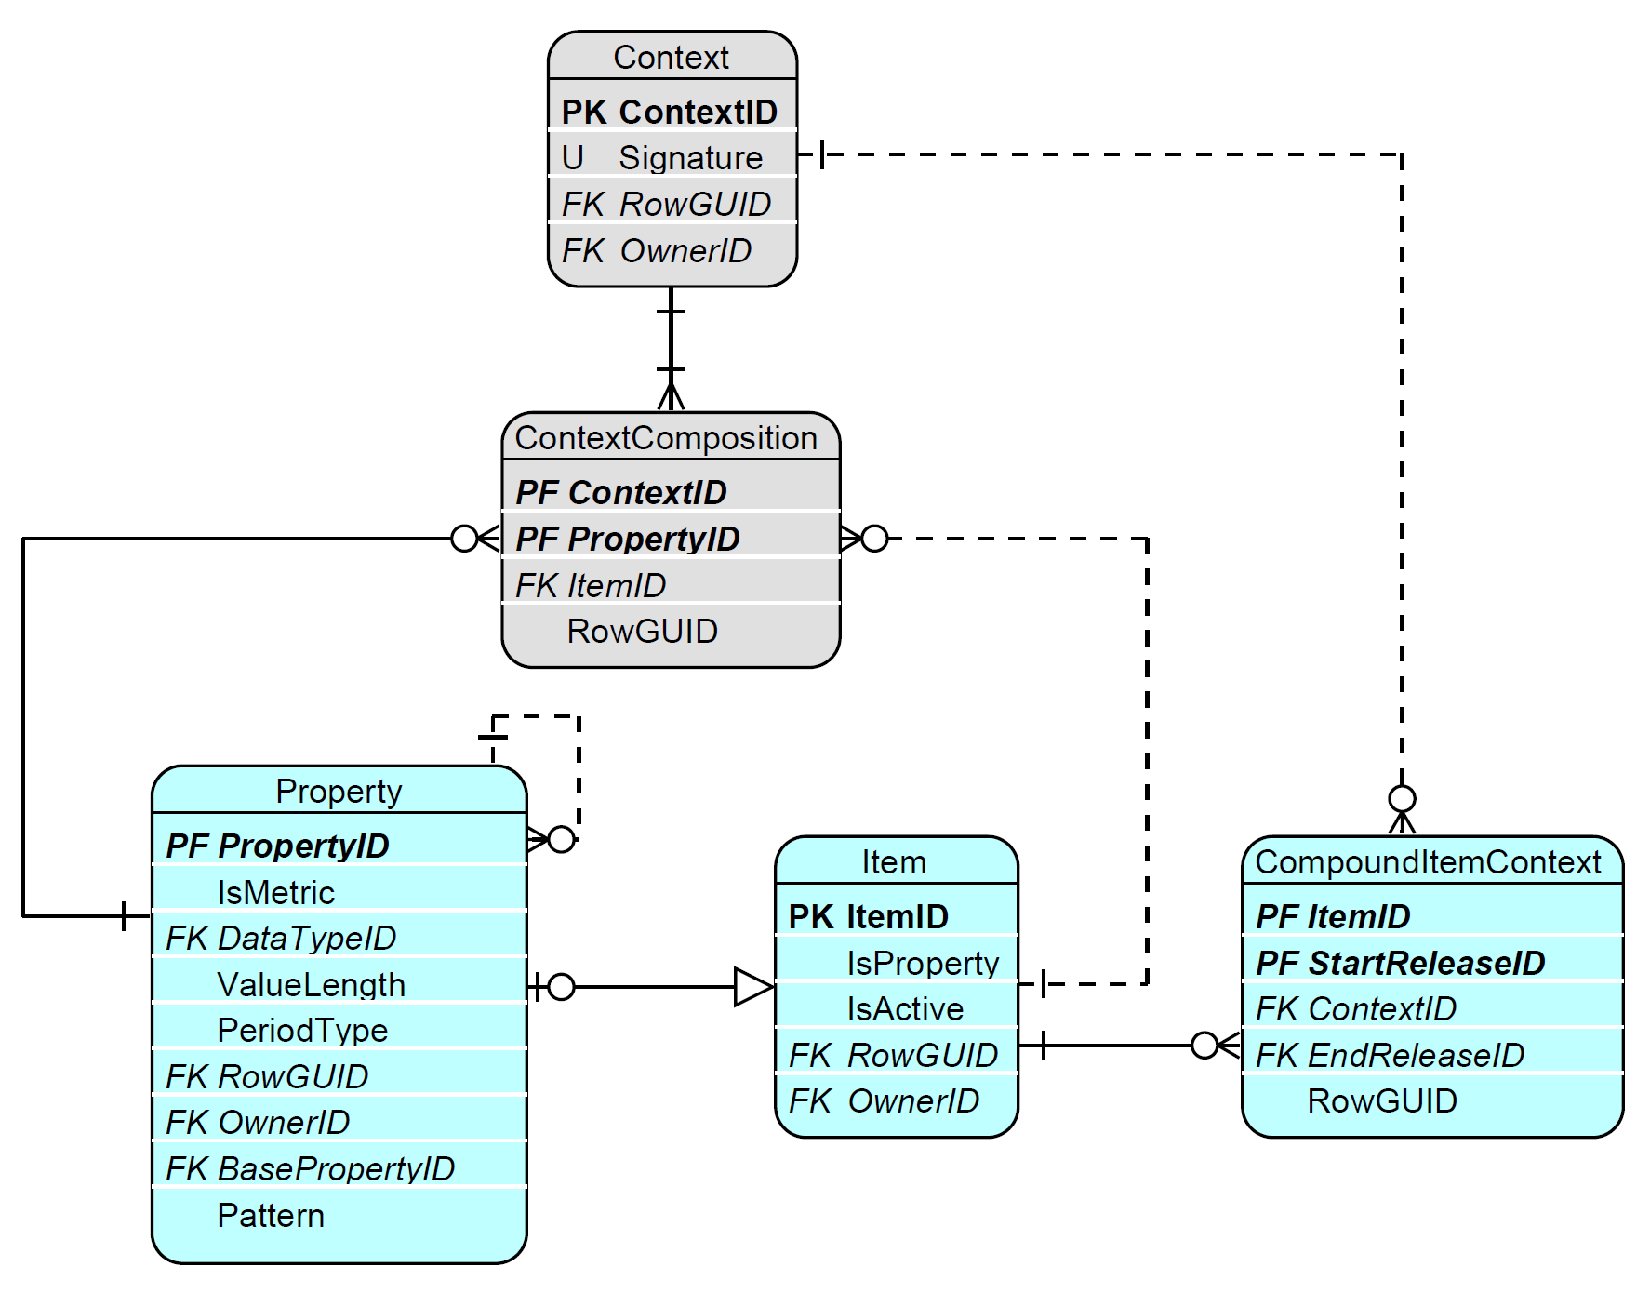
Figure 20. Compound Item.
An example of a Compound Item is the financial instrument “Treasury bills”. When broken down, its definition consists of the following Property-Item pairs:
- “Instrument type”: “Debt security”,
- “Issuer sector”: “Central government”,
- “Original maturity”: “< 1 year”.
Compound Items reduce the complexity of information requirements, while still allowing decomposition into their underlying atomic Items when needed. They also enable the definition of dropdowns whose individual options are themselves composed of several Items (4.1.2) for various Properties (4.1.4) (i.e. Property-Item pairs).
As an Item, a Compound Item belongs to a Category (which can be the same as any of its contributing Items or a different one) and, like any other Item in that Category, can be paired with to Properties linked to it. It also inherits all other characteristics of an ordinary Item.

Super Category

As presented in Figure 21, a Super Category must be identified by the SuperCategoryComposition.SuperCategoryID, and results in the union of all the Categories referred by the SuperCategoryComposition.CategoryID. As a consequence, if any of the referred Categories is enumerated, Items (4.1.2) indirectly belong to that Super Category.
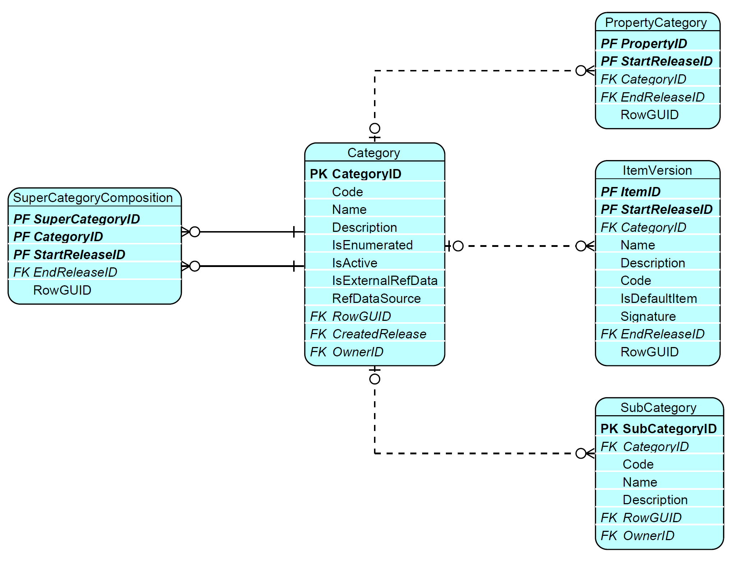
Figure 21. Super Category.
A Super Category can have its own Properties and, if it is enumerated, also its own Items.
The composition of a Super Category, in terms of the Categories it references, is versioned through SuperCategoryComposition’s reference to a Release (3.2.1).
A Super Category enables the inclusion of Items from more than one Category. Similarly to Compound Items (5.1.6), Super Categories can help simplifying modelling by reducing the number of Properties in rendering (5.2.1) or in Variable definition (5.3.3). They also support the creation of dropdowns comprising Items from various Categories, which can be applied to SubCategories (5.1.3) of Super Category and subsequently used by Table Headers (5.2.1.2) or Variables (5.3.1).
A default Item can be assigned directly to a Super Category (i.e. one of the Items belonging to the Super Category’s itself, marked when ItemVersion.IsDefaultItem equals TRUE). If no such dedicated default is assigned at the Super Category level itself, the default Item(s) of its constituent Categories is instead assumed to serve as the Super Category’s default Item.

Application of glossary terms to other components of the metamodel
As presented in Figure 22, and explained in the next sections of this document, Properties (4.1.4), Items (4.1.2) and SubCategories (4.1.3)are typically assigned by Modellers to TableVersions (4.2.1.1), HeaderVersions (4.2.1.2) and VariableVersions (4.3.3) when describing information requirements, in particular reflecting/constructing a tabular representation of such requirements, or defining a Variable (if the latter is not derived from rendering - see 3.3 and 4.3.5).
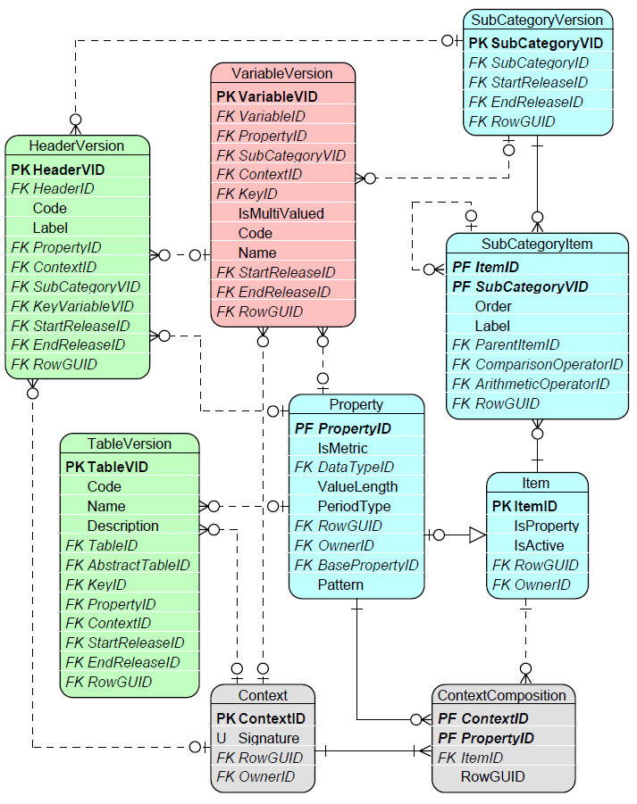
Figure 22. Application of Glossary terms to other components of the model.
Qualitative Properties are referred directly from TableVersion, HeaderVersion and VariableVersion. The same applies to quantitative Properties of non-enumerated Categories (4.1.1), and to Properties of enumerated Categories that are applied as dropdowns on table Headers or Variables. In the case of the latter, the list of Items to appear as dropdown values is defined by the SubCategory identified on these entities (i.e. HeaderVersion.SubCategoryVID, VariableVersion.SubCategoryVID). A Property must be indicated on every Variable.
Property-Item pairs are assigned to TableVersion, HeaderVersion and VariableVersion through Contexts (4.1.5).

Grouping, rendering, and packaging of information requirements
Information requirements defined in regulations are typically represented in tabular format and grouped by subject, area or scope. Therefore, as presented in Figure 23, the DPM Metamodel enables the definition of Tables (4.2.1.1) that can be related to one another and gathered in TableGroups (4.2.1.4). This covers both template-based reporting where Tables often represent closed templates, as well as entity-relationship-based (ERM-based) reporting, where the DPM Table construct is instead used to represent underlying entities, attributes, and their relationships.
Tables are generally referenced by Modules (4.2.2.2) in order to indicate what information must be reported, by which reporting agents, under what circumstances, and for which given reference date.
Modules are packaged thematically in Frameworks (4.2.2.1), where a Framework typically represents a piece of legislation that gave rise to the need to define a set of Tables to be reported under these Modules.
Tables are built from column Headers (4.2.1.2) and, optionally, rows or sheet Headers with Cells formed at their intersection (4.2.1.3). These Cells, and also the Key Headers in the case of open Tables, result in Variables (4.3.1) representing each reportable value.
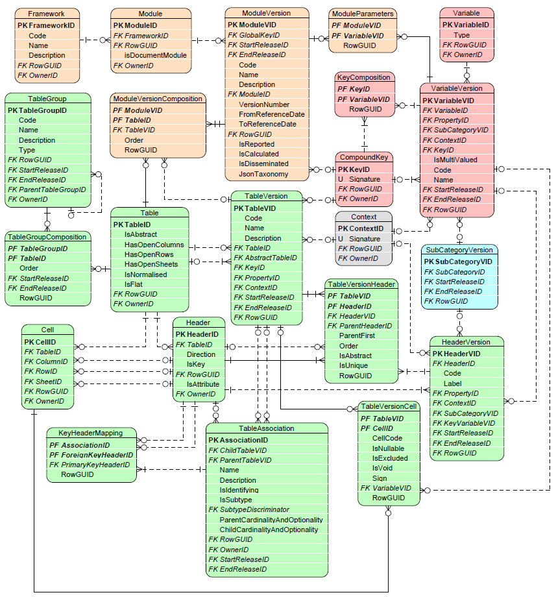
Figure 23. Information requirements component entities and relations.

Grouping and Rendering
The rendering component of the metamodel serves an important role in the modelling process, linking information requirements to the Glossary and to Variables.
Modellers define Tables describing the underlying information requirements, as presented in Figure 24, by assigning Glossary terms (4.1) to these Tables (4.2.1.1) and their Headers (4.2.1.2). Table Cells (4.2.1.3) result from the intersection of row, column, and/or sheet Headers, inheriting the glossary meaning those Headers carry.Table Headers or Cells, in turn give rise to Variables (4.3.1) representing each reportable value.
Tables can be grouped (4.2.1.4), associated with one another in terms of primary/foreign keys, optionality and cardinality of the relations, subtyping, etc. (4.2.1.5) or related to one another in other ways (4.2.1.2).
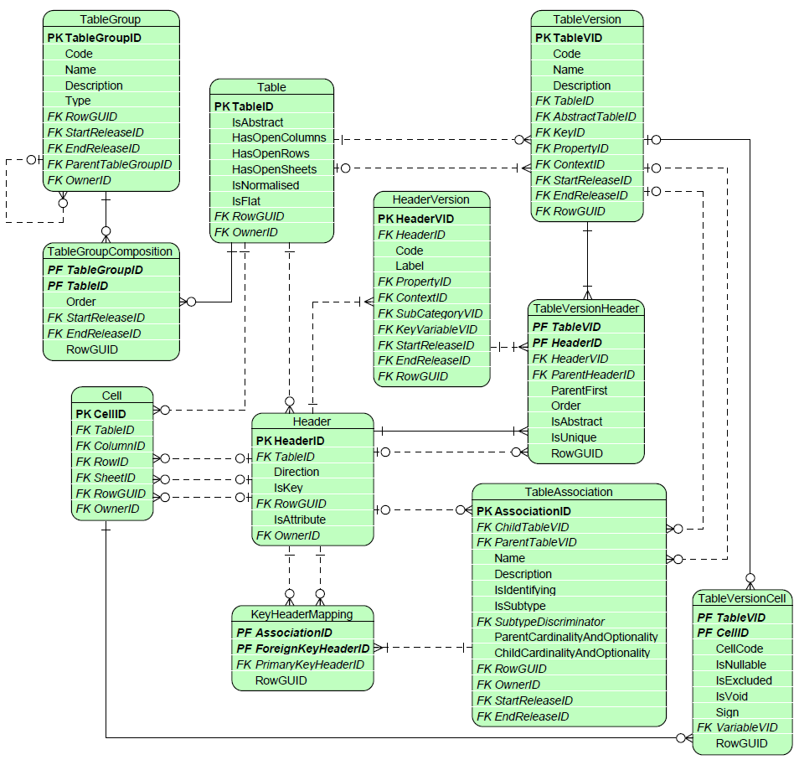
Figure 24. Rendering component entities and relations.

Table and TableVersion
As presented in Figure 25, a Table can be flagged as abstract (Table.IsAbstract set to TRUE) or non-abstract (Table.IsAbstract set to FALSE). Abstract Tables are defined when a single tabular view defined in the regulation needs to be decomposed in more than one Table, due to for example:
- DPM modelling assumptions and constraints, disallowing for example one Property (4.1.4) to be used on a Header (4.2.1.2) of a row and a Header of a column of one Table at the same time,
- normalisation of tables to minimise redundancies and dependencies, in which case Table.IsNormalised set to TRUE indicates that a non-abstract Table resulted from normalissation of an abstract Table.
In the case when there is no need to split a tabular view defined in the legislation into more Tables (i.e. abstract and non-abstract Tables are identical), the model does not define any abstract Table for this tabular view and contains only one non-abstract Table.
Information about the relationship between an abstract Table and the resulting decomposed non-abstract Tables is defined on TableVersions (see below) of non-abstract Tables by indicating there the originating abstract Table using the TableVersion.AbstractTableID.
While both abstract and non-abstract Tables can be assigned with Headers (4.2.1.2) and Cells (4.2.1.3), only non-abstract Tables can be modelled with glossary (4.1) concepts (i.e. their Headers may refer to Properties, SubCategories, Contexts and link to Variables).
The Table.IsFlat flag set to TRUE indicates that the Table modelling is done using Properties only and contains no Contexts which is typical case for statistical tables as defined for example in SDMX. This may impact the behaviour of Operations (e.g. filter function).
Tables are versioned by means of TableVersion referring to a Release. This enables tracking the evolution of a Table over time for both the Table’s structure as well as changes in its referenced glossary terms. The Concept relations “version_fix” and “version_new” (3.1.4) may be used to support this tracing in more explicitly (e.g. when updating past versions).
Modellers refer to a Table by its Code and Name and may provide a Description (3.4). These attributes are defined on the TableVersion corresponding to that Table, allowing them to change and be historised over time.
HasOpenColumns, HasOpenRows and HasOpenSheets indicate if a Table is open. A Table is open if it contains Headers (4.2.1.2) that represent Key Variables, used to identify the Fact Variables (4.3.2) produced by the Table’s other Headers, rather than having a fixed, predetermined set of columns, rows or sheets. HasOpenColumns, HasOpenRows and HasOpenSheets each indicate whether the Table is open in that specific direction; a Table can be open in one, two, or all three directions simultaneously.
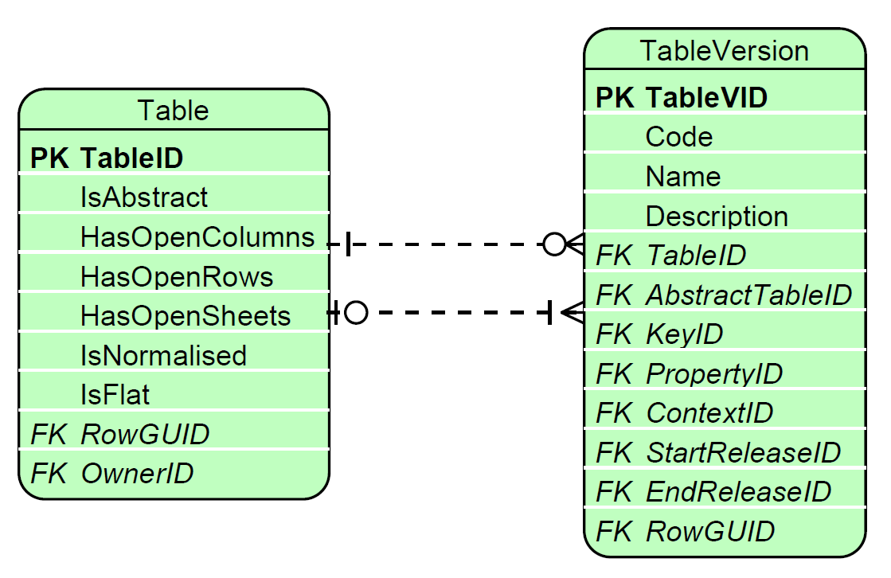
Figure 25. Table and TableVersion.
A TableVersion may link directly to glossary terms – Properties (4.1.4) or Property-Item pairs gathered in Contexts (4.1.8). This information is applied to all Headers (4.2.1.2) and hence all Cells (4.2.1.3) of that TableVersion.
A TableVersion.KeyID links to a CompoundKey (4.3.4), which gathers together all the Key Variables applicable to the Fact Variables (4.3.2) of that TableVersion.
A Table is a Concept that has to be assigned to an Owner (3.1.2). TableVersion inherits the Owner from the Table it corresponds to. Both Table and TableVersion can be linked to References (3.1.3.2). TableVersion.Name and TableVersion.Description are translatable (3.1.3.1).

Header, TableVersionHeader and HeaderVersion
A Header represents each “Row”, “Column” or “Sheet” as per Header.Direction.
As the Header label may change over time (due to bug fixes, improvements to modelling, etc), each Header is associated with a HeaderVersion. A HeaderVersion is versioned by referring to a Release.

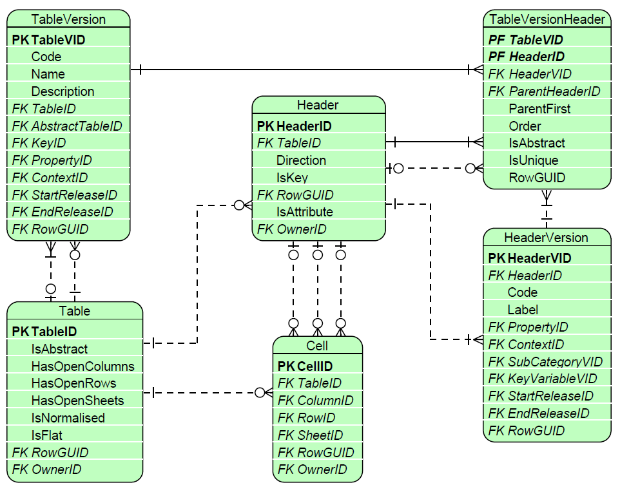
Figure 26. Header, TableVersionHeader and HeaderVersion.
As presented in Figure 26, a HeaderVersion indicates the Header Code and Label (the latter is translatable, 3.1.3.1).
The HeaderVersion links to glossary terms (4.1) that provide semantics to explain the meaning of each header. As explained in section 4.1.8, this is achieved by referring from HeaderVersion to:
- Property (4.1.4) that is quantitative (metric) or qualitative but non-enumerated or enumerated Property in which case it is required to also indicate SubCategory,
- Property-Item pairs gathered in Contexts (4.1.5).
IsKey set to TRUE implies that the Header represents a Key Variable (4.3.2). As a result, HeaderVersion.KeyVariableVID of this Header points to the VariableVersion (4.3.3) that is a Key Variable. Such a Header is not linked from any Cell (4.2.1.3). Only headers that contribute to definition of a Fact Variable result in Cells.
A HeaderVersion refers to a TableVersion (4.2.1.1) via TableVersionHeader. This enables the reuse of Headers across TableVersions and provides information about changes in the structure of any Table over time. As the Headers’ structure can be rearranged between TableVersions, the following attributes are applied at the TableVersionHeader level:
- nesting of Headers (ParentHeaderID),
- rendering of Parent Header before (ParentFirst set to TRUE) or after its Children,
- Order of presentation of Headers,
- marking Headers as “grouping only” – i.e. not resulting in cells (IsAbstract set to TRUE),
- indicating if values reported for a Key Variable corresponding to this Header or Fact Variables in Cells resulting from Headers must be unique (IsUnique set to TRUE).
The Owner (3.1.2) of a Header (and hence its HeaderVersion) must be the same as the Owner of the Table to which this Header belongs to (Header.TableID).
Some headers are identified as “attribute headers,” describing attribute information for other key or fact headers. This information is captured by the flag IsAttribute. The relation between attribute headers and the corresponding key or fact headers can be identified through the ConceptRelation artefact. A similar relation can be described between attribute variables and key or fact variables.
Concepts, Headers and HeaderVersions can be linked to References (3.1.3.2). HeaderVersion.Label is translatable (3.1.3.1).

Cell and TableVersionCell
As presented in Figure 27, a Cell must refer to at least one leaf-level Column or Row Header (4.2.1.2) but may also point to two or maximum three Headers (i.e. one for each: Column, Row and Sheet).
Key Headers (4.2.1.2) do not result in Cells, since they identify a row, column or sheet directly though their own Key Variable, rather than contributing to an intersection that produces a Fact Variable.
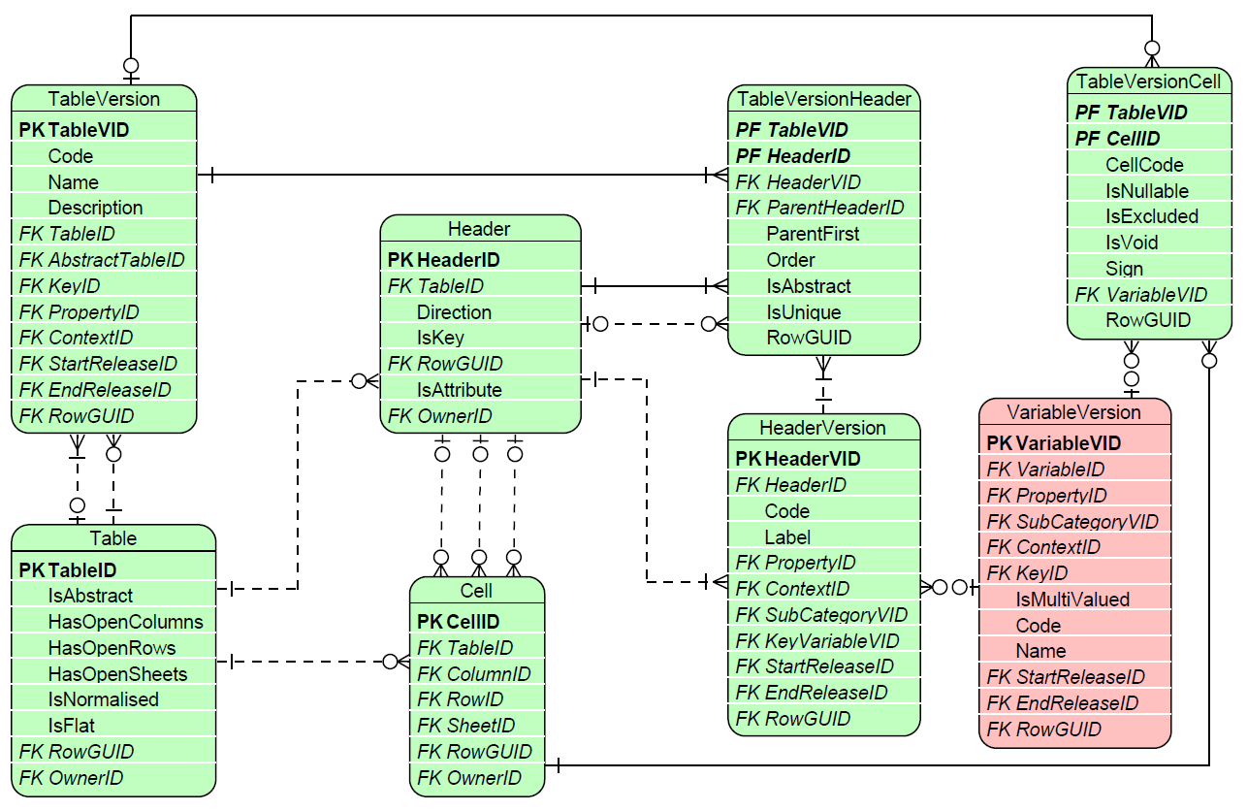
Figure 27. Cell and TableCellVersion.
As described in 4.2.1.1, a Table’s structure may change over time: TableVersion relates to HeaderVersion (4.2.1.2) through TableVersionHeader, allowing the same Headers to be reused across different TableVersions. In the same way, a Cell can be associated with multiple TableVersions via TableVersionCell, while still representing the same underlying Header(s).
TableVersionCell indicates:
- Whether a Cell has a code (CellCode): useful, for example, when mapping to legislation that uses such codes, or to legacy systems and exchange formats that are form-driven and therefore base on cells coordinates;
- whether a Cell is mandatory (IsNullable set to FALSE): the report must contain data for the Variable (4.3.1) corresponding to this Cell, subject to the presence of the relevant filing indicators;
- whether a Cell is not reportable (IsExcluded set to TRUE): data for the Variable corresponding to this Cell is not requested for this Table; such a Cell is typically displayed as greyed out or crossed out;
- whether a Cell results in no Variable (4.3.1) at all (IsVoid is set to TRUE): i.e. the combination of glossary (4.1) terms carried by Headers whose intersection defines this Cell is semantically illogical (e.g. “Equity instruments” issued by “Government” with a certain “Maturity period”); note that a TableVersionCell whose IsVoid is set to FALSE must instead point to a VariableVersion (4.3.3) resulting corresponding to this Cell;
- whether the value reportable for a Cell is a “positive” or “negative” number (imposed by Sign attribute): note that this, and other more complex constraints on a Cell’s expected value, are instead imposed through Operations (4.4.1).
Where a Cell results from a Header whose TableVersionHeader.IsUnique is set to TRUE, the values reported across all Cells resulting from that Header must be unique.
The Owner (3.1.2) of a Cell, and therefore of its TableVersionCell, must be the same as the Owner of the Table to which this Cell belongs to (Cell.TableID).
Concepts, Cells and TableVersoinCells can be linked to References (3.1.3.2).

Table Group
As presented in Figure 28, TableGroups gathers Tables (4.2.1.1) via TableGroupComposition. TableGroupComposition.Order indicates the sequence of Tables in a TableGroup, to be applied, for example, when displaying Tables under TableGroup in a user interface. The composition of a TableGroup, in terms of Tables it gathers, may change between Releases.
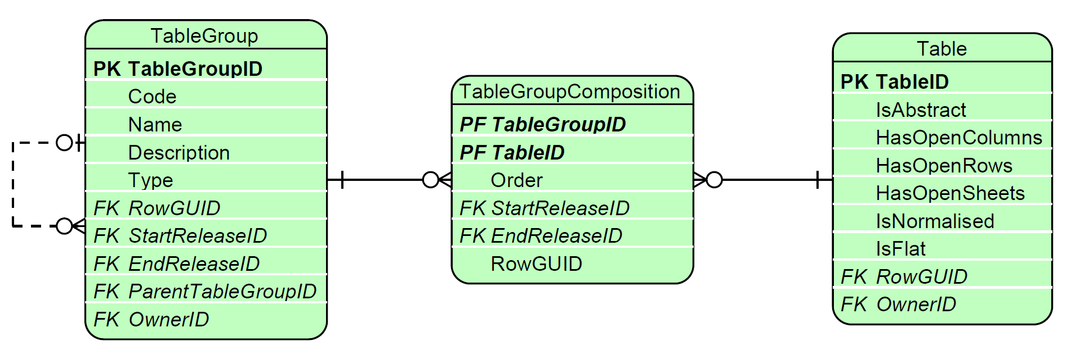
Figure 28. TableGroup and TableGroupComposition.
TableGroups are assigned a Code and a Name, and may also be provided with a Description.
TableGroups can also gather other TableGroups by having another TableGroup indicated as their Parent (ParentGroupID). This nesting can have multiple levels.
TableGroups may be created for various purposes, as indicated by TableGroup.Type. The DPM metamodel envisages at least the following options (extendedable by metadata modellers):
- “templateGroup”,
- “template”,
- “templateVariant”,
- “templateScope”.
For example, a TableGroup of Type “templateGroup” gathers TableGroups which are “templates”, that in turn result in multiple “templateVariant” Type TableGroups.
TableGroups of Type “templateScope” can also be nested. The DPM XL syntax enables using their Codes in Operation.Expression instead of Table Codes. This mechanism simplifies the definition of Operations that apply to multiple Tables belonging to that TableGroup, or to any of its descendant TableGroups whose Type is also “templateScope”.

TableGroups are relatively stable metamodel Concepts. Nevertheless, their application can be controlled by indicating the Release in which they were created, or in which they ceased to be used (which can be also determined by calculating whether any Tables still in use are linked to the TableGroup through TableGroupComposition).

A TableGroup is a Concept and has to be assigned an Owner (3.1.2). It can be linked to a Reference (3.1.3.2), and its Name and Description attributes are translatable (3.1.3.1).

Table Relation
The primary relation between Tables, resulting from the decomposition of one Table into many (for various purposes), is described in section 4.2.1.1.
Other relations between Tables can be constructed using Concept Relation mechanism (3.1.4). The DPM currently enables linking tables using “table_variant” ConceptRelation.Type, which indicates that the Table at the target of the relation is a variant of the Table at its source. This mechanism can be used, for example, to indicate that the “Balance sheet for ring fence funds” is a variant of the “Balance sheet” Table. Other relation types can be defined by Modellers.

TableAssociation and KeyMapping
As explained in 4.2.1.1, Tables can be split due to normalisation. More detailed information about how these decomposed Tables relate to one another, or how they can be assembled back in the denormalised view, may be indicated using TableAssociation and KeyHeaderMapping, as presented in Figure 29.
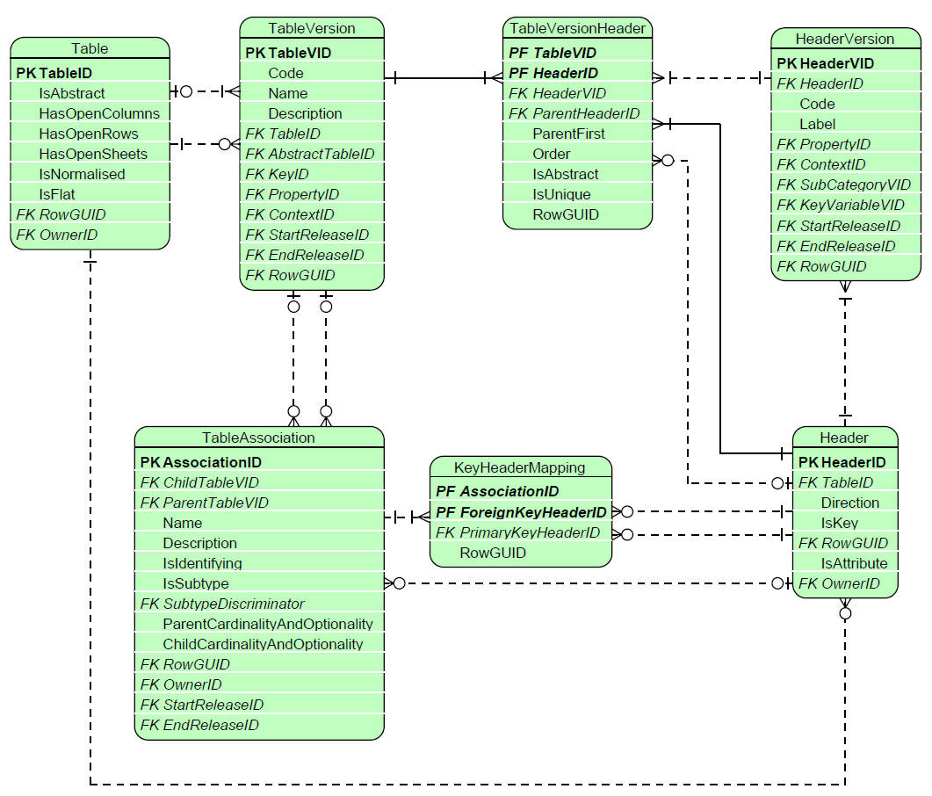
Figure 29. TableAssociation and KeyMapping.
TableAssociation associates a Child Table with a Parent Table. The definition and documentation of the association are contained in TableAssociation.Name and TableAssociation.Description (both of which are translatable - 3.1.3.1). Other attributes of TableAssociation describe the characteristics of the association:
- whether the relationship is identifying (IsIdentifying set to TRUE), indicating that the Child Table is dependent on the Parent Table and cannot exists without it;
- whether the Child Table is a subtype of the Parent Table, which in turn acts as a supertype (IsSubtype set to TRUE); in this case, the SubtypeDiscriminator attribute points to a Header of the Parent Table whose values determine the target subtype(s);
- the cardinality and optionality of the relationship, defined on:
  - The parent end (ParentCardinalityAndOptionality): '0_1', '1', '0_m', '1_m',
  - The child end (ChildCardinalityAndOptionality): '0_1', '1', '0_n', '1_n'.
For an association between Open Tables (i.e. Tables including one or more Key Variables), it is possible to map Headers of these Tables by indicating, in the KeyHeaderMapping entity, which Header from the Parent Table is used as Foreign Key Header in the Child Table. Note that associated Headers do not need to be Key Headers (e.g. a Header from Parent Table used as a Foreign Key in the Child Table does not need to be a Key Header in the Parent Table).
The Owner (3.1.2) of a TableAssociation could be the same as the Owner of the Tables which it associates.
A TableAssociation must have a Name and may have a Description (both translatable, 3.1.3.1).
As a Concept, a TableAssociation can be linked to a Reference (3.1.3.2).
A TableAssociation is independently versioned using StartReleaseID and EndReleaseID, making it valid for a specific period of time (i.e. across releases).

Packaging
Information requirements are packaged thematically in Frameworks (4.2.2.1), which typically reflect the legislation that gives rise to the reporting requirements. Beyond what is being collected, regulations also determine the reporting population, the reporting calendar, and the circumstances under which data must be submitted. This is managed by means of Modules (4.2.2.2). Figure 30 presents the Packaging component’s entities and their relations to rendering and Variables, described in more detail in the following sections.
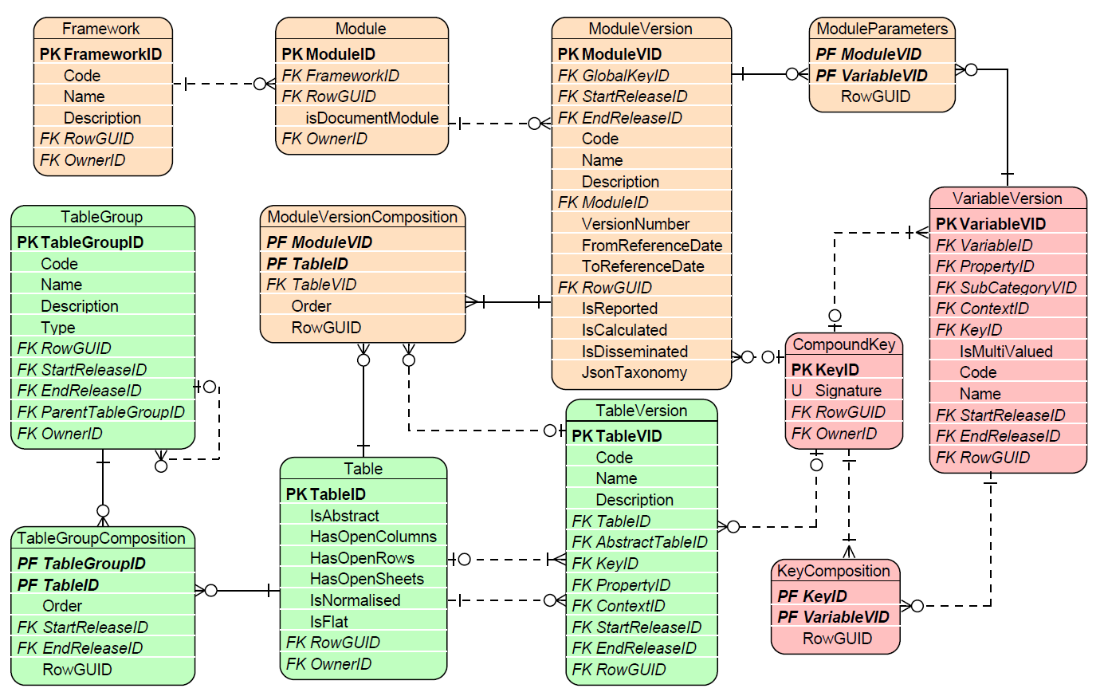
Figure 30. Packaging component entities and relations.

Framework
A Framework is the uppermost level of grouping of information requirements. As it typically corresponds to a piece of legislation, its Owner (3.1.2) and Reference (3.1.3.2) are particularly important: the Owner establishes which Organisation issued and/or manages the underlying regulation, while the Reference identifies the specific legislative document itself.
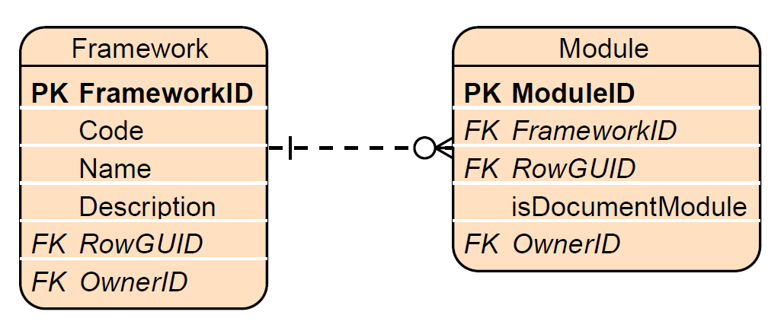
Figure 31. Framework and Module.
As presented in Figure 31, a Framework is referred to by its Code. In addition, Framework must have a Name and may be provided with a Description (both translatable, 3.1.3.1).
A Framework can host either a logical model or a physical implementation model. To distinguish between the two, the ModelLevel attribute is set to either “logical” or “physical”.
A logical model is primarily created for documentation purposes, providing a unified representation of reporting requirements that is independent of how data ends up being rerported across specific frequencies, thresholds, derogations, and other implementation-specific factors. Relationships between logical and physical models can be described using the ConceptRelation construct.

Module
A Module gathers information requirements that are supposed to be reported together, i.e., in one report.
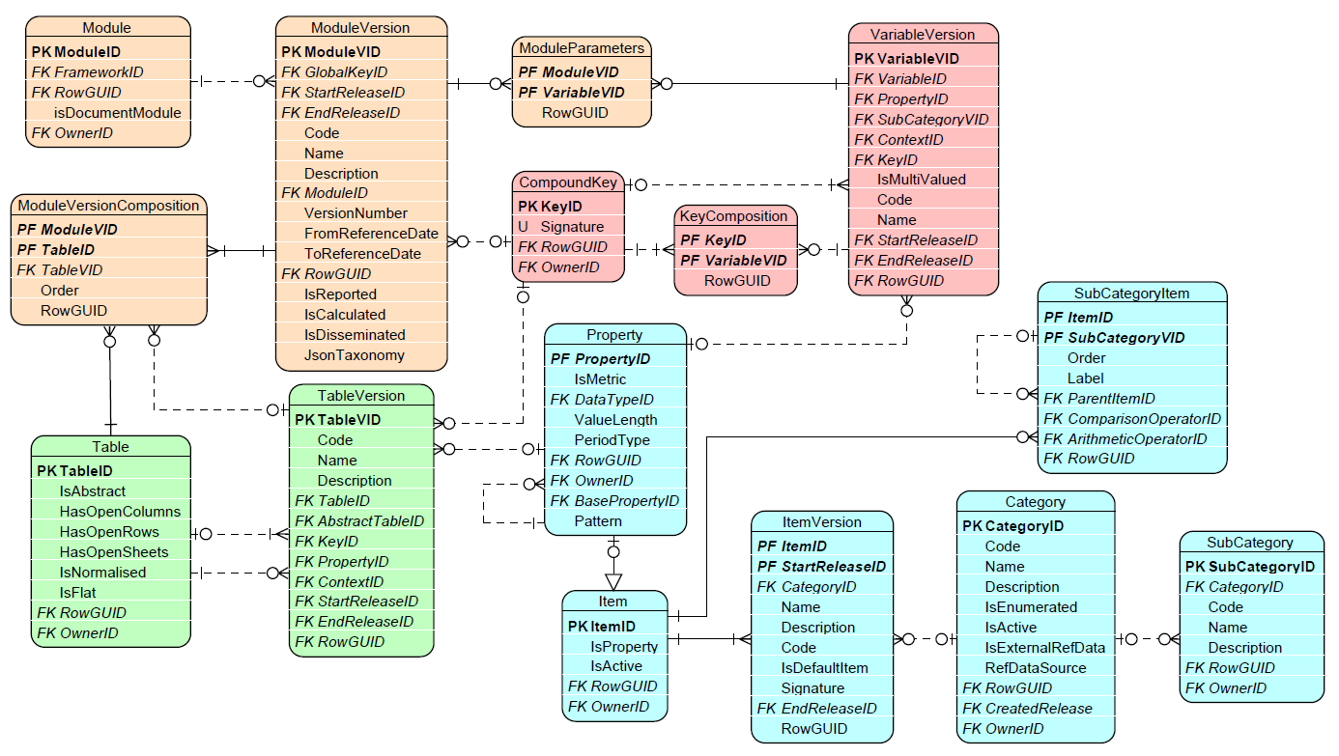
Figure 32. Module, its Composition and Parameters.
As a result of bug fixes or modifications to the underlying regulations, the composition of information requirements for a Module may change over time. Therefore, a Module is versioned by means of a ModuleVersion that refers to a Release. More importantly, a ModuleVersion’s definition includes a FromReferenceDate and an optional ToReferenceDate attribute that identify its application dates (3.2.2). This enables determining which ModuleVersion shall be used for the reporting of data for a given reference date (for a given Module, there must be only one ModuleVersion applicable for any given reference date).
A ModuleVersion is referred to by its Code and Name, and may be provided with a Description.
As presented in Figure 32, information requirements to be reported for a ModuleVersion are defined by indicating the applicable Tables and their Versions (4.2.1.1), assigned to this ModuleVersion through the ModuleVersionComposition. This indirectly identifies all Variables (4.3.1) to be reported for a ModuleVersion (which result from the Key Headers and Cells of all linked TableVersions).
The DPM can be used to design data models beyond the reporting scope. For internal purposes, data models may be created for derived datasets, where data is compiled or calculated, or for dissemination datasets, where data is prepared for sharing with end users.
The attributes IsReported, IsCalculated, and IsDisseminated can be used at the ModuleVersion level to indicate the purpose of the modelling. Since these attributes are not mutually exclusive, each can be set independently to either TRUE or FALSE.
The jsonTaxonomy attribute contains the JSON file associated with a specific module version within the XBRL taxonomy. This JSON file serves as a tool to navigate and explore the glossary codes and variables utilised by each ModuleVersion through relative paths in the taxonomy’s hierarchical structure. Notably, glossary codes are often shared across multiple ModuleVersions, ensuring consistency and reusability within the taxonomy.
Module covers a reporting scenario, it is usually applicable to a specific type of reporting entity/agent, with observations measured in specified manner for a given period or at a specific point in time, in a particular currency applicable to all monetary amounts. Such global parameters applicable to all Fact Variables (4.3.2) in ModuleVersion can be expressed by Key Variables composed in a CompoundKey (4.3.4) associated with a ModuleVersion, or by Attribute Variables linked to a ModuleVersion via ModuleParameters. The latter are typically constructed as Variables indicating a Property and a SubCategoryVersion that consists of only one Item.
Module-level parameters and Keys do not need to be directly assigned to every Fact Variable belonging to this Module. They can, however, be overridden by another value, if explicitly attached to a Fact Variable or its Key Variable, for a given Property represented by Key or Attribute Variable applied at the Module level.
Module and ModuleVersion are Concepts. They usually inherit their Owner from a Framework. Both may have References (3.1.3.2). ModuleVersion.Name and ModuleVersion.Description are translatable (3.1.3.1).
The “Document module” is a special type of Module. Unlike other Modules, it does not follow the standard structured granularity pathway (templates, Headers, Cells, Variables, etc.). Instead, it consists of a set of Documents designed to meet specific needs (e.g., disclosing information). The non-versioned attribute “IsDocumentModule” specifies whether a module is of the “document” type.

Identification and description of each reported value
The unique identification and description of each reportable value is required to provide a single, unambiguous reference for what is expected to be exchanged. It also enables tracking changes in how each submitted value is modelled over time.

Variable
Each distinct quantitative or qualitative reportable value, regardless of its representation in the rendering component, is described in the DPM as a Variable. The next sections of this chapter provide an overview of the types and versioning of Variables. This component’s entities, and their relations among other components of the metamodel, are presented in Figure 33.
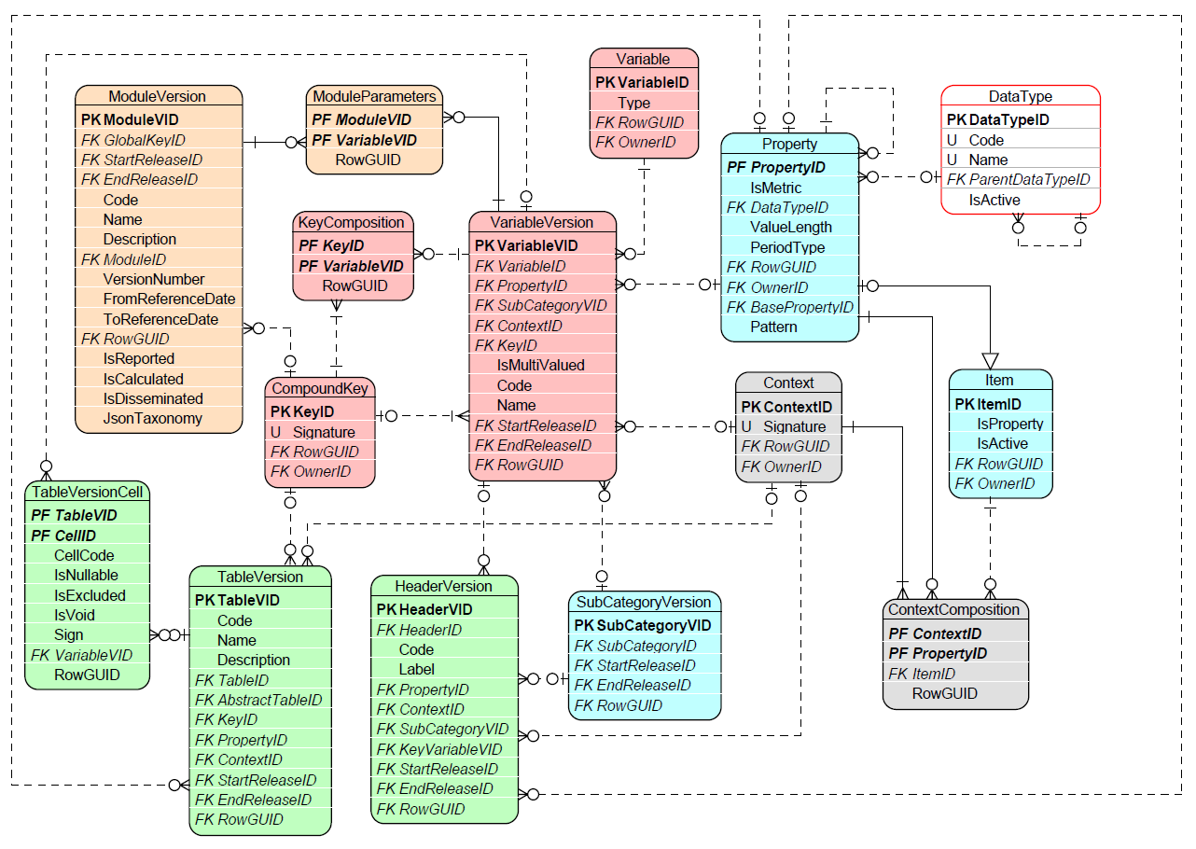
Figure 33. Variables component entities and relations.

Variable Types
There are four Types of Variables:
- A Fact Variable, which represents reported observation, typically a monetary amount, other numeric data, a text, a date or an enumeration. Fact Variable may refer to one or more Key Variables and/or Attribute Variables, needed to complement the understanding of the data it carries;
- A Key Variable may be needed by some Fact Variables in order to explicitly and uniquely identify an exchanged observation; this identification can be Module-wide (e.g., reporting entity/agent and period), or can apply to individual Fact Variables (for example, in an Open Table - 4.2.1.1, where key column(s) identify the non-key columns in each row, or key sheet(s) identify all cells in that sheet of a Table);
- An Attribute Variable provides information about some properties of an exchanged observation, such as its unit of measure, accuracy, or a comment expected to be associated with it by a reporting entity/agent in its report; An attribute Variable typically applies to Fact Variables, but can also be applied also to Key Variables if needed;
- A Filing Indicator Variable, which corresponds to each reporting unit (e.g. a TableGroup or a Table), used by Operations to determine whether they should be executed, based on whether that reporting unit is declared as present in a submitted report. Filing Indicator Variables generally result from dedicated Content Tables, that list all reportable units for each Module. For modelling purposes, Headers and Variables of this Table apply a dedicated Property and Items of FilingIndicators Category (Table 8).
Variables can be related to one another by means of Concept Relation (3.1.4). The following ConceptRelation Types are dedicated to connecting Variables:
- “factVariable_keyVariable” – links a Fact Variable (at the source of Relation) to a Key Variable (at the target of the Relation) that is needed to identify this Fact Variable,
- “variable_attributeVariable” links a Fact Variable or Key Variable (at the source of the Relation) to its Attribute Variable (at the target of the Relation).
Other Relation Types that can be used on Variables are “equivalent_concept”, that connects two or more Variables (Fact, Key, Attribute or mix of any of these) whose meaning is the same but whose representation within the model differs, and “version_fix”/“version_new”, to support historisation by means of Releases.

VariableVersions
The modelling of Variable may change over time. For this reason, a VariableVersion represents a Variable for a given Release.
Each VariableVersion must refer to a Property (4.1.4).
Additionally, as explained in 4.1.8, an enumerated Variable refers to a SubCategory (4.1.3) listing and constraining the Items (4.1.2) that are selectable options for this VariableVersion. VariableVersion.IsMultiValued set to TRUE indicates that an observation corresponding to such an enumerated Variable can be reported with two or more Items from the indicated SubCategory. When VariableVersion.IsMultiValued is set to FALSE, reporting entities/agents can report only one Item per observation from the indicated SubCategory.
A Fact Variable may refer to a Context (4.1.5) if the Property assigned to it is insufficient to fully describe the meaning of that Fact Variable.
A Fact Variable that requires Key Variables to be identified refers to a CompoundKey (4.3.4), gathering (via KeyComposition) all Key Variables applicable to this Fact Variable.
A VariableVersion is referred to by its Code, and its description can be included in the Name attribute (which is translatable, 3.1.3.1).
Variable and VariableVersions are Concepts and therefore have an Owner (which VariableVersion inherits from Variable), and can have References (3.1.3.2).

CompoundKey and its KeyComposition
Open Tables (4.2.1.1) contain one or more Key Headers (4.2.1.2). Each Key Header results in Key Variable (4.3.2). As presented in Figure 34, all Key Variables of a given TableVersion are gathered, via KeyCompositon, into one CompoundKey. This CompoundKey can be referred to at more than one level:
- from a TableVersion and all Fact Variables of this TableVersion and/or
- from a ModuleVersion (4.2.2.2), applying, unless overridden at a lower level to all Fact Variables of all Tables in that ModuleVersion.

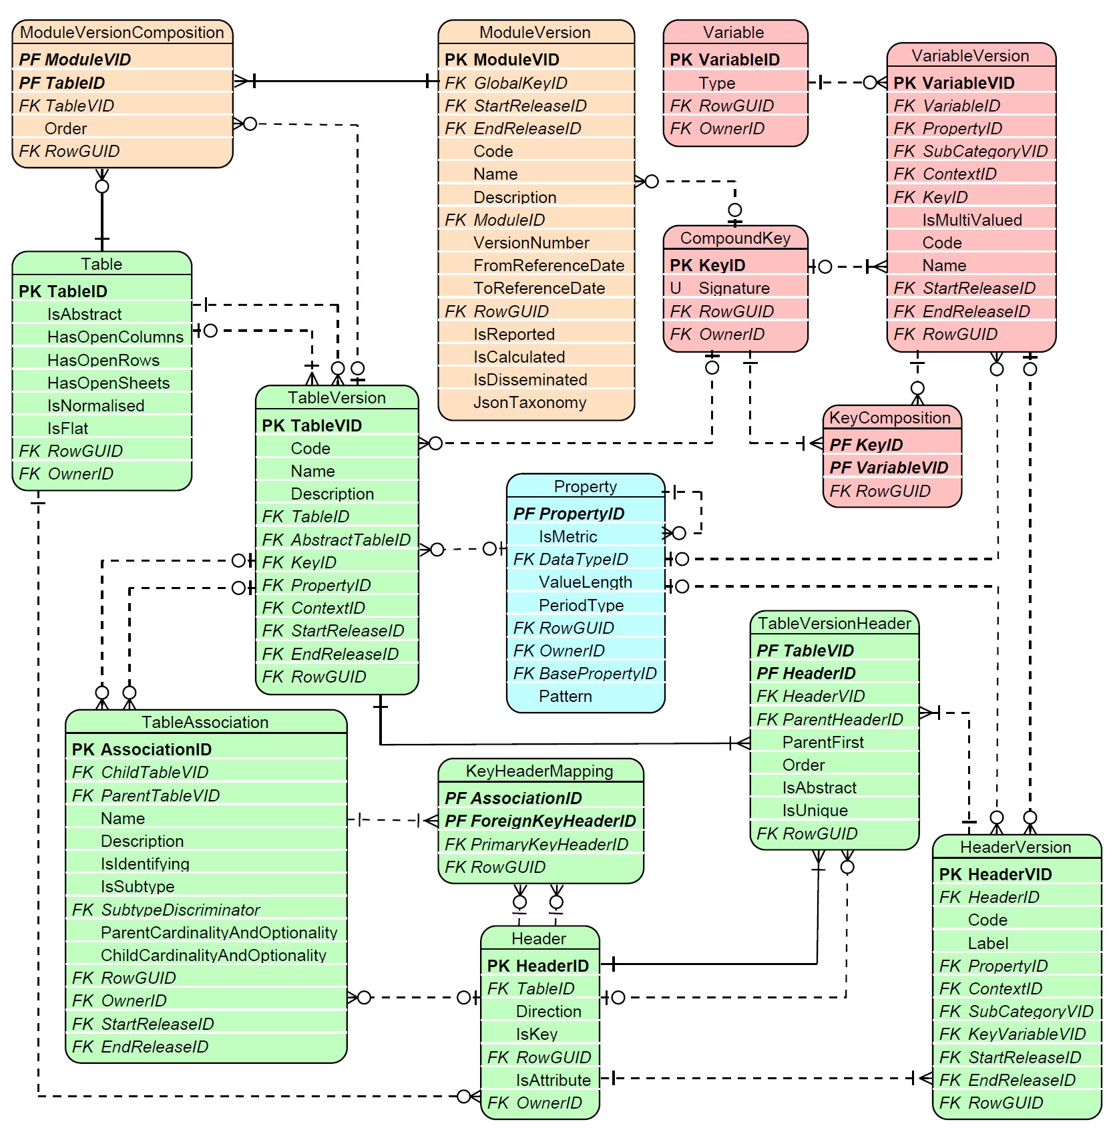
Figure 34. CompoundKey and KeyComposition application to TableVersion and ModuleVersion.

Variables’ definition process
Although Variables (4.3.1) can be defined irrespective of rendering, in the typical modelling process they are derived from Tables (4.2.1.1).
Fact Variables (4.3.2) are derived from Cells (4.2.1.3): Table-level Glossary terms contribute to definition of Headers (in which case Glossary terms are inherited, unless overridden, from upper-level Headers - 4.2.1.2) and are propagated to Cells at the intersection of these Headers.
Key Variables are linked from Key Headers, which have no Cells attached. This ensures that open (or semi-open, i.e. enumerated and constrained by means of a SubCategory - 4.1.3) Sheets, Columns or Rows are modelled in the same way regardless of their graphical orientation, since it is ultimately a subjective decision for a Modeller in which direction to display these.
Global Attribute Variables and Key Variables (i.e. those applying Module-wide, see ModuleParameters and CompoundKey, 4.2.2.2) are identified during the definition of the Modules (4.2.2.2) to which they refer.

Operations on data
In addition to the explicit and comprehensive description and unique identification of information requirements, the DPM enables the representation of definitions of Operations on data. These could be:
- quality checks, imposing constraints on reported data values or their formats;
- the documentation of logical and arithmetic relations between reported data;
- data transformations, enabling the production of new data from reported observations according to certain formulas.
These definitions can be used by software applications that parse reports and execute Operations on the reported data.

Operations
As indicated in Figure 35, Operations are represented in the form of an Abstract Syntax Tree (AST), where tree nodes are Operators (3.1.1.5) or OperandReferences referring to Variables (4.3.1), Properties (4.1.4), Items (4.1.2), SubCategories (4.1.3), or, through OperandReferenceLocation, to Cells (4.2.1.3).

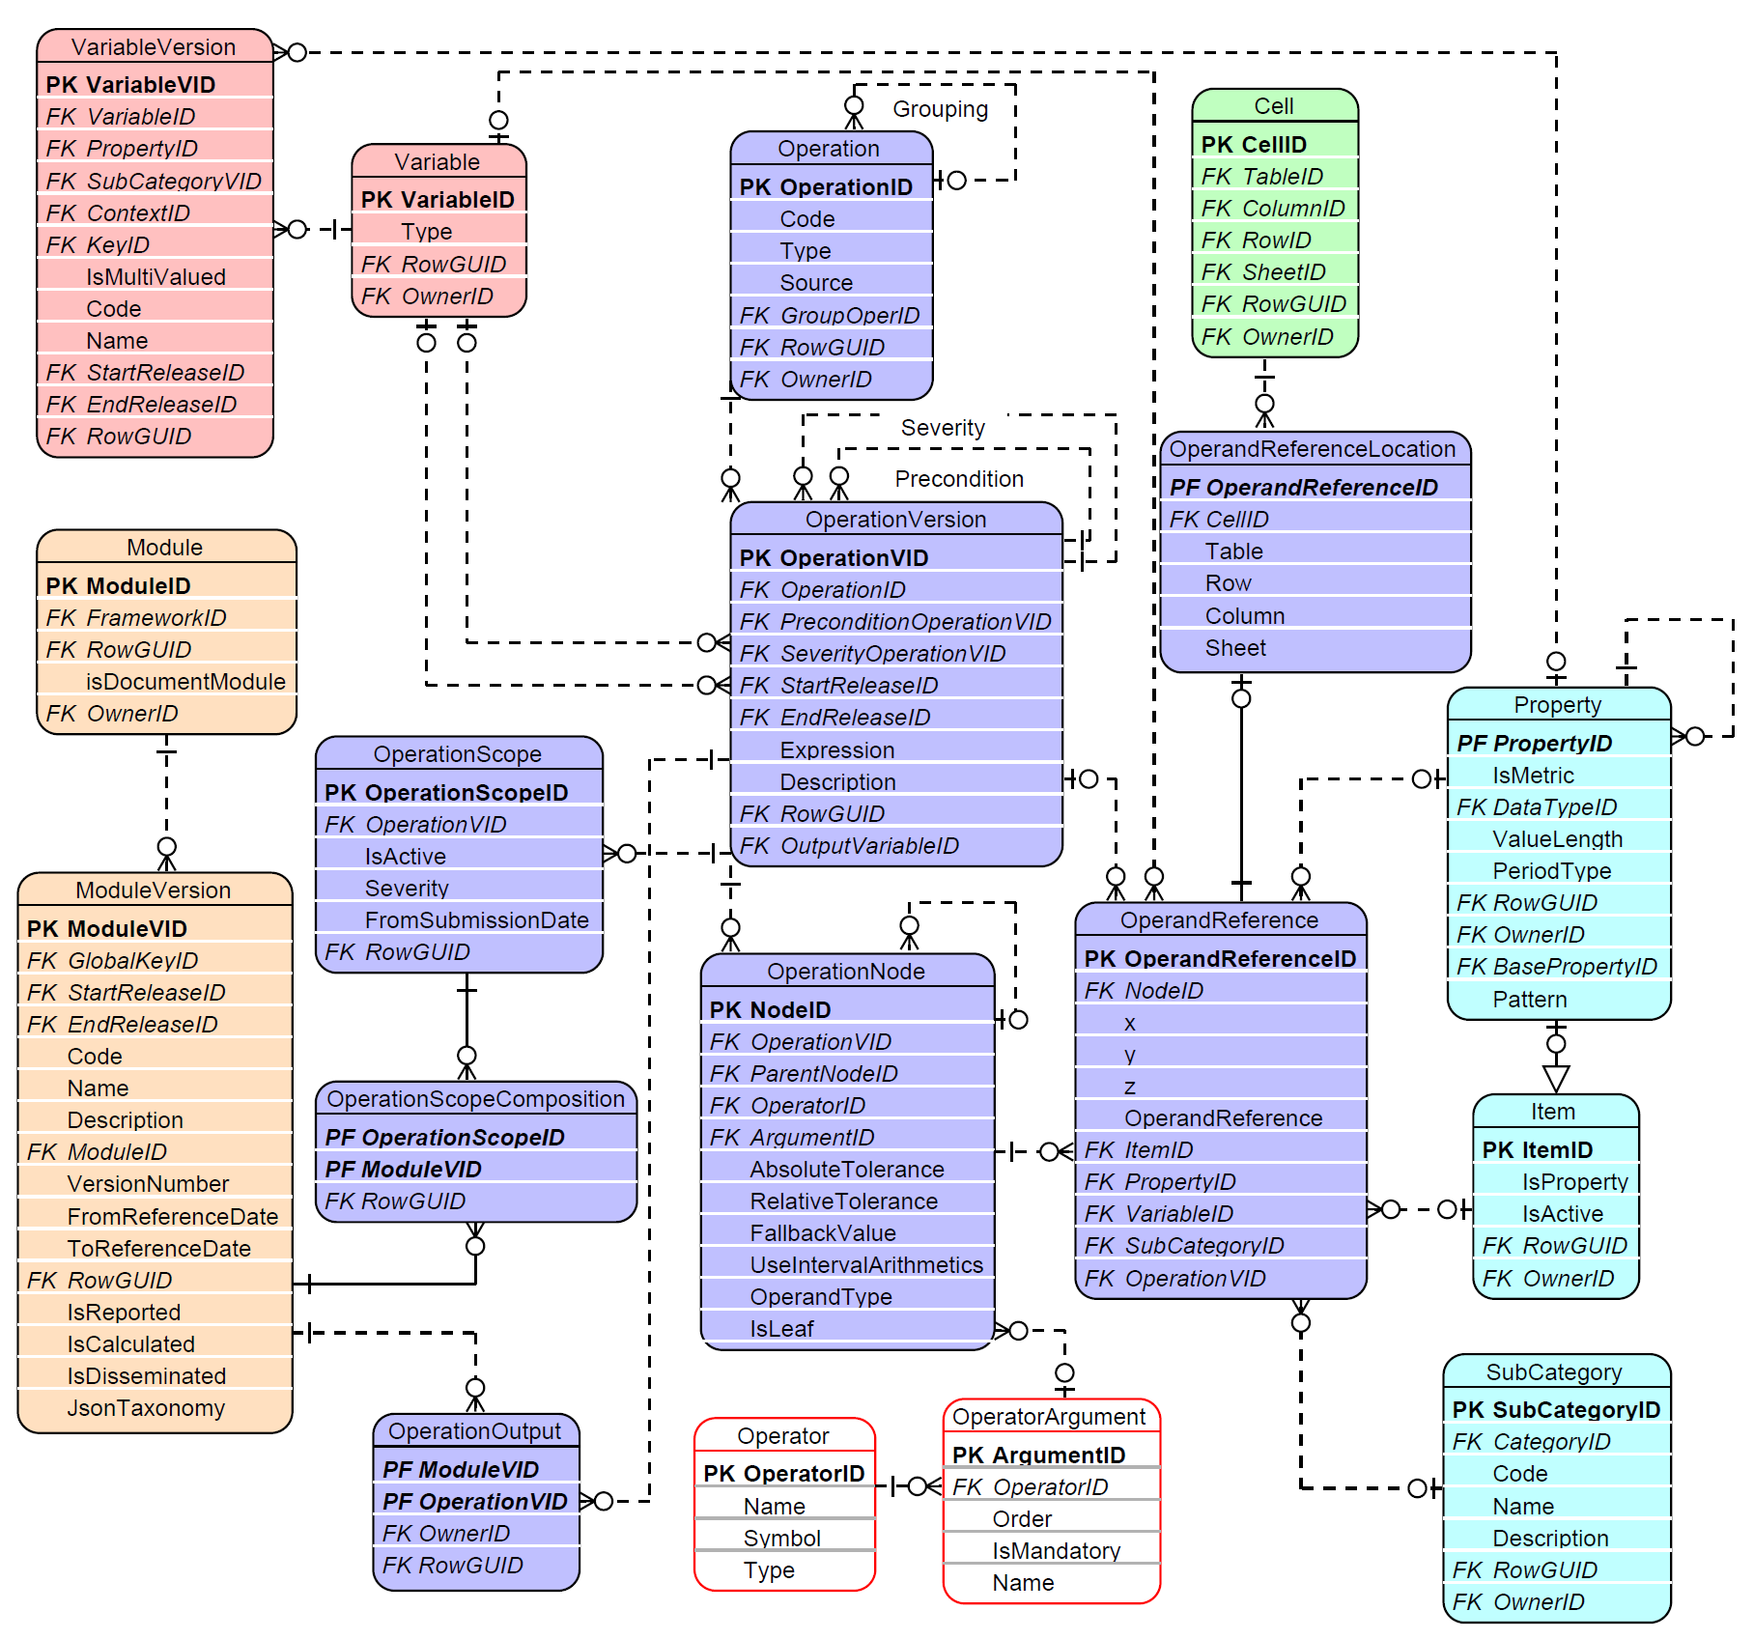
Figure 35. Entities and relations of Operations component.
The Operation Type indicates what an Operation represents, and can be one of the following:
- “validation” – a quality check that verified the correctness and consistency of reported data;
- “calculation” – a transformation of reported data to produce derived data, e.g. ratios or aggregates;
- “precondition” – a check that determines whether another related Operation should be executed,
- “conditional_severity” – a test that determines the severity of another related Operation.
Operations can be grouped, nested and sequenced. Sequencing is used for Operations that serve as a precondition, or that inform how severity is determined.
The Operation Source indicates the origin of an Operation and can be one of the following:
- “sign” – a check if a reported value is positive or negative, derived from TableVersionCell.Sign (4.2.1.3);
- “hierarchy” – originates from one of a SubCategory hierarchy whose structure, together with the ArithmeticOperators and ComparisonOperators (4.1.3), is applicable to verify reported data or producing new data;
- “existence” – a check of whether mandatory data was reported, derived from TableVersionCell.IsNullable (4.2.1.3);
- “property_constraint” – ensures that a Property is assigned an Item from among its allowed Items (derived from SubCategories applied to Variables for a given Property),
- “user_defined” – neither of the above; typically defined by a modeller by indicating Table Headers, Cells, Variables or glossary terms and applying them in test expression along with Operators and scalars;
- “variant” – as above but defined on TableGroups whose Type is “templateScope” (4.2.1.4), and therefore propagated to all Tables of which this TableGroup, or its descendants, are composed (via TableGroupComposition).
An Operation is versioned by means of OperationVersion referring to Release .
An OperationVersion applies to data reported for the Modules for which it is connected. For Operations whose Type is “validation”, this connection is made through OperationScope and OperationScopeComposition, to enable handling situations where an Operation’s severity differs depending on the Module, or where it can be deactivated/re-activated starting from a certain submission date (3.2.3). Operations whose Type is “calculation” are additionally linked to the derived Variable through OperationVersion.OutputVariableID.
As explained above, Operations are represented as trees whose branches and leaves (OperationNodes) link to Operators (3.1.1.5) and Operands. A detailed explanation of this mechanism and a description of the attributes of these entities, can be found in the DPM XL and ML documentation.
Operation, OperationVersion and OperationScope are Concepts and are therefore assigned an Owner, with the latter two inherit the Owner of the first. All three can have References (3.1.3.2).
The Description of OperationVersion can be translated (3.1.3.1) into any natural language, while its Expression can be reflected in any programming language (e.g. Java, .Net, Python, R, SQL) or other formal language (different syntaxes build according to a specified grammar).
For operations of Type “calculation”, the resulting output is assigned to a specific ModuleVersion. This assignment is managed using the OperationOutput, uniquely identified by the ModuleVersion and the OperationVersion. The output Variable is specified by the OutputVaraibleID attribute of th OperationVersion entity.
Some Operations refer to external data, i.e. information not belonging to any Framework (4.2.2.1 – and hence Modules 4.2.2.2), and therefore not exchanged in reports. This could be in particular:
- master data about reporting entities which may impact the data to be disclosed in reports, or determine which ratios or aggregates can be computed based on the reported data; or
- reference data, such as a registry of entities or instruments that can be crosschecked against the reported information.
Such metadata can be resembled in the DPM as Properties (4.1.4) of dedicated Categories (4.1.1), and, where applicable, as Variables (4.3.1) which, as Operands, can be referred by Operations and treated as parameters that, during execution, are replaced with values from this master or reference data.

APPENDIX 1: Changes applied on DPM 2.1.0

No. |  | Impacted Object | Change
1 |  | Category | - Remove field Category.IsSuperCategory. This can be inferred by the existence of SuperCategoryComposition in the corresponding table.  - Add Category.CreatedRelease field to point out in which Release this specific category has been created.
2 |  | Item | Remove field: Item.IsCompound, This relevant information can be inferred by the table CompoundItemContext.
3 |  | Header | Add field: Header.IsAttribute. This identifies if this is an Attribute header to another header of the same direction of the current table.
4 |  | Module | Add field: Module.IsDocumentModule. This specifies whether this module is of a specific type where we are not collecting datapoint facts for this but rather attached documents.
5 |  | ConceptRelation | Enhanced the list of ConceptRelatioon.Type lookupsm by an additional allowed value: ‘header_attributeHeader’
6 |  | ChangeLogAttribute | Added this table in order to structure better the ChangeLog.  Now ChangeLog captures all the actions at Object (table) level.  ChangeLogAttribute itself breaks down these actions to provide a more granular view at attribute level.
7 |  | Category | Added OwnerID information to several DPM objects, in order to allow several owners to host information in the same meta-data repository.  Currently, the Owner of such objects, is linked to Organisation.OrgID. That is to say, metadata ownership is at organisation level. Still, we acknowledge that there might be other alternatives to consider in the future.
 |  | Cell
 |  | CompoundKey
 |  | Context
 |  | Framework
 |  | Header
 |  | Item
 |  | Module
 |  | Operation
 |  | Property
 |  | Release
 |  | SubCategory
 |  | Subdivision
 |  | Table
 |  | TableAssociation
 |  | TableGroup
 |  | Variable
8 |  | OperationOutput | New Table to host to which Calculated Module the Output of an Operation is directed.  Used to dictate to which Module(Version), the outcome of an Operation(Version) is directed to.  This is used only for "Calculations" to identify the destination (calculated Module) of the calculation result.  PK: (ModuleVID, OperationVID)
9 |  | TableAssociation | Versioned TableAssociations so as to allow changes over time in such associations.  Added the fields: StartReleaseID, EndReleaseID
 | 10 | Property | Data Type Constraints:  Add to the table “Property” the new field “Pattern” nvarchar(4000).  This new field serves as to define a RegEx expression with all the constraints associated with the data type of this Property.  It applies only to Properties that do not take values from an enumerated drop-down list of Items.  Example: A LEI code has exactly 20 alphanumeric characters where the 5th & 6th characters are always digits and the last 2 characters are necessarily numeric, whilst all alphabetic characters are capital letters. Such constraints can be defined in this Regex expression in the “Pattern” field of the Property table:  ^(?=.{20}$)[A-Z0-9]{4}[0-9]{2}[A-Z0-9]{12}[0-9]{2}$
 | 11 | Organisation | How to distinguish between different domains in the same organisation?  In the “Organisation” table, the new field: “ParentOrgID” and a relationship between Organisation.OrgID (0..M) -> Organisation.ParentOrgID (0..1) were added.
 | 12 | ItemVersion | Ability to link regulation and definition to an item and to version it  The table “ItemCategory” to “ItemVersion” were renamed. Previously, versioning has been applied to the fields: CategoryID, Code, Signature, IsDefaultItem  Hereafter, on “ItemVersion” the fields Name and Description have been moved from table Item to ItemVersion. Hence, all changes on these fields can be tracked.  In any case, even in the up to now regime, a DPM user can set up and identify References of any Item Concept to Legal Document Subdivisions and also to versions of such Legal Document.
 | 13 | ModuleVersion | Allow glossary codes being explicitly shown for each module that uses them  As the glossary versioning cannot be attached to a single module itself (since glossary can be independently shared by many modules), it is extremely useful for users to be aware which glossary codes are employed by a module.  This information is currently available in the JSON taxonomy for each module version, that is currently deployed as a .json file.  It has been decided to incorporate that JSON taxonomy explicitly to the DPM, by adding the field: ModuleVersion.jsonTaxonomy  The Data type for the field will be BLOB and any other variants available in the deployable Data Base of the DPM.  Theoretically, this information can be derived by the DPM structure. However, as there are several particularities, it is always useful to provide to any interesting users, a ready version of this module version json taxonomy.
 | 14 | Framework | Explicitly identify Frameworks for physical or logical Modelling  As the DPM can be used for Modelling template based data collections, it could host either logical models or physical (implementation) models.  To explicitly include such information, the “Framework” table has an additional attribute “ModelLevel” with values (“logical”, ”physical”).  The user might define one logical framework and also one physical framework and relate them not only at the top framework level but at lower granularity levels such as Template or Template Header levels. Such relations could be attained by using the “ConceptRelation” construct, already included into the DPM.
 | 15 | ModuleVersion | Ability to explicitly identify the Data Management Life Cycle by qualifying the capabilities assigned to each Module Version  In DPM, some modules are reported and some are not reported.  Similarly, some are derived by calculation based on other modules; hence they are calculated.  Moreover, some modules could be disseminated, but some others are not to be disseminated.  In order to explicitly, qualify the role of each module in the data management life cycle, the “ModuleVersion” table of the DPM has three additional attributes (fields): IsReported, IsCalculated, IsDisseminated.  Note that any ModuleVersion could satisfy noen, one, or more than one of the above attributes.
 | 16 | Property | Enable the Explicit Specification and breakdown of Compound Properties  Example of a Use Case for the need of Compound Property  In the same Template we have 2 columns with Properties: “ISIN Cide” and “CUSIP Code”. Someone could claim that these could be defined as “Compound Properties” with the ”Main Property” be “Codein both cases and different Context. In one case, the Context is: Type of Code=”ISIN” and in the other case, the Context is: Type of Code=”CUSIP”.  Such decomposition of a Property considered as “Compound”, is possible to be represented in DPM. However, at implementation level, especially if these 2 Properties have to co-exist as Key Properties in the same Template, we are obliged to always use the “Compound Property” (e.g.”ISIN Code”, ”CUSIP Code”) for modelling them into the Template and not the “Base Property” (e.g. “Code”).  To technically implement compound property specification in the current DPM, we are going to add field in Property table called “BasePropertyID” which is a foreign key to the property itself. If BasePropertyID is not NULL then this Property is a Compound Property.  Each Compound Property might also be accompanied by one Context. Such context is accommodated in the corresponding “CompoundItemContext” table for the Item for which ItemID=PropertyID.  To explain more extensively, the DPM obligatorily records each Property also as an ItemID with PropertyID=ItemID. This facilitates that some attributes relevant to a Property are “borrowed” by the corresponding attributes defined for the Item (e.g. Code, Name, Description and now CompoundItemContext for the Compound Properties themselves).
 | 17 | VariableCalculation removed | The VaraibleCalculation entity was removed and replaced by OutputVariableID in the OperationVersion Entity.
 | 18 | Release | Added the field Release.Type, indicating the reason for which a given Release was created. Most frequent values are 'module' (for Releases created to include module updates) and 'deactivation' (for Releases created to deactivate validation rules). Other values may be added as new needs arise.

APPENDIX 2: Document history
Version | Date | Description
0.1 | 28/02/2022 | First internal working draft. Presents proposed skeleton of the document structure. Provides description and outlines intended content of each section.
0.2 | 30/06/2022 | Second internal working draft. Extended to cover all sections in more detail as well as updated to resemble the most recent version of the metamodel diagram and status of discussions.
0.2.1 | 13/07/2022 | Second internal working draft updated with comments and changes to versioning of SubCategories and removal of ItemHierarchy as well as addressing other editorial changes.
0.3 | 30/09/2022 | Third internal working draft including comments from the first review. Metamodel description has been updated and completed for all parts (for metamodel diagram as of 15/09/2022).
0.4 | 14/11/2022 | Fourth internal working draft including updates to the model between 15/09/2022 and 10/11/2022.
0.5 | 14/12/2022 | Internal working draft including updates to the model between 10/11/2022 and 14/12/2022.
0.6 | 31/03/2023 | Internal working draft including some updates to the model between 10/11/2022 and 31/03/2023.
0.7 | 22/05/2023 | Public draft including updates to the model as of 30/04/2023.
2.0 | 13/06/2023 | First major published version of the new DPM metamodel to address growing challenges around data volumes, granularity, and complexity. Established a modern metadata standard capable of supporting the hosting of relational (entity-relationship) data models.
2.1 | 31/07/2026 | Public working draft extending the DPM 2.0 standard. Introduces enhanced metadata versioning and extends the metamodel to host logical data models among other updates.

https://www.eba.europa.eu/
https://www.ecb.europa.eu/ecb/html/index.en.html
https://www.eiopa.europa.eu/
https://sdmx.org/
https://www.srb.europa.eu/en/about
https://www.xbrl.org/the-standard/what/an-introduction-to-xbrl/
https://www.eiopa.europa.eu/tools-and-data/supervisory-reporting-dpm-and-xbrl_en
https://www.eba.europa.eu/eba-publishes-draft-version-its-revised-taxonomy-architecture
This is typically an external publication e.g. in a public repository or on the website of the author organisation managing information requirements, however it may also be used to support internal workflows and processes within the organisation.
This is required for example to enable serialisation in XBRL format, in situation where Item changes Category to one for which its code is already occupied by another Item.
This mechanism enables also definition of Compound Properties, but as all Properties belong to one dedicated Category the more natural way of identifying that one Property combines semantics of two or more other Properties would be to assign it as a Parent Hierarchy Item of the Items representing the combined Properties.
A sheet being a third dimension along which the same row/column structure is repeated.
Applying this mechanism requires consistent assignment of Header Codes across Tables under that TableGroup.
https://en.wikipedia.org/wiki/Abstract_syntax_tree

