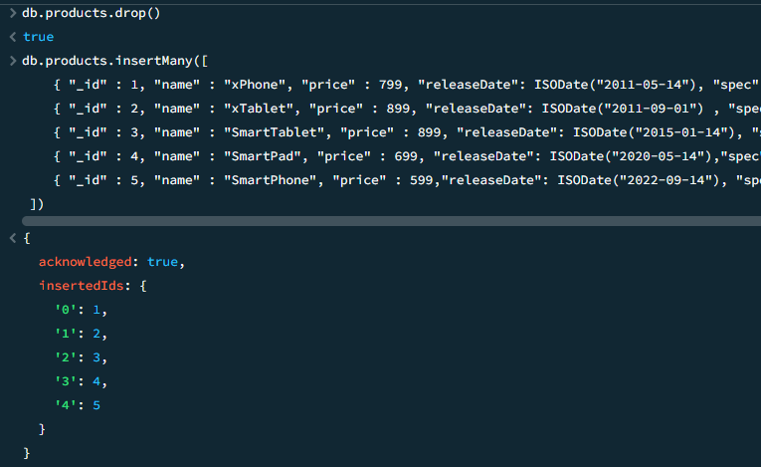

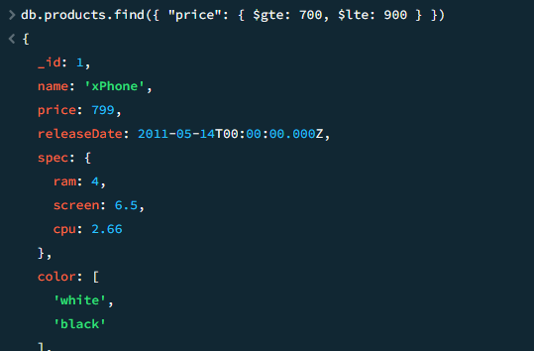

MongoDatabase database = mongoClient.getDatabase("vit");

MongoCollection<Document> collection = database.getCollection("products");

Document priceRangeQuery = new Document("price", new Document("$gte", 700).append("$lte", 900));

FindIterable<Document> products = collection.find(priceRangeQuery);

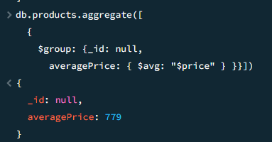

AggregateIterable<Document> result = collection.aggregate(Arrays.asList(

new Document("$group", new Document("_id", null)

.append("averagePrice", new Document("$avg", "$price")))

));

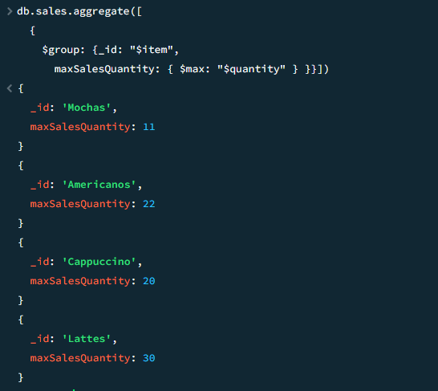

AggregateIterable<Document> result = collection.aggregate(Arrays.asList(

new Document("$addFields", new Document("totalSale", new Document("$multiply", Arrays.asList("$price", "$quantity")))),

new Document("$group", new Document("_id", "$item").append("maxSales", new Document("$max", "$totalSale")))

));