# Mininet实验报告

SA14011026 李博杰

## 实验步骤

见README，运行ThreeLayerDC.py即可。

实验代码说明见Python文件中的注释。

## 实验结果

详细实验输出见README。

从下述输出可见，创建的网络拓扑结构与题目要求相同。

*** Adding hosts:

h1 h2 h3 h4 h5 h6 h7 h8

*** Adding switches:

a1 a2 c1 e1 e2 e3 e4

*** Adding links:

(a1, c1) (a1, e1) (a1, e2) (a2, c1) (a2, e3) (a2, e4) (e1, h1) (e1, h2) (e2, h3) (e2, h4) (e3, h5) (e3, h6) (e4, h7) (e4, h8)

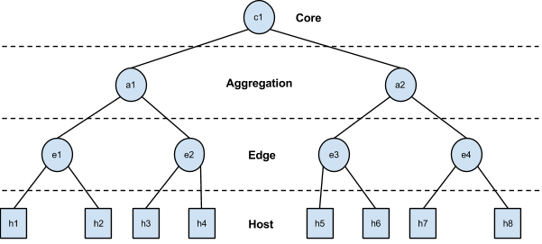

Ping 测试结果：8个节点互相ping，全通。

Connectivity (ping) test:

*** Ping: testing ping reachability

h1 -> h2 h3 h4 h5 h6 h7 h8

h2 -> h1 h3 h4 h5 h6 h7 h8

h3 -> h1 h2 h4 h5 h6 h7 h8

h4 -> h1 h2 h3 h5 h6 h7 h8

h5 -> h1 h2 h3 h4 h6 h7 h8

h6 -> h1 h2 h3 h4 h5 h7 h8

h7 -> h1 h2 h3 h4 h5 h6 h8

h8 -> h1 h2 h3 h4 h5 h6 h7

*** Results: 0% dropped (56/56 received)

吞吐量测试结果：

* 同一机架内的吞吐量：20.525 Gbps
* 同一aggregation switch下不同机架的吞吐量：14.375 Gbps
* 不同aggregation switch的吞吐量：12.34 Gbps

吞吐量测试方法：对每种类型，找4组主机进行iperf，取平均吞吐量。iperf使用一个TCP连接，窗口大小为默认，测试时间为5秒，以iperf server端接收到的数据量为准。

##### Throughput in same rack:

*** Iperf: testing TCP bandwidth between h1 and h2

*** Results: ['20.8 Gbits/sec', '20.8 Gbits/sec']

*** Iperf: testing TCP bandwidth between h3 and h4

waiting for iperf to start up...*** Results: ['19.8 Gbits/sec', '19.8 Gbits/sec']

*** Iperf: testing TCP bandwidth between h5 and h6

*** Results: ['20.5 Gbits/sec', '20.5 Gbits/sec']

*** Iperf: testing TCP bandwidth between h7 and h8

*** Results: ['21.0 Gbits/sec', '21.0 Gbits/sec']

##### Average throughput: 20.525 Gbps

##### Throughput in different racks but in same aggregation switch:

*** Iperf: testing TCP bandwidth between h1 and h3

*** Results: ['14.8 Gbits/sec', '14.9 Gbits/sec']

*** Iperf: testing TCP bandwidth between h2 and h4

*** Results: ['16.8 Gbits/sec', '16.8 Gbits/sec']

*** Iperf: testing TCP bandwidth between h5 and h7

*** Results: ['10.3 Gbits/sec', '10.3 Gbits/sec']

*** Iperf: testing TCP bandwidth between h6 and h8

*** Results: ['15.6 Gbits/sec', '15.6 Gbits/sec']

##### Average throughput: 14.375 Gbps

##### Throughput in different racks and different aggregation switches:

*** Iperf: testing TCP bandwidth between h1 and h5

*** Results: ['14.3 Gbits/sec', '14.3 Gbits/sec']

*** Iperf: testing TCP bandwidth between h2 and h6

*** Results: ['8.16 Gbits/sec', '8.17 Gbits/sec']

*** Iperf: testing TCP bandwidth between h3 and h7

*** Results: ['13.0 Gbits/sec', '13.0 Gbits/sec']

*** Iperf: testing TCP bandwidth between h4 and h8

*** Results: ['13.9 Gbits/sec', '13.9 Gbits/sec']

##### Average throughput: 12.34 Gbps

## 实验总结

由实验结果可见，随着主机间所跨层数的增加，吞吐量有所降低。

不过这个mininet实验不能很好地反映真实网络条件下的网络特性。因为mininet是用的OpenVSwitch做仿真，OpenVSwitch是按照CPU的速度尽可能快地转发数据包，没有按照链路的物理特性来限制链路上的带宽（如10 Gbps）。Mininet里的交换机每增加一层，就会增加一些CPU处理的开销，发送速度就会减慢一些。而在实际的数据中心网络中，交换机都是用ASIC而非CPU来转发，数据中心交换机一般都能达到线速（line-speed），不会出现交换机级数多了，吞吐量就降低的情况。

要反映数据中心中core switch成为网络瓶颈的问题，需要在不同的aggregation switch下面开多对iperf，由于core switch不能达到full bisection，会出现core switch成为瓶颈。在mininet里由于不方便同时开启多对iperf，就不做实验了。