计算机图形学第一次作业

PB10000603 李博杰

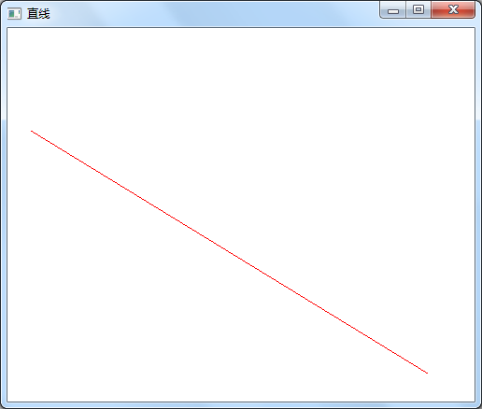

代码:

#include "stdafx.h"

#include <gl\glut.h>

void init(void)

{

glClearColor(1.0, 1.0, 1.0, 0.0);

glMatrixMode(GL_PROJECTION);

gluOrtho2D(0.0, 200.0, 0.0, 200.0);

}

void lineSegment(void)

{

glClear(GL_COLOR_BUFFER_BIT);

glColor3f(1.0, 0.0, 0.0);

glBegin(GL_LINES);

glVertex2i(180,15);

glVertex2i(10,145);

glEnd();

glFlush();

}

int _tmain(int argc, _TCHAR* argv[])

{

glutInit(&argc, (char **)argv);

glutInitDisplayMode(GLUT_RGB | GLUT_SINGLE);

glutInitWindowPosition(50, 100);

glutInitWindowSize(500, 400);

glutCreateWindow("直线");

init();

glutDisplayFunc(lineSegment);

glutMainLoop();

return 0;

}