redis安装

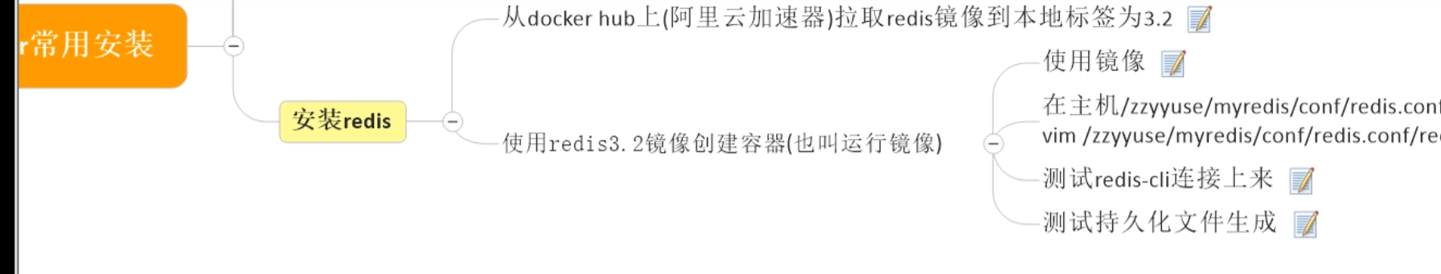

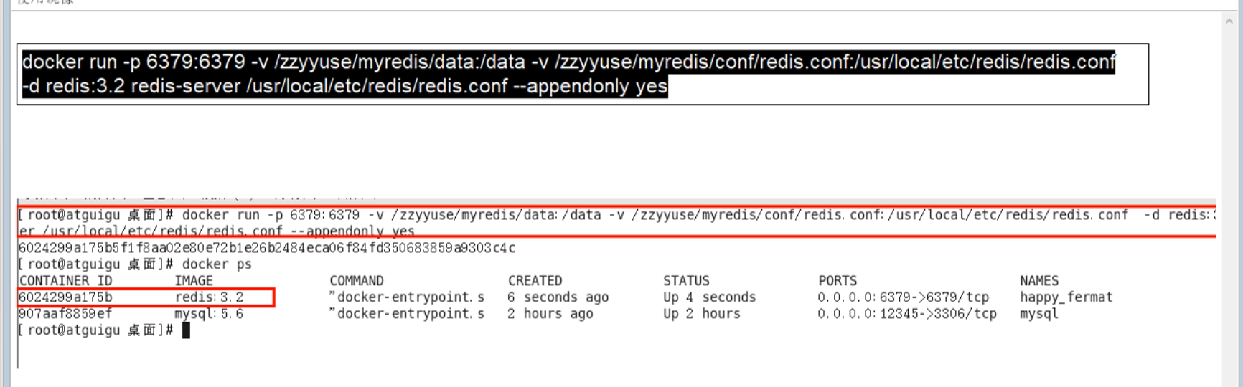

完整配置步骤

https://truedei.blog.csdn.net/article/details/106418353?spm=1001.2101.3001.6661.1&utm_medium=distribute.pc_relevant_t0.none-task-blog-2%7Edefault%7ECTRLIST%7Edefault-1.essearch_pc_relevant&depth_1-utm_source=distribute.pc_relevant_t0.none-task-blog-2%7Edefault%7ECTRLIST%7Edefault-1.essearch_pc_relevant