WORKSHEET 4 SQL

**Refer the following ERD and answer all the questions in this worksheet. You have to write the queries using MySQL for the required Operation.**

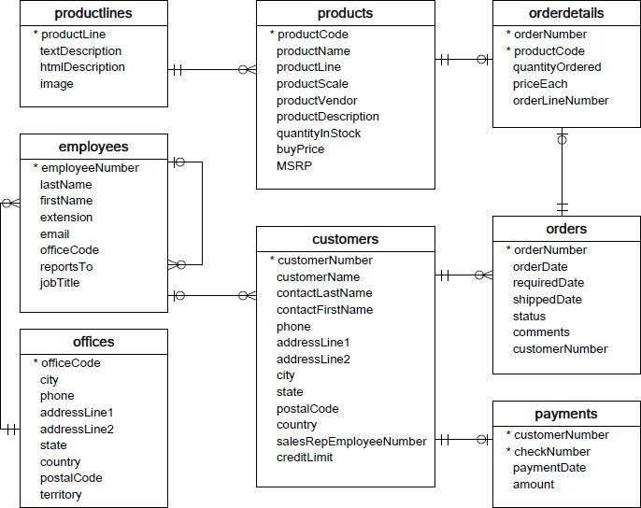

* **Customers**: stores customer’s data.
* **Products**: stores a list of scale model cars.
* **Product Lines**: stores a list of product line categories.
* **Orders**: stores sales orders placed by customers.
* **Order Details**: stores sales order line items for each sales order.
* **Payments**: stores payments made by customers based on their accounts.
* **Employees**: stores all employee information as well as the organization structure such as who reports towhom.
* **Offices**: stores sales office data.

**QUESTIONS:**

1. Write a SQL query to show average number of orders shipped in a day (use Orders table).

Ans :

SELECT

orderNumber,

status

FROM

orders

ORDER BY

FIELD(status,

'In Process',

'On Hold',

'Cancelled',

'Resolved',

'Disputed',

'Shipped');

1. Write a SQL query to show average number of orders placed in a day.

Ans:

SELECT

orderNumber,

status

FROM

orders

ORDER BY

FIELD(status,

'In Process',

'On Hold',

'Cancelled',

'Resolved',

'Disputed',

'Shipped');

1. Write a SQL query to show the product name with minimum MSRP (use Products table).

Ans: SELECT

ProductName

FROM

Products

WHERE

Min MSRP;

1. Write a SQL query to show the product name with maximum value of stockQuantity.

ANS : SELECT

ProductName

FROM

Products

WHERE

MAX quantityInStock;

1. Write a query to show the most ordered product Name (the product with maximum number of orders).

ANS: SELECT ProductName

FROM Products

WHERE

MAX orderNumber ;

FROM

Orderdetails

1. Write a SQL query to show the highest paying customer Name

Ans: .

Select Customername

from Customers

where salary = (select max(salary) from Customers)

1. Write a SQL query to show cutomerNumber, customerName of all the customers who are from Melbourne city.

Ans; SELECT customerNumber, CustomerName

FROM

Customers

WHERE

City = Melbourne ;

1. Write a SQL query to show name of all the customers whose name start with “N”.

Ans:

SELECT contact_last_name , contact_first_name

FROM Customers

WHERE (first_name) like ‘N’;

* + Write a SQL query to show name of all the customers whose phone start with ‘7’ and are from city ‘LasVegas’.

Ans: SELECT customer_name,customer_no

FROM customer

WHERE PHONE_NO = 7 , City = LasVegas;

1. Write a SQL query to show name of all the customers whose creditLimit < 1000 and city is either “Las Vegas” or ”Nantes” or “Stavern”.

ANS : SELECT Customername

FROM Customers

WHERE creditLimit<1000 and city = “Las Vegas” or ”Nantes” or “Stavern”;

1. Write a SQL query to show all the orderNumber in which quantity ordered <10.

ANS: SELECT *orderNumber

FROM orderdetails

WHERE quantityOrdered<10;

1. Write a SQL query to show all the orderNumber whose customer Name start with letter ‘N’**.**

**ANS :** SELECT*orderNumber , customerNumber

FROM customers,orders

WHERE customerName like ‘N’;

1. Write a SQL query to show all the customerName whose orders are “Disputed” in status.

Ans: SELECT*status , customerNumber

FROM customers,orders

WHERE customerName is “Disputed” in status ;

1. Write a SQL query to show the customerName who made payment through cheque with checkNumber starting with H and made payment on “2004-10-19”.

ANS :

SELECT CustomerName , customerNumber

FROM customers,paymensts

WHERE checkNumber starting with H and paymentDate on “2004-10-19”;

1. Write a SQL query to show all the checkNumber whose amount > 1000.

Ans: SELECT checkNumber

FROM payments

WHERE amount >1000;