REPORT TITLE
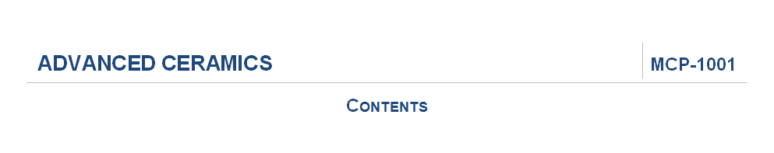
Title
Font & Style: Arial, Bold
Size: 16
Font Color: R:31, G:73, B:125
Code & Contents
Font & Style: Arial, Bold
Size: 14
Font Color: R:31, G:73, B:125
TABLE OF CONTENTS (TOC)
Chapters
Font & Style: Arial, Bold
Size: 10
Font Color: R:0, G:112, B:0
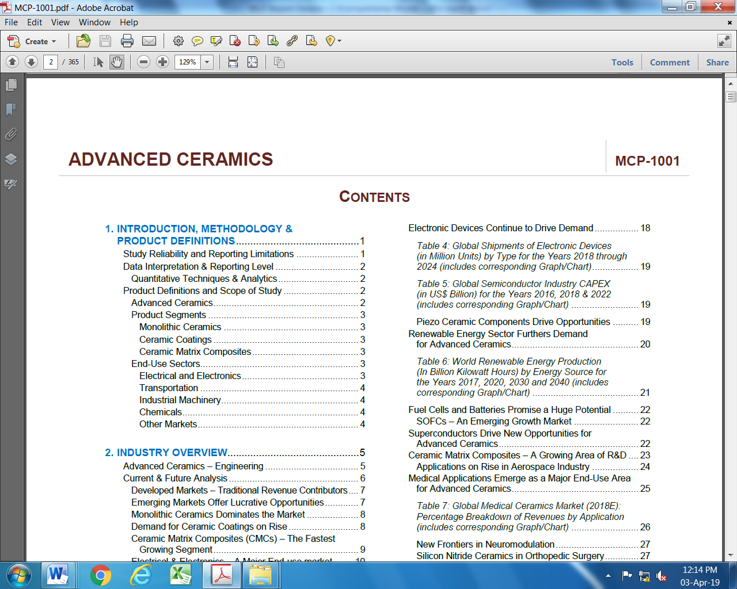
Table Headings
Font & Style: Arial, Italic
Size: 10
Font Color: Automatic (RGB:0)
Other TOC Text
Font & Style: Arial, Regular
Size: 10
Font Color: Automatic (RGB:0)

REPORT
Section Header

Executive Summary
Font & Style: Arial, Bold
Size: 14
Font Color: R:31, G:153, B:159

Chapter Header

Industry Overview
Font & Style: Arial, Bold
Size: 14
Font Color: R:196, G:96, B:68

Heading 1
Font & Style: Arial, Bold

Heading 1
Size: 12
Font Color: R:5, G:5, B:145

Heading 2
Font & Style: Arial, Bold

Heading 2
Size: 12
Font Color: R:0, G:72, B:0
Heading 3
Font & Style: Arial, Bold

Heading 3

Heading 5
Size: 12
Font Color: R:240, G:82, B:18
Heading 4
Font & Style: Arial, Bold

Heading 4
Size: 12
Font Color: R:102, G:79, B:217
Heading 5
Font & Style: Arial, Bold
Size: 12
Font Color: R:0, G:176, B:80
Heading 6
Font & Style: Arial, Bold

Heading 6
Size: 12
Font Color: R:246, G:176, B:34

Table Heading
TABLE 1: Global Number of 5G Subscriptions
(2020-2025) (in Millions)
Font & Style: Arial, Bold
Size: 12
Font Color: Automatic (RGB:0)

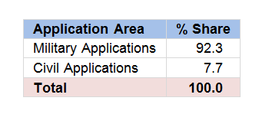
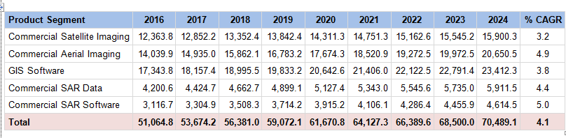
Table Text
Font & Style: Arial, Bold & Regular
Size: 7 to 11
Font Color: Automatic (RGB:0)
Table Footer
Source: International Monetary Fund (IMF)
Data is not adjusted for inflation. It is reported in nominal terms.
Data is reported at the Manufacturer/Service Provider’s level.
Font & Style: Arial, Regular
Size: 7 or 8
Font Color: R:1, G:186, B:142 (Source)
& R:200, G:100, B:10 (Rest of Footer)

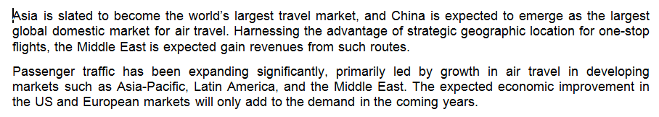
Normal Text
Font & Style: Arial, Regular
Size: 11
Font Color: Automatic (RGB:0)
GRAPHS AND CHARTS
Graph Segment Colors
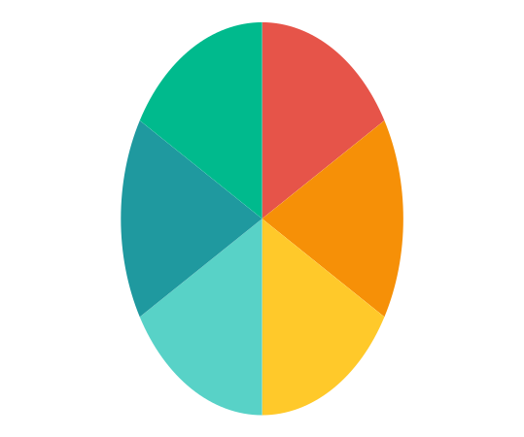

rgb (230,84,73)
rgb (246,144,7)
rgb (255,201,42)
rgb (88,210,199)
rgb (31,153,159)
rgb (0,186,141)

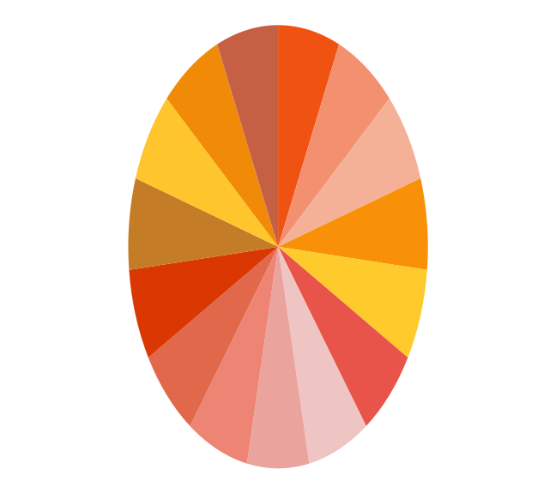
rgb (240,82,18)
rgb (243,144,112)
rgb (245,177,151)
rgb (248,145,8)
rgb (255,202,44)
rgb (232,84,73)
rgb (238,197,195)
rgb (234,164,157)
rgb (238,132,116)
rgb (225,104,74)
rgb (218,55,3)
rgb (197,124,38)
rgb (254,197,44)
rgb (241,138,7)
rgb (197,96,68)

