Bojun Yang

CS3600 Project 4 Analysis

Q5: Learning with restarts

Pen Data Test:

* Max: 0.904230989137
* Average: 0.901229273871
* Standard Deviation: 0.00614175073159

Car Data Test:

* Max: 0.890052356021
* Average: 0.883507853403
* Standard Deviation: 0.00654973612733

Continued next page.

Q6: Varying the hidden layer

Pen Data

|  |  |  |  |
| --- | --- | --- | --- |
| Perceptrons | Max | Average | Standard Deviation |
| 0 | 0 | 0 | 0 |
| 5 | 0.8401943968 | 0.8213836478 | 0.0197990857 |
| 10 | 0.9053744997 | 0.8949113779 | 0.009819553775 |
| 15 | 0.9090909091 | 0.9028016009 | 0.005487063746 |
| 20 | 0.905946255 | 0.8995425958 | 0.00654054064 |
| 25 | 0.909948542 | 0.9068038879 | 0.002706039924 |
| 30 | 0.905946255 | 0.9050886221 | 0.0006765099809 |
| 35 | 0.9093767867 | 0.904974271 | 0.002211444209 |
| 40 | 0.9053744997 | 0.895997713 | 0.00720366285 |

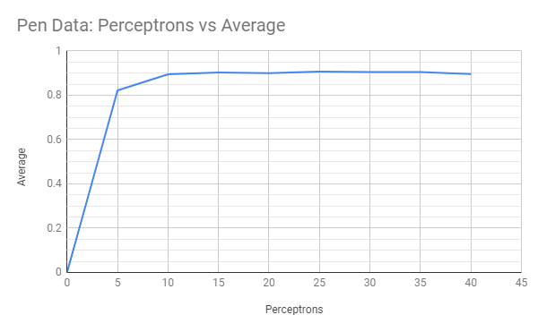

Car Data

|  |  |  |  |
| --- | --- | --- | --- |
| Perceptrons | Max | Average | Standard Deviation |
| 0 | 0.710078534 | 0.710078534 | 0 |
| 5 | 0.8808900524 | 0.8768324607 | 0.003711373528 |
| 10 | 0.8926701571 | 0.8797120419 | 0.00786865883 |
| 15 | 0.8907068063 | 0.8839005236 | 0.004730186126 |
| 20 | 0.8808900524 | 0.8781413613 | 0.002996210247 |
| 25 | 0.8841623037 | 0.8732984293 | 0.007364819318 |
| 30 | 0.877617801 | 0.8763089005 | 0.00137278645 |
| 35 | 0.8795811518 | 0.8735602094 | 0.00529093794 |
| 40 | 0.8815445026 | 0.8731675393 | 0.004446410406 |

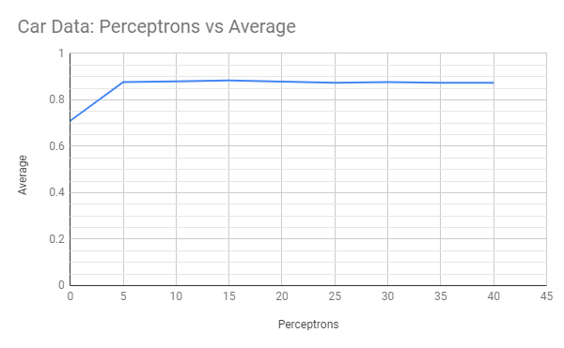

For both neural nets, accuracy greatly increases when the number of hidden layers is increased from zero to five. Accuracy for both data sets continue to increase until the number of hidden layers reach 15. After 15 hidden layers, the accuracy appears to stabilize around 0.905 for pen data and 0.876 for car data. As the number of hidden layers passes 30, there seems to be a small decrease in accuracy as the accuracy for the max number of hidden layers (40) is never the most accurate. It is also interesting that with zero perceptrons the accuracy for car data is around .70 but the neural net has not started learning yet.

Q7: Learning XOR

When the neural net was trained without a hidden layer, the average accuracy was 0.247 with a max accuracy of 0.5. The average accuracy decreases until the 7th perceptron, to an average accuracy of 0.292857142857. As the number of perceptrons increases from here, the average accuracy starts increasing for the rests of the tests. 100% max accuracy is reached at 24 perceptrons with 5 iterations, 8 perceptrons with 400 iterations, and 2 perceptrons with 8000 iterations. The results are what I expected based on class material. As the number iterations increased, it takes less perceptrons to fully train the neural net.