Bojun Yang

9/25/2018

CS4950: Project Deliverable #1: User Domain Research

1)

I started off researching the effects that sound had on either daily life or on people with special needs. I found a TED talk about how sounds can affect us in different ways, such as our hormones, breathing, heart rate, and brain waves (Treasure). The video gave examples on how certain sounds affect our physiological, psychological, cognitive, and behavioral state and how one may analyze or produce such sounds.

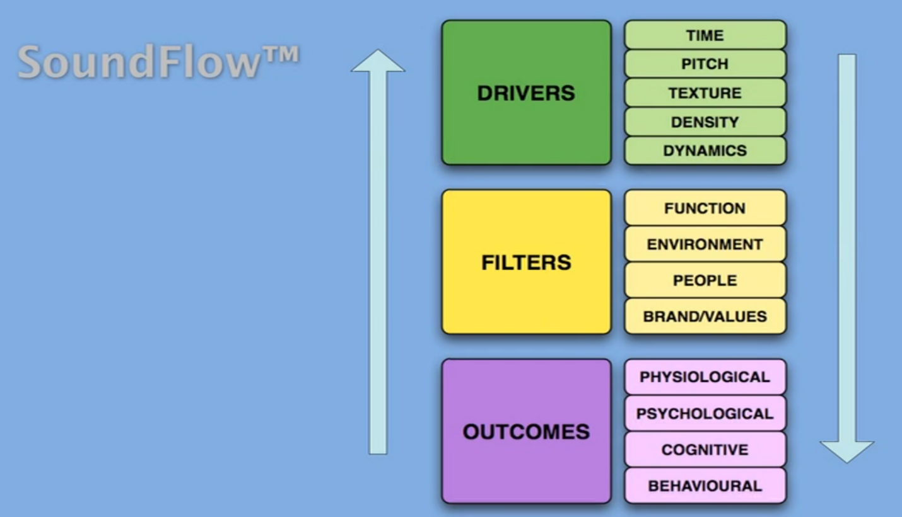

After a bit more research, I chose my domain to be an open-space work office or any generic open-space working area such as the library or Clough. In such a space, attention is the focus. Either an employee or student is trying to focus on their work or they are collaborating with a coworker/peer. Even though both collaboration and focus is important, in these environments we are easily distracted when we are trying to focus (Cooper 2017). Due to evolution, our brains try to change focus four times per second; good for sensing danger but poor for focusing. A wearable computing application that could mitigate distractions but still emphasize important events can improve work efficiency in the work place and quality of studying in a college study area.

Doing more research on what sounds are best for focusing, I found that silence is very important as well. We are very much affected by sounds but the absence of sound also affects our brains significantly. Research has shown that silence is relaxing for the brain and may even help with memorization (Gross, 2014). However, in our environment, it is practically impossible to achieve total silence. In busy student commons or during the workday in an open-space office, there will be constant sounds and only the best noise cancelling headphones can achieve near-silence. These headphones are not practical because of their cost. Which is why I researched on noises that help you focus. Noises such as white noise, neutral ambient noise, or nature noises can help improve attention and memory (Goodrich, 2017).

2)

The user needs include dampening irrelevant conversations and distracting background noise in the work area. The current strategy workers use is sound masking (Softdb). Sound masking is a technique in which a soft inconspicuous background sound with the use of a loudspeaker system creates a more uniform ambient sound level so that undesirable conversations and other noise distractions are less audible. This implementation however, is not perfect because it doesn’t completely mask the distractions. And if implemented using a loudspeaker, there will be areas that are less effective than others. A wearable device for an employee would be able to better mask such sounds and be able to detect when attention should be diverted. The wearable would be more effective because it is attached to the person. It will produce the sound masking appropriate for the individual much like noise cancelling headphones and can remove the masking when something needs attention.

3)

John is a 20-year-old computer science major living in Woodies Dorm. Since his dorm is very bad, he goes to the CULC to study. He is taking 16 credit hours this semester and is involved in 2 organizations. John is easily distracted and is often unproductive in CULC until 2am when the only people left are those who are quietly studying. He wants to be able to study in the CULC without being distracted but listening to music just distracts him even more. John wonders if he will be able to balance academics and his outside involvement and still get enough sleep.

My potential user group are people who work in open spaces or in environments with lots of traffic and background noise and distractions. These are the people who need to be able to focus even with so many distractions around them.

4) Sources

1. Treasure, Julian, director. *TED: Ideas Worth Spreading*. *TED: Ideas Worth Spreading*, [www.ted.com/talks/julian_treasure_the_4_ways_sound_affects_us](http://www.ted.com/talks/julian_treasure_the_4_ways_sound_affects_us).
2. Cooper, Belle Beth. “Quiet Doesn't Cut It: Why Your Brain Might Work Better In Silence.” *Fast Company*, Fast Company, 17 Feb. 2017, [www.fastcompany.com/3068168/quiet-doesnt-cut-it-why-your-brain-might-work-better-in-silence](http://www.fastcompany.com/3068168/quiet-doesnt-cut-it-why-your-brain-might-work-better-in-silence).
3. Softdb. “What Is Sound Masking and How Does It Work?” *Soft DB*, Soft DB, 18 Sept. 2018, [www.softdb.com/sound-masking/technology/#what-is-sound-masking](http://www.softdb.com/sound-masking/technology/#what-is-sound-masking).
4. Gross, Daniel A. “This Is Your Brain on Silence - Issue 16: Nothingness.” *Nautilus*, 21 Aug. 2014, [www.nautil.us/issue/16/nothingness/this-is-your-brain-on-silence](http://www.nautil.us/issue/16/nothingness/this-is-your-brain-on-silence).
5. Goodrich, Kaitlin. “Can ‘Distracting’ Noise Actually Help You Study Better?” *BrainScape*, 2017, [www.softdb.com/sound-masking/technology/#what-is-sound-masking](http://www.softdb.com/sound-masking/technology/#what-is-sound-masking).