GENED 1104: Science & Cooking midterm 2

Thursday, November 16, 2023, 12-1:15 pm Calculators permitted

Expectations
- Read the directions carefully.
- For problems involving calculation, please show your work.
- Academic Integrity:

Cheating, no matter how slight, is never acceptable.
It violates the standards of our community and disrupts learning.
A higher score is not worth compromising your integrity.

- I have not consulted anyone or any reference material
in completing this exam.
- I will not discuss exam questions and solutions
until the exam is handed back.

- I understand and agree to abide by this policy:

_______________________________________________
Name (Printed)

_______________________________________________
(Signature)

Section Time/TF (circle):

Tu 3:45  Alex | Tu 6:45  Kate | W 12:45  Caroline | W 3:45  HyoJeon | W 6:45  Blake | Th 9:45  Tim | Th 3:45  Larissa

Grading (to be completed by teaching staff)
Question | Score
1-6 | /18
7-9 | /16
10-12 | /14
13-16 | /25
16-21 | /27
Total | /100

Multiple Choice Questions: (3 pts each)

- At what volume fraction does the elastic modulus of an emulsion start increasing?
  - 50%
  - 1%
  - 74%
  - 64%

- Which of the following statements is true about diffusion? Select all that apply.
  - Diffusion is always faster for molecules with a positive or negative charge
  - The overall direction of diffusion is from areas of high concentration to low
  - Large molecules take longer steps in a “random walk” motion and therefore diffuse faster
  - Moving a dish into a hotter environment will speed up diffusion of heat into the food but will have no effect on diffusion of ions

- Which of the following are true? Select all that apply.
  - Ostwald ripening happens between two differently sized droplets due to differences in internal pressure.
  - Creaming happens in substances with different densities.
  - Laplace pressure describes why there is a difference in pressure between small and large droplets.
  - Phase inversion occurs when the volume fraction of an emulsion rises above 1.

- What types of molecules are required for Maillard reactions? Select all that apply.
  - Fats
  - Carbohydrates
  - Salts
  - Proteins

- Which of the following are true about polymers? Select all that apply.
  - A polymer’s effective volume can be estimated by the principles of a “random walk”
  - Flour is commonly used in recipes because it is a better thickener than xanthan gum
  - Polymers that are less likely to entangle are typically better thickening agents
  - Polymers affect the rate that molecules in a liquid can move around each other

- Draw lines between each food and what is diffusing into it. Connect all that apply; i.e. each food can have more than one line.

Tuna ceviche H+ ions

Molten lava cake Oil

French fries CO gas

BBQ ribs Heat

Short Answer Questions:

- What type of emulsion is represented in the following picture? In each box, write in the depicted component and in 1-2 sentences explain how you reached your conclusion. (6 pts)

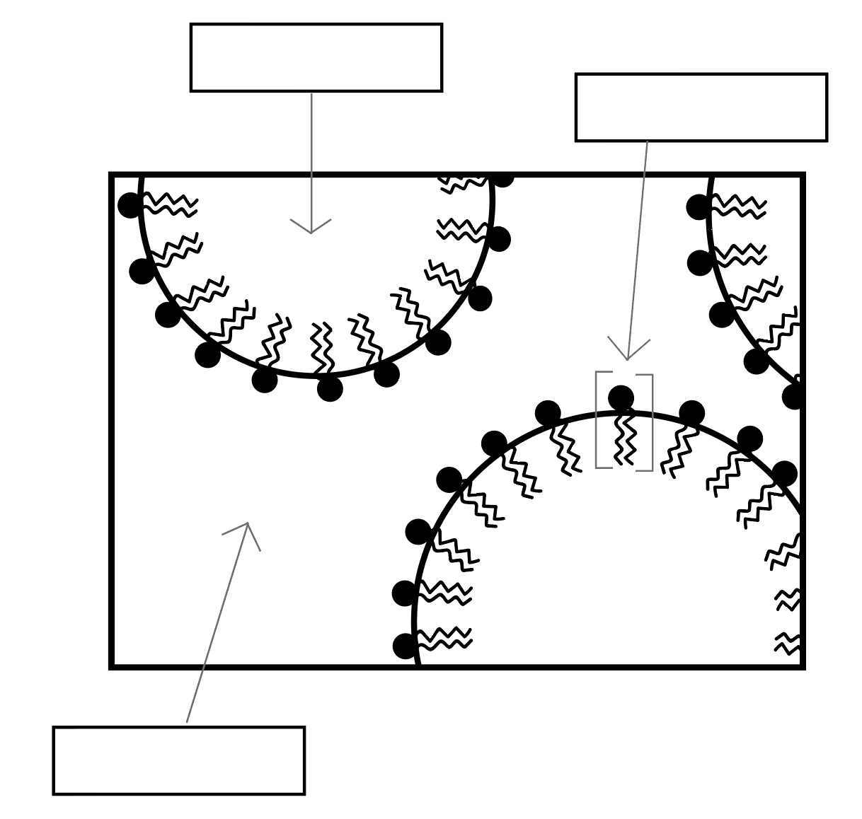
top left box: oil (dispersed phase)
top right box: surfactant, phospholipid or amphipathic/philic molecule (just not protein!), emulsifier
bottom box: water (continuous phase)
Oil in water, or direct emulsion. Can tell by the orientation of the surfactants; head (hydrophilic), tail (hydrophobic).

- Why does spherification not work as well with low-pH substances? Explain. (5 pts)

We know that alginate is a polymer with many negative charges, which is why it is attracted to the positively charged Ca²⁺. The double positive charge of Ca²⁺ ions is also very important as this means it is able to bring two alginate molecules together to create crosslinking. In a low-pH environment there is an excess of H+ ions, and since they are positively charged these ions would also be attracted to the negatively charged alginate. However, H+ ions only have one charge, and would therefore not help crosslink, meaning the spherification structure would not occur as readily. (H+ ions would compete with Ca²⁺ ions)

- Can you have an oil-in-oil emulsion? Explain why or why not. (5 pts)

Yes, but only if one oil is solid and the other is liquid at room temperature--they must not be both liquid or both solid, otherwise it will just be a mixture rather than an emulsion. Alternatively, if they have highly different hydrophobicities an emulsion might also be possible.

Hot Chocolate
Head TF Heide visits a local shop where they show her how cocoa beans are fermented, dried and ground to form cocoa powder. She uses this cocoa powder to make a hot chocolate by
gently stirring together 10g of cocoa powder, 10g of sugar and 500mL of milk while heating on the stove.

- Is Heide’s hot chocolate a colloid, emulsion and/or foam? Explain why or why not for all three. (6 pts)
  - Definitely a colloid! Cocoa powder particles are floating around in the hot chocolate. alternatively if they say if the particles dissolve then it is not a colloid that would also be correct.
  - Also an emulsion - milk is an emulsion, and if mixed well enough the cocoa butter could also be dispersed and turn it into an oil in water emulsion.
  - No noticeable incorporation of air though so not a foam
- Heide measures that her recipe makes 510mL of hot chocolate. If cocoa powder has a density of 1.6 g/mL, what is the volume fraction of cocoa powder in Heide’s hot chocolate? (4 pts)
10g cocoa powder/1.6 g/mL = 6.25mL cocoa powder
volume fraction = 6.25mL cocoa powder / 510mL total volume = 0.012 = 1.2%
- Heide thinks her hot chocolate could be just a bit thicker. Without adding any ingredients, what could she do to thicken her hot chocolate? Using the volume fraction equation, explain how this would lead to an increase in viscosity. (4 pts)
  - Boil the hot chocolate to carefully evaporate some of the water in the milk. In the volume fraction equation this would reduce the total volume (bottom of equation) while leaving the half of the equation the same, making the volume fraction higher.
  - Or reduce temperature - has effect on slowing molecular motion but doesn’t affect the volume fraction equation though
  - whip into a foam – this would increase both dispersed volume and total volume but by the same amount, so overall fractions would increase - would need some very vigorous whipping for this though :)
Steak Dinner
TF Tim wants to make the perfect steak for a dinner party. He decides to cook it using a sous vide water bath set to 55ºC, the temperature of a medium-rare steak. He seals the steak in a plastic bag with some herbs and seasoning, and submerges the steak completely in the water bath to cook.
- Tim’s steak is a rectangular block with dimensions 10cm x 10cm x 6cm. What is the shortest amount of time (in minutes) that Tim needs to leave the steak in the water bath to ensure the center of the steak reaches 55ºC? Note: the diffusion coefficient of heat for beef is 1.3 x 10⁻³ cm²/sec. (5 pts)

L = (4Dt)^{1/2} and here, L = 3 cm since that’s the shortest distance to the center of the steak.
t = L² / 4D
t = (3 cm)² / (4 * 1.3E-3 cm²/sec)
t = 1730.76 sec * 1 min / 60 sec = 28.84 min

- Tim wants his steak to be ready faster, so he decides to make a thinner slice. How thick should he make the steak if he wants the sous vide cooking to take half as long? Assume that the length and width of the cut steak are still both 10 cm as in Problem #13. (5 pts)

L = (4Dt)^{1/2} and here, we want to solve for L using t = 14.42 min * 60 sec/min = 865.38 sec.
L = (4*1.3E-3 cm²/sec*865.38 sec)^{½}
L = 2.12 cm

Since L is the value for distance to the center, the thickness is 2*L = 4.24 cm

- After his steak has finished in the sous vide bath, Tim quickly sears both the top and bottom sides on high heat just until Maillard reactions occur, about a few minutes each.

Using the axes provided, draw three temperature profiles for Tim’s steak (1) immediately after the sous vide but before searing, (2) immediately after searing the first side and (3) immediately after searing the second side. Please use the key provided for drawing the three different profiles. (9 pts)

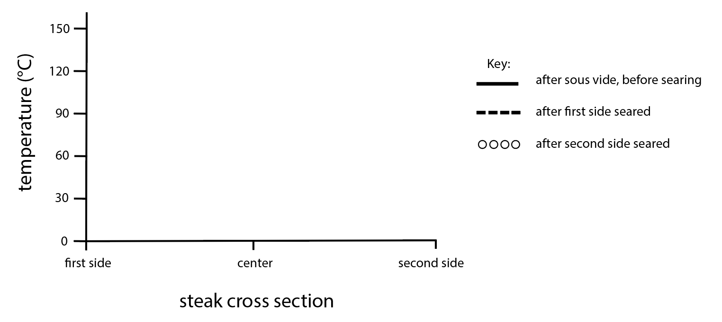
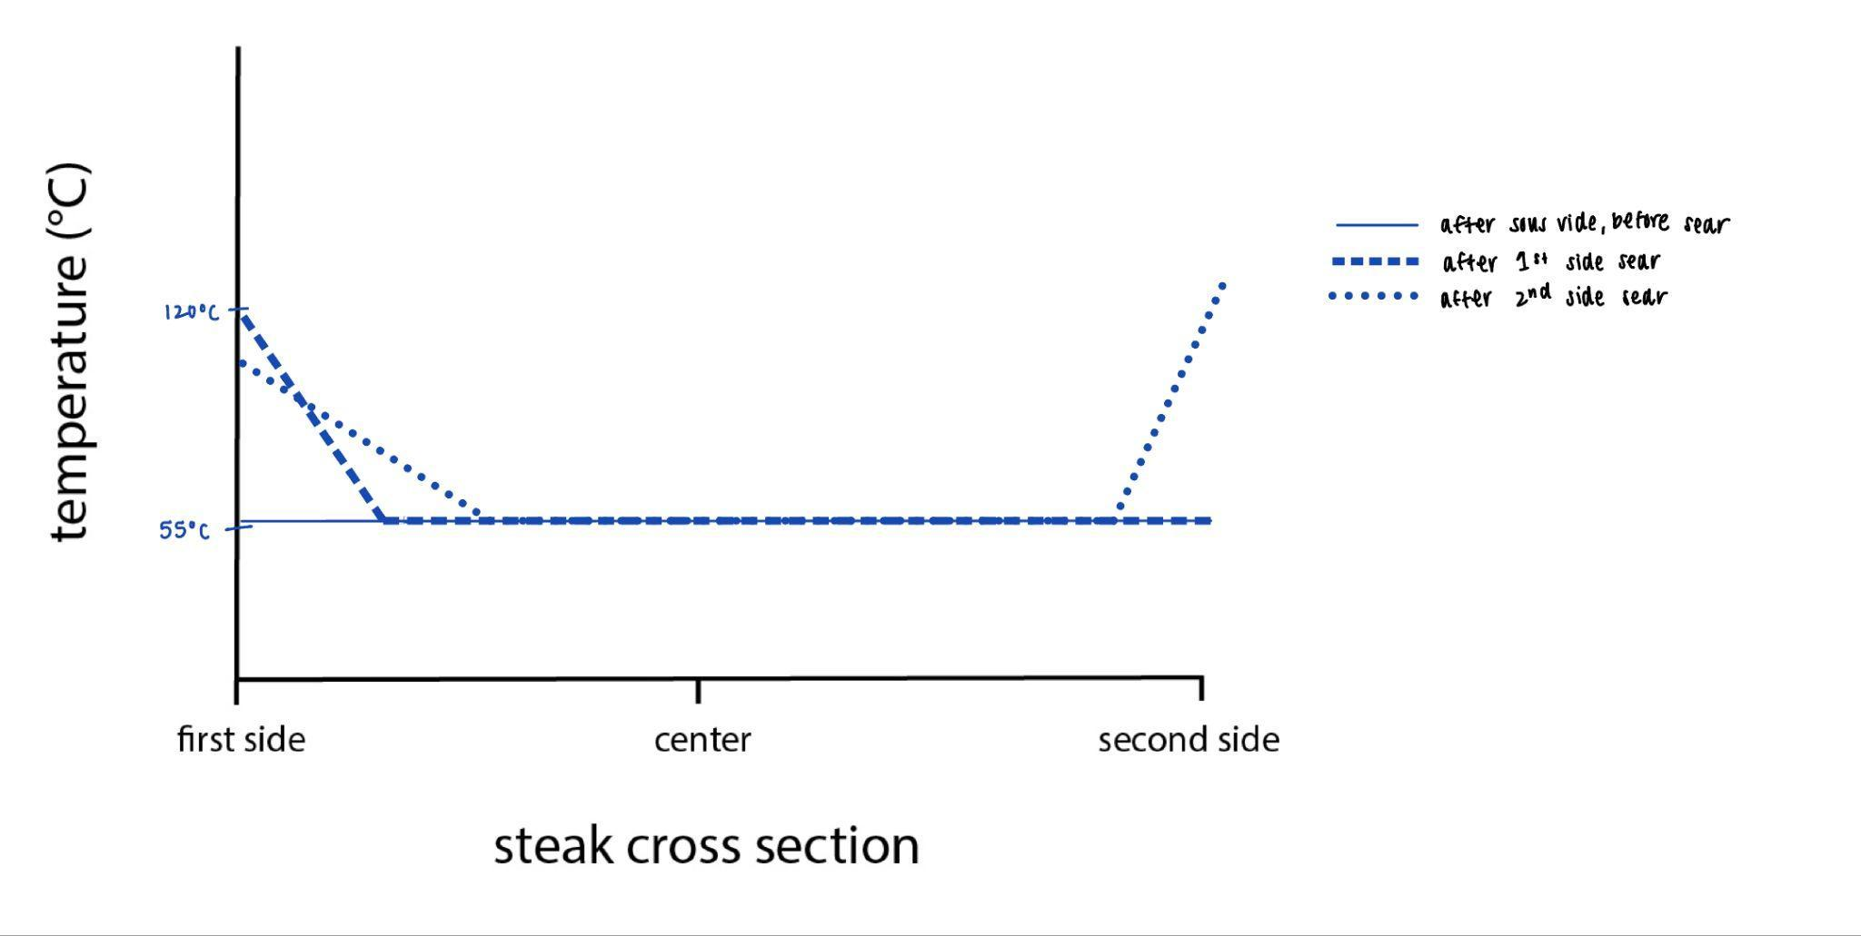

Key considerations:
- - straight line at 55ºC bc of sous vide
- - first side reaches at least 120ºC to achieve Maillard reactions, should be a steep enough curve/line that the rest of the steak is still 55 (aka fast enough that the heat hasn’t diffused through the whole steak)
- second side reaches at least 120ºC to achieve Maillard reactions, while heat has diffused farther into the steak on the first side, outermost temperature on first side has also dropped slightly as no more heat is applied (curve or line both ok)

- Tim wants to add more flavor into his steak by marinating it in red wine vinegar, olive oil, and salt in the fridge for 12 hours before repeating the above recipe for cooking. However, he finds that this time the steak is overcooked! Explain why this happened on a molecular level. (6 pts)
Vinegar (H+ ions) in the marinade diffused into the steak overnight to denature and cook the proteins slightly before cooking. This is because H+ ions change the overall charge of the protein (neutralizing negative charges & adding positive charges to previously neutral amino acids), making it overall much more positively charged and unstable, causing the protein to denature. (Might also mention that like repels like, which causes it to unfold). Therefore, the thermal energy that was perfect for a raw steak ended up being too much for this partially cooked steak and ended up overcooking it.

Dalgona Coffee
For an extra fancy morning, TF Larissa likes to make “Dalgona coffee”. You make this type of coffee by vigorously whisking equal parts instant coffee (readily dissolvable powdered coffee), hot water, and white sugar until it foams up.
- One morning Larissa prepared her coffee, but then forgot about it. When she came back after a while the coffee foam had disappeared. Give two reasons why this may have occurred, describing the processes and what causes them. (6 pts)
- creaming/sedimentation: based on the density of the continuous phase, gravity pulls down the continuous phase while the bubbles in the foam rise and eventually pop
- Ostwald ripening: driving force = la place’s pressure - pressure within a droplet is higher than outside, and higher within smaller droplets than within larger droplets so small droplets combine to form larger droplets
- coalescence - same size droplets
- Larissa’s friend suggests she use an electric whisk or blender instead of whisking the coffee by hand. This not only makes it foam more quickly, but the foam is also much stiffer. Explain in terms of droplet size what you think may have changed and why. (6 pts)
  - Blending creates shear stress which causes droplets to get smaller
  - An electric mixer would likely make smaller bubbles → can pack tighter to get a higher volume fraction, therefore stiffer

- Larissa whisks 80mL of coffee mixture until the total volume reaches 250mL. Assume the droplet radius for the dispersed phase is 5μm (10⁶ μm = 1m) and that the surface tension is 0.02N/m. What is the elastic modulus of the foam? (6 pts)
𝐸 = 𝜎/𝑅 (𝜑 − 𝜑𝐶)
𝜎 = 0.02 N/m
R = 5um = 5 x 10^-6m
𝜑air = (250-80m)L/250mL = 170mL/250mL = 0.68
E = 3.33 x 10^3 N * (0.68-0.64)
E = 160N/m^2 = 160Pa
- Larissa’s friend also suggests adding 1 tsp of milk to try to stabilize the whipped coffee. Larissa suggests adding 1 tsp of egg whites instead. Which method would work better and why? (5 pts)

Egg whites would work better than milk. The protein from the egg white acts as a surfactant and goes to the interface, making the foam more stable by protecting the air bubbles. (Alternative answer: coffee is slightly acidic, so this could denature the proteins in the egg white, causing them to crosslink or make a gel that would increase viscosity and also stabilize the foam).

Milk has some proteins and fats to also act as surfactants but is mostly water (~85%), so wouldn’t make nearly as much of a difference.

- After adding this stabilizer, Larissa calculates that the volume fraction of air in her whipped coffee is 0.60. Would this coffee technically be considered a solid? Would it be considerably viscous? Explain each answer. (4 pts)

No, would not be a solid--less than the critical vol fraction of 0.64
However it is considerably viscous because it’s over the 50-60% threshold

SCRATCH PAPER

Equation Sheet

Unit conversions
N = kg·m/s² | J = N·m |  | Pa = N/m² = J/m³ |  | 1 L= 1·10⁻³m³ |  | 1 ml = 1 cm³
Kelvin = Celsius+273 | Fahrenheit = (Celsius*9/5)+32 |  | Area circle = πr² |  | Volume sphere = (4/3)πr³ |  | Surface area sphere = 4πr²
Constants
Room temp = 23˚C |  | 1Cal = 1000 cal = 4.18 kJ |  | Gravitational acceleration  (g=-9.8 m/s²) |  | Avogadro’s number (6.022·10²³ molecules/mol)
Boltzmann constant  k_{B} = (1.38·10⁻²³ J/K) |  | Specific heat water 4.19 J/gK |  | Latent heat of vaporization for water  2260 J/g |  | Latent heat of  fusion for water  334 J/g
1 mol = 6.022 x 10²³ molecules |  | gas constant = 22.4L/mol |  | D_{heat} water  1.4⋅10⁻³ cm²/sec |  | D_{Ca} 8.0⋅10⁻¹⁰ m²/sec

Equation |  | Description | Units
 | L | Distance of diffusion | m
 | D | Diffusion coefficient | m²/s
 | t | Time to diffuse | s
$ϕ=\frac{V_{dispersed}}{V_{total}}$ | φ | Volume fraction | -
 | V_{dispersed} | Volume of dispersed phase | L
 | V_{total} | Total volume | L
 | E | Elastic modulus | Pa
 | σ | Surface tension | N/m
 | R | Droplet radius | m
 | φ | Dispersed phase volume fraction | -
 | φ_{C} | Critical volume fraction (0.64 for spheres) | -
 | N | Number of nuclei | -
 | ΔG | Activation energy | J
 | k_{B} | Boltzmann constant | J/K
 | T | Temperature | K

Equation |  | Description | Units
pH = -log₁₀[H⁺] | [H⁺] | Concentration of protons (also known as H⁺ ions) in solution | mol/L
 | pH | A measure of acidity | none
 | Q | Heat | J
 | m | Mass | g
 | c_{p} | Specific heat capacity | J/g K or J/g˚C
 | ∆T | Change in temperature | K or ˚C
 | Q | Heat | J
 | m | Mass | g
 | L_{v} | Latent heat of vaporization | J/g
 | L_{f} | Latent heat of fusion | J/g
 | U | Interaction energy for  liquid to gas transitions | J
 | C | Constant (1.5 for water) | none
 | k_{B} | Boltzmann constant | J/K
 | T | Temperature | K
 | E | Elastic modulus | Pa
 | F | Force | N
 | A | Area over which force is applied | m²
 | ∆L | Change in length | m
 | L₀ | Initial length | m
 | E | Elastic modulus | Pa
 | k_{B} | Boltzmann constant | J/K
 | T | Temperature | K
 | l | Average distance between crosslinks | m
$N\left(t\right)=N_{0}e^{kt}$ where | N(t) | Number of cells at time t | microbes
 | N₀ | Number of cells at time 0 | microbes
 | k  t  $τ$ | Growth or death rate of cells  Time elapsed  Doubling time | s⁻¹  s  s

