USE CASES AND Scenario
CSIS6809 Honours Project
Bokang Ntovana
2025

ITSL Login and Registration
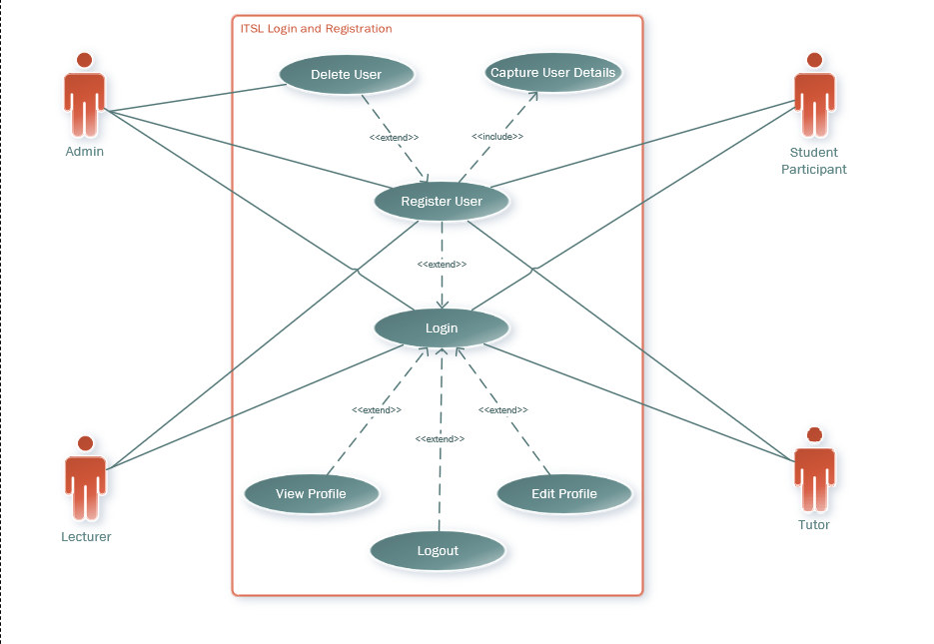
Brief Description
The Login functionality applies to all primary users of the system (Admin, Lecturer, Tutor and student participants) for them to log in and log out of the system
Step By Step of the Login Functionality
The user will first see the landing page on the ITSL Admin website, where they will be presented with the login textbox
The user will enter their credentials after being prompted to enter their username and password. The credentials will have to match the ones in the ITSL Admin system database
The identity database will authenticate their credentials and check their authorisation level for role-based access. If nothing is entered in one of the text boxes, the website will prompt the user not to leave the boxes empty.
Once both textboxes are filled, the website will check the user’s credentials against the ones stored in the identity database; if they match, the user will be granted access to the website according to their authorisation level.
If the credentials do not match, the user will not be granted access to the system. Instead, the system will display an error telling the user that the password or username is not matching.
They will have to register their new credentials if they don't have credentials. The user will enter a new username and password, and then once they are saved, they can use those to log in.
When the user is logged in they can see their role next to their name, and they can view their profile to see the details they have entered when they click on the profile icon.
The user can edit their profile in the View Profile when they click on the ‘Update Profile’ button.
When the user is done with their session, they can click on logout, to exit the website, and they will be redirected to the login page.
Best Case Scenario
- The user arrives on the landing page, and the login textbox loads properly without any delay or errors.
- The user enters valid credentials (username and password) and submits the form.
- The identity database authenticates the credentials instantly and determines the user's authorization level accurately.
- If any textbox is left empty, the system immediately prompts the user with a clear message to fill in all required fields.
- Upon successful login, the user is granted access to the system with permissions aligned to their authorization level. Their role is displayed next to their name.
- All profile functionalities, such as viewing and editing profile details, work seamlessly without errors.
- When logging out, the system redirects the user to the login page without delays or glitches.
Worst Case Scenario
- The login textbox fails to load on the landing page, preventing the user from entering their credentials.
- The system does not prompt the user when they leave a textbox empty, leading to confusion or errors.
- The credentials entered by the user are valid, but the identity database experiences technical issues, delaying or denying access.
- If the user enters incorrect credentials, the system fails to display a clear error message or does not offer a way to recover or reset credentials.
- Registration for new credentials fails due to system errors, leaving the user unable to create a new account.
- Profile-related functionalities (e.g., viewing or updating profile) experience glitches, leading to incorrect display or failure to save updates.
- The logout functionality fails, leaving the user logged in and unable to exit the system securely.
Alternative Scenario
- If the system experiences delays during authentication, a loading indicator could reassure the user that the process is ongoing.
- If the login attempt fails, the system provides a password recovery option (e.g., a "Forgot Password?" link), allowing the user to reset their credentials via email or SMS.
- During the registration process, if the user is unable to complete entering their credentials, the system saves partial data temporarily, enabling them to continue the process without starting over.
- If the user forgets their password and chooses not to reset it immediately, the system could offer guest access or limited functionality while they resolve their login issue.
- If the logout button fails, the system automatically logs the user out after a period of inactivity to maintain security.
- In scenarios where the user cannot edit their profile online, they could request manual updates by contacting ITSL Admin, which would reflect in the database after approval.
- If a user encounters errors or issues at any stage, an on-page assistant or chatbot could guide them through troubleshooting steps or redirect them to appropriate support channels.
- If the user's session times out or logs them out unexpectedly, the system could display an alert prompting them to re-enter their credentials and continue their session without losing unsaved changes.

Content Management System
Use Case Diagram
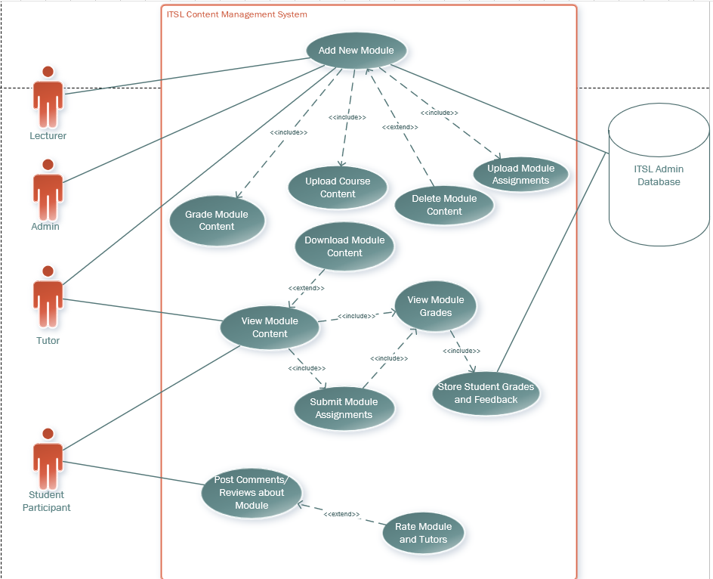
Brief Description
In the content management system, this is where mainly the lecturer, tutors and the admin can add content for the student participants. This is the main repository where all the content used by the ITSL Admin student participants is managed by the lecturer, tutors, and the admin. This is the heart of the ITSL Admin Website.
Step By Step
The lecturer, tutors, and the admin can add content for the student participants. The lecturer and the tutors will primarily perform this functionality, and the admin will only be called to add content under exceptional circumstances, in case the lecturer and tutor cannot.
The lecturer and tutor can upload content for the module, and those who can upload content can also grade the content for the module, delete the provided content, and update the content if needed. Since the participants must also be assessed, the lecturer, tutors, and the admin can upload assignments since they are part of the module content.
The tutor and student participants can view the content uploaded by the lecturer, and they can choose to download the content if they need to work on their devices. The student participants can submit their assignments in the content management system, and when they have been graded by the tutors and/or lecturer, they can view their grades for their assignments. The student participants grades will be able to view feedback from their assignments by the tutors and lecturer, and the feedback and grades will be stored in the ITSL Admin database, which manages all the data related to ITSL.
The student tutors can be able to post comments about the module they are doing, and they can voice how they feel about the content of the module, and this will be enabled by the post-comment feature. The student participants can review assignments, can voice what they found good, what they found challenging and what can be done to improve the module content and assignments.
The student participants can also rate the performance of the tutors who tutor them, so there’s a high standard of performance.
Best Case Scenario
- Jonah, the administrative user; Dr Robinson, the lecturer; and Thuto, the tutor, can all upload module content and assignments, which are successfully stored in the ITSL DB. The content can be retrieved as requested.
- Dr Robinson and Thuto send out a notification that can be viewed by everyone in the system who is registered in the system that the content for, in this case, the Excel module has been uploaded in the system.
- Dr Robinson and Thuto decide that the assignment in its current form is not up to standard, and Dr Robinson navigates to his modules tab, clicks on Excel and clicks on the delete button for the Excel assignment.
- Dr Robinson sees a prompt, ‘Are you sure you want to delete Excel Assignment 1 from Excel Module? Yes or No’, then Dr Robinson clicks on ‘Yes’, and the system shows a green pop-up that ‘Excel Assignment 1 has been deleted successfully from Excel Assignments’.
- Dr Robinson must now upload the new ‘Excel assignment 1’. He navigates to ‘Upload assignment’.
- Here, he sees a dialog box that has a small form; it has the text box ‘Assignment Instructions’, where he types out the instructions for the assignment, and another text box that is labelled ‘Due Date’, where he types the due date for the assignment.
- There is another textbox labelled ‘Browse’, which navigates to the file system of the device where ‘Excel assignment 1’ is located and then he clicks on open file.
- ‘Excel assignment 1.xlsx’ is now listed on the ‘Browse’ textbox to show that it is ready to be uploaded.
- Dr Robinson can now click on upload, and then the system shows a green pop-up button with the message ‘Excel Assignment 1 has been uploaded to Excel Assignments 1’.
- Dr Robinson sees that he made a mistake with the spelling of the title of the Excel Assignment 1, and also with one of the instructions listed for the assignment.
- He clicks on update assignment, and then the same dialog for upload pops up and now he can rectify the mistakes he made with the title and instructions and then he clicks on ‘Save’.
- Dr Robinson then sees a green pop up with the message ‘Excel assignment 1 has been updated successfully’.
- Lerato is a student participant who enrolled in ITSL because she knows the value of computer literacy.
- She logs in to the ITSL Administrative website and navigates to her modules tab, and she can immediately see her modules; she clicks on the Excel module, and she sees the newly uploaded content, and she can also see the Excel assignment that was recently uploaded.
- Lerato downloads the content that was made available so that she can study at home in her own time, she clicked on download content for this to happen.
- On the Excel assignment, Lerato can see the instructions given by Dr Robinson and the tutors, she can see the due date, and she can also see the submission link.
- Lerato writes her excel assignment to the best of her ability and when she is finished, she clicks on submit assignment.
- When Lerato clicks on submit assignment, she is taken to the device’s file system where she has her assignment stored. She clicks on the excel file ‘Lerato_assignment1.xlsx’ file.
- She then clicks on submit, and immediately she sees a purple dialog box with the message ‘Lerato_assignment1.xlsx has been successfully for Excel Assignment 1’.
- Lerato clicks on ‘Post Comment’ about the assignments she was given, she writes a review and explains that the assignment was good, it wasn’t too difficult, but also not too easy, she has gained a lot from doing this assignment and then clicks on post comment. These comments can be viewed by Dr Robinson and the tutors.
- Lerato also gives a rating out of 10 for the tutors of the Excel Module after every class, so that the tutors can see how they are being received by the student participants after the excel class.
- Dr Robinson, Thuto, and Jonah are all able to see that Lerato has submitted Excel Assignment 1 when they navigate to Excel Module Assignments. On the submissions tab they can see the name and the file of the student participants who submitted. Dr Robinson assigns Thuto to mark Lerato, while he assigns other tutors to mark other student participants.
- Thuto then navigates to Lerato, and sees Lerato’s name, and her file for Excel Assignment 1 labelled as ‘Lerato_assignment1.xlsx’. There’s an icon with the downward arrow (↓) for downloading the student files, Thuto clicks the arow and downloads Lerato’s excel assignment.
- Dr Robinson, Thuto and other tutors mark the student participants’ work. After marking Dr Robinson and Thuto click on ‘Grade Participant’ and then a dialog box appears, where you can add the student’s grade out of a specific total. Thuto enters Lerato’s grades, while Dr Robinson and other tutors do the same for other student participants.
- On the same dialog box that popped up for Grade Participants is a textbox labelled ‘Feedback’, where Dr Robinson, Thuto and other tutors can send the student participants feedback about their performance on assignment 1, and how they can improve going forward.
- Thuto clicks ‘Save’ on the Grade Participant dialog box and these are stored on the ITSL Admin Database for all the student participants.
- After Dr Robinson notified the student participants in class that their grades and feedback have been made available, Lerato navigates to her Excel Module and she navigates to the Excel Assignments tab where she sees her grades and the feedback for her performance in assignment 1, and who marked her assignment, in this case it was Thuto who marked Lerato.
Worst Case scenarios
- Jonah, Dr. Robinson, and Thuto try to upload module content and assignments, but the system repeatedly crashes, and the content fails to save in the ITSL DB. None of the content can be retrieved when requested.
- Dr. Robinson decides to delete the assignment because it's not up to standard, but the "Delete" button is unresponsive. He cannot proceed, and the system doesn't provide any error messages.
- When Dr. Robinson eventually manages to delete the assignment after multiple failed attempts, no confirmation prompt appears, and the wrong file is deleted without notice.
- Dr. Robinson tries to upload the new Excel Assignment 1, but the "Upload Assignment" page does not load, displaying a constant loading spinner.
- The dialog box for uploading assignments is incomplete, missing key fields like "Assignment Instructions" or "Due Date," making it impossible to submit the assignment correctly.
- The "Browse" button fails to connect to the device's file system, so Dr. Robinson cannot select the new Excel Assignment 1 file for upload.
- Even when a file is somehow selected for upload, clicking "Upload" triggers a system error, and no green pop-up is displayed. The assignment never appears in the system.
- After finally uploading the assignment, Dr. Robinson realizes errors in the title and instructions. However, the "Update Assignment" feature is disabled, preventing any corrections.
- Lerato logs in to the ITSL system but cannot access her modules due to a login failure or system error. She is stuck on the login page.
- If Lerato manages to log in, the modules fail to load, showing an empty page or an error message. The Excel module and its content are inaccessible.
- Lerato tries to download the available content, but the download fails repeatedly or retrieves corrupted files, making studying impossible.
- The Excel assignment lacks clear instructions, a due date, or a submission link, leaving Lerato confused about how to proceed.
- Lerato attempts to submit her assignment, but the "Submit Assignment" button is broken and does not respond.
- Even when Lerato accesses the file system and selects her file, clicking "Submit" triggers an error, and the submission fails. She receives no confirmation or feedback.
- Lerato tries to post a comment about the assignment but encounters an unresponsive or missing "Post Comment" button, preventing her from sharing her experience.
- Lerato cannot rate the tutors because the rating system crashes or does not display after her classes.
- Jonah, Dr. Robinson, and Thuto check the submission tab, but the submissions are not recorded in the system. They see blank entries with no student names or files listed.
- Dr. Robinson assigns Thuto to mark Lerato's assignment, but the system does not allow Thuto to download her file. The download arrow icon is unresponsive.
- Dr. Robinson, Thuto, and other tutors are unable to enter grades for student participants because the "Grade Participant" dialog box does not load.
- The feedback textbox for assignments is also missing, preventing tutors from providing any remarks or suggestions to students.
- Grades and feedback are not stored in the ITSL DB due to database connectivity issues, meaning student records remain incomplete.
- After being informed in class that grades are available, Lerato navigates to her Excel Assignments tab but cannot see her grades, feedback, or the name of the tutor who marked her assignment.
Alternative scenarios
- Jonah, Dr. Robinson, and Thuto upload module content and assignments, but the system has occasional glitches where uploads are delayed. The content is eventually stored in the ITSL DB, but retrieving it takes longer than expected.
- Dr. Robinson decides to delete the Excel assignment, but there is a lag before the "Delete" button becomes responsive. When clicked, the confirmation prompt appears as expected.
- Dr. Robinson clicks "Yes" to delete the assignment, but the green pop-up confirmation appears several seconds later, causing him to wonder if the action was successful.
- Dr. Robinson uploads the new "Excel Assignment 1," but the dialog box loads slowly. The form fields for assignment instructions, due date, and file selection work, but minor layout issues cause slight confusion.
- When entering the instructions and due date, the text boxes lag, delaying input. However, the data is ultimately saved correctly, and the file upload proceeds without issue.
- Dr. Robinson uploads "Excel Assignment 1.xlsx" successfully and receives a green pop-up message confirming the upload. However, the pop-up disappears too quickly for him to read fully.
- After noticing spelling mistakes in the assignment title and instructions, Dr. Robinson uses the "Update Assignment" feature. The dialog box for editing loads properly, but saving the updates takes a few attempts.
- Lerato logs in to the ITSL system smoothly, but navigating to her modules tab is slower than usual. She eventually accesses the Excel module and sees the updated content and the new Excel assignment.
- Lerato successfully downloads the Excel module content but reports that the download speed is inconsistent. The file is intact and usable for her studies.
- The Excel assignment displays its instructions, due date, and submission link correctly. However, some formatting inconsistencies in the instructions slightly reduce clarity.
- Lerato writes her assignment and clicks "Submit Assignment," but the system takes a few seconds to open her device’s file system. She selects "Lerato_assignment1.xlsx" and submits it successfully, seeing a purple confirmation dialog.
- Lerato tries to post a comment about the assignment, but the "Post Comment" button is slow to respond. Eventually, her comment is posted and visible to Dr. Robinson and Thuto.
- Lerato rates the tutors after her class, but the rating interface occasionally freezes. She manages to give a rating, though it takes more effort than it should.
- Jonah, Dr. Robinson, and Thuto navigate to the submissions tab and see the student submissions, but there are occasional delays in loading the list of names and files.
- Dr. Robinson assigns Thuto to mark Lerato's assignment. The download arrow icon works, but there is a slight lag before the file is available for download.
- Dr. Robinson, Thuto, and other tutors mark the assignments. However, the "Grade Participant" dialog box takes a few moments to load for each student, slowing down the grading process.
- In the "Grade Participant" dialog box, grades and feedback can be entered. Saving the data works but occasionally requires multiple clicks before confirmation.
- After Dr. Robinson informs students that grades and feedback are available, Lerato accesses her Excel Assignments tab. The grades and feedback are visible, but the feedback text appears truncated, requiring her to scroll excessively to read it all.

Student Chat
Use Case Diagram
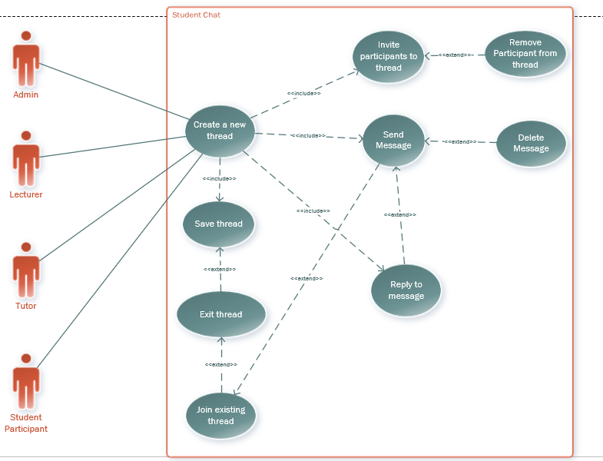
Brief Description
Student Chat is a way for all the registered users of different roles to communicate with each other in real-time within the system. If someone wants to communicate, they just open a thread and invite anyone they want to chat with, and the invited person can choose to respond. They can then carry on the conversation for as long as they wish, and they can even invite more participants to the chat. If someone joins the wrong chat or misbehaves in the chat, they can be removed from the chat by one of the participants in the chat. When a participant wants to exit the chat, they can join in later at another time. The participants can save the chat if they feel it is necessary to do so.
Step By Step
Registered users (Admin, Lecturer, Tutor and Student Participant) can open a thread anytime when logged in to the system.
Any active users at the time can be invited, and then the user can send a message and wait for a response from anyone invited.
As soon as any active user responds, the conversation at the time can carry on as long as someone keeps responding.
The creator of the thread can remove any of the participants they invited to chat if they ask to be removed, if they have been invited by mistake, or if they start misbehaving in the chat.
The users can save the chat if they think so and exit the thread if they no longer want to continue participating.
The users who were part of a thread that existed can come back to the conversation and continue the conversation later. Other users who were part of the thread can respond back, thus continuing the conversation again.
If the user types a message that they don’t like, they can delete the message in the chat.
Best Case Scenario
- Any registered user (Admin, Lecturer, Tutor, or Student Participant) can easily open a new thread at any time when logged in. The interface is intuitive, and the thread setup happens instantly.
- Active users can be invited seamlessly, and the invitation notifications are delivered without delay. Invited users can join the chat effortlessly.
- The conversation flows smoothly as invited participants actively engage, responding in a timely manner. Notifications alert users when new messages are posted, ensuring continuity.
- The thread creator can remove participants without issues. When a participant asks to be removed, the request is honoured promptly. Mistaken invites and misbehaving participants are efficiently managed.
- All users in the thread have the option to save the chat with a single click. Saved chats are stored securely and are easy to retrieve later.
- Users can exit the thread without impacting the ongoing conversation. Their departure is logged clearly, and the remaining participants can continue chatting uninterrupted.
- Users who were previously part of a thread can return later and resume the conversation without losing context. Messages sent during their absence are visible, and others can respond to their input.
- Users can delete messages they don't like quickly and easily. The system immediately updates the chat for all participants to reflect the changes.
Worst Case Scenario
- Registered users face challenges opening a new thread. The "Open Thread" button is unresponsive, and the system displays error messages or crashes frequently.
- Inviting active users to the thread is problematic. Notifications fail to deliver, or the invitees are unable to join due to technical errors.
- Conversations stall as messages are delayed or lost in the system. Notifications for new messages are unreliable, causing confusion and frustration.
- The thread creator cannot remove participants. Attempts to remove users are met with system errors, leaving the chat cluttered with unwanted participants.
- Saving chats does not work. Users are unable to store important conversations, and any chats saved are inaccessible or corrupted when retrieved later.
- Users trying to exit the thread encounter issues. The "Exit Thread" option is non-functional, and their profiles appear as active in the chat even after logging out.
- Participants attempting to rejoin an old thread find it missing or incomplete. Previous messages fail to load, and they cannot resume the conversation effectively.
- Users trying to delete their messages cannot do so. The "Delete" button is either missing or non-functional, leaving unwanted messages visible to all participants.
Alternative Scenario
- Registered users can open a new thread, but there are occasional delays during thread creation. The process completes successfully after a short wait.
- Inviting active users works, but some notifications are delayed, causing minor confusion. Invited participants eventually join without major issues.
- Conversations generally flow well, but sporadic message delays occur. Notifications for new messages are slightly inconsistent but functional enough to maintain engagement.
- The thread creator can remove participants, but the process is somewhat slow. For example, confirming a removal requires multiple clicks or a system refresh.
- Saving chats is possible, but the storage process occasionally fails if the system is under heavy load. Chats saved during these periods may be incomplete.
- Users can exit threads, but their departure status is not immediately reflected. Other participants may briefly assume they are still active in the thread.
- Returning to old threads is partially successful. Some previous messages load correctly, but others are missing, causing gaps in the conversation history.
- Users can delete messages, but the system takes a few seconds to register the deletion. Occasionally, the message remains visible until the user refreshes the page.

Quiz System
Use Case Diagrams
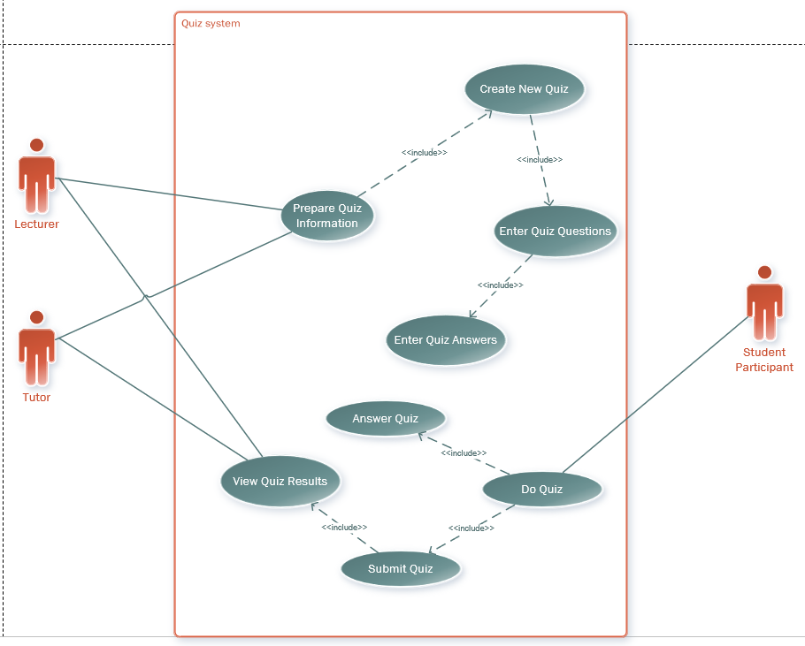
Brief Description
The quiz system works in conjunction with the content management system as it is part of the assessments for the student participants. The quiz system is designed to test the knowledge of the student participants quickly to see how well they are keeping up with the content being given to them before they can be tested thoroughly with assignments and tests. This functionality is mainly used by the lecturer, tutors and the student participants.
Step By Step
The lecturer, tutors and student participants are the main users of this functionality. The tutor or lecturer can set up a quiz for the student participants by clicking on ‘Prepare Quiz Information’.
From ‘Prepare Quiz Information’, the lecturer or tutor can click ‘Create New Quiz’. This will redirect the tutor or lecturer to the page where they called ‘Enter Quiz Questions’. Here, they can enter as many questions for their quizzes. When done, they can click ‘Save Questions’ to save the list of questions they want to include in the quiz.
After clicking ‘Save Questions’ the lecturer or tutor will be redirected to a page called ‘Quiz Answers’, where the answers will be mapped onto their corresponding questions. They can enter the same amount of answers as the available questions.
When they are satisfied with their answers, they can click on ‘Save Answers’ to save the answers to the quiz.
They can then look at the questions and answers, see if they map correctly, and make changes. The lecturer or tutor can set the due date if they wish and can set up how many attempts can be made for the quiz. Then click on ‘Save Quiz’ to save the quiz and make it available for the student participants to view and take the quiz.
The student participant will click on ‘Do Quiz’ to start their attempt at the quiz. They will answer all the quiz questions, and when they are done, the student participant will click on ‘Submit Quiz’. Immediately after submitting the quiz, the student participant is redirected to ‘View Quiz Result’ to view their quiz result. The lecturer and Tutors can also view this quiz result for all student participants.
This result will be saved to the ITSL Admin Database with the overall grades of the student participants.
Best Case Scenario
- The lecturer or tutor clicks on ‘Prepare Quiz Information’, and the page loads immediately without any issues. The ‘Create New Quiz’ button works seamlessly, redirecting them to the ‘Enter Quiz Questions’ page.
- The ‘Enter Quiz Questions’ page allows the lecturer or tutor to input as many questions as needed. The input interface is intuitive and user-friendly, with no delays or errors. Clicking ‘Save Questions’ successfully saves all questions.
- After saving the questions, the system redirects the lecturer or tutor to the ‘Quiz Answers’ page instantly. Answers are entered without any difficulty, and the correct number of answers maps automatically to the corresponding questions.
- Clicking ‘Save Answers’ works flawlessly, and the lecturer or tutor can review the questions and answers to ensure accuracy. Any corrections can be made quickly and efficiently.
- The lecturer or tutor sets a due date and specifies the number of attempts allowed for the quiz. Clicking ‘Save Quiz’ makes the quiz immediately available for all student participants.
- Student participants start their quiz smoothly by clicking ‘Do Quiz’. The questions load without issues, and students can navigate between questions easily.
- After completing the quiz, students click ‘Submit Quiz’, and the submission is processed instantly. They are immediately redirected to the ‘View Quiz Result’ page, where they see their scores and feedback, if applicable.
- Lecturers and tutors can view all quiz results for student participants in real-time, with the data stored accurately in the ITSL Admin Database. The system provides a clear and organized display of grades and participant details.
Worst Case Scenario
- When the lecturer or tutor clicks on ‘Prepare Quiz Information’, the page fails to load or shows an error message. The ‘Create New Quiz’ button is either unresponsive or crashes the system when clicked.
- On the ‘Enter Quiz Questions’ page, the system frequently crashes or lags, preventing the lecturer or tutor from entering questions properly. Clicking ‘Save Questions’ triggers an error, and the entered questions are lost.
- The ‘Quiz Answers’ page fails to load after saving questions. When it does load, the mapping between questions and answers is broken or incorrect. Some answers disappear, and the system does not allow for corrections.
- Clicking ‘Save Answers’ results in data loss, forcing the lecturer or tutor to re-enter answers repeatedly. The saved answers do not match the intended questions.
- The system does not allow the lecturer or tutor to set the due date or specify the number of attempts. Clicking ‘Save Quiz’ causes the system to freeze, and the quiz is not made available to student participants.
- Student participants encounter issues when clicking on ‘Do Quiz’. The questions fail to load, or the interface becomes unresponsive, making it impossible to start the quiz.
- After completing the quiz, the ‘Submit Quiz’ button does not work, leaving students unable to submit their responses. If submission succeeds, the students are not redirected to the ‘View Quiz Result’ page, and their results are not available.
- Lecturers and tutors cannot access quiz results due to database connectivity issues. The stored data is incomplete, showing incorrect grades or missing records entirely.
Alternative scenario
- The lecturer or tutor clicks on ‘Prepare Quiz Information’, and the page takes a few seconds to load. The ‘Create New Quiz’ button redirects them to the ‘Enter Quiz Questions’ page, but with a minor delay.
- On the ‘Enter Quiz Questions’ page, questions are entered successfully, but there are occasional lags while typing or saving. Clicking ‘Save Questions’ eventually works, but the process is slower than expected.
- The ‘Quiz Answers’ page loads with a slight delay. Most answers map correctly to their corresponding questions, but a few mismatches require manual adjustments. Clicking ‘Save Answers’ works, albeit with some lag.
- The lecturer or tutor reviews the questions and answers, but the interface for corrections is not as intuitive, requiring extra time to make changes. The due date and number of attempts can be set with minimal issues.
- Clicking ‘Save Quiz’ makes the quiz available, but some student participants report delays before the quiz becomes visible on their dashboard.
- Students can click on ‘Do Quiz’ and start their quiz, but navigating between questions occasionally lags. The overall experience is functional but not seamless.
- After completing the quiz, students click on ‘Submit Quiz’. The submission takes slightly longer to process, but they are eventually redirected to the ‘View Quiz Result’ page and can see their results.
- Lecturers and tutors can view quiz results for student participants, but the database occasionally takes longer to load the data. Some delays occur when viewing individual participant grades.

Donations
Use Case Diagram
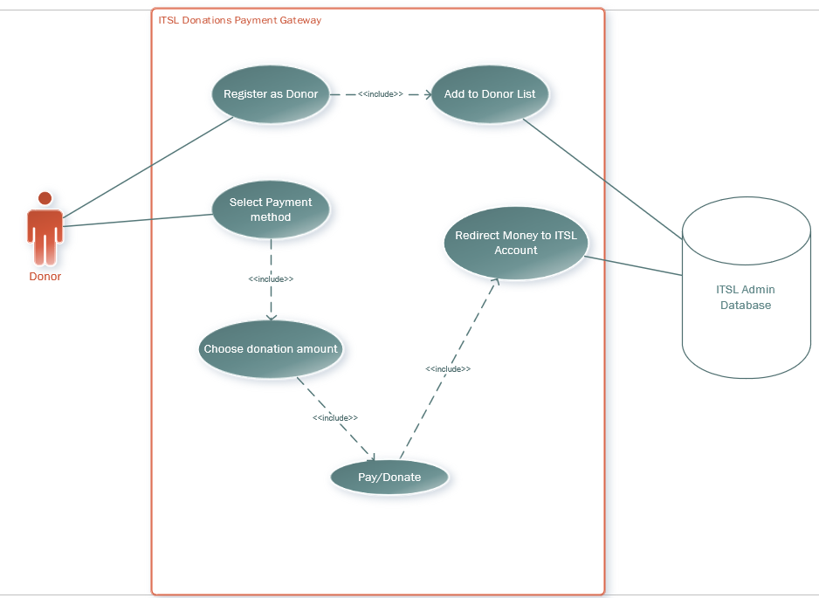
Brief Description
The donations functionality is made to allow individuals who are supportive of the mission of the ITSL initiative carried out by the University of the Free State to donate any sum of their money to support the cause of teaching computer literacy to disadvantaged communities.
Step By Step
Individuals who want to donate to the ITSL initiative will navigate to the donate to ITSL page.
From this page, the user, now known as the Donor, will be met with a form titled ‘Register as Donor’. On this page, the donor will register their details like name, surname, email, and cell phone numbers.
The Donor will click on ‘Save Donor Details’, and after clicking save, a green pop-up will appear with the message ‘Thank You for Registering as a Donor for the ITSL Initiative’.
Their details will be added to the ITSL Admin database and will be added to the record of past donors.
The Donor will then be redirected to the payment gate, where the donor will have to choose a payment method, either EFT or Credit or Debit Card.
After choosing a payment method, the donor will enter their card details like card number and CVC number if they are paying by card or simply view the ITSL Initiative's account details and go to their banking app to send an EFT.
The donor will select the amount they would like to pay and send the payment through. Then a green pop-up will appear with the message ‘Your Payment to ITSL has been successful, thank you for your contribution’.
The paid amount will be redirected to the ITSL account, and the payment will be recorded in the ITSL Admin database.
Best Case Scenario
- The donor navigates to the donation page and fills out the registration form without encountering any issues.
- The donor clicks "Save Donor Details," and the green confirmation pop-up appears promptly, ensuring a smooth experience.
- The donor's details are successfully added to the ITSL Admin database and recorded accurately among past donors.
- The donor selects their preferred payment method (EFT or Credit/Debit Card) and inputs the payment details accurately.
- For card payments, the payment is processed immediately with no errors. For EFT, the donor completes the transaction via their banking app without any delays.
- The green "Payment Successful" confirmation pop-up displays immediately after the transaction.
- The payment is successfully recorded in the ITSL Admin database without discrepancies.
Worst Case Scenario
- The donor encounters technical errors on the donation page, preventing them from accessing the form.
- The donor fills out the form but encounters an error after clicking "Save Donor Details," such as the page crashing or the green confirmation pop-up not appearing. As a result, their details are not added to the database.
- At the payment stage, the payment gateway fails to load, causing the donor to abandon the process.
- The donor selects EFT but cannot access the provided account details or encounters errors with their banking app, resulting in an incomplete payment.
- Card payments are declined due to incorrect details, insufficient funds, or payment gateway errors.
- Even after successful payment, the system fails to record the transaction in the ITSL Admin database, leading to reconciliation challenges.
Alternative Scenarios
- After the payment gateway times out or crashes, the donor is presented with an option to retry the transaction immediately without restarting the entire donation process.
- For donors who might be less comfortable with online forms, the page could offer contact details (email or phone) for the ITSL Initiative. These donors can then manually arrange their donation via direct bank transfers or other offline methods.
- Once the offline donation is completed, ITSL Admin staff could manually input the donor's details and payment records into the Admin database to ensure consistency with online donations.
- If donors experience consistent payment issues (e.g., card declined or EFT errors), the platform could redirect them to a support page. This page might include FAQs or contact details for quick assistance.
- Clear instructions or visual aids could guide donors step-by-step, and a help button could provide real-time assistance.
- If the donor is concerned about data security when entering personal or payment details, the system could prominently display its security measures (e.g., SSL encryption) and offer options like PayPal or third-party secure payment gateways.

Grades and Feedback
Use Case Diagram
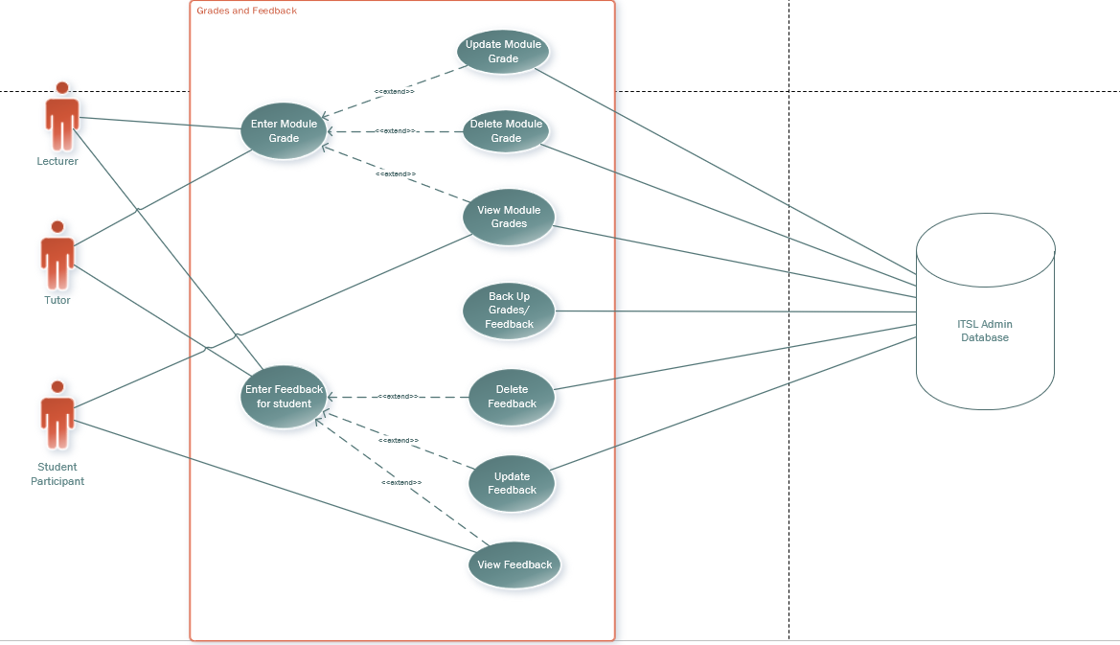

Brief Description
Grades and Feedback is a subsystem of the content management system. This system is responsible for the management of grades and performance of the student participants; it also records the feedback that the lecturer and the tutors give to their student participants.
Step By Step
The lecturer and tutors will navigate to the grade participant page, where they will see the work of the student participants. If they had an assignment, they would see the name of the participant and their submitted file next to their name.
The lecturer or tutor will click the download button to download the participant’s work onto their device for marking. After marking the participant's work, the lecturer or tutor will click on ‘Grade Participant’ and will grade the participant out of a specific total.
This grade can be updated if a participant requests a remark or the lecturer or tutor sees a mistake in their marking. Similarly, if an assignment is deemed invalid, the grades for that assignment can be deleted. All these actions can be recorded in the ITSL Admin database
After marking the student, the lecturer and tutor will navigate to ‘Feedback’ on the grade participant page to give the participant feedback on their performance, and it will also be recorded in the database.
The student can view their grades and feedback when they navigate to their modules, and click on the grades for that particular module. They will also see their feedback from who marked them, which would be either the lecturer or one of the tutors.
If it were a quiz, the lecturer and tutors would see the grade of the quiz already displayed since the system already marks the quiz.
Best Case Scenario
- Lecturers and tutors access the grade participant page without delays or technical glitches.
- All assignments are displayed correctly with participant names and their corresponding submitted files.
- The download button works seamlessly, allowing lecturers and tutors to download files without any issues.
- Lecturers and tutors grade participants’ work accurately and smoothly using the "Grade Participant" functionality, with grades recorded correctly in the ITSL Admin database.
- Feedback for participants is entered efficiently and stored without errors, enabling students to view it promptly.
- Any updates to grades (e.g., after a remark request) or deletions of invalid assignments are processed correctly and reflected accurately in the database.
- Students can view their grades and feedback without any errors or delays in their respective module sections.
- Quiz grades are displayed automatically and correctly, saving time for lecturers and tutors while ensuring accuracy.
Worst Case Scenario
- The grade participant page fails to load, preventing lecturers and tutors from accessing student submissions.
- Submitted files are not displayed properly, or download buttons are unresponsive, making it impossible to retrieve participants’ work.
- Grading functionalities experience errors, such as failing to save grades or mismatches between grades entered and those recorded in the database.
- Feedback is not saved correctly, leading to missing or incomplete feedback for participants.
- The system fails to process grade updates or deletions accurately, resulting in discrepancies in the ITSL Admin database.
- Students encounter issues accessing their grades and feedback, such as modules not displaying grades or feedback failing to load.
- Quiz grades are inaccurately displayed due to a malfunction in the automatic grading system, causing confusion for both students and staff.
Alternative Scenario
- If the grade participant page partially loads (e.g., only some student submissions are visible), lecturers and tutors receive a clear error message and an option to reload the page without losing progress.
- Download errors are mitigated with retry options, allowing lecturers and tutors to download files individually or in bulk.
- In cases of extended technical difficulties, the system allows export student submissions and a grading template. Lecturers and tutors can grade offline and re-upload the grades to the ITSL Admin database once the system is operational.
- If feedback functionality malfunctions, lecturers and tutors can temporarily email feedback to participants or upload feedback files directly to the system, which then updates the database.
- If a grade update conflicts with existing database entries (e.g., due to simultaneous access by multiple tutors), the system notifies the user and logs the conflict for review, ensuring that no grades are overwritten unintentionally.
- If feedback cannot be immediately displayed for students, the system generates a notification informing them of the delay and confirming that their feedback will be available shortly.
- In the event of automatic quiz grading issues, lecturers and tutors can manually review and adjust quiz grades to ensure accuracy before they are displayed to students.
- To enhance trust, participants could receive an automated notification whenever their grade or feedback is updated or deleted, providing transparency in the grading process.
- If a lecturer or tutor is disconnected while entering feedback, the system saves their input as a draft, allowing them to resume where they left off upon reconnecting.

Class Scheduling and Events
Use Case Diagram
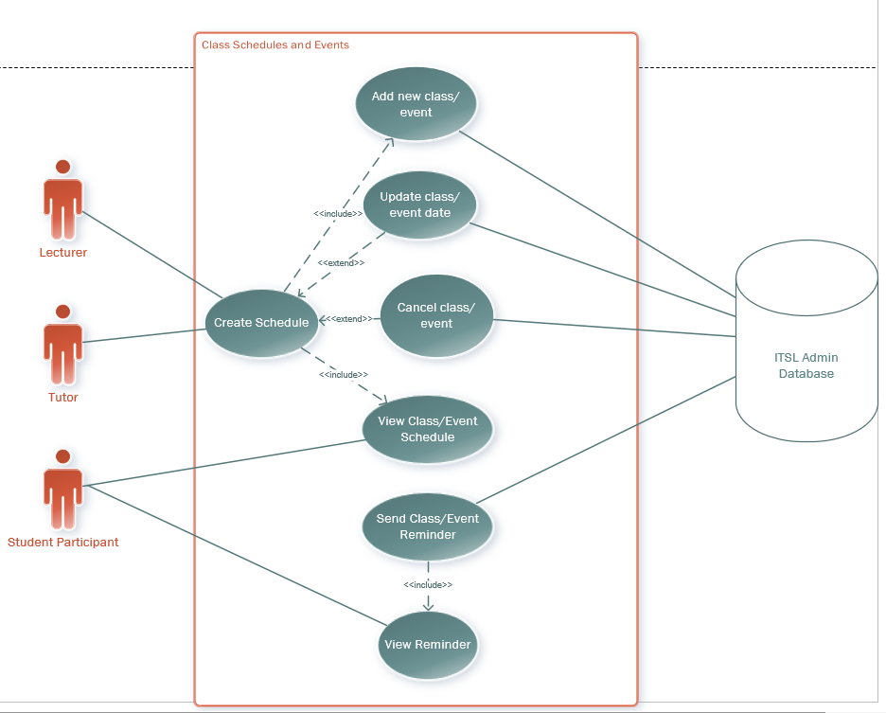
Brief Description
The class scheduling functionality allows the lecturer and tutors to schedule classes and other events related to any ITSL Initiative activity. We need this functionality because ITSL activities exist outside of the normal timetable of the UFS modules even though it’s part of the university’s activities, so a separate way of organizing classes and events for the module is needed.
Step By Step
The lecturer and the tutors are the ones who can create a schedule for a new event by clicking on ‘Create Schedule’, this will redirect them to the ‘Class and Events’ page where they will see ‘Add New Event’.
On this page, they will add the event or class details, such as the date and time of the class, the location of the class and who will oversee the class or event. Once done, they can click on ‘Save Class/Event’ to save the event, and this will be recorded in the ITSL admin database.
The class or event can be updated in case some details change if it is necessary by clicking on ‘Update Class/ Event Details’, and they can change whatever they want to and then click on ‘Save Class/Event’ and this update will be recorded in the ITSL admin database.
If something happens that gets in the way of a class or event, the lecturer or tutors, upon their discretion, can cancel the event by clicking on ‘Cancel Class/ Event’. A pop-up will appear asking the user, ‘Are you sure you want to cancel the event? Yes or No?’. Users can cancel the event or class if they click' Yes'. If they click ‘No’, the pop-up will close.
All registered users in the system can view the schedule of events and classes once they are created by clicking on ‘View Class/Event Schedule’ to view the calendar for the module.
The ITSL Admin database records the times when the event or class take place, and it will send reminders about the next event a few days before it happens.
The reminders can be viewed by all registered users when they click on ‘View Events’.
Best Case Scenario
- Lecturers and tutors can easily access the ‘Create Schedule’ option, and it redirects them smoothly to the ‘Class and Events’ page.
- The event or class details (date, time, location, and overseer) are entered accurately and saved successfully in the ITSL Admin database upon clicking ‘Save Class/Event’.
- Updates to class or event details are processed seamlessly, with all changes reflected immediately in the database after clicking ‘Update Class/Event Details’.
- If an event needs to be cancelled, the pop-up confirmation works as intended, allowing the user to confirm or cancel their decision without glitches.
- Registered users can view the schedule of events and classes without any errors by navigating to the ‘View Class/Event Schedule’ option.
- The ITSL Admin database sends timely reminders about upcoming events or classes to all registered users, ensuring they are informed in advance.
- Registered users can view reminders through the ‘View Events’ functionality without delays or issues.
Worst Case Scenario
- The ‘Create Schedule’ option is unresponsive, or the system fails to redirect to the ‘Class and Events’ page, leaving lecturers and tutors unable to add events.
- Errors occur while filling out the ‘Add New Event’ form, such as missing validation checks leading to incorrect or incomplete information being saved.
- Clicking ‘Save Class/Event’ fails to record the event in the ITSL Admin database, but the user is not notified, causing confusion.
- The ‘Update Class/Event Details’ button malfunctions, or changes are not saved, leading to discrepancies between what users see and what’s in the database.
- Notifications about updates fail to reach registered users, leaving them unaware of schedule changes.
- The ‘Cancel Class/Event’ confirmation pop-up does not display correctly or fails to close when users click ‘No’.
- A cancelled event is still visible in the schedule due to database synchronization issues, causing misinformation.
- Users trying to view the schedule encounter missing or outdated information due to errors in syncing with the ITSL Admin database.
- Notifications for upcoming events are sent too late, arrive multiple times, or fail to reach some users.
- The ITSL Admin database fails to generate reminders, leaving users unaware of upcoming events.
- Users clicking on ‘View Events’ cannot see relevant reminders or encounter display glitches.
Alternative Scenario
- During schedule creation, if the system crashes or a connection issue occurs, the system temporarily saves entered details as a draft. A message notifies users that they can resume the process later without losing progress.
- In cases of incomplete form submissions, the system highlights missing fields in real-time, ensuring the user knows what needs to be corrected.
- A downloadable scheduling template allows lecturers and tutors to plan events offline. This feature is helpful during maintenance periods or for unstable internet connections. Once uploaded, the system validates the file and syncs the events with the database.
- If the in-platform reminder system fails, registered users receive notifications via email or SMS with details about the upcoming class or event.
- If the ‘Cancel Class/Event’ pop-up fails, users can cancel events directly via the ITSL Admin portal by selecting events from a list and marking them as cancelled.
- A timeline or history tracker within the schedule allows registered users to view past, updated, or cancelled events, ensuring transparency. This feature includes details like who made the changes and when they were made.
- Users can customize reminder settings, choosing when (e.g., 1 day, 3 days, or 1 week prior).
- Dynamic reminders adjust automatically for rescheduled events, ensuring users stay updated with minimal manual intervention.
- If a schedule is updated, the system could flag the changes (e.g., highlight the new date/time in the calendar view) and send a follow-up notification to affected users for clarity.
- Lecturers and tutors could add notes or explanations when cancelling or updating an event, which would appear alongside the notification sent to users.
- Registered users accessing the schedule could have personalized views based on their roles. For instance:
- Students see only the events relevant to their registered modules.
- Tutors and lecturers see a comprehensive view of all events they oversee.

