Beam Bending Visualization

Ben Tan, Karan Bokil, Manish Khanna

University of Illinois, Urbana-Champaign

Abstract

During the design process of any object, one of the most important factors to take into consideration is the amount of force the object needs to withstand. For example, let’s consider a door handle which the majority of people have used. Some questions that might come up during the design process of a door handle might be how strong does one need to make the door handle, what material is needed, how thick should one design the door handle. We have created an interactive graphical tool that estimates the amount of stresses and displacement a material undergoes under different force conditions to help users answer these questions.

**Keywords**: Beam bending.

**Index Terms**:

# Introduction

Many objects can be approximated as a beam. A beam is a three dimensional object that has a length and identical cross section throughout its length. Examples of beam objects in our daily lives are spaghetti and 2X4 wall studs. For most analysis, the beam will have constraints such that it is in static equilibrium, in other words, the beam cannot move. For this reason, a force applied to the beam will not accelerate the beam but instead bending and stressing it. Different constraint methods on the beam will affect stress distribution and displacement of the beam. The magnitude, direction, location and distribution of force on the beam will also stress the beam differently. Different materials will have different properties that determine how much the material will bend as well as the maximum stress it can receive before breaking. Lastly, the beam geometry will have a great impact on how much force a beam can withstand. In the web-based analytical tool we developed, we have incorporated user interfaces to change many parameters that will affect the beam stress and deflection profile.

# Support Type

Simply supported beams are supported at both ends of the beam. On one end, the support will be “pin” type which allows the beam to pivot but not translate. On another end, the support will be a “roller-pin” type which allows the beam to pivot and move in the horizontal direction. Simply supported beams are completely supported vertically on both ends but able to rotate freely.

Cantilever beams are only supported completely on one end such that the supported part of the beam cannot move in any direction.

# Deflection

Deflection is the amount of the distance the beam has drift compared to its shape when there is no force applied.

### Deflection On Simply Supported Beam

On a simply supported beam, the maximum deflection occurred at a point somewhere around the center of the beam no matter where the force is located. This is to be expected because both ends of the beam cannot move up or down. When the force is applied right at the support point, the beam will not have any deflection. The beam will deflect the most when the force applied is right at the middle of the beam.

1. Deflection of simply supported beam

### Deflection On Cantilever Beam

On a cantilever beam, the maximum deflection is always at the free end of the beam. The closer the force is to the free end of the beam, the higher the deflection. If force is applied at the support location, then no deflection is observed.

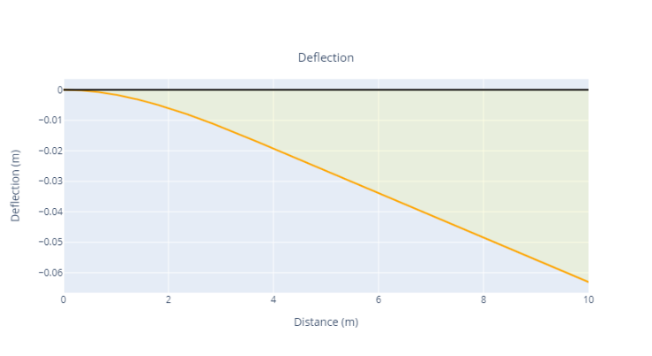

1. Deflection of simply cantilever beam

# Stresses

Shear stress is caused by the difference in location of force applied to the beam. In a cantilever beam, the beam experiences forces at two locations; one where the force is applied somewhere in the beam and the second where the beam is supported. These two forces are opposite of each other and will subject the beam to a shear stress. One example from daily life is tearing a paper in half. Essentially, a person is applying force in two different directions that induces shear stress which tears the paper.

Similarly, bending stress is also caused by forces acting on different points of the beam and different directions. In contrast to shear stress, bending stress is caused by rotation movement of the beam. Breaking spaghetti is an example of applying force which creates a bending stress in the spaghetti.

Von Mises stress is the total combination of shear and bending stress and can be used to determine if the beam can withstand the stresses without breaking. If Von Mises at any location on the beam exceed the beam’s ultimate strength; a material property, then the beam will break.

### Stress On Simply Supported Beam

On the other hand, maximum Von Mises stress on a cantilever beam is located at the fixed end of the beam.

On a simply supported beam, the maximum deflection occurred at a point somewhere around the center of the beam no matter where the force is located. This is to be expected because both ends of the beam cannot move up or down. When the force is applied right at the support point, the beam will not have any deflection. The beam will deflect the most when the force applied is right at the middle of the beam.

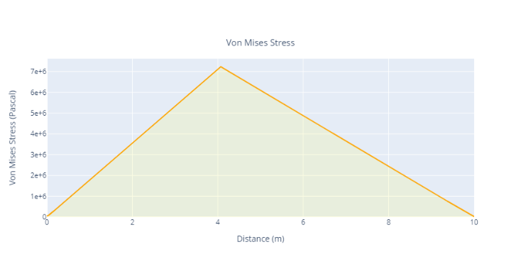

1. Von Mises Stress of simply supported beam

### Stress On Cantilever Beam

On the other hand, maximum Von Mises stress on a cantilever beam is located at the fixed end of the beam.

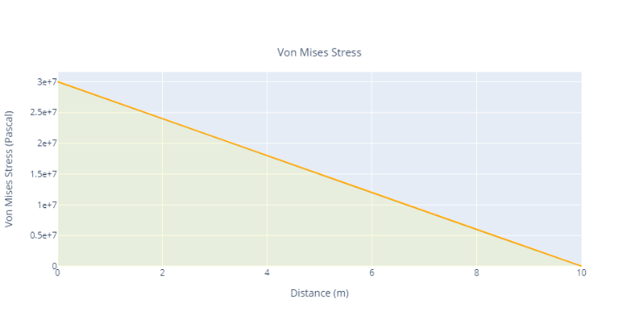

1. Von Mises Stress of cantilever beam

References

LEAVE 0.5 INCH SPACE AT BOTTOM OF LEFT COLUMN ON FIRST PAGE FOR COPYRIGHT BLOCK

1. J. Allebach. Binary display of images when spot size exceeds step size. *Applied Optics*, 15:2513–2519, August 1980. E. Catmull. A tutorial on compensation tables. In *Computer Graphics*, volume 13, pages 1–7. ACM SIGGRAPH, 1979.

* email address: btan90@gmail.com

1. Peter Litwinowicz and Lance Williams. Animating images with drawings. In Andrew Glassner, editor, *Proceedings of SIGGRAPH ’94* (Orlando, Florida, July 24–29, 1994),Com- puter Graphics Proceedings, Annual Conference Series, pages 409–412. ACM SIGGRAPH, ACM Press, July 1994.