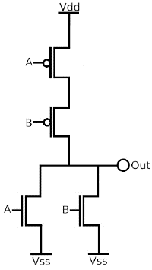

Write NOR gate Verilog module using CMOS switch devices and testbench to verify it.