ADVANCED DATABASE SYSTEMS
  - Project Summary
Selected Organization: SwiftRide Nigeria
GitHub Repository: https://github.com/bola2008-git/advanced-database-portfolio

1. Organization and Project Overview
SwiftRide Nigeria is a simulated ride-hailing organization covering passenger registration, driver and vehicle management, ride requests, payments, ratings, and driver-location tracking. The project designed and implemented a database solution to explore relational design, query optimization, transaction management, NoSQL data models, and distributed/cloud databases.
Microsoft SQL Server supported the relational component, while MongoDB and MongoDB Atlas were used for document-based and cloud database activities.
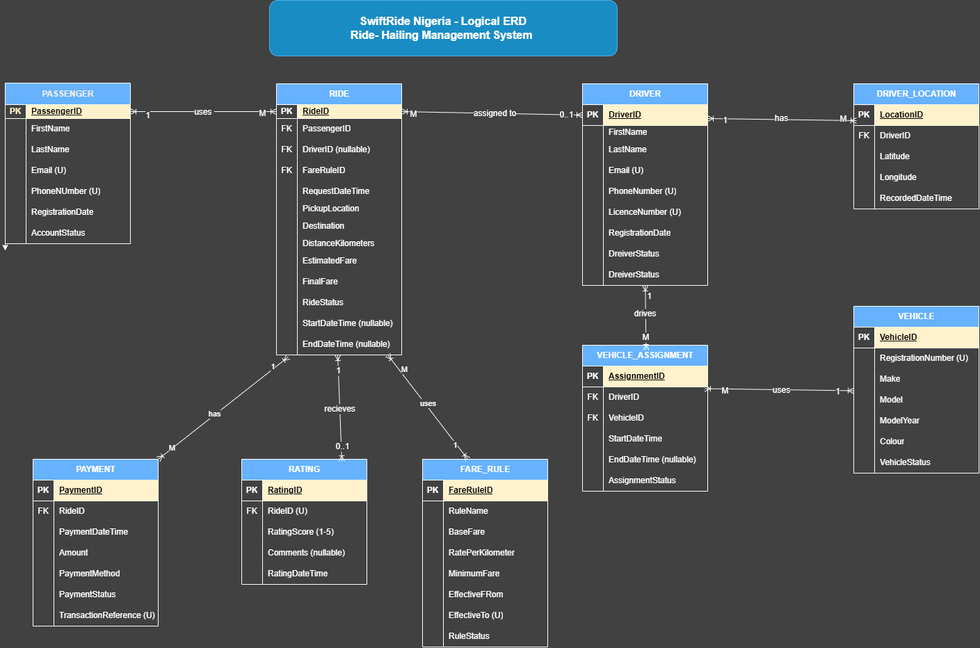
Figure 1. SwiftRide entity relationship diagram

2. Relational Database Design and Query Optimization
The SQL Server database contains PASSENGER, DRIVER, VEHICLE, VEHICLE_ASSIGNMENT, FARE_RULE, RIDE, PAYMENT, RATING, and DRIVER_LOCATION. Primary and foreign keys, relationships, and constraints support data integrity. RIDE stores request details, passenger/driver references, distance, fare, status, and timestamps; PAYMENT stores ride references, amounts, methods, statuses, and transaction references.
A passenger ride-history query was tested using passenger, completed-status, and date-range filters, ordered by request time. The execution plan showed an Index Seek and Key Lookup. Recorded results were:
Metric | Initial | Later
Logical reads | 14 | 3
CPU time | 32 ms | 15 ms
Elapsed time | 52 ms | 15 ms
The tested executions showed improved performance. Because the indexes existed before testing, the comparison does not isolate the benefit of creating them. A covering index was identified as a possible future optimization, subject to workload analysis.

3. Transactions, Concurrency and NoSQL Data Models
Transaction exercises covered atomicity, integrity, commit/rollback, isolation, and locking. A transaction was designed to update a ride and insert its payment together, with error handling and rollback to prevent partial changes. A rollback demonstration reversed an uncommitted update. READ COMMITTED and UPDLOCK were used to examine isolation and concurrent-update coordination; a full blocking demonstration would require two simultaneous sessions.
MongoDB documents modelled flexible driver-location and availability data. Practical tasks included inserting driver documents, querying available drivers, updating availability, creating a 2dsphere index, and running a geospatial proximity query. Document, key-value, column-family, and graph models were compared; only MongoDB was implemented practically.

4. Distributed and Cloud Database Implementation
The MongoDB work was extended to Atlas through cluster SwiftRideCluster, database SwiftRideCloud, and collection DriverLocations. A database ping verified connectivity; a test document was inserted, retrieved, and updated. A majority write concern update was followed by a majority read concern query, which returned the updated availability status.
Atlas displayed a three-node replica set, supporting discussion of primary/secondary members, replication, and automatic election/failover. No deliberate node-failure test was performed, so failover is described as a platform capability, not a tested result. Sharding was considered but not configured. The proposed hybrid design uses SQL Server for structured ride/payment transactions and MongoDB Atlas for flexible driver-location and availability documents.

5. Individual Reflection
The project strengthened my understanding of how database choices depend on business needs and workload. I gained practical experience in relational modelling, SQL queries, document modelling, geospatial indexing, and cloud deployment. Execution-plan review and performance measurements connected indexing concepts with query behaviour, while transaction exercises demonstrated the importance of integrity, atomicity, and concurrency control.
A key challenge was troubleshooting the MongoDB Atlas connection and distinguishing network, DNS, and configuration issues. The work reinforced the need to report implementation outcomes accurately: the three-node replica set was confirmed, but failover was not simulated and sharding was not implemented. Future work would include multi-session concurrency tests, broader query benchmarks, shard-key evaluation with realistic data, and monitoring, backup, and recovery evidence.

6. Screenshots and Practical Evidence
Supporting evidence includes: (1) relational ERD, schema, and constraints; (2) SQL query and execution plan; (3) query-performance comparison; (4) transaction commit/rollback; (5) concurrency and isolation; (6) MongoDB documents and geospatial query; (7) Atlas connection and ping; (8) majority write/read concern results; and (9) Atlas three-node replica-set overview.

7. References
- Microsoft. (n.d.). SQL Server documentation. https://learn.microsoft.com/sql/
- Microsoft. (n.d.). SQL Server index architecture and design guide; Display and save execution plans. Microsoft Learn.
- MongoDB. (n.d.). MongoDB Manual; MongoDB Atlas documentation; Replication; Read concern; Write concern; Sharding. https://www.mongodb.com/docs/
- Elmasri, R., & Navathe, S. B. (2016). Fundamentals of database systems (7th ed.). Pearson.
- Silberschatz, A., Korth, H. F., & Sudarshan, S. (2019). Database system concepts (7th ed.). McGraw-Hill.
- Gray, J., & Reuter, A. (1993). Transaction processing: Concepts and techniques. Morgan Kaufmann.
- Bernstein, P. A., Hadzilacos, V., & Goodman, N. (1987). Concurrency control and recovery in database systems. Addison-Wesley.
- Kleppmann, M. (2017). Designing data-intensive applications. O’Reilly Media.
- Brewer, E. A. (2012). CAP twelve years later: How the “rules” have changed. Computer, 45(2), 23–29. https://doi.org/10.1109/MC.2012.37.

8. AI-Use Declaration
OpenAI ChatGPT was used to support explanations, troubleshooting, organisation, and drafting of portfolio documentation. The database implementation, executed commands, observations, and practical evidence are based on my coursework activities. AI-assisted content was reviewed and adapted; technical claims and references will be checked before submission. This declaration should be amended as needed to comply with institutional AI-use policy and accurately reflect the assistance received.

