Unit testing is the simplest form of testing where we test individual scenarios separately.
The more cases we make to cover every single scenario that might happen inside our code or project the better our testing is.
Unit Testing is a concept where we test atomic or a single piece of code like a function for example. And we can use it in Java or JavaScript or any type of programming language or project just to check if our individual components are working correctly as separate pieces.
Whenever we test if a code throws some type of an exception we use the assertThrows() method.
Unit tests also ensure that whenever you make changes to your code, that code actually runs correctly. That will only happen if you have complete test scenarios that test every single piece of your code.
I used JUnit 5 framework for testing.
In this project there are 2 classes for main functions (SimpleCalculator , Grader) and 2 other classes for their tests ( SimpleCalculatorTest , GraderTest).
Whenever we indicate a function to be a test function we must let java know by adding “@Test” annotation.
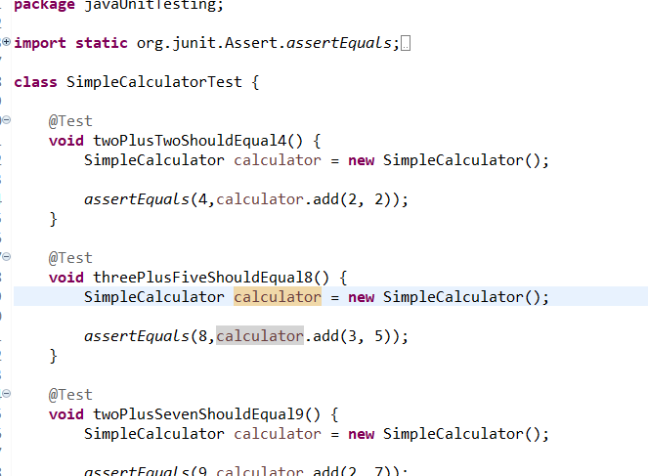

Each function corresponds to a specific test that appears in console.
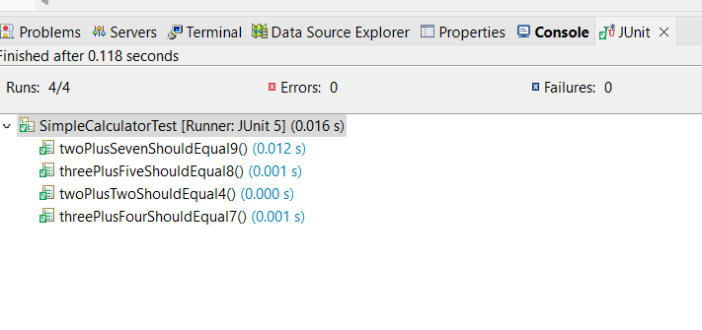
If a test fails, it shows a blue x instead of green on each test function.
There are different methods in java for testing whether it be (assertEquals, or assertNotEquals, or assertThrows).
The assertEquals function checks if it equals a specific value, assertNotEquals check if it does not return a specific value. The assertThrows function makes sure that a code will throw some error.

