Thursday, May 21, 2026
Version 1.0

Prepared by
Mr. Phuc, Mr. Minh, Mrs. Minh, Mr. Toan

BUSINESS REQUIREMENTS,
Prepared for Driver's License Training and Testing System
Revision History
Date | Version | Author | Change Description
01/03/2026 | 0.1 | Dang Phuc | Initial draft
08/03/2026 | 0.2 | Quang Minh | Scope updates
15/03/2026 | 0.3 | Dang Phuc | Requirements refinement
20/03/2026 | 0.4 | Quang Minh | Added user stories
28/03/2026 | 0.5 | Tri Minh | Architecture draft
05/04/2026 | 0.6 | Tri Minh | Updated diagrams
18/04/2026 | 0.7 | Nhat Toan | Content review and edits
25/04/2026 | 0.8 | Quang Minh | Final edits
01/05/2026 | 1.0 | Nhat Toan | Finalized document — released
Approval
Date | Version | Approver Name | Position
01/03/2026 | 0.1 | Dang Phuc | Application Owner
01/03/2026 | 0.1 | Quang Minh | ITPM
08/03/2026 | 0.2 | Dang Phuc | Application Owner
08/03/2026 | 0.2 | Quang Minh | ITPM
15/03/2026 | 0.3 | Dang Phuc | Application Owner
15/03/2026 | 0.3 | Quang Minh | ITPM
20/03/2026 | 0.3 | Quang Minh | ITPM
20/03/2026 | 0.4 | Dang Phuc | Application Owner
28/03/2026 | 0.5 | Tri Minh | Application Owner
28/03/2026 | 0.5 | Nhat Toan | ITPM
05/04/2026 | 0.6 | Tri Minh | Application Owner
05/04/2026 | 0.6 | Nhat Toan | ITPM
18/04/2026 | 0.7 | Nhat Toan | ITPM
18/04/2026 | 0.7 | Quang Minh | ITPM
25/04/2026 | 0.8 | Quang Minh | ITPM
25/04/2026 | 0.8 | Tri Minh | Application Owner
01/05/2026 | 1.0 | Nhat Toan | ITPM
01/05/2026 | 1.0 | Dang Phuc | Application Owner

Table of Contents
1. Objective and Scope 4
2. Business Requirement 4
2.1. Application Overview 4
2.2. Domain Model 5
2.2.1. Diagram 5
2.2.2. Domain Object Descriptions 5
2.3. Workflow 7
2.3.1. Usecases and Actors 7
2.3.1.1. Diagram 7
2.3.1.2. Description Actors 8
2.3.1.3. Description of Usecases 8

Objective and Scope
This document describes the business requirements for the Driver's License Training and Testing System. It provides a comprehensive overview of the application, the development scope of 7 core modules (including exam management, virtual practice assistant, and learning data analysis), and the training workflows requiring digitalization.
Together with the prototype, this document is used for requirement validation and requires formal approval from all stakeholders. Any business logic or user interface details not directly addressed in this document will be elaborated in future detailed system design specifications.

Business Requirement

Application Overview
The Driver's License Training and Examination System is a comprehensive online training and evaluation platform. The system enables training centers to manage the student learning lifecycle while providing students with an environment for theoretical review and realistic practical simulation.
Administrators (Admins) and Center Managers are responsible for managing user accounts, student profiles, and core data configurations. Admins specifically handle the creation of exam configurations for each license category (A1, A2, B1, B2, etc.), structuring question banks, and defining criteria for "fatal questions" (câu điểm liệt). Both roles collaborate to create and manage training course information and assign appropriate license categories to students.
Students can access the system based on their registered license category. The system offers a mock exam feature powered by an Execution Engine that automatically generates random test variants from the question bank, accompanied by a countdown timer and instantaneous grading. Students have the capability to track their personal progress, review exam history, reset learning progress when necessary, and review frequently missed questions through system-generated review sets.
The system provides a specialized feature called the 'Virtual Practice Assistant'. Through this feature, students can familiarize themselves with the closed-course driving test via an interactive 2D map (Practice track simulation) and practice on-road driving situations through audio command flows (Practice driving scenarios).
Instructors can access the system to view their assigned student rosters and monitor learning progress. Based on this data, Instructors or Admins can dispatch academic warnings and study reminders to students with unsatisfactory performance or slow progress.
Additionally, the system integrates a Learning Data Analytics engine operating autonomously in the background. By collecting historical test data and applying the Spaced Repetition System (SRS) algorithm, the system automatically evaluates individual weaknesses to generate targeted review question sets, assisting students in optimizing their learning paths and maximizing pass rates.

Domain Model

Diagram
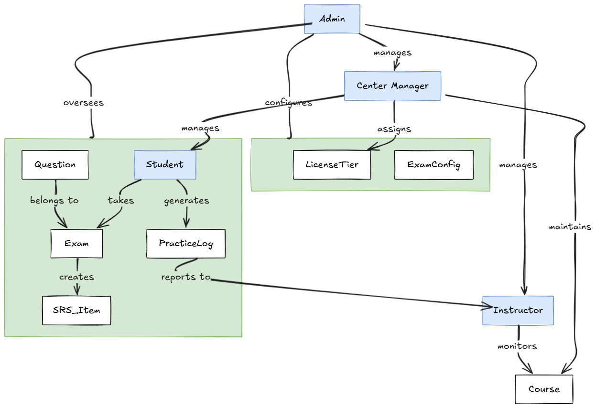

Domain Object Descriptions
# | Object Name | Object Description
1 | Admin | Users within this role possess system-wide administrative privileges, including managing accounts, configuring system rules, and overseeing student performance and warnings.
2 | Center manager | Users responsible for regional center operations, possessing privileges to manage student accounts, assign license categories, and maintain course information.
3 | Student | Users enrolled in specific license categories who can take exams, practice via simulations, and track their own progress.
4 | Instructor | Users authorized to monitor assigned student rosters, review exam histories, and dispatch academic warnings.
5 | Course | An entity containing information about driver training courses, including schedules, class details, and enrolled student rosters.
6 | License Tier | An entity defining driver's license categories (e.g., A1, B1, B2) used to structure training courses and exam rules.
7 | ExamConfig | An entity holding rules for exam generation, such as time limits, question counts, passing scores, and fatal question criteria.
8 | Question | An entity representing a single question in the bank, including content, options, and a fatal question flag.
9 | Exam | An entity representing a specific generated exam variant containing the set of questions assigned for a student's attempt.
10 | PracticeLog | An entity recording student performance during closed-course or on-road simulation sessions.
11 | SRS_Item | An entity storing incorrect answers with Spaced Repetition System metrics to generate targeted review recommendations.

Workflow

Usecases and Actors

Diagram
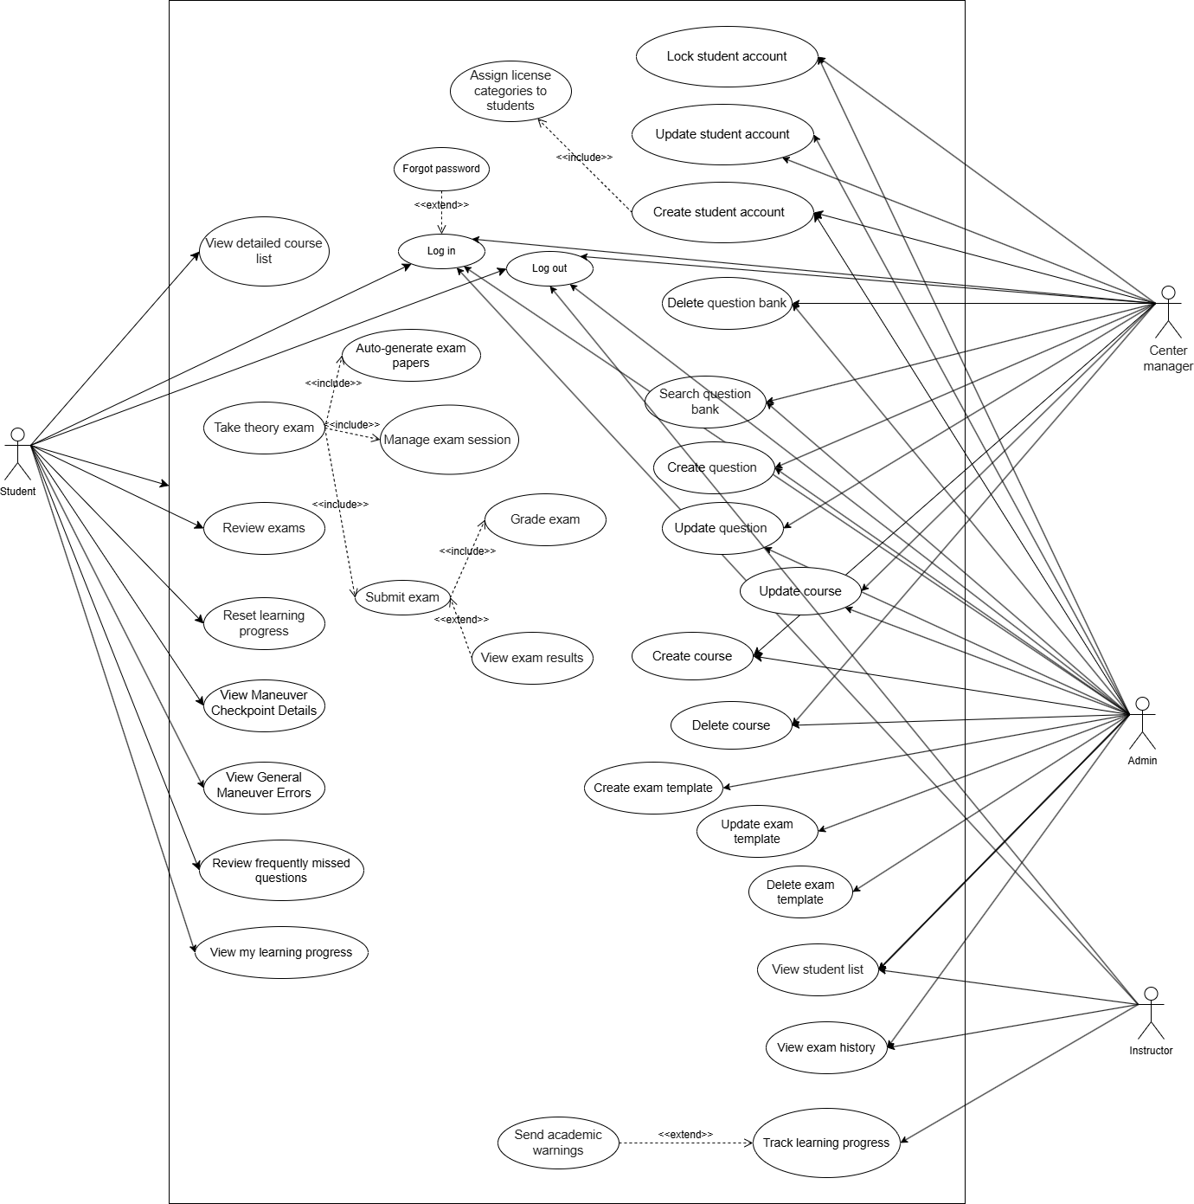

Description Actors

# | Actor Name | Definition
1 | Admin | System-wide administrator responsible for configuration, core data maintenance, and high-level monitoring of student history and warnings.
2 | Center manager | A management role focused on student account lifecycles, license category assignments, and course management within a center.
3 | Instructor | Users assigned to oversee specific courses, monitor student progress, review exam histories, and send academic warnings.
4 | Student | Users enrolled in training to take theoretical exams, practice in virtual simulation environments, and track personal learning progress.

Description of Usecases
# | Tên Usecase | Definition
1 | Log in | This usecase describes the process of a user logging into the system using their account and password to access features.
2 | Forgot password | This usecase describes the process of a user requesting a password reset via email or another authentication method when they forget their password.
3 | Create student account | This usecase describes the process of admins or center managers creating a new student account in the system.
4 | Update student account | This usecase describes the process of admins or center managers updating an existing student account in the system.
5 | Lock student account | This usecase describes the process of admins or center managers locking an inactive or invalid student account in the system.
6 | Assign license categories to students | This usecase describes the process of admins or center managers setting the license category a student will study when creating or updating an account.
7 | View detailed course list | This usecase describes the process of a user viewing the detailed list of available courses in the system.
8 | Create course | This usecase describes the process of admins or center managers creating a new course in the system.
9 | Update course | This usecase describes the process of admins or center managers updating an existing course in the system.
10 | Delete course | This usecase describes the process of admins or center managers deleting an existing course from the system.
11 | Take theory exam | This usecase describes the process of a student taking a theoretical exam on the system.
12 | Manage exam session | This usecase describes how the system supports in-exam features such as bookmarking questions, auto-saving answers, and displaying a countdown timer.
13 | Submit exam | This usecase describes the process of a student completing and submitting the exam to the system.
14 | Grade exam | This usecase describes the system automatically grading the exam based on the answer key and fatal question rules.
15 | View exam results | This usecase describes the process of a student viewing their results after completing an exam.
16 | Review exams | This usecase describes the process of a student reviewing the exams they have previously taken.
17 | Search question bank | This usecase describes the process of admins or center managers searching and filtering questions in the system.
18 | Create question | This usecase describes the process of admins or center managers creating a new question in the question bank.
19 | Update question | This usecase describes the process of admins or center managers updating an existing question in the question bank.
20 | Delete question | This usecase describes the process of admins or center managers deleting a question from the question bank.
21 | Create exam template | This usecase describes the process of an admin creating a new exam template with structure, number of questions, question types, and related rules.
22 | Update exam template | This usecase describes the process of an admin updating an existing exam template configuration.
23 | Delete exam template | This usecase describes the process of an admin deleting an unused exam template from the system.
24 | Auto-generate exam papers | This usecase describes the system automatically generating an exam based on the established configuration.
25 | View student list | This usecase describes the process of an instructor or admin viewing the list of students in the system.
26 | Track learning progress | This usecase describes the process of an instructor or admin tracking the learning progress and exam results of students.
27 | View exam history | This usecase describes the process of an instructor or admin reviewing a student's exam history, including information such as exam time, exam type, score, and pass/fail result.
28 | Reset learning progress | This usecase describes the process of a student resetting their learning progress when necessary.
29 | Send academic warnings | This usecase describes the process of an instructor or admin sending warnings to students when the system detects slow learning progress, low exam scores, or incomplete learning requirements.
30 | View Maneuver Checkpoint Details | This usecase describes the process of a student or instructor viewing detailed information about specific checkpoints in a maneuver test, including passing criteria and common technical requirements for each stage.
31 | View General Maneuver Errors | This usecase describes the process of a user viewing a list of general errors in maneuver practice, such as stalling the engine, crossing lines, or exceeding time limits, along with the corresponding point deductions.
32 | Review frequently missed questions | Review frequently missed questions | This usecase describes the process of a student taking review tests generated by the system based on questions or question types they frequently answered incorrectly in previous exams.
33 | Log out | This usecase describes the process of terminating an authenticated session, invalidating the server-side JWT, and clearing client-side state.
34 | View my learning progress | This usecase describes a student viewing their progress, including theory completion, pass rates, and weak topic analysis via cached data.

Security Matrix
Function | Admin | Student | Instructor | Center Manager
Login | x | x | x | x
Forgot Password | x | x | x | x
Create Student Account | x |  |  | x
Update Student Account | x |  |  | x
Lock Student Account | x |  |  | x
Assign License Categories To Students | x |  |  | x
View Detailed Course List | x | x | x | x
Create Course | x |  |  | x
Update Course | x |  |  | x
Delete Course | x |  |  | x
Take Theory Exam |  | x
Manage Exam Session |  | x
Submit Exam |  | x
Grade Exam | x
View Exam Results |  | x
Review Exams |  | x
Search Question Bank | x |  |  | x
Create Question | x |  |  | x
Update Question | x |  |  | x
Delete Question | x |  |  | x
Create Exam Template | x
Update Exam Template | x
Delete Exam Template | X
Auto-generate Exam Papers | X
View Student List | x |  | x
Track Learning Progress | x |  | x
View Exam History | x |  | X
Reset Learning Progress |  | x
Send Academic Warnings | x |  | X
View Maneuver Checkpoint Details |  | x
View General Maneuver Errors |  | x
Review Frequently Missed Questions |  | x
Logout | x | x | x | x
View my learning progress |  | x

User Story
Link User story: USER_STORY

Change Requirement
# | Item Name | Change Description

Appendix

Glossary
Term | Description
BRD | Business Requirements Document

Open Issues

User stories và security matrix:
https://docs.google.com/spreadsheets/d/19FY_iFS8SfuRvKvSX3tXmlPLBOsrmfJn_HXcPmnDXdc/edit?usp=sharing

