DRIVEMATE
Software Architecture Document

1. Solution Overview

1.1 Goals of the Solution
DriveMate is a comprehensive digital platform for driving license exam preparation in Vietnam. The system provides learners, instructors, and driving centers with an integrated, exam-accurate, and mobile-first environment that covers all aspects of the licensing process.
- Provide students with a realistic, rules-accurate exam simulation environment covering all Vietnamese driving license tiers (A1, A2, B1, B2, C, and others added by Admin as data, without code deployment).
- Enforce server-authoritative exam logic so that exam scores, timers, fatal-question outcomes, and answer correctness cannot be manipulated client-side. All grading runs exclusively on the backend; correct answers never appear in any API response.
- Support data-driven configuration — passing scores, question counts per topic, time limits, fatal-question criteria, and license tier definitions are all stored as configuration data in PostgreSQL and Consul KV. Admins modify them through the Admin UI without code deployment, build, or service restart.
- Deliver a 2D driving-practice simulation with data-driven map rendering and color-coded error alerts (red for fatal errors, yellow for point deductions) mapped to traffic-law specifications.
- Enable intelligent learning through a Spaced Repetition System that surfaces the most relevant weak-spot questions for each student, computed against pre-aggregated analytics data rather than real-time log queries.
- Empower Center Managers and Instructors with real-time student progress dashboards, exam history reporting, course management, and asynchronous academic-warning notifications.
- Guarantee an availability target of >= 99.9% uptime and horizontal scalability to handle thousands of concurrent exam sessions during peak licensing seasons via Kubernetes Horizontal Pod Autoscaling on stateless NestJS microservices.

1.2 System Scope

In-Scope
- Identity & Authentication: Registration, login, logout, password reset — delegated to Keycloak 24.0. JWT issued by Keycloak; revocation via Redis blacklist in identity-service. RBAC roles: Student, Instructor, Center Manager, Admin.
- Exam Module: Randomized exam generation from indexed question pools, server-authoritative timer, idempotent auto-save every 5–10 seconds with React Native local storage offline sync, atomic submission within a single PostgreSQL transaction, immutable COMPLETED results, fatal-question short-circuit grading.
- Question Bank Management: Full CRUD with soft-delete (questions with exam history are never hard-deleted), version history (every edit creates a new immutable version record), full-text search on PostgreSQL. Question images stored in Azure Blob Storage via media-service.
- Exam Configuration: Data-driven ExamConfig per license tier with snapshot pattern — the active configuration at exam-generation time is captured into the ExamSession record as a JSONB column, protecting in-progress sessions from subsequent admin changes.
- Course & Learning Content: Course CRUD with in-memory CacheManager (NestJS MemoryStore, TTL 5–10 minutes per service instance — no shared Redis cache), license-tier scoping, soft-delete on archival with audit-preserved enrolment history.
- Driving Practice Simulation: 2D road-map rendering from runtime-loadable JSON configs (no app release required for new maps), color-coded error alerts (Red = fatal, Yellow = deduction) mapped to traffic-law specifications.
- Learning Analytics & SRS: Pre-aggregated progress statistics in a dedicated analytics_db table (refreshed by scheduled aggregation job; never computed on raw log tables in real time), Spaced Repetition Algorithm running in-process with bounded recent exam history.
- Notification Service: Asynchronous email/push notification delivery via RabbitMQ. Failed deliveries route to a Dead Letter Queue after retry exhaustion.
- Admin & Center Management: Student account CRUD, license tier assignment with audit log, academic warning dispatch, system-wide ExamConfig and Question Bank management.
- Mobile App (React Native): All student-facing features — exam taking, driving practice, progress tracking, course viewing, offline mode.
- Admin Web (ReactJS): All management features — student management, question bank, course management, exam configuration, dashboards.

Out-of-Scope
- Real-world physical driving lessons or in-vehicle training — the system simulates scenarios only.
- Direct integration with the official Vietnamese DMV (GPLX) examination system.
- Online payment processing or subscription billing for student enrolment.
- Live video streaming, instructor-to-student real-time video calls, or screen sharing.
- Multi-language UI beyond English and Vietnamese (initial release).

1.3 Key Stakeholders
Stakeholder | Role & Interest
Student | Primary end-user. Studies theory, takes practice exams, runs driving simulations, tracks personal progress.
Instructor | Monitors assigned students’ progress, reviews exam histories, sends academic warnings, supports practice sessions.
Center Manager | Manages a driving training center. Creates student/instructor accounts, configures courses, oversees center-level reporting.
Admin | System-wide administrator. Manages question bank, exam configurations, license tiers, all user accounts, and global reports.
DevOps / SRE | Operates the production Kubernetes environment, manages observability stack (ELK + Prometheus), responds to alerts.
Product Owner / Sponsor | Defines requirements, prioritises features, accepts deliverables.
Architecture Reviewer | Validates that the implemented system satisfies all 41 ASRs and design constraints documented in the ADD.

1.4 Business & Technical Context

Business Context
DriveMate operates in the Vietnamese driving license preparation market. Demand is highly seasonal, concentrating around end-of-semester examination windows when thousands of students take practice exams concurrently. The system must therefore satisfy two competing pressures: (a) scale elastically during peak windows without manual intervention, and (b) maintain exam integrity — exam results must be fair, tamper-resistant, and legally defensible because they form part of the official training record that students rely on for the real DMV examination.
These two pressures shape almost every architectural decision in this document. Elasticity drives the choice of stateless microservices on Kubernetes with HPA. Integrity drives the choice of server-authoritative grading, immutable COMPLETED results, atomic submission transactions, soft-delete with question versioning, and the ExamConfig snapshot pattern.

Technical Context
DriveMate is composed of two client applications and ten backend components, kong and keycloak, all communicating through a single API Gateway boundary.
External actors (Student via React Native mobile app; Admin/Manager/Instructor via ReactJS admin web) enter the system exclusively through the Kong API Gateway. Kong terminates client connections, validates JWTs issued by Keycloak, and routes authorised requests to the appropriate NestJS microservice. The twelve backend components are:
- Kong API Gateway — single ingress, JWT validation, RBAC enforcement, rate limiting.
- Keycloak 24.0 — identity provider, JWT issuance, RBAC realm management, brute-force protection.
- identity-service — NestJS wrapper for Keycloak admin API, token blacklist management.
- user-service — user profiles, license tier assignment, account lifecycle.
- exam-service — exam templates, sessions, atomic scoring, config snapshots.
- question-service — question bank CRUD with soft-delete and versioning.
- course-service — courses, enrolments, lesson progress.
- simulation-service — driving-practice FSM, scenario management.
- analytics-service — pre-aggregated progress statistics, SRS algorithm.
- notification-service — async email/push delivery via RabbitMQ.
- media-service — file metadata + Azure Blob Storage integration.
- docs-service — centralised Swagger UI aggregation.
All NestJS microservices read runtime configuration from Consul KV, ship logs to the ELK stack via Winston HTTP transport, and expose metrics scraped by Prometheus. The cloud provider is currently TBD but the design assumes an Azure-leaning deployment (Azure Blob Storage is already committed; managed PostgreSQL and Redis would map to Azure Database for PostgreSQL and Azure Cache for Redis if Azure is selected).

2. Technology Stack
The following table presents all core technologies used in DriveMate, their roles, and the rationale behind their selection. The stack is intentionally homogeneous on the backend (NestJS everywhere) to favour operational simplicity, shared tooling, and a single CI/CD pipeline over the potential performance gains of a polyglot backend.
Technology | Role in System | Primary Rationale
NestJS 11 (Node.js / TypeScript) | All backend microservices (12 components) | Modular DI architecture, OpenAPI auto-generation from decorators, mature Keycloak guard ecosystem, TypeScript strict-mode safety; stateless services scale freely under K8s HPA.
ReactJS (TypeScript) | Admin Web frontend | Component-based UI used by Admin, Center Manager, and Instructor roles. All API access flows through Kong.
React Native (TypeScript) | Student Mobile App | Cross-platform iOS/Android from a single codebase; supports offline answer buffering via device local storage and audio preload for driving-practice sessions.
PostgreSQL 15 | Primary transactional store (9 isolated databases, one per service) | ACID compliance for atomic exam submission, row-level locking for race-condition safety, JSONB for ExamConfig snapshots, full-text search for question bank, native composite indexing for sub-500 ms searches at 10,000+ records. Database-per-service pattern eliminates cross-service coupling at the data layer.
Redis 7 | JWT token blacklist (identity-service only) | Sub-millisecond O(1) GET for blacklist lookup performed by TokenBlacklistGuard on every authenticated request; native TTL eviction matches token remaining lifetime; no business-data caching uses Redis in this architecture.
RabbitMQ 3 | Asynchronous message broker (durable queues, noAck=false) | Reliable async delivery with Dead Letter Queue for notification dispatch and inter-service event propagation (identity.user.created, exam.submitted, etc.). Decouples non-critical workflows from the synchronous request path.
Kong (declarative DB-less mode) | API Gateway — single ingress | Stateless, configuration-driven routing (kong.yaml / kong.dev.yaml), built-in plugins for rate limiting and JWT validation, horizontally scalable behind Nginx Ingress, no separate gateway database to operate.
Keycloak 24.0 | Identity Provider — authentication, RBAC, SSO, brute-force lockout, password reset | Industry-standard OIDC provider; built-in features (brute-force detection, single-use reset tokens with TTL, session revocation API, realm management) replace large amounts of custom auth code; reduces SEC-01 / SEC-02 implementation surface area.
Consul 1.19 | Per-service runtime configuration via KV store | Centralised config with namespacing per service, supports hot-reload through ConsulConfigFactory in @repo/common; configuration priority: env vars > Consul KV > application defaults. Decouples deployment from configuration changes.
Prisma v7 + @prisma/adapter-pg | ORM with custom client output per service (e.g. @prisma/exam-client) | Type-safe queries; isolated generated client per service enforces the database-per-service boundary at compile time — exam-service literally cannot import question-service’s models. Migration tooling included.
Turborepo + @repo/common shared library | Monorepo build system + DDD base classes, ConsulConfigFactory, AppLoggerModule, ApiResponseInterceptor, DomainExceptionFilter | Single source of truth for cross-cutting concerns (logging, config, error shape, response envelope); incremental builds across all 10 NestJS services; shared library eliminates copy-paste of guard/interceptor logic.
Docker + Kubernetes (HPA) | Containerisation & orchestration | Stateless microservices scale independently; HPA handles peak exam traffic on CPU/RPS thresholds; rolling-update deployments with zero downtime. Dev stack uses Docker Compose for local development.
Azure Blob Storage | Object storage for question images, road-map JSON configs | Durable, cost-effective storage; CDN-ready; map JSON configs are hot-loaded by simulation-service at runtime without an app rebuild (ASR-MOD-03). Access via media-service which holds only metadata in PostgreSQL.
Winston → Logstash → Elasticsearch → Kibana (ELK Stack) | Centralised logging — all 10 NestJS services ship structured logs via Winston HTTP transport; Kong and Keycloak ship their native log formats to the same ELK stack via Filebeat sidecars | Aggregated log search and visualisation across all components; structured JSON logs enable cross-service trace correlation; AppLoggerModule in @repo/common provides a consistent logger interface for NestJS services.
Prometheus + Grafana + Alertmanager | Metrics scraping, dashboards, proactive alerting | Pull-based metrics from every NestJS service; Grafana dashboards for P95 latency, error rate, queue depth, DLQ depth, HPA scaling events; Alertmanager fires on health-check failures and SLA breaches.
Biome + TypeScript strict mode | Code quality enforcement (lint + format) | Single tool replaces ESLint + Prettier with faster CI runtime; strict mode catches null-safety and type errors at build time.
OpenAPI / Swagger (per service, aggregated by docs-service) | API documentation | Auto-generated from NestJS decorators; single source of truth for all REST contracts; docs-service exposes a unified Swagger UI across all services.
The use of NestJS across all backend services (rather than a polyglot backend) is a deliberate trade-off: operational simplicity, shared tooling, a unified observability story, and a single CI/CD pipeline outweigh the potential performance gains of mixing runtimes for this class of application. Where CPU-bound operations could become a bottleneck (password hashing in identity-service via Keycloak, exam generation in exam-service), the affected service is sized for independent HPA scaling rather than rewritten in a different runtime.

3. Overall Architecture

3.1 Architecture Model
Microservices Architecture with Database-per-Service Pattern:
Each bounded domain (Identity, User, Exam, Question Bank, Course, Driving Practice, Analytics, Notification, Media, Documentation) is encapsulated in an independent NestJS service, deployed as its own Kubernetes Deployment. Services are stateless and own their own PostgreSQL database with no cross-service foreign keys — inter-service references are by UUID only. Eventual consistency is maintained via domain events published through RabbitMQ.
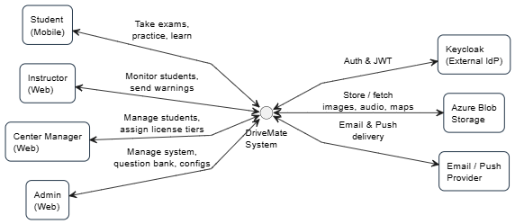
Figure 3.1: DriveMate Context Diagram
Communication patterns:
- Synchronous (REST/HTTP) — for user-facing, latency-sensitive calls routed through Kong API Gateway and for inter-service calls where an immediate response is required.
- Asynchronous (RabbitMQ with DLQ) — for notifications, cross-service event propagation (identity.user.created, exam.submitted), and any workflow that must not block the synchronous request path.
Cross-cutting infrastructure:
- Kong API Gateway — single entry point; enforces TLS termination at the Ingress boundary, JWT validation, RBAC routing, and rate limiting before any request reaches a downstream microservice.
- Keycloak 24.0 — identity provider for authentication, token issuance, session management, brute-force lockout, and password-reset flows. All identity logic is delegated to Keycloak rather than implemented in application code.
- Consul KV — centralised configuration store. Every microservice loads its runtime configuration from Consul on startup with the priority order: environment variables > Consul KV > application defaults.
- ELK Stack (Winston → Logstash → Elasticsearch → Kibana) — structured-log aggregation. The 10 NestJS services ship logs via Winston HTTP transport through the shared AppLoggerModule from @repo/common; Kong and Keycloak ship their native log formats via Filebeat sidecars to the same ELK stack.
- Prometheus + Grafana + Alertmanager — metrics scraping, dashboards, and proactive alerting on SLA breaches and health-check failures.
Supporting architectural patterns:
- API Gateway — single ingress; centralised auth, RBAC, rate limiting; downstream services do not duplicate authentication logic.
- Cache-Aside (NestJS in-memory CacheManager) — applied to course detail responses (TTL 5–10 minutes per service instance). No Redis is used for business data caching in this architecture.
- Pre-aggregated Analytics Tables — progress statistics and chart data are pre-computed by a scheduled aggregation job and stored in a dedicated analytics_db table. Real-time aggregation against raw log tables is strictly prohibited.
- Soft-Delete + Versioning — questions with exam history are never hard-deleted; every edit creates a new immutable version record. Historical exam reports always reference the exact version active at exam time.
- ExamConfig Snapshot — the active exam configuration at generation time is captured as a JSONB blob attached to each ExamSession record, protecting in-progress exams from subsequent admin changes.
- Atomic Submission Transaction — exam answer recording, grading, fatal-question evaluation, COMPLETED-status persistence, and SRS_Item updates all execute within a single PostgreSQL transaction. A failure at any step rolls back the entire operation.
- Token Blacklist (Redis) — JWT revocation handled via Redis blacklist key with TTL = remaining token lifetime; checked by TokenBlacklistGuard on every authenticated request.

3.2 Key Components and Relationships
The following twelve components form the complete backend architecture. Each is described in terms of its primary function, the components it communicates with, and key implementation notes derived from the ADD.
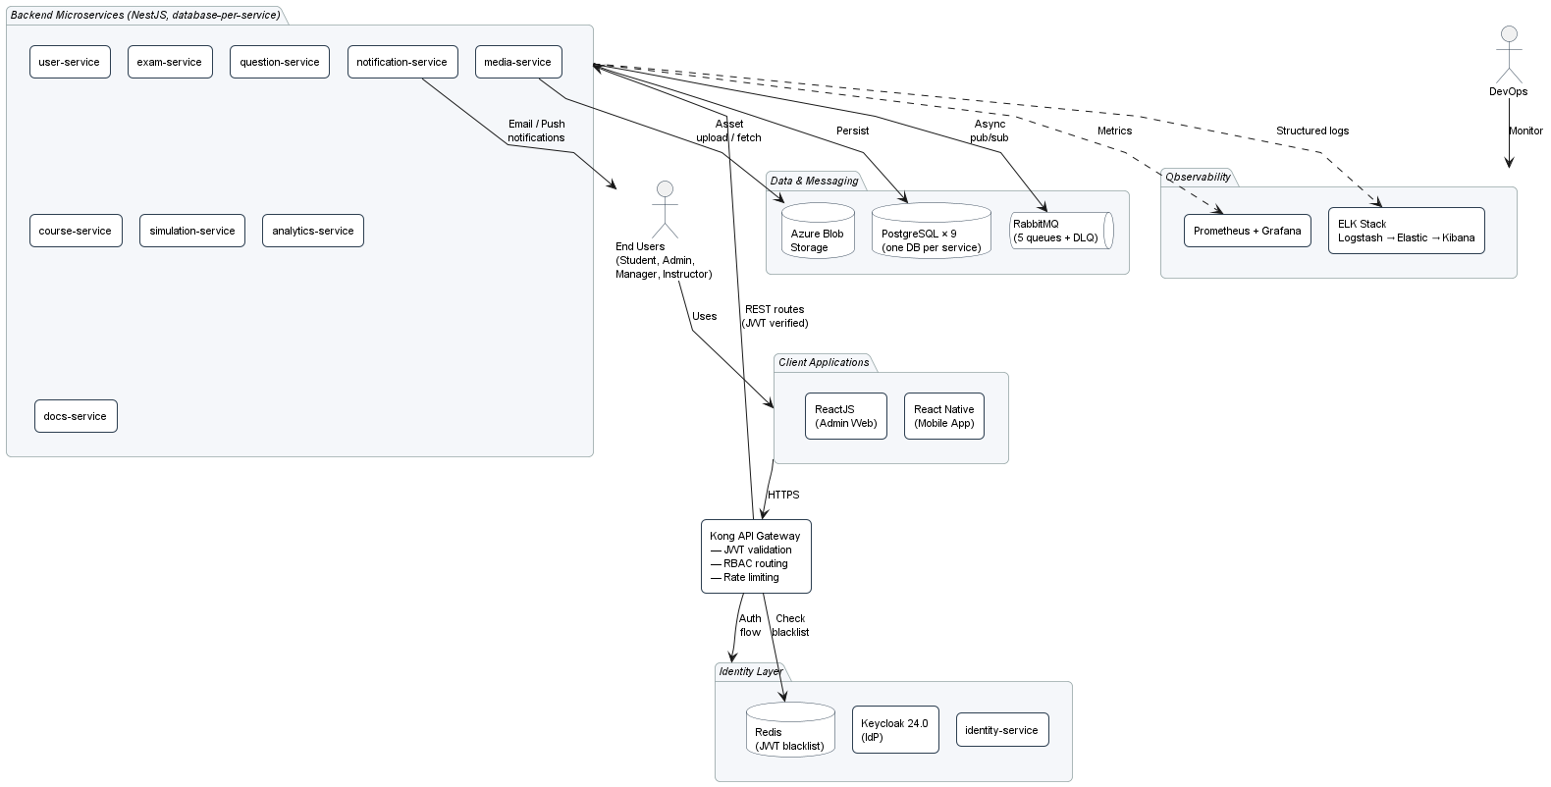igure 3.2: Component Diagram

3.2.1 Kong API Gateway
- Primary Function: Single ingress point for all external traffic from the ReactJS Admin Web and React Native Student App. Performs declarative routing (DB-less mode), JWT signature validation via Keycloak public key, rate limiting, CORS handling, and request forwarding to downstream microservices.
- Communicates With: All NestJS microservices; Keycloak (JWT public key endpoint); Redis (via identity-service for blacklist check).
- Implementation Notes: Configured via kong.yaml (production) / kong.dev.yaml (development); declarative routing eliminates the need for a Kong-specific database. TLS termination occurs at the Nginx Ingress Controller before Kong. Rate-limit counters use the Redis plugin. TokenBlacklistGuard registered globally so revoked tokens are rejected before reaching any downstream service.

3.2.2 Keycloak 24.0
- Primary Function: Identity provider for the entire system. Issues JWT access and refresh tokens, manages password hashing (Bcrypt cost >= 12 / Argon2id), enforces brute-force lockout (5 failed attempts within a 5-minute window, 30-second initial wait, 15-minute cap), generates single-use password-reset tokens (TTL = 15 minutes), and revokes sessions via its admin API.
- Communicates With: identity-service (admin API for user provisioning, role assignment, session revocation); Kong (JWT public key endpoint for signature verification).
- Implementation Notes: Deployed as a Kubernetes StatefulSet with persistent volume. Realm configuration defines the four roles (Student, Instructor, Center Manager, Admin) and the brute-force policy. Built-in Forgot Password flow handles email dispatch via the configured SMTP provider (Mailpit in dev, real SMTP in prod).

3.2.3 identity-service
- Primary Function: NestJS wrapper around Keycloak’s admin API. Handles user provisioning on registration, role synchronisation, and JWT revocation on logout (writes jti claim to Redis blacklist with TTL = token remaining lifetime). Publishes identity.user.created events to RabbitMQ for downstream services to consume.
- Communicates With: Keycloak (admin API); Redis (token blacklist key writes); RabbitMQ (publishes user lifecycle events to user_service_events).
- Implementation Notes: TokenBlacklistGuard is exported from this service and registered globally in every other microservice via @repo/common. Blacklist write is atomic (Redis SET with EX option). identity_db stores only IdentityUser cache and TokenAudit records.

3.2.4 user-service
- Primary Function: Owns user profile data, student details (license tier, enrolment date), and account lifecycle operations (create, update, lock, unlock). Consumes identity.user.created events to keep its user_db in sync with Keycloak. Maintains a LicenseAssignmentAudit table recording every license-tier change.
- Communicates With: identity-service (via RabbitMQ user_service_events queue); Kong (REST API for profile and license operations); analytics-service (publishes student-context events).
- Implementation Notes: user_db enforces email uniqueness via DB unique constraint (returns HTTP 409 on duplicate). License tier is foreign-keyed to a LicenseTier configuration table — no tier identifier is hardcoded in application code (ASR-MOD-02). Audit writes occur within the same transaction as the license change (ASR-DI-05). Student progress reset operations are exposed via user-service; resets clear progress counters but never delete historical exam records — historical data remains queryable for audit (ASR-REL-05).

3.2.5 exam-service
- Primary Function: Owns the exam lifecycle end-to-end. Generates randomized exam papers from indexed question pools, applies the active ExamConfig (snapshotted as JSONB at generation time), enforces the server-authoritative timer, performs atomic submission and grading within a single PostgreSQL transaction, evaluates fatal questions on the server, and persists immutable COMPLETED results.
- Communicates With: question-service (REST for question retrieval at generation time); exam_service_publish queue (publishes exam.submitted and result.ready events, routed by the RabbitMQ exchange to analytics-service via analytics_service_events for SRS computation, and to notification-service via notification_service_events for result-ready alerts).
- Implementation Notes: The full submission flow (answer write, grading, fatal-question short-circuit evaluation, result persistence, SRS_Item update) runs in one PostgreSQL transaction. COMPLETED status is immutable after commit — no UPDATE is permitted (DB-level enforcement). Exam generation target: P95 <= 3 seconds (ASR-PERF-12). Active session state lives in exam_db, not Redis; client retains its own copy for offline resilience.

3.2.6 question-service
- Primary Function: Full CRUD for exam questions with strict soft-delete-only policy for questions referenced in any exam history. Every content edit creates a new QuestionVersion record. Stores question text and option text in PostgreSQL; question images are referenced via URL pointing to Azure Blob Storage (uploaded through media-service).
- Communicates With: exam-service (REST for question retrieval); media-service (REST for image upload coordination).
- Implementation Notes: DELETE /questions/{id} sets isDeleted=true rather than physically deleting; a service-layer guard clause and DB-level check prevent hard-delete of any question with existing exam references (ASR-SEC-06, ASR-DI-03). Question search uses PostgreSQL full-text search with composite index on (licenseTierId, status, isDeleted). Question bank scales without schema migration up to 5,000+ questions (ASR-PERF-11).

3.2.7 course-service
- Primary Function: CRUD for course content, instructor assignments, license-tier scoping, and student enrolment. Serves course detail and list endpoints. Implements soft-delete on archival with audit-preserved enrolment and learning history.
- Communicates With: user-service (REST for instructor and student lookup); notification-service (publishes course-update events).
- Implementation Notes: Course detail uses NestJS in-memory CacheManager (MemoryStore, TTL 5–10 minutes per service instance) — no shared Redis cache. Cache key: {licenseCategory}:{courseId}. Cache invalidation on update is synchronous within the same instance; multiple instances tolerate up to TTL of staleness across replicas (acceptable for ASR-PERF-05). Hard-delete is prohibited when active enrolments exist — returns HTTP 409 (ASR-DI-10).

3.2.8 simulation-service
- Primary Function: Manages the 2D driving-practice simulation. Renders driving scenarios with color-coded error feedback (Red = fatal, Yellow = deduction) when the student makes incorrect actions. Loads 2D map definitions from runtime JSON configs in Azure Blob Storage.
- Communicates With: Kong (REST API for scenario actions); media-service (map JSON configs).
- Implementation Notes: Map types are loaded from JSON configs and can be added without app release (ASR-MOD-03). Mobile rendering target: >= 60 fps on mid-range (3 GB RAM) devices.

3.2.9 analytics-service
- Primary Function: Pre-aggregated learning progress tracking and Spaced Repetition algorithm. Consumes exam.submitted events from RabbitMQ and updates SRS_Item records. Runs a scheduled aggregation job that pre-computes progress statistics into the progress_stat table. Serves progress dashboard and SRS practice-set generation endpoints.
- Communicates With: analytics_service_events queue (receives events routed by the exchange from exam-service's exam_service_publish queue); user-service (REST for student context); React Native and ReactJS clients (REST for dashboard data).
- Implementation Notes: Progress queries hit the pre-aggregated table directly via indexed lookup on (studentId, licenseTierId). Real-time aggregation against raw log tables is strictly prohibited (ASR-PERF-04, ASR-PERF-07). SRS computation is bounded to recent exam records and runs in-process; no external worker is required (ASR-PERF-09). Aggregation job frequency determines data freshness.

3.2.10 notification-service
- Primary Function: Asynchronous consumer of the notification_service_events RabbitMQ queue. Delivers email and push notifications for account events (account creation), exam events (result-ready alerts), academic warnings, and password resets. Failed deliveries are retried automatically; messages exhausting their retry budget are routed to a Dead Letter Queue.
- Communicates With: RabbitMQ (consumer of notification_service_events); external SMTP and push providers (Mailpit in dev; production SMTP + FCM/APNs TBD).
- Implementation Notes: Pure event-driven consumer — no synchronous REST endpoints from publishing services. DLQ depth is monitored via Prometheus; Alertmanager fires on threshold breach. Warning records are persisted to notification_db with PENDING/QUEUED/DELIVERED states (ASR-PERF-08 UC29 dispatch transaction).

3.2.11 media-service
- Primary Function: Centralised file metadata service and the only component permitted to talk to Azure Blob Storage. Handles uploads, generates signed URLs for client downloads of question images, and tracks file metadata in media_db.
- Communicates With: question-service (image upload coordination); simulation-service (audio MP3 and map JSON config retrieval); Azure Blob Storage (direct SDK calls); RabbitMQ (media_service_events for file lifecycle events).
- Implementation Notes: Application services never embed Azure SDK credentials directly — all blob operations are proxied through media-service. Stored metadata includes file checksum, content type, and content length. Public access is granted via short-lived signed URLs only; bucket public-read access is disabled.

3.2.12 docs-service
- Primary Function: Aggregates OpenAPI / Swagger documentation from all 11 other backend services into a unified developer-facing Swagger UI. Auto-discovers service endpoints and merges their OpenAPI specs.
- Communicates With: All other backend services (HTTP GET on each service’s /api-docs endpoint).
- Implementation Notes: Read-only service with no persistent storage. Refreshes the aggregated spec on a schedule (default: every 5 minutes) and on-demand via an admin endpoint. Hosted internally; not exposed to public internet. Useful for development, integration testing, and consumer-driven contract verification. # 4. Architecture Decisions

4. Architectural Decisions and Constraints

4.1 Key Decisions and Rationale
The following architectural decisions were made to satisfy the 41 Architecturally Significant Requirements (ASRs) documented in the ADD. Each decision references the specific ASRs it addresses.
Decision ID | Decision Statement | Rationale (linked to ASR) | Key Trade-off
AD-001 | Adopt Microservices Architecture | ASR-PERF-01, ASR-PERF-12, ASR-REL-04, ASR-REL-07: Independent scalability of exam-service and identity-service under peak load; fault isolation between domains; per-service deployment cadence. | Increased operational complexity — requires API Gateway, service discovery, distributed tracing, centralised logging. Mitigated by Kong + Consul + ELK + Prometheus.
AD-002 | Kong as the Single Entry Point | ASR-SEC-01, ASR-SEC-03, ASR-SEC-04: Centralised JWT validation, RBAC enforcement, and rate limiting across all services without duplicating logic in each microservice. Declarative DB-less mode eliminates the need to operate a Kong-specific database. | Kong becomes a bottleneck if not scaled. Mitigated by stateless Kong replicas behind Nginx Ingress with HPA.
AD-003 | Delegate Identity to Keycloak 24.0 + Redis Token Blacklist | ASR-SEC-01, ASR-SEC-02, ASR-SEC-03: Keycloak provides industry-standard password hashing, brute-force lockout, single-use reset tokens, and session management out-of-the-box. Custom auth code is eliminated. Redis blacklist (TTL = remaining token lifetime, checked by TokenBlacklistGuard on every request) enables immediate revocation while keeping authentication stateless across services. | Keycloak adds an operational dependency (StatefulSet, persistent volume). Mitigated by deploying Keycloak in HA mode and treating its realm config as version-controlled infrastructure-as-code.
AD-004 | Data-Driven ExamConfig with Snapshot Pattern | ASR-MOD-01, ASR-MOD-02, ASR-DI-04, ASR-DI-08: Admin changes pass score, question count, time limit, fatal-question criteria, or license tiers via UI; changes take effect immediately for newly generated exams. The ExamConfig active at generation time is snapshotted into the ExamSession record (JSONB column), so in-progress exams are unaffected by subsequent admin changes. | Config validation must run server-side before persistence (ASR-DI-04) to prevent invalid states. Snapshot column increases ExamSession row size; mitigated by JSONB compression.
AD-005 | Server-Authoritative Logic — Exam Grading, FSM, and Timer | ASR-SEC-05, ASR-DI-01, ASR-DI-02, ASR-REL-02: Correct answers never leave the server (response serialiser strips them); fatal-question evaluation runs exclusively in exam-service; exam timer start-time is recorded server-side and elapsed time is validated on submission. The client is treated as untrusted. | Higher server compute per student action. Mitigated by indexed question queries, lightweight FSM logic, and HPA scaling of exam-service and simulation-service under peak load.
AD-006 | Synchronous Grading within Submission Transaction; Async Notification and Inter-Service Events via RabbitMQ | ASR-DI-01, ASR-REL-04, ASR-REL-07, ASR-PERF-08, ASR-PERF-09: Exam submission, answer recording, fatal-question evaluation, grading, COMPLETED result persistence, and SRS_Item update all execute as one coordinated submission flow in exam-service; the student receives the result immediately.. Notification delivery (HTTP 202 returned to the instructor on academic warning) and inter-service events (identity.user.created) flow through RabbitMQ. | The submission transaction is heavier, but the absolute correctness benefit (no partial state, no eventual-consistency window for the result) outweighs the cost. Notification failure is non-fatal and isolated via DLQ.
AD-007 | Soft-Delete + Question Versioning | ASR-SEC-06, ASR-DI-03: Questions appearing in any exam history are never hard-deleted (DB-level enforcement). Every content edit creates a new immutable QuestionVersion record. ExamSessionQuestion stores a snapshot of the question content as it appeared at exam time, so historical exam reports remain accurate regardless of subsequent edits. | Storage grows over time. Mitigated by soft-delete partitioning, archive policies, and the fact that question records are small (text + URL references).
AD-008 | Database-per-Service Pattern (9 isolated PostgreSQL DBs) | ASR-PERF-11, ASR-DI-03, ASR-DI-10: Each service owns its own database; no cross-service foreign keys; inter-service references by UUID only. Eventual consistency via RabbitMQ events. Enforced at compile time by Prisma generating an isolated client per service (e.g. @prisma/exam-client). | Cross-service queries require API calls or event projection. Mitigated by RabbitMQ event distribution and read-replica strategies per service. Eliminates the most common source of microservices coupling.
AD-009 | In-Memory CacheManager + Pre-aggregated Tables (No Business-Data Redis) | ASR-PERF-04, ASR-PERF-05, ASR-PERF-07: Course detail uses NestJS in-memory CacheManager (MemoryStore, TTL 5–10 min per service instance). Progress statistics and chart data are pre-computed by a scheduled aggregation job and stored in a dedicated analytics_db table; real-time aggregation against raw log tables is strictly prohibited. Redis is reserved exclusively for JWT token blacklist (identity-service). | Per-instance cache tolerates up to TTL of staleness across replicas — acceptable for course detail (rarely changes). Aggregation job latency determines progress-stat freshness; mitigated by tuneable schedule. Avoids the operational cost of a shared Redis cluster for business data.
AD-010 | Consul KV for Runtime Configuration | ASR-MOD-01, ASR-MOD-03: Every microservice loads runtime configuration from Consul KV on startup with priority order env vars > Consul KV > application defaults. Configuration changes propagate without code deployment. Road-map JSON configs for driving practice are stored in Azure Blob Storage and hot-loaded by simulation-service. | Consul becomes a critical dependency. Mitigated by Consul HA cluster (StatefulSet with persistent volumes) and local defaults as fallback.

4.2 Technical Constraints
The following technical constraints govern the design and implementation of DriveMate:
- Mandatory Technology Stack: NestJS 11, ReactJS, React Native, PostgreSQL 15 (database-per-service), Redis 7 (token blacklist only), RabbitMQ 3, Kong, Keycloak 24.0, Consul 1.19, Prisma v7, Docker, Kubernetes (as detailed in §2 Technology Stack). These are non-negotiable.
- Performance Targets: P95 of all user-facing API requests <= 3 s under normal operating conditions. Login API P95 <= 300 ms (ASR-PERF-01). Exam generation P95 <= 3 s (ASR-PERF-12). Course list page <= 500 ms at 1,000 courses (ASR-PERF-05). Progress dashboard <= 200 ms (ASR-PERF-04). Color-coded error alert rendered <= 100 ms from server response receipt (ASR-UX-02).
- Availability Target: System uptime >= 99.9%. MTTR < 30 min with Prometheus Alertmanager and on-call rotation.
- Concurrency Target: Support thousands of concurrent exam sessions during peak licensing seasons via Kubernetes HPA on stateless NestJS services. In-progress exam state lives in PostgreSQL (exam_db), not in application memory.
- Data Integrity Rules: Exam submission, grading, fatal-question evaluation, COMPLETED-status persistence, and SRS_Item update all execute within a single PostgreSQL transaction. COMPLETED exam status is immutable after transaction commit (DB-level enforcement). ExamConfig snapshot is immutable after ExamSession creation. Questions with exam history are never hard-deleted.
- Security Standards: All external traffic encrypted via HTTPS/TLS 1.2 or higher (terminated at Nginx Ingress). Passwords hashed with Bcrypt (cost >= 12) or Argon2id by Keycloak. Correct answers must never appear in any API response payload (verified by contract test in CI pipeline). All state transition logic for driving practice runs exclusively on the server.
- Offline Resilience: Student React Native app must support offline answer buffering via device local storage and silent auto-sync on reconnect. Auto-save is idempotent (ASR-REL-03). Offline indicator must appear within 2 seconds of network loss (ASR-UX-05).
- Cloud Provider: TBD with an Azure-leaning baseline (Azure Blob Storage is already committed via media-service). All application services are containerised — no cloud-provider lock-in at the application layer; managed services (PostgreSQL, Redis, RabbitMQ, Keycloak) are deployment-time choices.

4.3 Design Principles
- Single Responsibility Principle (SRP): Each microservice owns exactly one bounded domain. No service performs cross-domain business logic directly. Cross-domain interactions occur exclusively through well-defined REST or RabbitMQ event interfaces.
- Database-per-Service: Each service owns its own PostgreSQL database; no cross-service foreign keys; inter-service references by UUID only. Enforced at compile time by Prisma’s per-service client generation.
- Loose Coupling: Services interact exclusively through REST or message-queue interfaces. No direct DB-to-DB access between services. Async events are preferred for non-time-critical workflows.
- High Cohesion: Functionality within each service is tightly related to its domain. Cross-cutting concerns (JWT validation, RBAC, logging, error shape, response envelope) are packaged as shared NestJS modules in the @repo/common library.
- Design for Failure / Resilience: Timeouts, retries, and circuit breakers at Kong; DLQ for all RabbitMQ consumers; idempotent endpoints for client-retry safety (ASR-REL-03); Prometheus Alertmanager for proactive failure detection; failover on PostgreSQL primary failure (Patroni or managed-service equivalent).
- Horizontal Scalability: All NestJS services are stateless and scaled via Kubernetes HPA. No in-memory session state outside the per-instance CacheManager (which tolerates replica staleness).
- Security by Design: JWT + RBAC at Kong; correct answers never leave the server (contract test in CI); soft-delete for audit-safe question management; all passwords one-way hashed by Keycloak; server-side FSM for driving practice; TLS at all trust boundaries.
- API-First Design: All service contracts defined as OpenAPI specs, auto-generated by NestJS decorators, aggregated by docs-service for a unified Swagger UI.
- Config Over Code: Exam rules, license tiers, road-map definitions, and brute-force policies are data-driven (stored in PostgreSQL, Consul KV, or Azure Blob Storage). Zero code deployments or service restarts are required for configuration changes (ASR-MOD-01, MOD-02, MOD-03).
- Observability First: Every service ships structured logs to ELK via @repo/common’s AppLoggerModule and exposes Prometheus-scrapable metrics endpoints. Cross-service trace correlation is the default, not an afterthought.

5. Logical Architecture

5.1 Key Modules
This section describes the logical function, inputs, outputs, interactions, and storage for each of the twelve backend components. Naming and responsibilities are consistent with §3.2 and the ADD v2.0 Logical View.

5.1.1 Kong API Gateway
- Function: Single entry point for all client requests. Handles declarative routing, JWT signature validation, RBAC enforcement, rate limiting, and CORS.
- Input: HTTPS requests from React Native (mobile) and ReactJS (admin web).
- Output: Proxied HTTP responses from backend services after authorization and rate-limit checks.
- Interactions: Keycloak (JWT public key); identity-service (token blacklist check via TokenBlacklistGuard); all backend microservices (routing).
- Storage: Stateless. Rate-limit counters live in the Redis plugin instance.

5.1.2 Keycloak 24.0
- Function: Identity provider. Authenticates users, issues access and refresh JWTs, manages password storage and reset, enforces brute-force lockout, manages realm-based RBAC.
- Input: Login credentials (email/username + password), refresh token requests, password-reset requests, admin API calls from identity-service.
- Output: JWT access + refresh tokens, password-reset emails, session revocation confirmations.
- Interactions: identity-service (admin API); Kong (JWT public key endpoint); SMTP provider (password-reset emails); persistent volume (its own internal database).
- Storage: Keycloak-managed internal database (user identities, roles, sessions, reset tokens). Treated as a black box by application code.

5.1.3 identity-service
- Function: NestJS bridge to Keycloak. Synchronises user lifecycle events to the rest of the system, manages JWT revocation, and exposes a TokenBlacklistGuard used globally across all services.
- Input: User registration/update requests, logout requests, admin role-change requests.
- Output: Provisioning confirmations, blacklist writes, identity.user.created events published to RabbitMQ.
- Interactions: Keycloak (admin API); Redis (blacklist key writes); RabbitMQ (publishes to user_service_events queue); Kong (REST endpoints for logout and registration).
- Storage: identity_db {IdentityUser cache, TokenAudit}; Redis (blacklist:{jti} keys with TTL = token remaining lifetime).

5.1.4 user-service
- Function: Owns user profile data, license tier assignment, student detail, and account lifecycle (create / update / lock / unlock). Maintains an audit log of license-tier changes.
- Input: Profile create/update requests, license tier assignment requests, lock/unlock actions, identity.user.created events.
- Output: User profile payloads, license assignment confirmations, audit records, downstream events for analytics-service.
- Interactions: Kong (REST API); identity-service (consumes user_service_events); analytics-service (publishes student-context events).
- Storage: user_db {UserProfile, StudentDetail, LicenseAssignmentAudit}.

5.1.5 exam-service
- Function: Generates randomized exam papers, applies ExamConfig with snapshot, enforces server-authoritative timer, performs atomic submission and grading, evaluates fatal questions, and persists immutable COMPLETED results.
- Input: Exam-start requests (studentId, licenseTierId), auto-save events (every 5–10 s, idempotent), submission requests, admin ExamConfig and ExamTemplate CRUD.
- Output: Exam paper (questions only, no correct answers), in-session state, immutable graded result.
- Interactions: question-service (REST for question retrieval); RabbitMQ exam_service_publish queue (publishes exam.submitted and result.ready events; routed by exchange to analytics_service_events for analytics-service and to notification_service_events for notification-service).
- Storage: exam_db {ExamTemplate, ExamSession (with config_snapshot JSONB), ExamSessionQuestion (with content snapshot)}.

5.1.6 question-service
- Function: Question bank CRUD with strict soft-delete + version history. Manages question text/option text in PostgreSQL and image URLs pointing to Azure Blob Storage.
- Input: Question create/update/delete requests, search queries (keyword + license tier filter), version history requests.
- Output: Question lists, question details, version history payloads.
- Interactions: exam-service (REST for question retrieval at generation time); media-service (REST for image upload coordination); Admin Web (REST CRUD).
- Storage: question_db {Question, QuestionOption, QuestionTopic, QuestionVersion}; Azure Blob Storage (images, via media-service).

5.1.7 course-service
- Function: Course CRUD, instructor assignment, enrolment management, lesson progress, archival (soft-delete) with audit-preserved enrolment history.
- Input: Course create/update/archive requests, enrolment requests, lesson progress events.
- Output: Course list (paginated, cursor-based), course detail (cached), enrolment confirmations.
- Interactions: Kong (REST API); user-service (REST for instructor and student context); notification-service (publishes course-update events).
- Storage: course_db {Course, Lesson, Enrollment, LessonProgress}; NestJS in-memory CacheManager (MemoryStore, TTL 5–10 min, key {licenseCategory}:{courseId}).

5.1.8 simulation-service
- Function: 2D driving-practice simulation. Renders driving scenarios and displays color-coded error feedback. Loads 2D map configs at runtime from Azure Blob Storage.
- Input: Scenario session requests, map config fetch requests.
- Output: Scenario session state, error feedback (severity Red/Yellow), map JSON configs.
- Interactions: Kong (REST API); media-service (map config retrieval).
- Storage: simulation_db {SimulationScenario, SimulationSession}; Azure Blob Storage (map JSON — via media-service).

5.1.9 analytics-service
- Function: Pre-aggregated learning progress tracking and Spaced Repetition algorithm. Consumes exam.submitted events to update SRS_Item records. Runs a scheduled aggregation job that populates progress_stat. Serves dashboard and SRS practice-set endpoints.
- Input: exam.submitted events (consumed from analytics_service_events queue, originally published to exam_service_publish by exam-service), progress dashboard requests, practice-set generation requests.
- Output: Progress stat payloads (completion %, attempt count, pass rate, weak topics), recommended practice-set question lists.
- Interactions: exam-service (RabbitMQ consumer); user-service (REST for student context); Kong (REST API).
- Storage: analytics_db {ProgressStat (aggregated, indexed by studentId+licenseTierId), SRSItem}.

5.1.10 notification-service
- Function: Asynchronous email and push notification delivery. Consumes notification_service_events. Persists notification records with PENDING/QUEUED/DELIVERED states. Routes exhausted retries to a Dead Letter Queue.
- Input: notification_service_events messages (event type, recipient, payload).
- Output: Delivered email / push notifications; DLQ entries for unrecoverable failures.
- Interactions: RabbitMQ (consumer); external SMTP and push providers (Mailpit in dev; production TBD).
- Storage: notification_db {NotificationRecord}.

5.1.11 media-service
- Function: Centralised file metadata service. The only component permitted to talk to Azure Blob Storage. Handles uploads, generates short-lived signed URLs for downloads, tracks file metadata.
- Input: File upload requests (multipart), signed-URL requests, media metadata queries.
- Output: Upload confirmations with blob URL, signed download URLs, file metadata payloads.
- Interactions: question-service (image uploads); simulation-service (map JSON and audio MP3 retrieval); Azure Blob Storage SDK; RabbitMQ (publishes media_service_events).
- Storage: media_db {MediaFile metadata: id, blobUrl, contentType, contentLength, checksum, uploadedAt}; Azure Blob Storage (actual file bytes).

5.1.12 docs-service
- Function: Aggregates the OpenAPI / Swagger specifications from all 11 other backend services into a unified developer-facing Swagger UI. Refreshes on a schedule and on-demand.
- Input: HTTP GET on each service’s /api-docs endpoint (auto-discovery).
- Output: Aggregated OpenAPI spec; unified Swagger UI.
- Interactions: All other backend services.
- Storage: In-memory aggregated spec (no persistent storage).

5.2 Data Flow
This section documents the six most architecturally significant data flows in DriveMate. Each flow is described as a sequence of steps from client request to final response or eventual consistency. Sequence diagrams referenced in Figure X.Y-S are produced separately and stored alongside this SAD.

5.2.1 User Login via Keycloak
Description: A user submits credentials via the mobile or admin web app. The request is forwarded to Keycloak, which authenticates and issues a JWT pair. All subsequent requests carry the access token and are validated by Kong + TokenBlacklistGuard.
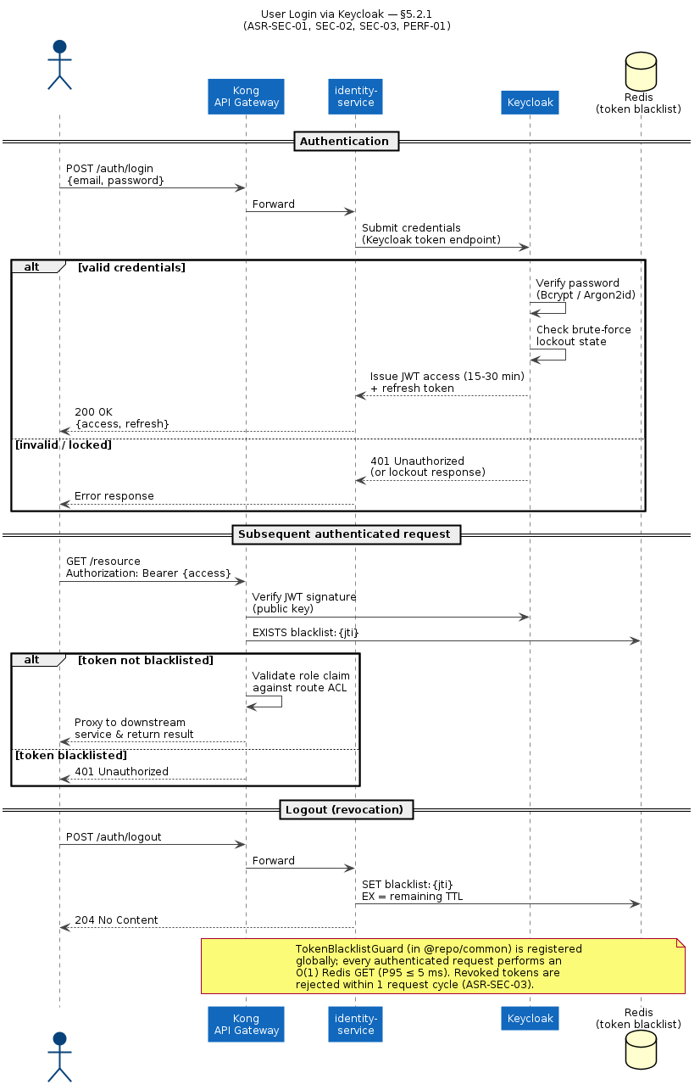
Figure 5.2.1-S: Sequence Diagram — User Login via Keycloak.
- Client → Kong: POST /auth/login {email, password}.
- Kong → identity-service: Forward request.
- identity-service → Keycloak token endpoint: Submit credentials.
- Keycloak: Verify password (Bcrypt/Argon2id), check brute-force lockout state, issue JWT access + refresh tokens.
- identity-service → Client: Return JWT pair (or 401 / lockout response).
- Subsequent requests: Client sends Authorization: Bearer {access_token}.
- Kong: Validate JWT signature using Keycloak public key; check TokenBlacklistGuard against Redis blacklist:{jti}; reject with 401 if blacklisted.
- On logout: identity-service writes jti to Redis blacklist:{jti} with TTL = remaining token lifetime; client clears local token. Subsequent calls with the revoked token return 401 at Kong.
ASR coverage: SEC-01 (stateless auth, P95 <= 300 ms), SEC-02 (single-use reset token TTL 15 min), SEC-03 (revocation enforced within 1 request).

5.2.2 Start & Submit Exam (Atomic Grading)
Description: A student starts an exam. exam-service generates the paper using the active ExamConfig (snapshotted), enforces the server-authoritative timer, auto-saves answers, and on submission performs answer recording, fatal-question evaluation, grading, COMPLETED-status persistence - all within a single PostgreSQL transaction.
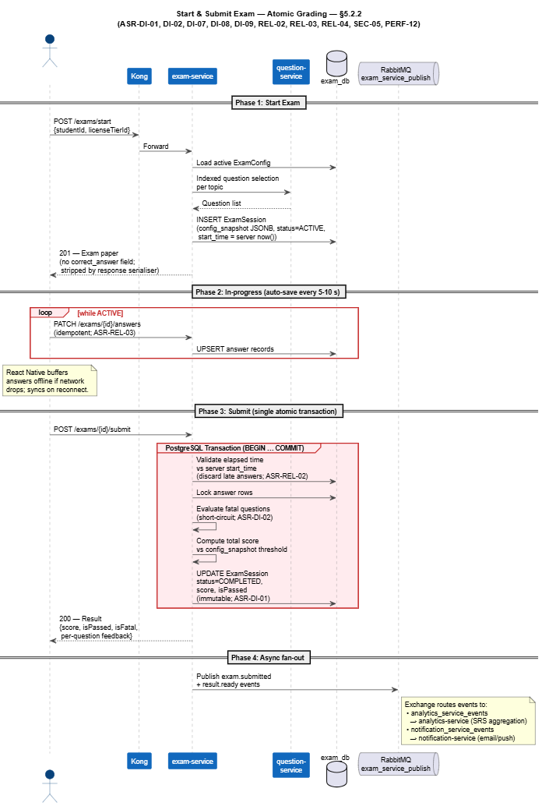
Figure 5.2.2-S: Sequence Diagram — Start & Submit Exam.
- Client → Kong → exam-service: POST /exams/start {studentId, licenseTierId}.
- exam-service: Load active ExamConfig from exam_db (DB-cached); snapshot it into the new ExamSession (config_snapshot JSONB column); call question-service for indexed question selection per topic; create ExamSession (status=ACTIVE); record server-side start time.
- exam-service → Client: Return paper (question text + option text only — correct_answer field stripped by response serialiser; ASR-SEC-05).
- Client → exam-service: PATCH /exams/{id}/answers (auto-save every 5–10 s, idempotent; offline buffer in React Native local storage; sync on reconnect; ASR-REL-03).
- Client → exam-service: POST /exams/{id}/submit.
- exam-service: Open single PostgreSQL transaction:
  - Validate elapsed time against server-recorded start time; discard any answers received after the deadline (ASR-REL-02).
  - Lock all answers (no further edits permitted).
  - Evaluate fatal questions first; any wrong answer on a fatal question short-circuits to FAIL (ASR-DI-02).
  - Compute total score; compare against passing threshold from config_snapshot.
  - Persist ExamSession with status=COMPLETED, score, isPassed (immutable after commit; ASR-DI-01).
  - Update SRS_Item records in the same submission flow (ASR-DI-07).
- exam-service → Client: Return result payload (score, pass/fail, fatal-question flag, per-question feedback).
- exam-service → RabbitMQ exam_service_publish queue: Publish exam.submitted and result.ready events. The RabbitMQ exchange routes these events to analytics_service_events (consumed by analytics-service for SRS_Item aggregation) and to notification_service_events (consumed by notification-service for async email/push delivery to the student).
ASR coverage: SEC-05 (answer confidentiality), REL-02 (server timer), REL-03 (idempotent auto-save), REL-04 (atomic submit), DI-01 (immutable result), DI-02 (fatal-question on server), DI-07 (SRS transactional consistency), DI-08 (ExamConfig snapshot), DI-09 (structural correctness), PERF-12 (generation P95 <= 3 s).

5.2.3 Driving Practice Session
Description: A student opens the driving-practice screen. The simulation-service loads the 2D map config from Azure Blob Storage and presents the scenario. When the student makes an incorrect action, simulation-service returns a color-coded error response (red for fatal, yellow for point deduction). The client renders the error alert within 100 ms of receiving the response.
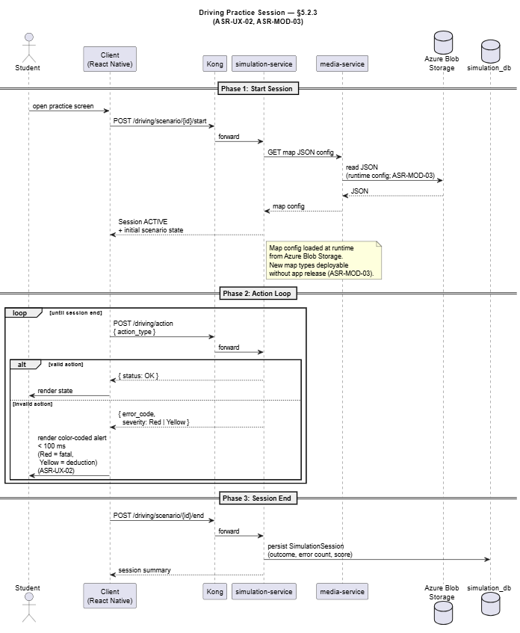
Figure 5.2.3-S: Sequence Diagram — Driving Practice Session.
- Client → Kong → simulation-service: POST /driving/scenario/{id}/start.
- simulation-service: Load map JSON config from Azure Blob Storage via media-service; initialise scenario session.
- Loop — per student action:
  - Client → simulation-service: POST /driving/action.
  - simulation-service: Process the action and respond with either confirmation or a structured error {error_code, severity: Red | Yellow}.
  - Client: Render color-coded alert within 100 ms of response receipt.
- On session end: simulation-service persists SimulationSession outcome to simulation_db.
ASR coverage: UX-02 (<= 100 ms alert), MOD-03 (runtime map configurability).

5.2.4 Progress Dashboard Load (Pre-aggregated Read)
Description: A student or instructor opens the progress dashboard. The data is served exclusively from the pre-aggregated progress_stat table — no real-time computation against raw log tables is permitted.
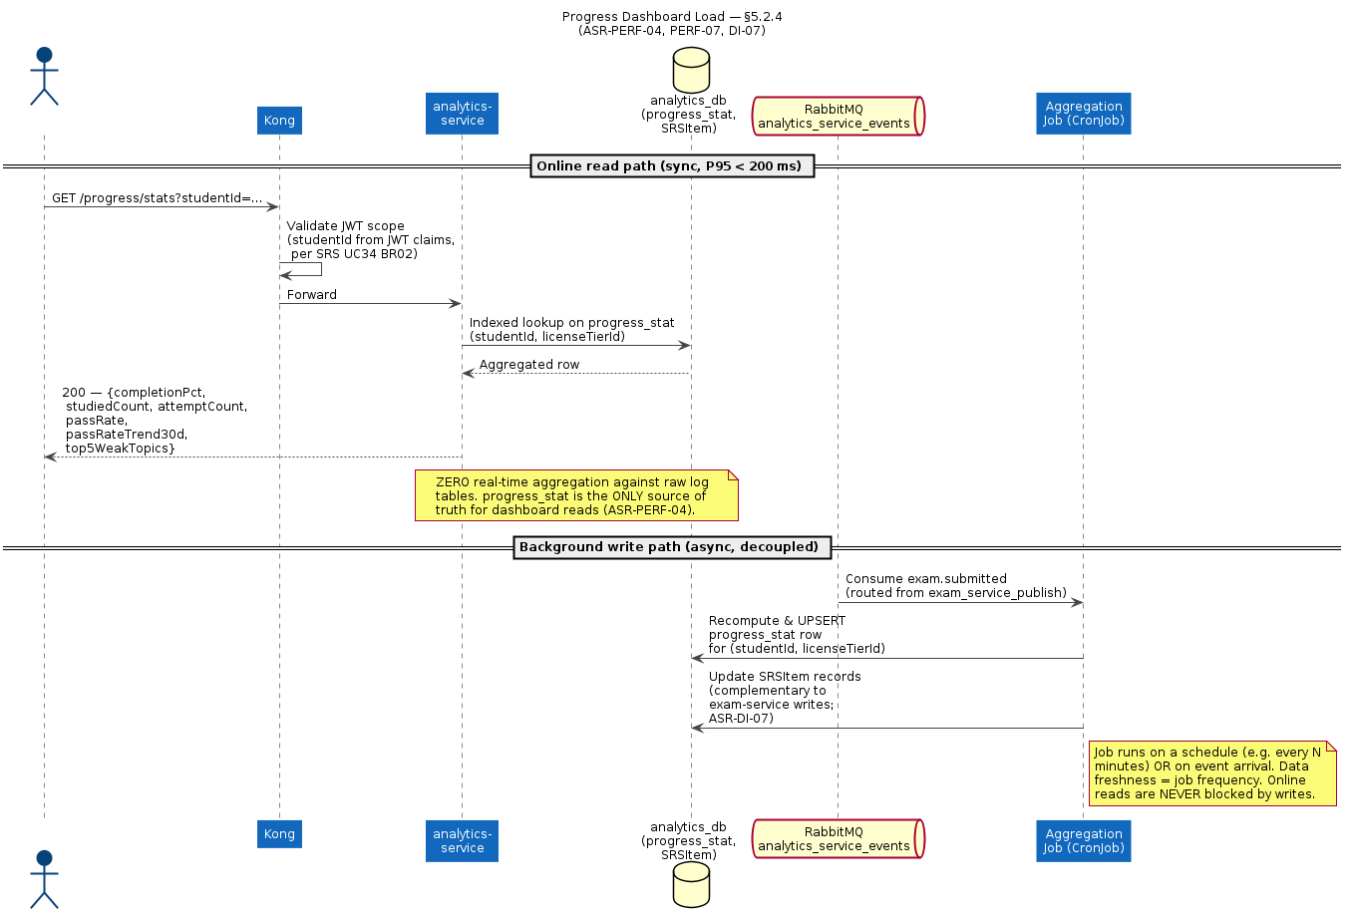
Figure 5.2.4-S: Sequence Diagram — Progress Dashboard Load.
- Client → Kong → analytics-service: GET /progress/stats?studentId={…}.
- analytics-service: Validate JWT scope.
- analytics-service → analytics_db: Indexed lookup on progress_stat (studentId, licenseTierId).
- analytics-service → Client: Return payload {completionPct, studiedCount, attemptCount, passRate, passRateTrend30d, top5WeakTopics} within 200 ms (ASR-PERF-04).
Note: The progress_stat table is refreshed periodically by a scheduled aggregation job consuming exam.submitted events. The job frequency determines data freshness. No Redis cache layer is involved.
ASR coverage: PERF-04 (progress stats < 200 ms via pre-agg), PERF-07 (chart data via aggregation), DI-07 (SRS items consistent with exam results).

5.2.5 Async Notification with DLQ
Description: Any service publishes a notification event without blocking the user’s response path. notification-service consumes asynchronously. Retries are automatic; exhausted retries route to the Dead Letter Queue.
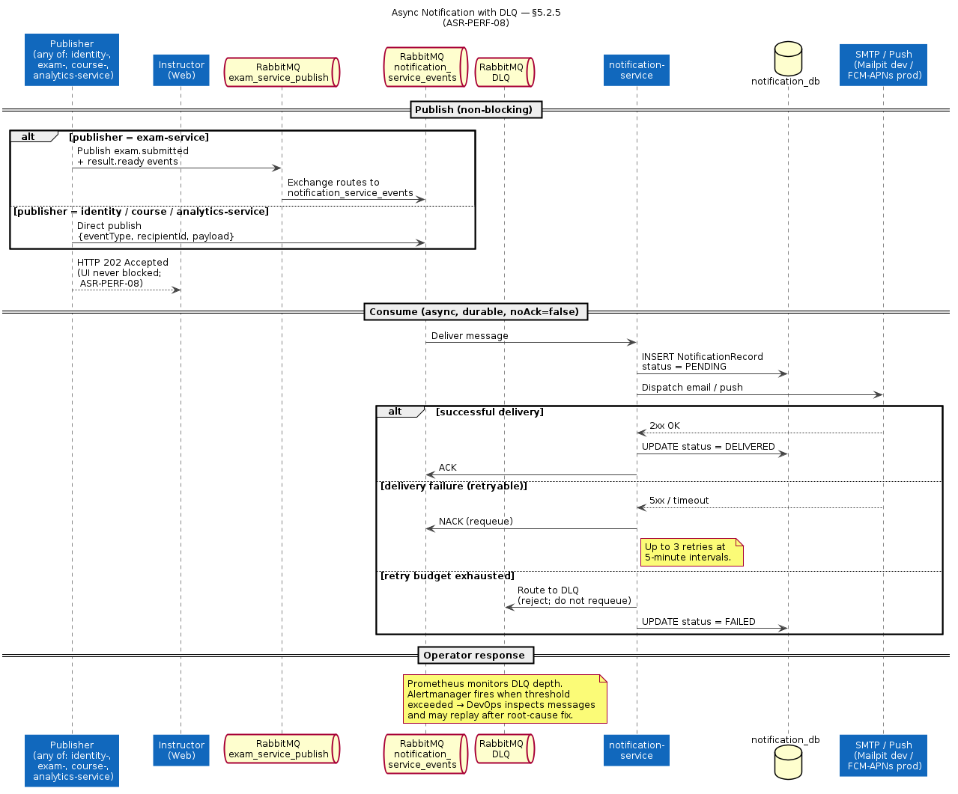
Figure 5.2.5-S: Sequence Diagram — Async Notification.
- Publisher → RabbitMQ: identity-service, course-service, and analytics-service write directly to notification_service_events (consumer-named queue); exam-service publishes to exam_service_publish which the RabbitMQ exchange routes to notification_service_events. Message payload: {eventType, recipientId, payload}.
- Publisher → Client: Return HTTP 202 immediately (instructor UI never blocked on academic warning dispatch; ASR-PERF-08).
- notification-service: Consume message; persist NotificationRecord with status=PENDING → QUEUED → DELIVERED progression. Deliver via SMTP / push.
- On failure: notification-service NACKs (max 3 retries with 5-min interval; configurable). Final exhaustion → message routed to DLQ.
- Prometheus: Alertmanager fires when DLQ depth exceeds threshold; DevOps inspects and replays.
ASR coverage: PERF-08 (async non-blocking dispatch).

5.2.6 Course Detail Read with In-Memory Cache
Description: A user opens a course detail page. course-service serves the response from its in-memory CacheManager when possible, falling back to course_db on cache miss. The cache is per-instance — no shared Redis cache layer is used.
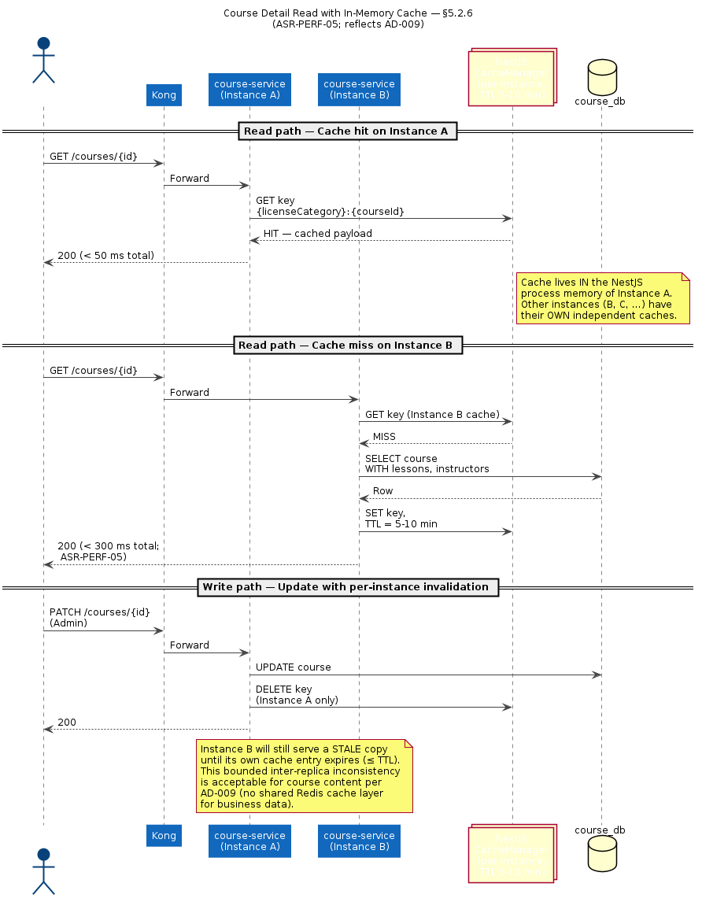
Figure 5.2.6-S: Sequence Diagram — Course Detail Read.
- Client → Kong → course-service: GET /courses/{id}.
- course-service: Check NestJS in-memory CacheManager with key {licenseCategory}:{courseId}.
- Cache hit (< 50 ms): Return cached payload directly.
- Cache miss: Query course_db; return result; populate cache with TTL 5–10 min.
- On update (PATCH /courses/{id}): course-service invalidates the cache key synchronously within its own instance. Other instances tolerate up to TTL of staleness; this is acceptable for course content (rarely changes; ASR-PERF-05).
ASR coverage: PERF-05 (cache hit < 50 ms, miss < 300 ms, list page < 500 ms at 1,000 courses). # 6. Physical Architecture

6. Physical Architecture

6.1 Deployment Overview
DriveMate is fully containerised with Docker. Two deployment configurations are documented: the development stack running on Docker Compose for active development, and the production target running on a Kubernetes cluster (cloud provider TBD with an Azure-leaning baseline).

6.1.1 Development Deployment (Docker Compose)
The development stack runs entirely via Docker Compose, with two configurations:
- docker-compose.yaml — full stack: all 10 NestJs microservices + Kong + Keycloak + Consul + PostgreSQL instances (9) + Redis + RabbitMQ + Elasticsearch + Logstash + Kibana + Prometheus + Grafana + Mailpit.
- docker-compose.infra.yml — hybrid mode where backend services run on the host machine (for fast hot-reload during development) while infrastructure (databases, queues, observability) runs in Docker. Kong uses kong.dev.yaml and routes to host.docker.internal:{port}.
Consul is seeded at startup via a consul-init container using consul-seed-development.json. Mailpit replaces a real SMTP server for email testing.

6.1.2 Production Target Deployment (Kubernetes)
For production deployment, all NestJS microservices run as stateless Kubernetes Deployments with Horizontal Pod Autoscaling. External traffic enters through Nginx Ingress (TLS termination) before being forwarded to Kong.
- Nginx Ingress Controller — routes external HTTPS traffic; TLS termination at this boundary; no plaintext HTTP accepted.
- Kong API Gateway — deployed as a Deployment (2–N replicas, HPA on CPU/RPS). Declarative DB-less config from a ConfigMap.
- NestJS Microservices — each service is an independent Kubernetes Deployment (2–N replicas). HPA enabled with CPU and RPS thresholds tuned per service. Heavy services: identity-service (Bcrypt hashing via Keycloak), exam-service (exam generation).
- Keycloak 24.0 — StatefulSet with persistent volume; HA configuration with 2+ replicas behind an internal Kubernetes Service with session affinity (sticky session) enabled. Replicas serve both failover and load distribution; horizontal scaling beyond a small replica count is bounded by Keycloak's inter-cluster session-replication overhead, so vertical scaling becomes the primary lever once the HA replica count is established.
- Consul — StatefulSet with persistent volumes; HA cluster of 3 or 5 nodes.
- PostgreSQL (9 isolated databases) — managed cloud service or self-managed StatefulSet per service. Read-replica enabled per service where read traffic warrants it (analytics-service, course-service in particular).
- Redis — HA cluster (managed service preferred) used exclusively for the JWT token blacklist by identity-service.
- RabbitMQ — clustered with persistent queues. DLQ configured for notification_service_events. Quorum queues for durability under broker failover.
- Azure Blob Storage — managed Azure service; accessed only by media-service via IAM-scoped service principal.
- Observability Stack — Elasticsearch + Logstash + Kibana for log aggregation; Prometheus + Grafana + Alertmanager for metrics and alerting. All deployed as StatefulSets or via managed services depending on cost trade-offs.

6.2 Infrastructure Components
Component | Technology / Service | Role
Ingress | Nginx Ingress Controller | Routes external HTTPS traffic; TLS termination at the cluster boundary.
API Gateway | Kong (declarative DB-less, K8s Deployment + HPA) | Single entry point; JWT validation; rate limiting; RBAC routing; CORS.
Identity Provider | Keycloak 24.0 (StatefulSet + persistent volume) | Authentication, JWT issuance, RBAC realm, brute-force lockout, password reset.
identity-service Wrapper | NestJS (K8s Deployment + HPA) | Keycloak admin API integration, token blacklist management, identity events publisher.
Backend Services | NestJS (K8s Deployment + HPA × 9) | user-service, exam-service, question-service, course-service, simulation-service, analytics-service, notification-service, media-service, docs-service.
Configuration Store | Consul 1.19 (StatefulSet, HA cluster) | Per-service runtime configuration via KV store.
Primary Databases | PostgreSQL 15 × 9 isolated instances (one per service, optional read-replicas) | Transactional data store; database-per-service pattern; analytics queries on read-replica.
Token Blacklist Store | Redis 7 (HA cluster — managed service preferred) | JWT blacklist keys with TTL = remaining token lifetime; checked by TokenBlacklistGuard on every authenticated request.
Message Queue | RabbitMQ 3 (clustered, persistent queues + DLQ) | Async notification delivery; inter-service event propagation (user, exam, analytics, media).
Object Storage | Azure Blob Storage | Question images, road-map JSON configs. Accessed only via media-service.
Centralised Logging | Elasticsearch + Logstash + Kibana (ELK Stack) | Structured log aggregation from all services via Winston HTTP transport.
Monitoring & Alerting | Prometheus + Grafana + Alertmanager | Metrics scraping; dashboards (P95 latency, error rate, queue depth, DLQ depth, HPA scaling); proactive alerting on SLA breaches.
API Documentation | OpenAPI / Swagger (NestJS) + docs-service aggregator | Auto-generated REST contracts for all services; unified Swagger UI.
Container Registry | Docker Hub / Private Registry (TBD) | Stores Docker images for all microservices.
CI/CD Pipeline | TBD (GitHub Actions or GitLab CI recommended) | Turborepo build → Docker image build → K8s rolling-update deployment; test gate before production push.
Email Provider (Dev / Prod) | Mailpit (dev) / Production SMTP (TBD) | Dispatches password-reset and notification emails.

6.3 Security Architecture
This section documents the system’s security architecture as a series of scenarios in the same format as the ASR scenarios in the ADD. Each sub-section addresses one cohesive security concern. Cross-references to the relevant ASR IDs are inline.

6.3.1 Authentication & Session Management
- Stimulus: A user attempts to authenticate (login, register, or reset password), maintain an active session, or explicitly terminate a session.
- Stimulus Source: End-users (Student / Instructor / Center Manager / Admin) via mobile app or admin web; potentially a malicious actor attempting brute-force, credential stuffing, or session hijacking.
- Environment: Normal and peak-load operating conditions.
- Artifact: Nginx Ingress, Kong API Gateway, identity-service, Keycloak 24.0, Redis (token blacklist).
- Response:
- All identity and authentication concerns are delegated to Keycloak 24.0, which is deployed as a dedicated StatefulSet inside the cluster. identity-service is a thin NestJS wrapper that integrates the rest of the system with Keycloak’s admin API and adds JWT blacklist management. This separation means application code never handles raw passwords and never implements custom auth logic — vastly reducing the SEC-01 / SEC-02 implementation surface area.
- Credential storage. When a user registers or changes their password, Keycloak hashes the password one-way using Bcrypt (cost >= 12) or Argon2id with a per-user salt before writing to its internal database. Plaintext passwords never leave Keycloak’s boundary and are never logged or persisted anywhere else in the system.
- Login flow. On a valid POST /auth/login, identity-service forwards credentials to Keycloak’s token endpoint. Keycloak verifies the password, evaluates brute-force lockout state, and issues a JWT access token (short-lived, 15–30 minutes) plus a longer-lived refresh token. The access token encodes the user’s ID, role claims, and a unique JWT ID (jti) used for revocation tracking. All downstream services trust the JWT signature without calling Keycloak again — keeping the authentication path stateless and horizontally scalable.
- Session revocation. On POST /auth/logout, identity-service writes the JWT’s jti claim to a Redis blacklist key (blacklist:{jti}) with TTL = the token’s remaining lifetime. The TokenBlacklistGuard, registered globally in @repo/common across all services, validates every authenticated request against this blacklist before any business logic executes. A revoked token is rejected with 401 Unauthorized within a single request cycle, with no possibility of stale-token replay.
- Password reset. Keycloak’s built-in Forgot Password flow generates a single-use UUID token with TTL = 15 minutes, signs it, and dispatches it via the configured SMTP provider (Mailpit in dev). On first use the token is consumed; subsequent uses return 400 Bad Request. After TTL expiry the token is automatically invalidated by Keycloak — no external token store or background cleanup job is required.
- Brute-force protection. Keycloak’s built-in Brute Force Detection feature is enabled. After 5 consecutive failed login attempts within a 5-minute window, the affected account is locked for an initial 30 seconds, doubling on subsequent failures up to a 15-minute cap. Counters live inside Keycloak — no Redis or external counter store is involved.
- Response Measure:
  - P95 latency of POST /auth/login <= 300 ms under peak load (cross-referenced with ASR-PERF-01).
  - Revoked token rejected within 1 request after logout; TokenBlacklistGuard performs O(1) Redis GET <= 5 ms.
  - Account lockout applied within 1 request after the 5th consecutive failed attempt.
  - Password-reset link expires exactly 15 minutes after issuance; reuse returns 400 Bad Request.
  - 100% of passwords stored as irreversible salted hashes by Keycloak — zero plaintext in storage or logs anywhere in the system.
  - ASR coverage: SEC-01, SEC-02, SEC-03, PERF-01.

6.3.2 Authorization & Access Control
- Stimulus: An authenticated user holding a valid JWT attempts to access a resource or perform an action anywhere in the system.
- Stimulus Source: Any logged-in user or inter-service request within the cluster.
- Environment: Normal operating conditions, after successful authentication.
- Artifact: Kong API Gateway, Keycloak realm, identity-service, all backend microservices.
- Response:
- Authorization is enforced through Keycloak realm-managed RBAC, with the authorization decision occurring at the Kong API Gateway before any request reaches a downstream service. This boundary placement means individual microservices never duplicate role-check logic — authorization rules live in exactly one place.
- Role model. Four roles are defined in the Keycloak realm: Student, Instructor, Center Manager, Admin. Roles are assigned at account creation (by Admin or Center Manager via the user-service flow that calls Keycloak’s admin API) and encoded directly into every issued JWT as a realm role claim. Email addresses are unique system-wide; duplicate registration returns HTTP 409 (enforced both at user-service via DB unique constraint and at Keycloak’s user creation API).
- Enforcement mechanism. Kong decodes the JWT on every inbound request and evaluates the role claim against the route’s declarative ACL definition in kong.yaml. Requests with insufficient privilege are rejected at Kong with 403 Forbidden — no downstream service is invoked. At the service layer, additional fine-grained checks (for example, “the student requesting their own data”) are implemented as NestJS Guard decorators using JWT claims rather than re-querying any role database.
- Rule propagation. RBAC rules are owned by the Keycloak realm configuration. When an Admin changes a role assignment via the user-service Admin UI, user-service calls Keycloak’s admin API and publishes an event to RabbitMQ user_service_events. The next JWT issued to the affected user will carry the updated role claim — by design, role changes take effect on the user’s next token refresh (within the access-token TTL).
Role | Primary Responsibility | Example Permissions
Student | Study theory, take exams, practice driving simulation, view personal history. | Register/Login, GET /exams/start, POST /exams/{id}/submit, view exam history, run driving-practice sessions.
Instructor | Manage centre students, track progress, send academic warnings. | View student list, view student progress reports, dispatch academic warnings via notification-service.
Center Manager | Manage training centre, staff, course config, centre-wide reports. | Manage Instructor accounts, configure courses, view centre statistics, assign license tiers.
Admin | Manage entire system, question bank, exam configurations, all users, system-wide reports. | Manage all accounts, add/edit/soft-delete questions, system configuration (ExamConfig, LicenseTier), view nationwide reports.
- Response Measure:
  - Permission changes propagate to issued tokens within 1 access-token TTL cycle (15–30 minutes).
  - 100% of protected endpoints covered by Kong ACL rules — verified by automated route-coverage tests in CI.
  - Duplicate-email registration returns HTTP 409 Conflict from user-service.
  - Unauthorised access returns HTTP 403 Forbidden at Kong; no downstream service is invoked for unauthorised requests.
  - ASR coverage: SEC-04 (RBAC).

6.3.3 Exam Content Integrity
- Stimulus: A student (or a tampered client) attempts to extract correct answers from API responses, trigger a hard-delete on a referenced question, or send an out-of-sequence action event during a driving-practice session.
- Stimulus Source: Students via mobile app or browser DevTools; Admin via management interface; a malicious actor manipulating client-side logic.
- Environment: Active exam sessions, active driving-practice sessions, and normal content management operations.
- Artifact: exam-service, question-service, simulation-service, PostgreSQL exam_db, PostgreSQL question_db.
- Response:
- Three distinct mechanisms work together to ensure that the integrity of exam content — both at rest and during active sessions — cannot be compromised by client-side actors.
- Answer confidentiality (ASR-SEC-05). exam-service applies a strict response-projection layer before returning any GET /exams/{id}/questions payload. The serialiser uses a restricted DTO that includes only [questionId], [questionText], [options[] (option text only)], [questionOrder], and [isFatal]. The correctAnswer field, answer-key index, and any scoring metadata are structurally excluded from the response DTO — this is not a runtime conditional but a compile-time guarantee enforced by the type system. All scoring is performed exclusively server-side by comparing submitted answers against the stored correct answers. This invariant is verified by an automated contract test that runs on every CI build and blocks merges to main if violated.
- Question data integrity (ASR-SEC-06, ASR-DI-03). question-service enforces a strict soft-delete-only policy for any question that has ever appeared in a student’s exam history. A DELETE /questions/{id} request sets isDeleted=true rather than removing the record; a service-layer guard clause backed by a DB-level constraint prevents physical deletion of any question with existing exam references. Every content edit creates a new entry in the QuestionVersion table with a timestamp and editor ID, forming an immutable version chain. ExamSessionQuestion records carry a content snapshot taken at exam generation time, so historical exam reports always reflect the exact question wording as seen by the student — subsequent edits never alter past results.
- Response Measure:
  - Zero occurrences of correct_answer field in any GET /exams/{id}/questions response — verified by contract test on every CI build (ASR-SEC-05).
  - Zero successful hard-deletes on questions referenced in exam history — enforced by DB constraint and integration tests (ASR-SEC-06).
  - Question version chain intact; no version record is ever deleted or retroactively modified (ASR-SEC-06).
  - ASR coverage: SEC-05, SEC-06, DI-03.

6.3.4 API & Service Protection
- Stimulus: Inbound traffic arrives at the system’s public APIs from client applications or external actors; internal microservices communicate with each other across the cluster.
- Stimulus Source: Student mobile app, admin web interface, other microservices within the Kubernetes cluster, and potentially malicious actors attempting injection, abuse, or denial-of-service attacks.
- Environment: Normal and peak-load operating conditions, covering both public external traffic and internal inter-service communication.
- Artifact: Nginx Ingress Controller, Kong API Gateway, all backend microservices, Redis (rate-limit counters via Kong plugin).
- Response:
- The system applies a layered defence strategy across external and internal communication boundaries.
- TLS termination & transport encryption. All external HTTPS traffic enters the cluster through Nginx Ingress, which terminates TLS using a cert-manager-issued certificate (Let’s Encrypt or commercial CA, TBD). No unencrypted traffic is accepted at the ingress boundary. Internal traffic between Kong and downstream services traverses the cluster’s pod-to-pod network; any call that crosses a trust boundary (for example, between cluster networks or to external SaaS) uses TLS.
- Rate limiting & throttling. Kong enforces per-IP and per-user rate limits using its rate-limiting plugin backed by Redis atomic counters. Requests exceeding the configured threshold are rejected with HTTP 429 Too Many Requests before reaching any business logic. Rate-limit policies are tuned per route based on observed traffic patterns and SLA commitments.
- Input validation. All inbound API requests are validated against OpenAPI/JSON Schema contracts at the NestJS controller boundary using class-validator decorators. Requests failing schema validation are rejected immediately with HTTP 400 Bad Request. This prevents injection attacks (SQL injection via Prisma’s parametrised queries, XSS via response serialisation, NoSQL injection — not applicable since no NoSQL store is used for business data) and ensures malformed payloads never reach service logic. Validation coverage is enforced via contract tests in CI.
- Token validation boundary. JWT signature verification, expiry checks, and TokenBlacklistGuard execution are performed exclusively at Kong — downstream services do not re-validate tokens independently. This prevents clock-skew inconsistencies across services and ensures a single, consistent enforcement boundary. Any request carrying an expired or blacklisted token is rejected at Kong with HTTP 401 Unauthorized.
- Internal service isolation. All backend microservices are deployed inside the Kubernetes cluster with no direct public exposure. Only Nginx Ingress and Kong are reachable externally. Inter-service calls occur over the cluster’s internal pod network. Kubernetes NetworkPolicy rules whitelist the specific service pairs allowed to communicate (for example, exam-service → question-service is permitted; analytics-service → identity-service is not).
- Response Measure:
  - 100% of external API traffic received over HTTPS/TLS 1.2 or higher; no plaintext HTTP accepted at the Nginx Ingress boundary.
  - 100% of JWT expiry and blacklist checks performed at Kong before any downstream forwarding.
  - Requests exceeding the rate-limit threshold rejected with HTTP 429 within 1 request cycle.
  - Schema validation applied to 100% of inbound API request payloads; violations return HTTP 400.
  - Zero backend microservices reachable directly from the public internet — verified by network policy review and periodic penetration test.
  - Overhead introduced by gateway-layer protections (rate limiting, validation, token check) must not exceed 10% of total request processing time.

6.3.5 Data Encryption
- Stimulus: Sensitive student data (personal information, exam results, progress records) is written to or read from persistent storage, or transmitted across network boundaries.
- Stimulus Source: All data creation, update, and retrieval operations originating from any service that handles student PII or exam content.
- Environment: Data at rest in PostgreSQL (9 instances), Redis (identity-service blacklist only), Keycloak internal DB, and Azure Blob Storage; data in transit between clients, Nginx Ingress, Kong, and backend microservices.
- Artifact: PostgreSQL clusters, Redis HA cluster, Keycloak DB, Azure Blob Storage, all network communication channels.
- Response:
- Encryption in transit. All data transmitted between the client and the system boundary (Nginx Ingress → Kong → downstream services) is encrypted using HTTPS/TLS 1.2 or higher. Internal cluster traffic between microservices is carried over the Kubernetes pod network within the cluster’s private subnet; any call that crosses a trust boundary applies TLS. Unencrypted inter-service calls over public or untrusted networks are prohibited by policy and prevented by NetworkPolicy.
- Encryption at rest. Sensitive student PII stored in PostgreSQL (user_db: name, phone number, email address, license tier assignment) is protected by volume-level encryption at rest using the encryption capability provided by the chosen cloud provider’s managed database service (Azure Database for PostgreSQL if Azure is selected). All database backups inherit the same encryption policy; unencrypted backup files are never written to disk or object storage.
- Object storage encryption. Question images, and road-map JSON configs stored in Azure Blob Storage are encrypted at rest using Azure Storage Service Encryption (SSE) with platform-managed keys (or customer-managed keys if compliance dictates). Bucket public-read access is disabled; downloads are served exclusively through short-lived signed URLs issued by media-service.
- Sensitive data in Redis. Redis stores only the JWT blacklist (blacklist:{jti} keys). Although the jti values are non-PII, the Redis cluster operates with authentication enabled (requirepass / ACL) and is accessible only from within the Kubernetes cluster via NetworkPolicy. TTL-bounded entries are evicted automatically; nothing in Redis is logged.
- Password storage. As noted in §6.3.1, all passwords are hashed one-way with Bcrypt (cost >= 12) or Argon2id by Keycloak before persistence — this is the primary encryption control for credential data and does not rely on symmetric encryption or key management.
- Keycloak realm secrets. Keycloak’s signing keys for JWT issuance are stored encrypted at rest within Keycloak’s own database, with the database volume itself encrypted at the cloud-provider layer.
- Response Measure:
  - 100% of external and trust-boundary-crossing traffic encrypted with TLS 1.2 or higher.
  - 100% of database volumes and backup files encrypted at rest via cloud-provider managed encryption.
  - 100% of Azure Blob Storage containers configured with server-side encryption; zero containers with public read access.
  - Redis cluster accessible only from within the cluster network; authentication required on all connections.
  - Encryption configuration audited as part of every deployment cycle; any misconfiguration is treated as a critical finding and blocks deployment.

6.3.6 Infrastructure Resource Protection
- Stimulus: An unauthorised actor or misconfigured service attempts to access backend infrastructure components (databases, Redis, RabbitMQ, Keycloak admin console, Consul, monitoring dashboards) directly.
- Stimulus Source: External actors, misconfigured deployment scripts, or compromised internal services.
- Environment: All infrastructure components in the production Kubernetes environment.
- Artifact: PostgreSQL clusters, Redis cluster, RabbitMQ cluster, Keycloak, Consul cluster, ELK observability stack, Prometheus + Grafana + Alertmanager, Kubernetes nodes.
- Response:
- Database, cache, and queue access restriction. PostgreSQL instances, Redis, RabbitMQ, Keycloak, and Consul are all deployed as cluster-internal services with no public-facing ports. Access is restricted to explicitly named microservices via Kubernetes NetworkPolicy rules — services not in the allow-list cannot establish connections regardless of network position. Credentials (database passwords, RabbitMQ users, Consul tokens, Keycloak admin secrets) are injected at runtime via Kubernetes Secrets and are never hardcoded in application code, Docker images, or git repositories.
- Monitoring and admin console protection. Kibana, Grafana, Alertmanager, Keycloak admin console, Consul UI, and RabbitMQ management UI are not exposed publicly. Access is restricted to authorised operations personnel via IP whitelist or VPN, preventing the observability and admin stack itself from becoming an attack surface or a source of system intelligence for attackers.
- Principle of least privilege for infrastructure accounts. All services run under dedicated Kubernetes service accounts with the minimum permissions required for their function. Root-level access to any node or database is prohibited in the production environment. Database accounts used by application services are granted only the specific privileges required (SELECT, INSERT, UPDATE — not DROP or ALTER). Administrative database operations use a separate, audited credentials path.
- Server access via SSH key only. Where direct server access is required for break-glass operations, it is restricted to SSH key-based authentication — password-based SSH is disabled. All access events are logged and retained for audit.
- Secrets rotation. Database passwords, Redis ACL credentials, RabbitMQ users, Keycloak realm signing keys, and Consul ACL tokens are rotated on a documented schedule. Rotation is performed via Kubernetes Secret updates with rolling restarts of dependent services; no service stores credentials beyond its current Pod lifetime.
- Response Measure:
  - Zero database, cache, queue, or admin-console ports exposed outside the Kubernetes cluster network — verified by network policy review and external port scan.
  - 100% of production service accounts operate under the principle of least privilege; no service runs with cluster-admin or root-equivalent permissions.
  - Kibana, Grafana, Alertmanager, Keycloak admin, Consul UI, and RabbitMQ management UI accessible only via IP whitelist or VPN; access attempts from unlisted IPs are blocked and logged.
  - All Kubernetes Secrets used for credentials are never logged or included in error responses.
  - Infrastructure access configuration reviewed as part of each deployment cycle.
  - Secrets rotation completed within the documented SLA after schedule trigger or compromise indicator.

7. Performance & Scalability

7.1 Performance Assurance

7.1.1 In-Memory Caching (NestJS CacheManager)
DriveMate uses NestJS in-memory CacheManager (MemoryStore) rather than a shared Redis cache layer for business data. The architectural rationale is that the cached data is read-heavy, rarely updated, and tolerates per-instance staleness up to the configured TTL.
- Course Detail Cache. course-service caches course detail responses with key {licenseCategory}:{courseId} and TTL 5–10 minutes per service instance. Cache-hit returns within 50 ms; cache-miss falls back to PostgreSQL in under 300 ms (ASR-PERF-05). On course update the cache is invalidated synchronously within the updating instance; other replicas tolerate up to TTL staleness, which is acceptable for course content.
- Reasoning. A shared Redis cache would introduce additional network hops, an extra failure mode, and operational overhead. For business data that is mostly read-only between admin updates, an in-memory cache per instance gives sub-50-ms hits without any of those costs. The trade-off — temporary inter-replica inconsistency — is acceptable for this domain (course content, not exam results).

7.1.2 Pre-aggregated Analytics Tables
Progress statistics, pass-rate trends, and weak-topic analysis are served exclusively from a pre-aggregated table in analytics_db (progress_stat), populated by a scheduled aggregation job that consumes exam.submitted events. Real-time aggregation against raw log tables is strictly prohibited.
- Progress Dashboard. GET /progress/stats serves data from progress_stat via indexed lookup on (studentId, licenseTierId). P95 response time < 200 ms (ASR-PERF-04).
- Progress Chart. GET /progress/chart serves time-series data from the same aggregation table. P95 < 200 ms (ASR-PERF-07).
- SRS Practice Set. The SRS algorithm runs in-process against bounded recent exam records, never against the full history. Computation is lightweight and does not require an external worker or queue (ASR-PERF-09).
- Reasoning. Real-time aggregation against multi-million-row log tables would exceed every reasonable latency target. Pre-aggregation moves the cost from the request path to a background schedule, where data freshness is a tuneable trade-off rather than a user-blocking concern.

7.1.3 Asynchronous Processing with RabbitMQ
Heavy or non-time-critical workflows are offloaded asynchronously via RabbitMQ with durable queues and Dead Letter Queues.
- Notification Dispatch. notification-service consumes notification_service_events. Publishing services (identity-service, exam-service, course-service, analytics-service) return HTTP 202 immediately without waiting for delivery. Failed messages retry up to 3 times at 5-minute intervals before routing to DLQ. The instructor UI is never blocked on academic-warning dispatch (ASR-PERF-08).
- Inter-Service Event Propagation. identity.user.created events flow from identity-service to user_service_events; exam.submitted events flow from exam-service to analytics_service_events; media file lifecycle events flow on media_service_events. This decouples non-time-critical workflows from the synchronous request path.
- Dead Letter Queue. Messages exhausting their retry budget route to DLQ for inspection. Prometheus monitors DLQ depth; Alertmanager fires when the threshold is exceeded.
- Note on Exam Grading. Exam grading is intentionally synchronous, executing within the submission PostgreSQL transaction alongside answer recording and SRS_Item updates (AD-006). This guarantees the student receives an immediate, atomic result with no eventual-consistency window — a deliberate trade-off favouring correctness over the modest latency cost.

7.1.4 Database Optimization
- Per-Service Indexing. Each of the 9 isolated PostgreSQL databases maintains indexes optimised for its service’s query patterns. Critical indexes include composite indexes on student search fields (user_db: name, email, phone — ASR-PERF-02), exam history filters (exam_db: studentId, date, result — ASR-PERF-10), question search (question_db: licenseTierId, status, isDeleted — ASR-PERF-11), and progress lookups (analytics_db: studentId, licenseTierId — ASR-PERF-04).
- Cursor-Based Pagination. All list endpoints exceeding 100 records use cursor-based pagination rather than offset-based, eliminating the deep-pagination performance cliff (ASR-PERF-02, ASR-PERF-10).
- Connection Pooling. Each service uses PgBouncer or the equivalent Prisma connection pool to avoid per-request connection overhead.
- Read Replicas. Where read traffic warrants it (analytics-service, potentially course-service), a PostgreSQL read replica is provisioned. Application services route read queries to the replica via Prisma’s read-replica adapter, isolating read load from the write path.
- No N+1 Queries. Prisma’s includes / joins are used to fetch related data in a single round-trip. N+1 patterns are caught by integration tests that assert query count.

7.1.5 Centralised Logging Performance (ELK Async)
All 10 NestJS services ship structured JSON logs to Elasticsearch via Winston HTTP transport with async dispatch. The shared AppLoggerModule in @repo/common provides a consistent logger interface and ensures log shipping never blocks request handling. Kong and Keycloak, which are not NestJS, ship their native log formats (Nginx-style for Kong, JBoss logger for Keycloak) to the same ELK stack via Filebeat sidecars deployed alongside each component.
- Async transport. Winston buffers log entries in memory and ships them to Logstash on a background interval. A back-pressure mechanism drops the oldest non-error logs first if the queue saturates, preventing memory exhaustion under sustained load.
- Log volume control. DEBUG-level logs are disabled in production. ERROR and WARN-level logs are always shipped; INFO-level logs are sampled at a configurable rate.
- Cross-service trace correlation. A correlation ID (trace_id) is propagated via the X-Request-Id header through Kong → all services. Every log entry includes this ID, enabling end-to-end trace reconstruction in Kibana.

7.2 Scalability Strategy

7.2.1 Horizontal Scaling
Component | Scaling Mechanism | Notes
Kong API Gateway | HPA on CPU and request rate | Stateless declarative config; scales freely.
identity-service | HPA on CPU / RPS | CPU-bound on auth requests; sized for peak login storms.
user-service | HPA | Read-heavy; scaled alongside user_db read replicas where applicable.
exam-service | HPA on CPU / RPS | Critical path; pre-scaled before known peak exam periods. No shared state between pods.
question-service | HPA | Read-heavy; full-text search backed by PostgreSQL index.
course-service | HPA | Read-heavy; in-memory cache absorbs most read load.
simulation-service | HPA | Each action event is a small FSM evaluation; scales linearly.
analytics-service | HPA + read replica | Reads from analytics_db read replica; aggregation job runs as a separate K8s CronJob.
notification-service | HPA on RabbitMQ queue depth | Consumer count scales with queue depth; pure async work.
media-service | HPA | Stateless; Azure Blob SDK is the only external dependency.
docs-service | Static replica count (low traffic) | Internal-only; not on user critical path.
Kubernetes HPA is configured to trigger when CPU exceeds 70% or sustained request rate exceeds per-service thresholds (tuned during load testing). For known peak events (e.g., end-of-semester exam windows), services are pre-warmed by manually raising the minimum replica count ahead of expected load.

7.2.2 Vertical Scaling
- PostgreSQL Servers. Increasing RAM/CPU on the PostgreSQL node is the immediate response in emergencies before applying read replicas or partitioning. Managed cloud services (e.g., Azure Database for PostgreSQL) allow online vertical scaling without downtime.
- Keycloak. Keycloak runs in HA mode with 2+ replicas behind a Kubernetes internal Service with session affinity. Replicas serve both failover and bounded load distribution. Horizontal scaling beyond a small replica count is constrained by Keycloak's inter-cluster session-replication overhead, so vertical scaling (more CPU/memory per replica) becomes the primary lever once the HA replica count is established.
- Redis. Single-node Redis suffices for the JWT blacklist workload; vertical scaling (more memory) is the path forward if needed. Cluster mode is a future option, not a current requirement.

7.2.3 Cache-First Strategy Under High Load
During peak load periods, the system prioritises serving from cache and pre-aggregated tables. Read-heavy APIs (course detail, progress stats) are designed to degrade gracefully — returning stale cached data is preferable to returning errors. Write-heavy paths (exam submission) remain at full consistency.

7.3 Risks and Mitigation
Risk | Description | Impact | Mitigation | Response
Infrastructure & Service Risks
Keycloak unavailable | All authentication and token issuance halts; existing sessions continue until token expiry. | High | Deploy Keycloak in HA mode (2+ replicas behind internal Service); managed-service option preferred; persistent volume with frequent snapshots. | Failover to standby replica; existing valid tokens continue working until expiry, giving recovery window.
Consul unavailable | Services cannot load configuration on startup. | Medium | Consul HA cluster (3 or 5 nodes); local application defaults as fallback during startup; cached config persisted to local disk per service. | Restart services using cached config; restore Consul cluster.
Redis unavailable (token blacklist) | TokenBlacklistGuard cannot verify revocation; system fails closed (reject auth) or open (accept tokens) per policy. | Medium-High | Redis HA cluster (managed service); short access-token TTL limits exposure if blacklist is bypassed. | Fail closed by default — return 401 until Redis recovers; alert on-call.
Kubernetes HPA scales too slowly | Sudden surge during end-of-semester exam window exceeds HPA reaction time. | High | Pre-warm replicas ahead of predictable peak events; aggressive HPA thresholds; Cluster Autoscaler for node-level scaling. | Manual replica increase; prioritise cache + pre-aggregated reads; user-friendly error pages on capacity exhaustion.
PostgreSQL primary failure (any of 9 DBs) | Write path disrupted for affected service. | Very High | Streaming replication + automatic failover (Patroni or managed-service); regular encrypted backups; per-service isolation limits blast radius. | Failover to standby; restore from latest snapshot; affected service shows graceful degradation page.
RabbitMQ overloaded | Notification dispatch and inter-service event propagation delayed. | Medium | RabbitMQ cluster with quorum queues; DLQ prevents message loss; queue depth monitored. | Scale up consumer workers; drain DLQ once recovered; on-call alert.
ELK overload | Log ingestion lags; recent logs not searchable in Kibana. | Low-Medium | Winston async transport buffers logs in service memory; back-pressure drops oldest non-error logs first. | Scale Logstash; investigate log volume spike; never block request path on logging.
Security Risks
JWT leak / Session hijacking | Stolen access token used to impersonate a user. | High | Short access-token TTL (15–30 min); refresh token stored securely (httpOnly cookie on web, secure storage on mobile); Redis blacklist for immediate revocation. | Revoke token via blacklist; force logout via Keycloak session revocation API; investigate source.
Keycloak realm misconfiguration | Roles, permissions, or brute-force policies incorrectly applied. | High | Realm config managed as version-controlled infrastructure-as-code (e.g., Terraform or Keycloak Config CLI); review and CI validation before applying. | Roll back realm config; redeploy Keycloak from known-good state.
Third-party library vulnerability (CVE) | Security flaw in NestJS, Prisma, Keycloak, or other dependency. | High | Automated dependency scanning (Dependabot/Snyk) in CI/CD; periodic penetration testing; subscribe to security advisories for Keycloak and NestJS. | Emergency patch; isolate affected component; verify exploit conditions.
Data Risks
Cross-service data inconsistency | Exam result persisted in exam_db but analytics_db SRS_Item update lagged or lost. | Medium | exam-service publishes exam.submitted via RabbitMQ with at-least-once delivery; analytics-service consumer is idempotent. | Run reconciliation job replaying events from queue; identify root cause (network partition, broker outage).
Aggregation job failure | progress_stat falls behind, showing stale data. | Low-Medium | CronJob health monitored by Prometheus; alert on schedule miss; manual re-run trivial. | Re-run aggregation job; alert if persistent.
Question version corruption | Edits applied without creating version record. | High (legal/academic) | DB-level constraints + integration tests assert every edit creates a version row; soft-delete only enforced at DB level. | Restore from backup; replay missed version records from audit log; full audit of affected exams.

8. Glossary
Term | Definition
API Gateway | Single ingress point for all external traffic; enforces JWT validation, RBAC, rate limiting, and request routing. In DriveMate, this role is played by Kong.
ASR | Architecturally Significant Requirement — a requirement that has a measurable, direct impact on the software architecture. DriveMate has 41 ASRs documented in the ADD.
Bcrypt / Argon2id | One-way password hash functions with per-user salt and configurable cost factor, used by Keycloak for credential storage.
Biome | Single-tool replacement for ESLint + Prettier providing both linting and code formatting with faster CI runtime.
CacheManager | NestJS in-memory cache abstraction. In DriveMate it is used by course-service with MemoryStore and TTL 5–10 minutes per service instance.
Circuit Breaker | Pattern that detects repeated failures and short-circuits calls to a failing service to prevent cascade failures. Applied at Kong for downstream calls.
Config Snapshot | A JSONB copy of the active ExamConfig captured into the ExamSession record at exam-generation time, protecting in-progress exams from subsequent admin changes.
Consul KV | Centralised key-value configuration store. Every microservice loads runtime configuration from Consul on startup with priority order env vars > Consul KV > application defaults.
Database-per-Service | Architectural pattern where each microservice owns its own database with no cross-service foreign keys; inter-service references by UUID only. Enforced at compile time by Prisma’s per-service client generation.
DLQ | Dead Letter Queue — a RabbitMQ queue that receives messages that could not be successfully processed after all retries. Used for notification_service_events failures.
ELK Stack | Elasticsearch + Logstash + Kibana — DriveMate’s centralised logging stack. All services ship structured logs to Elasticsearch via Winston HTTP transport.
ExamConfig | Data-driven configuration per license tier: pass score, question count per topic, time limit, fatal-question IDs. Managed via Admin UI without code deployment.
Fatal Question (Kill Question) | A question whose incorrect answer produces an immediate FAIL verdict regardless of total score. Evaluated server-side in exam-service.
HPA | Horizontal Pod Autoscaler — Kubernetes mechanism that automatically scales pod replicas based on observed CPU/memory/RPS metrics.
JWT | JSON Web Token — compact, URL-safe token used for stateless authentication. Issued by Keycloak; validated by Kong on every request; revoked via Redis blacklist by jti claim.
jti | JWT ID claim — a unique identifier for each issued token. Used as the key in the Redis blacklist for revocation.
Keycloak | Open-source identity provider (version 24.0). Handles authentication, JWT issuance, RBAC realm management, brute-force lockout, and password reset for DriveMate.
Kong | Open-source API Gateway used in declarative DB-less mode. Routes external traffic to NestJS microservices and enforces JWT validation, RBAC, and rate limiting.
Microservices Architecture | Architectural style decomposing the system into small, independently deployable services aligned with bounded domains.
P95 Latency | 95th-percentile response time — the time within which 95% of all requests complete under the stated load condition. The primary performance measurement standard used in DriveMate ASRs.
Pre-aggregated Table | Database table populated by a scheduled job with summarised metrics, queried directly without real-time aggregation. In DriveMate, progress_stat in analytics_db serves the progress dashboard.
Prisma v7 | Type-safe ORM for Node.js. DriveMate generates a custom Prisma client per service (e.g., @prisma/exam-client) to enforce the database-per-service boundary at compile time.
Realm | Keycloak’s tenancy unit. A realm holds a set of users, roles, and authentication policies. DriveMate operates one realm with four roles.
RBAC | Role-Based Access Control — authorization model granting permissions based on a user’s assigned role (Student / Instructor / Center Manager / Admin). Enforced at Kong using JWT role claims.
Soft-Delete | Marking a record as deleted (isDeleted = true) without physically removing it from the database, preserving historical referential integrity. Applied to questions and courses in DriveMate.
SRS | Spaced Repetition System — algorithm that schedules review of questions at increasing intervals based on past answer accuracy, prioritising weak areas. Implemented in analytics-service.
TokenBlacklistGuard | NestJS Guard exported from identity-service and registered globally across all services via @repo/common. Validates every authenticated request against the Redis JWT blacklist.
Turborepo | Monorepo build system used by DriveMate to coordinate builds across all 10 NestJS backend services and the @repo/common shared library.
@repo/common | Shared library providing DDD base classes (AggregateRoot, Entity, ValueObject), ConsulConfigFactory, AppLoggerModule (Winston + ELK), ApiResponseInterceptor, and DomainExceptionFilter to all 10 NestJS services.

