What Matters to Happiness

Qihui Liu (Florence)

Tianhu Wu(Tia)

Guannan Liu

Team 3

BUS 696

Professor Murphy

12/11/2018

**Table of Contents**

**Abstract** 3

**Introduction** 4

**Setting up an Analytical Model** 4

A. Data Source 5

B. Dependent Variable and Independent Variable 5

C. Hypotheses 5

D. Data Cleaning 6

**Model Selection** 6

**Real-Life Example** 9

A. The Reasons for Comparing the United States, China, and Israel 9

B. Israel 10

C. China 11

D. The United States 11

**Conclusion and** **Suggestion** 13

**Reference** 15

**Appendix I: Data Dictionary** 16

**Appendix II: Analysis Process** 18

**Appendix III: Excel for Real-life Example** 19

# **Abstract**

Happiness is progressively being cited as a significant economic indicator in the news nowadays. Every country is aiming at improving their life quality and life satisfaction. Along with the raising awareness of life quality and life satisfaction, people pay great attention to the factors that impact their happiness. Therefore, researchers began to find a way to compare each country’s happiness. The first step is to quantify people’s happiness. However, researchers are still studying what contributes to quantifying happiness. No one has an absolute answer for what is the most important factor in happiness yet. This report is going to give an overall understanding of what matters to happiness from a macro perspective. The objective is to solve the relationship between various factors and happiness. It is interesting to discover why these factors are critical and how these factors might change people’s happiness as time goes on. The challenge of the research is to determine which factor will have a real impact on happiness. Looking at some economic data as a starting point, it is possible to conclude that happiness would be affected by the government, the economic status, and the demographic change.

# **Introduction**

What is happiness? Everyone might have different answers.

Aristotle said happiness is the meaning and the purpose of life, the whole aim, and end of human existence. As the change of times, people start looking deeper into happiness. Happiness is beneficial to both the human’s physical and mental health. There are researches that found happiness protects human’s heart, strengthens one’s immune system, lowers one’s blood pressure and eventually combats stress. In addition, the happiness cascade effect stated that “the clusters of happiness result from the spread of happiness and not just a tendency for people to associate with similar individuals.” If one is happy, his or her mood influences friends and family to be happier. Under those circumstances, happiness is more important than people might realize.

Although happiness is important, there is no simple way to achieve happiness. It is not just feeling good, being rich, or being successful. It is a combination of contentment from what you experience. Abraham Maslow, one of the earliest psychologists with a focus on happiness, announced there was a five-level hierarchy of needs to achieve one's happiness. Maslow described the path start from physiological need, safety, love, esteem, and end with self-actualization. He noted that happy people are not self-centered but rather problem-centered. There was a question that how to measure happiness from a quantitative perspective.

However, the human brain is a complex system. Maslow’s hierarchy might be outdated since the theory was developed in 1943. Therefore, it is necessary to re-examine what is happiness to people in the current era. The purpose of this research is to discover what can be used to predict happiness and what would be the best model for predicting happiness scores. After reading this project, people will get an overall understanding of what impact happiness.

# **Setting up an Analytical Model**

According to the textbook, supervised learnings are “fitting a model that relates the response to the predictors, with the aim of accurately predicting the response for future observations (prediction) or better understanding the relationship between the response and the predictors (inference) (James, Witten, Hastie, & Tibshirani, 2017, p. 26).” The goal of this report is to determine factors that can be used to predict happiness. Therefore, this report will focus on building a model under supervised learning.

1. Data Source

This project is based on the survey from the Gallup World Poll and the World Bank. World Bank conducted a report of happiness ranking utilizing the data collected by Gallup World Poll during the period from 2012 to 2017. This project has 156 observations, which represents 156 countries focus on the year of 2017.

1. Dependent Variable and Independent Variable

The dependent variable is the overall happiness score, which is taken from the happiness ranking report by the World Bank. The happiness scores were not calculated from other factors. It came from a survey that Gallup asked people to evaluate their life on a scale from 0 to 10 (World Bank, 2018). This survey was conducted in 2017 and published by the World Bank on the Happiness report of 2018.

Since this project is looking at a country’s overall happiness score, the independent variables are measured from the national level. There are 11 independent variables were chosen to build the best model. The independent variables are GDP per capita, social support, lifespan, freedom to make choice, generosity, perceptions of corruption, confidence in national government, democratic quality, foreign direct investment, birthrate, and population density. A detailed data dictionary was included as an appendix (Appendix I) at the end of this report.

1. Hypotheses

This research assumed that each variable is significant in terms of predicting the dependent variable. Below is the hypothesis for each independent variable.

*Hypothesis 1: If the GDP of a country is higher, the happiness score will be higher*

*Hypothesis 2: If the social support of a country is stronger, the happiness score will be higher*

*Hypothesis 3: If the lifespan of a country is long, the happiness score will be higher*

*Hypothesis 4: Freedom to make choice is a significant variable for predicting Happiness Scores.*

*Hypothesis 5: Generosity is a significant variable for predicting Happiness Scores.*

*Hypothesis 6: Perception of corruption is a significant variable for predicting Happiness Scores.*

*Hypothesis 7: Confidence in national government is significant in predicting Happiness Scores.*

*Hypothesis 8: Democratic quality is a significant variable for predicting Happiness Scores.*

*Hypothesis 9: Foreign direct investment is a significant variable for predicting Happiness Scores.*

*Hypothesis 10: Birth rate is a significant variable for predicting Happiness Scores.*

*Hypothesis 11: Population density is a significant variable for predicting Happiness Scores.*

1. Data Cleaning

One of the biggest challenges from the dataset was the missing data in the independent variables. Gallup was unable to run the survey every year for each country, especially the developing countries. Therefore, independent variables such as the perception of corruption, confidence in government and democratic quality were incomplete for a few developing countries in the happiness report of 2018.

This report tried two approaches to solve the above challenge. The first approach was to remove the observations with missing data. This approach removed 25 observations that contain missing data. It went smoothly in terms of the building model. The second approach was to fill the missing data with an R command that generated a reasonable value automatically for each missing data. The result showed that the first approach performed better than the second approach. Therefore, this report adopted the first approach for the rest of the model building process.

# **Model Selection**

A flow chart (Appendix II) was provided as an illustration for the selection process.

The dependent variable was a continuous variable. For this reason, the first step was to run a linear regression and a regression tree on the whole dataset. The pruned tree only used three variables while the linear regression used all variables. The result showed that the pruned tree had a close value of MSE with the linear regression model (Chart I). The linear regression model had an R-square of 82 percent, indicating that 82 percent of the variance in the happiness scores could be explained by the independent variables. It was too simple to just look at a linear regression and regression tree. Therefore, the next step was to separate the dataset into a training set and test set in order to figure out which model was more appropriate.

A training set was commonly used to build a model, and then the test set could be used to validate how well the model performs on unseen data. In this case, the dataset was separated into a training set and test set by half and half. The research took the significant variables from above, which was social support, freedom to make life choices, and population density, to run a linear regression first. Then, the research ran a linear regression with all variables. After comparing the results by a Chi-square test, the linear regression with all variables performed better than the one with only three significant variables. It had a test MSE of 0.3032 and an R-square of 85 percent. Also, the research ran serval tree models. The result showed that the lowest MSE was 0.2308 from the bagging model.

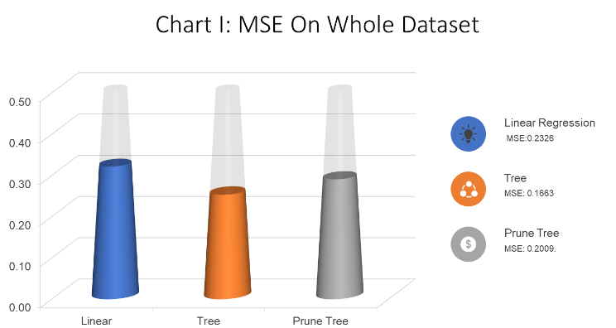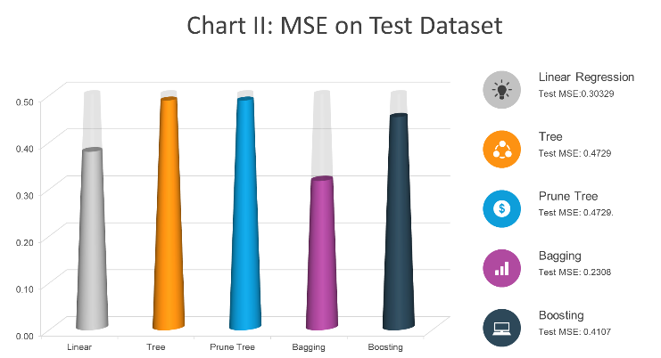

However, the linear regression model was the chosen model. This result was derived from the above analysis conscientiously. In the first place, the new linear regression model had a nice performance compare to other models. It explained 85 percent of the variance and it had a nice MSE. Second, the tree models, including bagging and boosting, are less explainable since happiness scores are a continuous variable. A clear interpretative ability of a tree is forfeited in this case. It was hard to interpret the tree results in a human term. Additionally, trees can be very non-robust. According to James, Witten, Hastie, and Tibshirani, “trees generally do not have the same level of predictive accuracy as some of the other regression and classification approaches seen in this book (James, Witten, Hastie, & Tibshirani, 2017, p. 316).” A small change in the data can cause a large change in the final estimated tree. As a result, the linear regression was chosen and the variable “social support” was the most significant variable.

This research decided to go in deeper by creating an indicator variable. From this standpoint, people will get some sense of what contributes to a high happiness score. A categorical dependent variable “high” was created for any happiness scores that are higher than 6 from the original dataset. In this part, a logistic regression, a tree model, bagging, random forest and boosting were performed on the training dataset and test dataset as well. From the R script results, the logistic regression model has the lowest test error rate of 6.57 percent, While the pruned classification tree model has an error rate of 16.39 percent. Meanwhile, bagging, random forest, and boosting model have a test error rate of 13.11 percent, 14.75 percent, and 13.11 percent respectively. Logistic regression outperformed the others when the goal was to find a high happiness score and the variables “social support” was again the most significant variable. The most important discovery was that the social support was always the most significant variable in linear regression and the first split in the tree models. For both continuous dependent variable and a categorical variable, social support was always the primary factor.

The results made sense if people look at the dictionary of social support. It evaluated the level of support that people thought they can get from their surroundings. From Mr. Gentry, “human beings are social creatures. So, it makes sense that we need social support to be happy. People are also wired for emotions, and you experience those emotions within a social context. Most people are at their best when they’re engaging one another in the course of daily activities. If those activities are productive, constructive, involve mutual cooperation, and contribute to our ultimate survival, you feel joyful, happy, and satisfied (Gentry, 2011)". Also, it is natural to think that when people have more freedom to make their own choice, they tend to be much happier than those who do not.

Surprisingly, variables such as the perception of corruption, democratic quality, and confidence in Government were not significant in terms of predicting Happiness Scores. Several reasons may explain the finding. Initially, the data came from a survey which based on self-reported questionnaires. People could be subjective about the rating on some independent variables. For instance, people could have a different perception of what is corruption. One example could be campaign distribution, a corrupted action in China, sometimes is not considered corruption in the United States. In addition, people might have different opinions towards the government influence: some may not like a large bureaucracy, while others may think a large bureaucracy is efficient in terms of emergency decision and important construction. Second, the data source may have some limitations since countries that have missing data were excluded for statistical analysis purpose. Therefore, it is possible that a relationship between the perception of corruption, democratic quality, and confidence in government could be found if more observations are included.

# **Real-Life Example**

In order to draw an accessible conclusion from the above model selection, this part will discuss how the real-world data corresponding to the finding discussed above. The analysis will focus on the data of Israel, China, and the United States. It would be persuasive that if the model was explained under the real-world circumstance. All data could be found on Appendix III.

1. The Reasons for Comparing the United States, China, and Israel

There were two main reasons that this research should focus on the Israel, China, and United States as real-life examples. First, these countries belong to different regions with various cultures. Israel is unique when people are looking at the country’s economic, culture and demography. It is a developed country in Western Asia, yet with substantial poverty and large income gaps, as well as the conflicts existing in their religion and culture. Also, the country has a liberal democracy, with a parliamentary system, proportional representation, and universal suffrage. Israel’s diverse culture stems from the diversity of its population. Jews from diaspora communities, which around the world brought their cultural and religious traditions back with them. This was creating a melting pot and thus Israel’s social economy stalely developed during recent years.

The United States could generally stand for the western culture, where is home to many cultures and a wide variety of ethnic groups, traditions, and values. Core American culture was established by Protestant British colonists and shaped by the frontier settlement process, with the traits derived passed down to descendants and transmitted to immigrants through assimilation. Americans have traditionally been characterized by a strong work ethic, competitiveness, and individualism, as well as a unifying belief in an "American creed" emphasizing liberty, equality, private property, democracy, rule of law, and a preference for limited government (Boyer, 2008). In the other side of the world, China is a country in East Asia with the world’s largest population. Chinese culture has been heavily influenced by Confucianism and conservative philosophies, which is different from the western culture system. In modern history, Chinese culture was mixed with the value from the western countries. As a result, the Chinese government has accepted numerous elements came from other nations. However, the recent changes are impossible to overturn people's definition of happiness. It is valuable to look at what influences happiness in a developing country like China.

Second, the sizes of these countries were representative in terms of population, geographical areas and economic strength. For example, on one hand, China is the most powerful developing country with the world’s largest population. It was interesting to point out what was the most important in peoples’ life in developing country. On the other hand, the United States is the most powerful developed country and it is the world's third largest country by total area (Boyer, 2008). Looking at the data of the United States, people can get sense of what makes a large developed country happy. Similarly, Israel is also a developed country but in a smaller size. This report was going to start from analyzing Israel and China. Then it would dig into the secret of happiness in the United States.

1. Israel

The happiness score of Israel climbed 1.10 percent. Most variables remained at the same level or increased slightly. For example, during the period between 2012 and 2017, the social support of Israel had an average growth of 1.42 percent. In addition, Israel's social economy was stably improved. The GDP and freedom to make life choices increased 0.75 percent and 11.28 percent respectively. Based on the linear regression model mentioned before, the changes in Israel's happiness score could be roughly explained. The change in social support was corresponding to the change in happiness score. Therefore, Israel is a good illustration for why social support matters to happiness score. All of GDP, social support and freedom to make choices were positive significant factors, which contributed a 1.10 percent increase in total in happiness score. The data shows a trend that the happiness score was slowly increased due to the increase of the above positive factors.

If people look at the relationship between social support and log GDP, there is evidence that they are correlated. For social support, log GDP was a significant variable in a new linear regression (regsocial in R script). Likely, freedom to make life choices is highly correlated with confidence in national government and democratic quality. For freedom to make life choices, confidence in national government and democratic quality was the significant variables. It could be concluded that the Israel government improved their democratic quality and their anti-corruption policies over recent years. It leads to an increase in citizens’ confidence, of course, their happiness score.

1. China

China is a different case for both the United States and Israel. In China, social support and freedom to make choices were not the only explanation for the change in happiness score. From 2012 to 2017, the happiness score increased 5.11% in China. Nevertheless, social support decreased by 20.7 percent. The hike in happiness score was mainly associated with the log GDP and the freedom to make life choices. In this period, China experienced a dramatic change in social economic perspectives. Comparing to other country's data, the volatilities in all parameter are significant. China has experienced a rapid economic growth since 2012 that results a 47.12 percent growth in log GDP (about five times of standard deviation when compared to the entire data set), which a factor is correlated to the happiness score. Along with the economic development, citizens' recognition of their freedom to make life choice increased 21.87 percent. It aligned with the finding regarding log GDP and freedom to make life choices were positively related to the happiness score.

Unexpectedly, there was evidence that implied China's social economic development in the recent year was abnormal. The lifespan dropped 13.68 percent. Originally, the hypothesis was that the longer the lifespan, the higher the happiness score. However, it was opposite in China. The lifespan declined while the happiness score was increasing. Other variables such as generosity and democratic quality also decreased over the four-year period. One possible explanation of the uptrend in happiness score was the increase in the freedom to make life choices and log GDP offset the deteriorations in other variables. According to the linear regression model, both log GDP and the freedom to make life choices were significant.

1. The United States

From 2012 to 2017, the happiness score dropped 2.03 percent in the United States. Social support, as the most significant variable, increased 1.93 percent. At the same time, the freedom to make life choices increased 5.28 percent and the log GDP’s grew stably at 0.64 percent. Other variables like lifespan, generosity, perceptions of corruption, confidence in national government and democratic quality were declined 0.03 percent, 9.66 percent, 4.23 percent, and 23.09 percent respectively. At a glance, people might think it was different from the above finding. In fact, it was not different and there was evidence that showed social support and freedom to make choice matters to happiness score. In the United States, the drop in happiness score was mainly associated with the drop in the democratic quality. Notably, the social support and freedom to make choice increased slightly and then these increase saved happiness scores from falling to the bottom.

As a developed country, both the United States and Israel scored a similar GDP growth from 2012 to 2017. However, similar economic development will not stand for the same level of happiness for citizen. The decline of happiness score in the United States could be partially explained as that the government is losing citizens' support. The democratic quality decreased by more than 20 percent during Obama’s second term. An article explained why the democratic quality decreased dramatically: “Experts lowered their estimates of democratic quality in the United States. It was because they began to be skeptical regarding the possibility that U.S. Congress will rein in executive overreach. Similarly, experts lost faith that the opposition party can contribute to overseeing, investigating or otherwise checking the majority party (Lührmann & Wilson, 2018).” Americans not just lose confidence in elected officials, they also lost confidence in the electorate.

Another report from Frank Newport, Gallup's Editor-in-Chief, shows that citizens’ confidence in the Supreme Court and Congress sunk to record lows in 2014, at 30 percent and 7 percent, respectively (Newport, 2014). Indeed, public opinion changed in significant ways under Barack Obama's eight years of leadership. Although Obama often spoke of bipartisanship, the president was a highly polarizing figure. The difference in his job approval rating among Democrats and Republicans is the largest in Gallup polling history. This is the continuation of an in-progress trend; Obama's immediate predecessor, George W. Bush, was also the most polarizing president ever when he left office (Newport & Dugan, 2018). While this might be true, many of these changes were the result of social and cultural forces. The public opinion, including on issues such as the economy, race relations, and the level of confidence, were changed because of many other factors.

Equally important, the individual financial stress may be a factor that caused the decreased in happiness. Although the United States’ log GPD reached a 0.6399 percent increase, many people are still experiencing a lack of financial support. The log GDP is just a general indicator of a nation’s economic performance. There was serious income inequality in the United State if people read the report from the Bureau of Labor Statistics (Bureau of Labor Statistics, 2017). The median annual household incomes for some area in the middle of the United States were still very low. In the same way, there were many homeless and people who lived under poverty line in a wealthy states like California.

In a word, there were different reasons why the happiness scores of United States, China, and Israel either decreased or increased. On one hand, social support and freedom to make choices did a good job in reporting the hike of happiness scores. On the other hand, democratic quality and confidence in government was the demotivator in happiness scores. These variables might not play a significant role in reporting the hike of happiness, but they did a decent job explaining why happiness scores decrease.

# **Conclusion and** **Suggestion**

In conclusion, the above analysis showed that the social support and the freedom to make life choices were the most significant factors, which impact citizens’ happiness. Likewise, the social support and the freedom to make life choices are also the key components of people’s life. In the modern era, could be explained as the societal balance and harmony. It should be set as one of the nation’s goals of governing. On a national level, the government should take further steps to build a better social environment. By doing so, they can increase their ability to make life choices and promote social support for their citizens. The application of data science allows the government to have more capacity in making a better policy with either of descriptive, diagnostic and prescriptive analysis technique. It could be too aggressive for decision makers and governments to be "analytical competitors”, which means all decisions are depended on data analysis according to Davenport’s theory (Harris & Davenport, 2017). The government should improve their data awareness and achieve the level of “local analytics” in their decision-making process.

On the individual level, citizens have rooted the concept that everyone should have right to pursue happiness regardless of nations, locations, languages, religions, ethnic origins or any other status. Based on the study of worldwide happiness, the level of social support and the freedom to make life choices should be two primary considerations for each person of choosing where to live. As such reason, the factors of economic development, lifespan, democratic quality and citizens' confidence in local government should be taken into consideration as well.

Also, the data shows that there is a worldwide inequality in happiness score. The happiness score varies from 3.08 to 7.63 with a standard deviation of 1.14. Eighteen years after the declaration of the United Nations Millennium Development Goals, there is still a huge gap between countries in term of social economy development. In the future, improve worldwide happiness should be a key consideration for world organization like WTO.

Furthermore, the recognition of happiness is based on peoples’ cultural background. It was clear that different cultures have a different definition of happiness. For this reason, the limitation of self-reported data source inhered in the entire analysis. It leaded to the result that most of the subjective variables from the data were not significant according to the model. This finding implied that each country should develop their unique policies to promoting citizens' happiness. The research could be improved by adding more objective variables from each country. For example, public sanitation and security, Gini coefficients, development sustainability, women and LGBT empowerment, public expenditure and transfer payment, education level, basic literacy, internet service coverage, and unemployment rate. Objective variables are comparable across different countries and cultures.

The second limitation would be the bias and variance tradeoff. The independent variables were polarized in some degree. Each variables has different subgroup, which this report did not included. If this report would like to improve the quality of the model, the tradeoff between bias and variation should be control in an acceptable level. For instance, the World Bank could create more subgroup for each country, such as gender, race, religions, location, and age. With more details of each interviewee, the research could arrive a more accurate conclusion. Using country to group citizens may not stand for the diversities in each country. The detailed data would provide a better implication to each country in decision making. From this standpoint, the World Bank should develop a better questionnaire design for their next research. The externalities of each factor should be also analyzed in further studies.

# **Reference**

Boyer, P. S., Clark, E., Kett, J. F., Salisbury, N, Sitkoff, H, & Woloch, N. (2008). *The enduring vision: A history of the American people.* Boston: Houghton Mifflin.

Bureau of Labor Statistics. (2017, October). Labor Force Statistics from the Current Population Survey. Retrieved December 8, 2018, from <https://www.bls.gov/cps/>

Harris, J. and Davenport, T. (2017). Competing on Analytics: Updated, with a New Introduction: The New Science of Winning. Harvard Business Review.

Gentry, W. D (2011). *Happiness for dummies*. Sydney: Read How You Want. The Collection between Social Support and Happiness

James, G., Witten, D., Hastie, T., & Tibshirani, R. (2017). *An introduction to statistical learning with applications in R*. New York: Springer.

Lührmann, A., & Wilson, M. (2018, July 04). One-third of the world's population lives in a declining democracy. That includes the United States. Retrieved from <https://www.washingtonpost.com/news/monkey-cage/wp/2018/07/03/one-third-of-the-worlds-population-lives-in-a-declining-democracy-that-includes-americans/?noredirect=on&utm_term=.991f1079be50>

Newport, F., & Dugan, A. (2017, January 27). 5 Ways America Changed During the Obama Years. Retrieved from <https://news.gallup.com/opinion/polling-matters/203123/america-changed-during-obama-years.aspx>

Newport, F. (2014). *God Is Alive and Well: The Future of Religion in America*. 1st ed. Gallup Press.

World Bank. (2018, March 14). World Happiness Report 2018. Retrieved from <http://worldhappiness.report/ed/2018/>

World Bank Open Data. (n.d.). Appendix I of Data Dictionary. Retrieved December 8, 2018, from <https://data.worldbank.org/>

# **Appendix I: Data Dictionary**

Dependent Variable: Happiness score

Happiness score or subjective well-being (variable name ladder): The survey measure of SWB is from the Dec 22, 2017 release of the Gallup World Poll (GWP), which covers the years from 2005 to 2017. Unless stated otherwise, it is the national average response to the question of life evaluations. The English wording of the question is “Please imagine a ladder, with steps numbered from 0 at the bottom to 10 at the top. The top of the ladder represents the best possible life for you and the bottom of the ladder represents the worst possible life for you. On which step of the ladder would you say you personally feel you stand at this time?” This measure is also referred to as Cantril life ladder or just life ladder in our analysis.

Independent Variable:

1. Log GDP per capita

in purchasing, power parity (PPP) at constant 2011 international dollar prices are from the September 15. 2017 update of the World Development Indicators (WDI). A few countries are missing the GDP numbers in the WDI release but were present in earlier releases. We use the numbers from the earlier release, after adjusting their levels by a factor of 1.17 to take into account changes in the implied prices when switching from the PPP 2005 prices used in the earlier release to the PPP 2011 prices used in the latest release. The factor of 1.17 is the average ratio derived by dividing the US GDP per capita under the 2011 prices with their counterparts under the 2005 prices. The same 1.17 is used to adjust the Taiwanese numbers, which are originally PPP dollars at 2005 constant prices and are based on the Penn World Table.

1. Social support

The national average of the binary responses (either 0 or 1) to the GWP question “If you were in trouble, do you have relatives or friends you can count on to help you whenever you need them, or not?”

1. Life Span

The time series of healthy life expectancy at birth is calculated by the authors based on data from the World Health Organization (WHO), the World Development Indicators (WDI), and statistics published in journal articles.

1. Freedom to make life choices

The national average of responses to the GWP question “Are you satisfied or dissatisfied with your freedom to choose what you do with your life?”

1. Generosity

The residual of regressing national average of response to the GWP question “Have you donated money to a charity in the past month?” on GDP per capita.

1. Perceptions of corruption

The measure is the national average of the survey responses to two questions in the GWP: “Is corruption widespread throughout the government or not” and “Is corruption widespread within businesses or not?” The overall perception is just the average of the two 0-or-1 responses. In case the perception of government corruption is missing, we use the perception of business corruption as the overall perception. The corruption perception at the national level is just the average response of the overall perception at the individual level.

1. Confidence in national government

The national average of responses to the GWP question "Are you feeling confident in your national government?"

1. Democratic Quality

The national average of responses to the GWP question “Are you satisfied or dissatisfied with the democratic of local government?”

1. FDI

Foreign direct investment (FDI) is an investment made by a firm or individual in one country into business interests located in another country. Generally, FDI takes place when an investor establishes foreign business operations or acquires foreign business assets, including establishing ownership or controlling interest in a foreign company

1. Birth rate

The birth rate (technically, births/population rate) is the total number of live births per 1,000 in a population in a year.

1. Population Density

Numbers of people per per-square kilometer

# **Appendix II: Analysis Process**

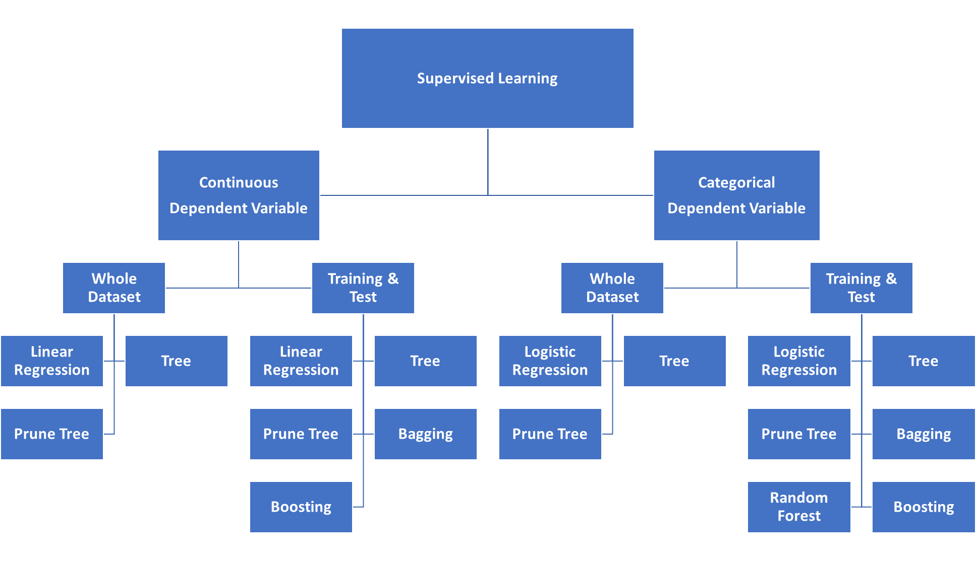

# **Appendix III: Excel for Real-life Example**

  