Professional Auto Transport, Inc.
TRANSPORTATION CONDITION REPORT
UNIFORM STRAIGHT BILL OF LADING - Original - Not Negotiable
Origin:
  MANHEIM DENVER
  17500 E. 32ND AVENUE
  DENVER,CO 80011
  Phone#: | 303-343-3443
  Contact: | under Makmal
  Destination: | AMERICAN EXPORTS  13500 S. FIGUEROA ST  LOS ANGELES,CA 90061
  Phone#: | 310-523-2300
  Contact: | car is for Makmal North America

  Color:
  Mileage: 96721
  Fuel Level: E
  Number of Keys/Remotes: 1
  Interior Condition Torn/Worn
  WT 4740 | LT 189 | HT 75
  Floor Mats: | Yes
  Books: | No
  Condition Report: | No
  Radio: | Yes
  CD: | Yes
  Spare Tire: | Yes
  Navigation Disc: | No
  Other/Notes
  missing shift knob
  Transport Fee: | $450.00
Year: 2004 Make:Lexus Model: GX 470 VIN: JTJBT20X440053747
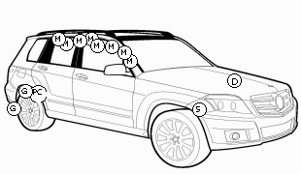 | 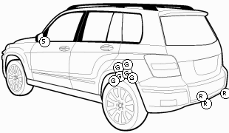

D | D | D | S | B | CR | PC | G | P | R | SS | M | L | T
Dent <1" | Dent 1-4" | Dent >4" | Scratch | Bent | Cracked | Paint Chip | Gouged | Pitted | Rubbed | Surface Scratch | Missing | Loose | Torn

Damages Recorded at origin are circled. Damages recorded at destination are squared.

  Origin
  Receipt and Condition Report
  Driver Name: MARC TAQUINO
  Truck #: 226
  Shipper Name mtaquino
  Date 6/1/2011 Time 3:03 PM
  Signature:
  
  
  Professional Auto Transport, Inc.
  Phone:888-839-7077
  Load #:161809
  Destination
  Received in good condition except as noted
  Driver Name: NORMAN ORDONEZ
  Truck #: 228
  Received by jesus
  Date 6/6/2011 Time 12:16 PM
  Signature:
  

Software by Auto Transport Logistics, Inc. www.autotransportlogistics.com 866-919-2854

