2007 TOYOTA 4 RUNNER 4X4 SR5 - SLIVER
VIN: JTEBU14R570117218 Work Order #: 1207713
GREATER NEW ORLEANS AUTO AUCTI P.O.BOX 320
SLIDELL, LA 70459
(985) 643 - 2061

VIN:
  JTEBU14R570117218
  Body Style: | SUV - Hard Top
  Ext Color/Code: | SLIVER
  Int Color/Code: | GRY
  Mileage: | 26,593
  Seller: | HERTZ CAR EXCHANGE, INC
  Title State: | MD
  Certified: | No
  Condition/Grade: | 3.0, Average
  MMR Value: | $18,664
  Sale: | 17
  Lane: | 94
  Run: | 10
  Inspection: | WJUNEAU 03/12/2008
  Drivable: | Yes
  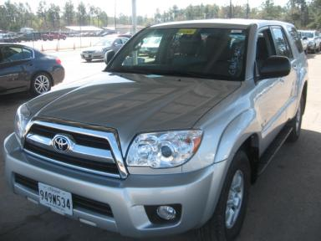 | 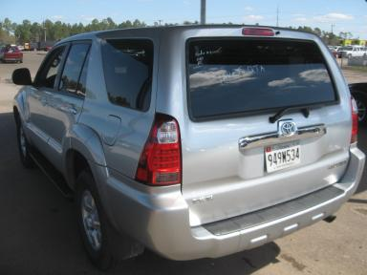
  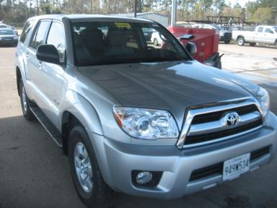 | 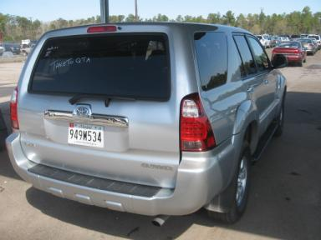
  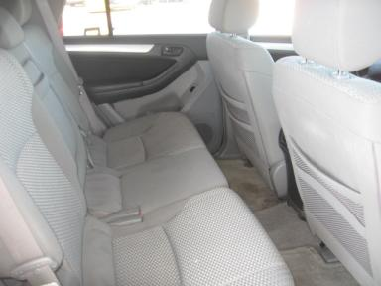 | 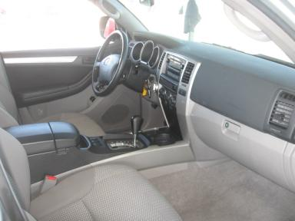
  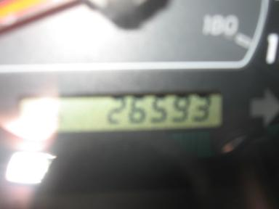

VEHICLE INFORMATION
  MECHANICAL
  6CY
  Automatic w O/D
  4X4
  Pwr Brakes
  4.6 L
  INTERIOR
  Odometer - 6 Digits Digital Operable
  Dirty
  GRY - Cloth
  Int Odor: OK
  Regular Dash
  OPTIONS
  Pwr Lock  Pwr Window  A/C  Rear Defrost  Dual Air Bags  ABS Brakes  Fog Lamps  Rear Wiper  Xenon Headlights |  | Pwr Steering  Tilt Steering  Cruise Ctl  CD Player  Power Mirrors  Tinted Windows  Trip Counter  Keyless Entry  US EPA Label
FLUID LEVELS
Fuel Level: Unknown

  TIRES AND WHEELS
  Tire | Tread Depth | Brand | Size
  Left Front: | 8/32" | DUNLOP | 265/70R16
  Right Front: | 8/32" | DUNLOP | 265/70R16
  Left Rear: | 8/32" | DUNLOP | 265/70R16
  Right Rear: | 8/32" | DUNLOP | 265/70R16
  Spare: | 12/32" | DUNLOP
  Tire Condition: Average
  Wheels: Alloy
  KEYS
  Master Key - 2
  Remote Key/Fob - 1

ANNOUNCED CONDITION:
INTERNET REMARKS:
REMARKS/ADDITIONAL DAMAGE:
DISCLOSURES:
NOTES TO CONSIGNOR:
REMARKS:
COMMENTS FOR CONSIGNOR:

2007 TOYOTA 4 RUNNER 4X4 SR5 - SLIVER
VIN: JTEBU14R570117218 Work Order #: 1207713
GREATER NEW ORLEANS AUTO AUCTI P.O.BOX 320
SLIDELL, LA 70459
(985) 643 - 2061

DAMAGES
 | DESCRIPTION | CONDITION | SEVERITY | REPAIR  HOURS | PAINT  HOURS | PART  HOURS | TOTAL  HOURS
 | Front Bumper Co | Scratch Light | 3" to 4" | .00 | .00 | .00 | .00
 | Hood | Ding | Less 1" | .00 | .00 | .00 | .00
 | LF Door Molding | Scratch Heavy | Less 1" | .00 | .00 | .00 | .00
 | L Qtr Panel | Ding | Less 1" | .00 | .00 | .00 | .00
 | Rear Door | Mult Scratches | 2" to 3" | .00 | .00 | .00 | .00
 | Rear Bumper Cov | Mult Scratches | 2" to 3" | .00 | .00 | .00 | .00
 | RF Fender | Scratched | 4" to 5" | .00 | .00 | .00 | .00
 | RR Door | Chipped | Less 1" | .00 | .00 | .00 | .00
 | RR Door Molding | Chipped | Less 1" | .00 | .00 | .00 | .00
 | Interior | Dirty | Acceptable | .00 | .00 | .00 | .00
 | Interior | Stained | Acceptable | .00 | .00 | .00 | .00
 | Overall Picture | Ovrall Picture |  | .00 | .00 | .00 | .00
 | Overall Picture | Ovrall Picture |  | .00 | .00 | .00 | .00
 | Overall Picture | Ovrall Picture |  | .00 | .00 | .00 | .00
 | Overall Picture | Ovrall Picture |  | .00 | .00 | .00 | .00
 | Overall Picture | Ovrall Picture |  | .00 | .00 | .00 | .00
 | Overall Picture | Ovrall Picture |  | .00 | .00 | .00 | .00
 | Picture #1 | Ovrall Picture |  | .00 | .00 | .00 | .00
 |  |  | TOTALS | .00 | .00 | .00 | .00



