2006 FORD EXPLORER 4X4 ED BAUER - BLACK
VIN: 1FMEU74E36UB15214 Work Order #: 5210860
NATIONAL AUTO DEALERS EXCHANGE P.O.BOX 188
BORDENTOWN, NJ 08505
(609) 298 - 3400

VIN:
  1FMEU74E36UB15214
  Body Style: | 4SUV - Hard Top
  Ext Color/Code: | BLACK
  Int Color/Code: | BEI
  Mileage: | 63,543
  Seller: | APEX FLEET AS AGENT OR ASSIGNEED OF GECFS
  Title State: | NJ
  Certified: | No
  Condition/Grade: | 3.0, Average
  MMR Value: | $12,262
  Sale: | 20
  Lane: | 94
  Run: | 31
  Inspection: | CMASSIMI 05/01/2008
  Drivable: | Yes
  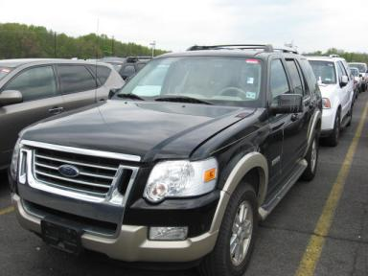 | 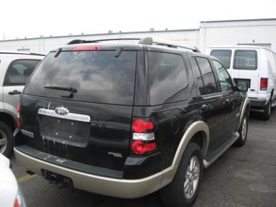
  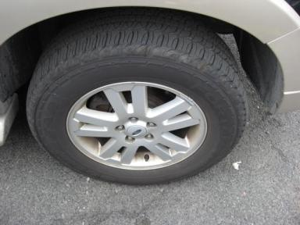 | 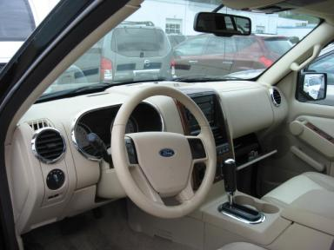
  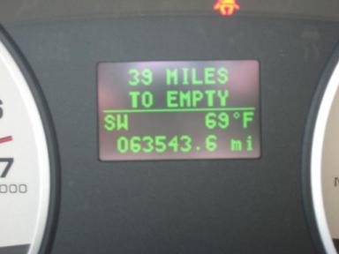

VEHICLE INFORMATION
  MECHANICAL
  6 Cylinder Gas
  Automatic
  4X4
  Pwr Brakes
  4.0 L
  INTERIOR
  Odometer - 6 Digits Digital Operable
  Average
  BEI - Leather
  Int Odor: OK
  Regular Dash
  OPTIONS
  Pwr Lock  Pwr Window  Tilt Steering  Cruise Ctl  CD Player  Dual Air Bags  ABS Brakes  4 Door  Trip Counter  NO Rear Air Conditioning  NO Third Seat  Security System  Steering Wheel Audio Control  Traction Control |  | Pwr Steering  Pwr Seats - Drivers Only  A/C  Rear Defrost  Side Air Bags  Power Mirrors  Tinted Windows  Fog Lamps  Rear Wiper  Luggage Rack  Keyless Entry  Running Board  Trailer Hitch
FLUID LEVELS
Fuel Level: Empty

  TIRES AND WHEELS
  Tire | Tread Depth | Brand | Size
  Left Front: | 10/32" | GOODYEAR | 245/65R17
  Right Front: | 10/32" | GOODYEAR | 245/65R17
  Left Rear: | 9/32" | GOODYEAR | 245/65R17
  Right Rear: | 9/32" | GOODYEAR | 245/65R17
  Spare: | 10/32" | BFGOODRICH
  Tire Condition: Good
  Wheels: Alloy
  KEYS
  Master Key - 1
  Remote Key/Fob - 1

ANNOUNCED CONDITION: 4X4
INTERNET REMARKS:
REMARKS/ADDITIONAL DAMAGE:
DISCLOSURES:
NOTES TO CONSIGNOR:
REMARKS:
COMMENTS FOR CONSIGNOR:

2006 FORD EXPLORER 4X4 ED BAUER - BLACK
VIN: 1FMEU74E36UB15214 Work Order #: 5210860
NATIONAL AUTO DEALERS EXCHANGE P.O.BOX 188
BORDENTOWN, NJ 08505
(609) 298 - 3400

DAMAGES
 | DESCRIPTION | CONDITION | SEVERITY | REPAIR  HOURS | PAINT  HOURS | PART  HOURS | TOTAL  HOURS
 | Hood | Multiple Chips | 10 or More | .50 | 3.90 | .00 | 4.40
 | Hood | Mult Scratches | Surface Damage | .00 | .00 | .00 | .00
 | Overall Picture | Ovrall Picture |  | .00 | .00 | .00 | .00
 | Overall Picture | Ovrall Picture |  | .00 | .00 | .00 | .00
 | Overall Picture | Ovrall Picture |  | .00 | .00 | .00 | .00
 | Overall Picture | Ovrall Picture |  | .00 | .00 | .00 | .00
 | Overall Picture | Ovrall Picture |  | .00 | .00 | .00 | .00
 |  |  | TOTALS | .50 | 3.90 | .00 | 4.40



