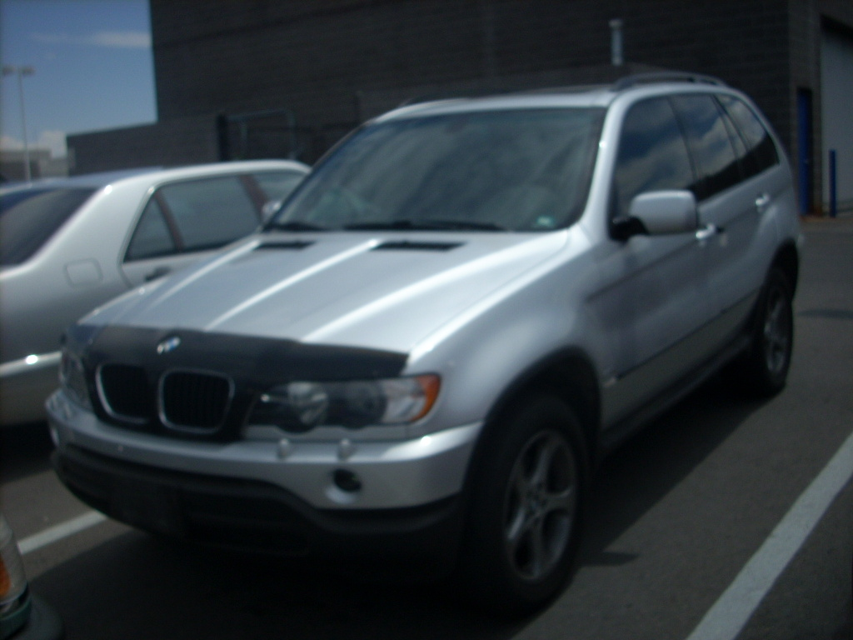

Seller Disclosure
Heated & memory seats, wood grain interior

2002 BMW X5 3.0i

National & Regional Pricing Guides
Hide
MMR  Above:  $17,100  Average:  $15,600  Below:  $14,100 | Black Book*  Extra Clean:  $19,450  Clean:  $18,050  Average:  $15,850  Rough:  $12,100
*Black Book adds and deducts are not currently included

Vehicle Specifications
Hide

Mileage: | 53,694
Transmission: | 5 Speed Automatic
Engine: | 3.0 Liter 6 Cylinder
Drive Train: | All-wheel drive
Fuel Used: | Premium Unleaded
Gas Mileage: | 15 mpg city / 20 mpg hwy
Ext Color: | Silver
Int Color: | Black
Interior Type: | Leather
Body Style: | SUV
Doors: | 4 Doors
Top Style: | Not Specified

VIN: | 5UXFA53502LP44936
Title Status: | Not Specified
Title State: | Not Specified

Vehicle Location | At Dealership  LAS VEGAS, NV
Frame Damage: | No
Prior Paint: | No

Equipment
Hide
Equipment Included:
- Air Bag - Side Curtain
- Air Conditioning
- Alloy Wheels
- Antilock Brakes
- Cruise Control
- Power Door Locks
- Power Mirrors
- Power Seats
- Power Steering
- Power Windows
- Rear Window Defroster
- Tilt/Telescope Wheel
- Tinted Glass

