Начало формы
2001 LEXUS RX300
VEHICLE IMAGES
 |  |  | GRADING
  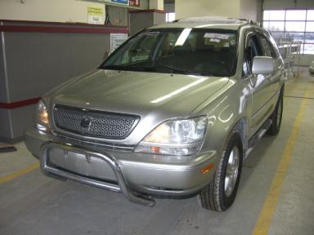 | 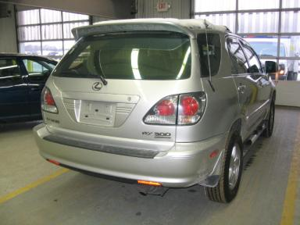
  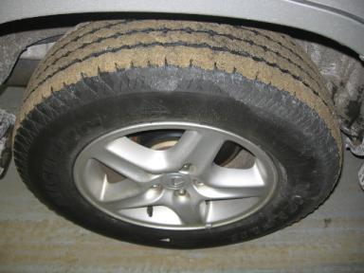 | 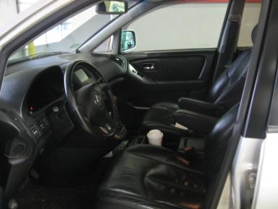
  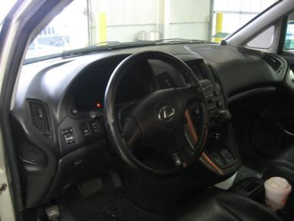 | 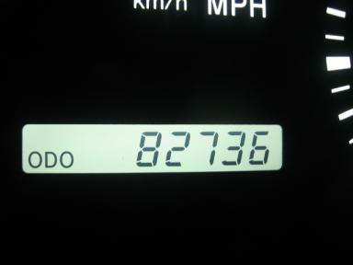
  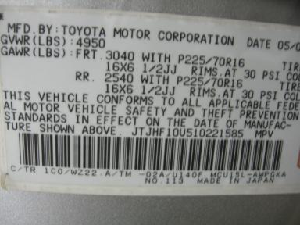
  
  Grade 3.7 Average
  Certified - No
  Drivable - Yes

VEHICLE INFORMATION
OPTIONS
Pwr Lock  Tilt Steering  Cassette Tape  ABS Brakes  NO Rear Air Conditioning  5 Passenger Seating  Running Board  Heated Seats |  | Pwr Steering  A/C  Dual Air Bags  Tinted Windows  Trip Computer  Floor Mats  Power Antenna  Memory Seat |  | Pwr Window  Cruise Ctl  50 State Emissions  4 Door  Luggage Rack  Spoiler  Traction Control  Rain Sheilds |  | Pwr Seats - Both  Rear Defrost  Power Mirrors  Rear Wiper  NO Third Seat  Security System  Grille Guard

MECHANICAL | INTERIOR
  6 Cylinder Gas
  Automatic
  Anti-lock Brakes
  3.0 L
  Dirty
  BLK - Leather
  Int Odor: OK
  Regular Dash
TIRES AND WHEELS | KEYS
  Tire Condition: | Good | Wheels: | Alloy
  Tire | Tread Depth | Brand | Size
  Left Front: | 9/32" | MICHELIN | 225/70R16
  Left Rear: | 9/32" | MICHELIN | 225/70R16
  Right Front: | 9/32" | MICHELIN | 225/70R16
  Right Rear: | 9/32" | MICHELIN | 225/70R16
  Spare: | 9/32" | GOODYEAR | 225/70R16
  Combo Key - 2

VIN: | JTJHF10U510221585 | Body Style: | 4CUV | Top Type: | Sun Roof
EXT COLOR/Code: | SILVER | INT COLOR/Code: | BLK | Mileage: | 82,736
Work Order #: | 7052730 | Lane Number: | 7 | Run Number: | 76
Seller: | BOCH TOYOTA/SCION SOUTH | Inspector: | ESULLIVAN3 01/15/2009 | Rcv Date: | 01/14/2009

ADDITIONAL INFORMATION
Common Abbreviations

DAMAGES - SUGGESTED REPAIRS
Suggested repairs are based on Manheim professional inspector's recommendation.
Total labor hours include paint, body or repair estimates.
 | DESCRIPTION | CONDITION | SEVERITY | SUGGESTED  REPAIR | TOTAL  LABOR  HOURS
 | Front Bumper Co | Repainted | Acceptable | No Action Required | .00
 | Hood | Peeling | Surface Damage | Refinish | 3.80
 | LF Fender | Repainted | Acceptable | No Action Required | .00
 | LR Door | Dent/No Paint Dmg | PDR/2 | PDR | .00
 | RF Fender | Repainted | Acceptable | No Action Required | .00
 | Owners manuals | Missing | Replacement Req | Replace | .00
 | LF Fender | Prev Repair | Acceptable | No Action Required | .00
 |  |  |  | TOTALS | 3.80


Конец формы
VIN: JTJHF10U510221585, Work Order #: 7052730

