2006 CHRYSLER 300 LIMITED - BLACK
VIN: 2C3KA53G96H532125 Work Order #: 1077124
MANHEIM NORTHSTAR MINNESOTA 4908 VALLEY INDUSTRIAL NO
SHAKOPEE, MN 55379
(952) 445 - 5544

VIN:
  2C3KA53G96H532125
  Body Style: | 4DSN - Hard Top
  Ext Color/Code: | BLACK
  Int Color/Code: | GRY
  Mileage: | 39,885
  ECM Mileage:
  Seller: | CITIFINANCIAL AUTO
  Title State: | MN
  Certified: | No
  Condition/Grade: | 3.0, Average
  Sale: | 47
  Lane: | 6
  Run: | 40
  Inspection: | TKES 11/04/2008
  Cyberlot: | No
  Drivable: | Yes
  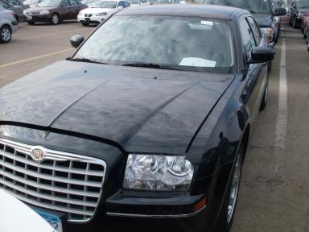 | 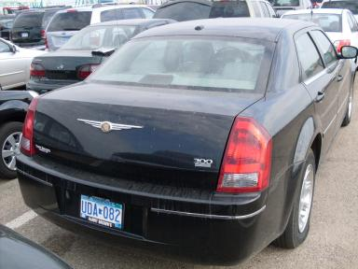
  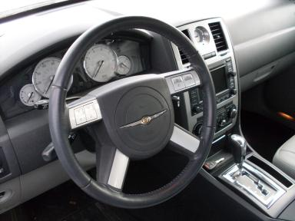

VEHICLE INFORMATION
  MECHANICAL
  6 Cylinder Gas
  Automatic
  4X2
  Pwr Brakes
  3.5 L
  INTERIOR
  Odometer - 6 Digits Digital Operable
  Dirty
  GRY - Leather
  Regular Dash
  OPTIONS
  Pwr Lock  Pwr Window  Tilt Steering  Cruise Ctl  CD Player  Power Mirrors  Tinted Windows  Fog Lamps  CD Changer - 6.00  NO Third Seat  Floor Mats  Steering Wheel Audio Control  Dual Air Conditioning  Heated Seats |  | Pwr Steering  Pwr Seats - Both  A/C  Rear Defrost  Dual Air Bags  ABS Brakes  4 Door  Trip Counter  NO Rear Air Conditioning  Two-Wheel Drive  MP3 Compatible Stereo  Traction Control  HomeLink  Navigation System
FLUID LEVELS
Fuel Level: 1/8

  TIRES AND WHEELS
  Tire | Tread Depth | Brand | Size
  Left Front: | 5/32" | GOODYEAR | 25/65R17
  Left Rear: | 5/32" | GOODYEAR | 25/65R17
  Right Front: | 5/32" | GOODYEAR | 25/65R17
  Right Rear: | 5/32" | GOODYEAR | 25/65R17
  Spare: | 4/32"
  Tire Condition: Average
  Wheels: Alloy
  KEYS
  Combo Key - 2

ANNOUNCED CONDITION: GOLD CERTIFIED
INTERNET REMARKS:
REMARKS/ADDITIONAL DAMAGE:
DISCLOSURES:
NOTES TO CONSIGNOR:
REMARKS:
COMMENTS FOR CONSIGNOR: NO NAV DISC FOUND

2006 CHRYSLER 300 LIMITED - BLACK
VIN: 2C3KA53G96H532125 Work Order #: 1077124
MANHEIM NORTHSTAR MINNESOTA 4908 VALLEY INDUSTRIAL NO
SHAKOPEE, MN 55379
(952) 445 - 5544

DAMAGES
 | DESCRIPTION | CONDITION | SEVERITY | REPAIR  HOURS | PAINT  HOURS | PART  HOURS | TOTAL  HOURS
 | F Bumper Cover | Mult Scratches | GR 12" | 1.00 | 4.20 | .00 | 5.20
 | Oil | Dirty | Replacement Req | .00 | .00 | .00 | .00
 |  |  | TOTALS | 1.00 | 4.20 | .00 | 5.20
REPAIRED
 | DESCRIPTION | CONDITION | SEVERITY | REPAIR  HOURS | PAINT  HOURS | PART  HOURS | TOTAL  HOURS
 | LR Door | Ding | PDR/1 | .00 | .00 | .00 | .00
 | R Bumper Cover | Hole | Less 1" | .00 | .00 | .00 | .00
 |  |  | TOTALS | .00 | .00 | .00 | .00



