1999 LEXUS RX300 - SILVER
VIN: JT6HF10U5X0048122 Work Order #: 2945102
MANHEIM AUTO AUCTION 1190 LANCASTER ROAD
MANHEIM, PA 17545
(717) 665 - 3571

VIN:
  JT6HF10U5X0048122
  Body Style: | 4SUV - Pwr Glass Sun Roof
  Ext Color/Code: | SILVER
  Int Color/Code: | GRY
  Mileage: | 99,630
  ECM Mileage:
  Seller: | BARD WHLS
  Certified: | No
  Condition/Grade: | 3.0, Average
  Sale: | 9
  Lane: | 18
  Run: | 940
  Inspection: | BHILL 01/16/2009
  Cyberlot: | No
  Drivable: | Yes
  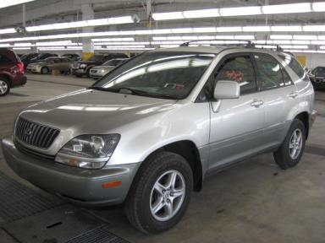 | 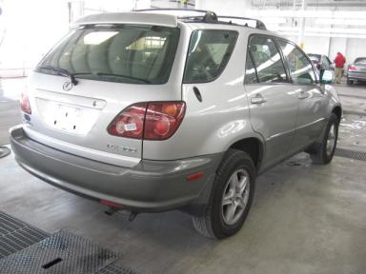
  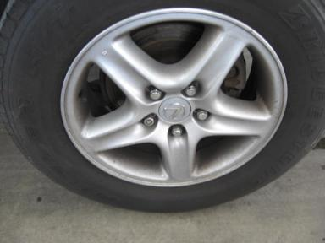 | 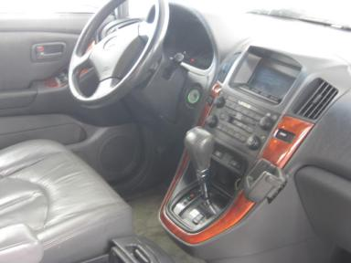
  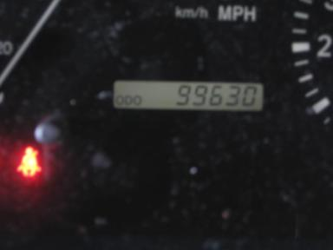 | 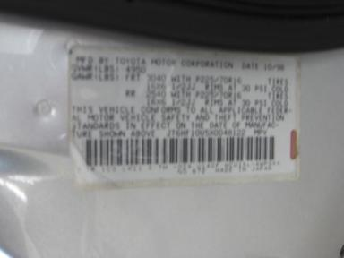

VEHICLE INFORMATION
  MECHANICAL
  6 Cylinder Gas
  Automatic w O/D
  AWD
  Pwr Brakes
  3.0 L
  INTERIOR
  Average
  GRY - Leather
  Int Odor: OK
  Wood Trim Dash
  OPTIONS
  Pwr Lock  Pwr Window  Tilt Steering  Cruise Ctl  Tape/CD  Dual Air Bags  Heated Mirrors  ABS Brakes  Trip Counter  NO Rear Air Conditioning  NO Third Seat  Power Antenna  Heated Seats  Memory Seat |  | Pwr Steering  Pwr Seats - Both  A/C  Rear Defrost  Side Air Bags  Power Mirrors  Owner's Manual  Tinted Windows  Rear Wiper  Luggage Rack  Security System  HomeLink  Wheel Locks  Woodgrain Interior Package
FLUID LEVELS
Fuel Level: Empty

  TIRES AND WHEELS
  Tire | Tread Depth | Brand | Size
  Left Front: | 6/32" | BRIDGESTONE | 225/70R16
  Left Rear: | 3/32" | BRIDGESTONE | 225/70R16
  Right Front: | 3/32" | BRIDGESTONE | 225/70R16
  Right Rear: | 3/32" | BRIDGESTONE | 225/70R16
  Spare: | 0/32" | MICHELIN
  Tire Condition: Poor
  Wheels: Alloy
  KEYS
  Combo Key - 1

ANNOUNCED CONDITION: Title Absent
INTERNET REMARKS:
REMARKS/ADDITIONAL DAMAGE:
DISCLOSURES:
NOTES TO CONSIGNOR: *HOLDING GP FOR PAYMENT
REMARKS: *HOLDING GP FOR PAYMENT
COMMENTS FOR CONSIGNOR:

1999 LEXUS RX300 - SILVER
VIN: JT6HF10U5X0048122 Work Order #: 2945102
MANHEIM AUTO AUCTION 1190 LANCASTER ROAD
MANHEIM, PA 17545
(717) 665 - 3571

DAMAGES
 | DESCRIPTION | CONDITION | SEVERITY | REPAIR  HOURS | PAINT  HOURS | PART  HOURS | TOTAL  HOURS
 | Hood | Chipped | Less 1" | .00 | .00 | .00 | .00
 | LF Door | Mult Scratches | Less 1" | .00 | .00 | .00 | .00
 | LR Door | Scratched | 3" to 4" | 1.00 | 2.80 | .00 | 3.80
 | LR Tire | Worn | Replacement Req | .00 | .00 | .00 | .00
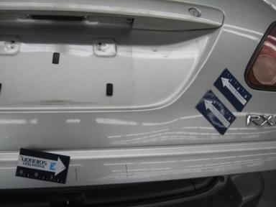 | Lift Gate | Multiple Dents | 1" to 2" | 2.00 | 3.10 | .00 | 5.10
 | Rear Bumper | Prev Repair | Substd Repair | 3.00 | 3.60 | .00 | 6.60
 | RF Tire | Worn | Replacement Req | .00 | .00 | .00 | .00
 | RR Door | Ding | PDR/1 | .00 | .00 | .00 | .00
 | R Qtr Panel | Ding | PDR/1 | .00 | .00 | .00 | .00
 | RR Tire | Worn | Replacement Req | .00 | .00 | .00 | .00
 | Front Bumper | Prev Repair | Acceptable | .00 | .00 | .00 | .00
 | Lift Gate | Mult Scratches | Less 1" | .00 | .00 | .00 | .00
 | Rear Bumper | Dent/Paint Dmg | 1" to 2" | .00 | .00 | .00 | .00
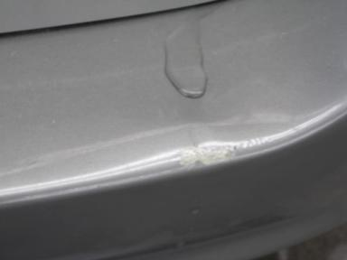 | Rear Bumper | Peeling | 5" to 6" | .00 | .00 | .00 | .00
 |  |  | TOTALS | 6.00 | 9.50 | .00 | 15.50



