Начало формы
VEHICLE DETAILS
VEHICLE IMAGES
 |  |  | GRADING
  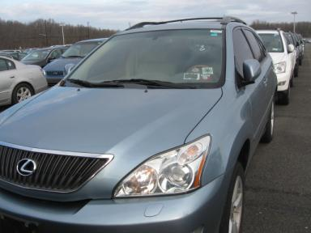 | 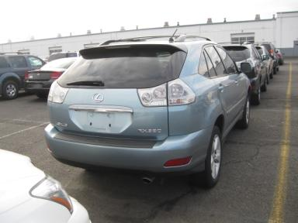
  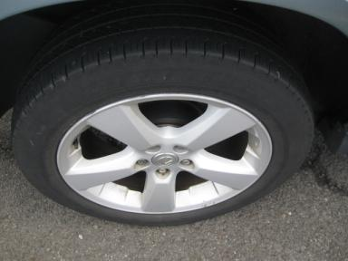 | 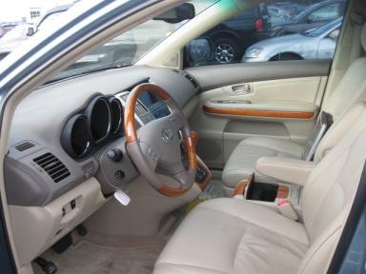
  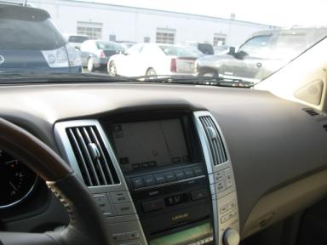 | 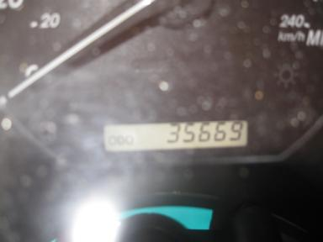
  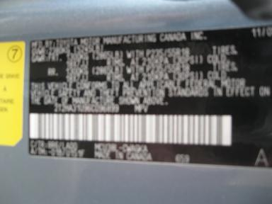 | 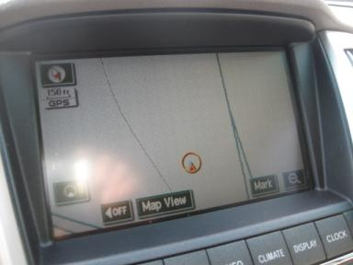
  
  Grade 4.9 Clean
  Certified - No
  Drivable - Yes

VEHICLE INFORMATION
OPTIONS
Pwr Lock  A/C  Side Air Bags  ABS Brakes  Trip Counter  Warranty Books  Security System  Heated Seats  Navigation System |  | Pwr Steering  Cruise Ctl  Dual Air Bags  Tinted Windows  CD Changer - 6.00  Luggage Rack  Steering Wheel Audio Control  Memory Seat |  | Pwr Window  Rear Defrost  Power Mirrors  4 Door  Rear Wiper  Floor Mats  Traction Control  Power Telescopic Steering |  | Pwr Seats - Both  CD Player  Owner's Manual  Maintenance Records  Power Trunk/Liftgate  US EPA Label  Dual Air Conditioning  Power Tilt Steering

MECHANICAL | INTERIOR
  6 Cylinder Gas
  Automatic
  AWD
  Pwr Brakes
  3.3 L
  Odometer - 6 Digits Digital - Operable
  Average
  BEI - Leather
  Int Odor: OK
  Regular Dash
TIRES AND WHEELS | KEYS
  Tire Condition: | Average | Wheels: | Alloy
  Tire | Tread Depth | Brand | Size
  Left Front: | 5/32" | MICHELIN | 235/55R18
  Left Rear: | 5/32" | MICHELIN | 235/55R18
  Right Front: | 5/32" | MICHELIN | 235/55R18
  Right Rear: | 5/32" | MICHELIN | 235/55R18
  Spare: | 0/32"
  Master Key - 1

2006 LEXUS RX330
VIN: | 2T2HA31U96C096899 | Body Style: | 4CUV | Top Type: | Sun Roof
EXT COLOR/Code: | BLUE | INT COLOR/Code: | BEI | Mileage: | 35,669
Work Order #: | 1922733 | Lane Number: | 11 | Run Number: | 14
Seller: | CHASE MANHATTAN AUTOMOTIVE FINANCE GROUP | Inspector: | RVERNAM 12/15/2008 | Rcv Date: | 12/10/2008

ADDITIONAL INFORMATION
Common Abbreviations

DAMAGES - SUGGESTED REPAIRS
Suggested repairs are based on Manheim professional inspector's recommendation.
Total labor hours include paint, body or repair estimates.
 | DESCRIPTION | CONDITION | SEVERITY | SUGGESTED  REPAIR | TOTAL  LABOR  HOURS
 | Hood | Chipped | 7 | Paint Chip Repair | .00
 | L Qtr Panel | Misaligned | Less 1" | PDR | .00
 |  |  |  | TOTALS | .00
REPAIRED
 | DESCRIPTION | CONDITION | SEVERITY | SUGGESTED  REPAIR | TOTAL  LABOR  HOURS
 | RF Door | Dent/No Paint Dmg | Less 1" | PDR | .00
 |  |  |  | TOTALS | .00


Конец формы
VIN: 2T2HA31U96C096899, Work Order #: 1922733

