001 LEXUS RX300 VSC - SLVER
VIN: JTJHF10U910225204 Work Order #: 6731926
MANHEIM AUTO AUCTION 1190 LANCASTER ROAD
MANHEIM, PA 17545
(717) 665 - 3571

VIN:
  JTJHF10U910225204
  Body Style: | 4SUV - Sun Roof
  Ext Color/Code: | SLVER - 1C0
  Int Color/Code: | BLK - WZ22
  Mileage: | 97,789
  ECM Mileage:
  Seller: | LEXUS FINANCIAL SERVICES/EASTERN
  Title State: | VA
  Certified: | No
  Condition/Grade: | 3.0, Average
  Sale: | 11
  Lane: | 20
  Run: | 742
  Inspection: | JMILTENBER 12/19/2008
  Drivable: | Yes
  Factory Category: | R
  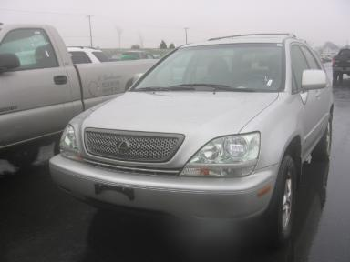 | 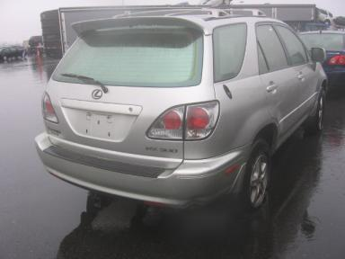
  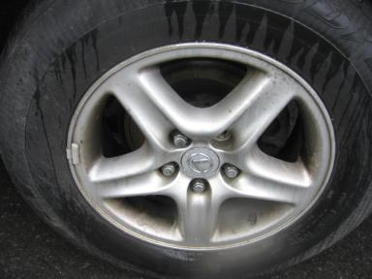 | 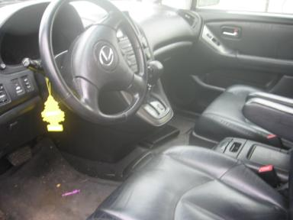
  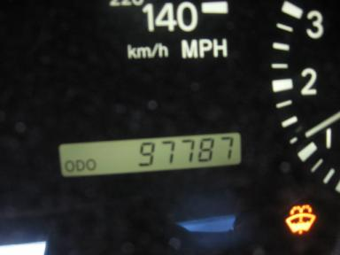 | 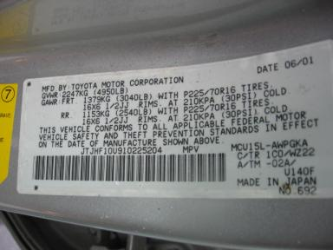

VEHICLE INFORMATION
  MECHANICAL
  6 Cylinder Gas
  Automatic w O/D
  AWD
  Pwr Brakes
  3.0 L
  INTERIOR
  Average
  BLK - Leather
  Int Odor: OK
  Regular Dash
  OPTIONS
  Pwr Lock  Pwr Window  Tilt Steering  Cruise Ctl  Cassette Tape  Dual Air Bags  Power Mirrors  Owner's Manual  Tinted Windows  Trip Counter  Rear Wiper  Trip Computer  NO Third Seat  5 Passenger Seating  US EPA Label  Trailer Hitch  HomeLink  Memory Seat |  | Pwr Steering  Pwr Seats - Both  A/C  Rear Defrost  Side Air Bags  50 State Emissions  Heated Mirrors  ABS Brakes  Fog Lamps  CD Changer - OEM - 6.00  NO Rear Air Conditioning  Luggage Rack  On-Board Computer  Floor Mats  Security System  Traction Control  Cargo Cover  Directional Stability Control
FLUID LEVELS
Fuel Level: Full

  TIRES AND WHEELS
  Tire | Tread Depth | Brand | Size
  Left Front: | 3/32" | GOODYEAR | 225/70R16
  Left Rear: | 3/32" | GOODYEAR | 225/70R16
  Right Front: | 3/32" | GOODYEAR | 225/70R16
  Right Rear: | 2/32" | GOODYEAR | 225/70R16
  Spare: | 8/32" | GOODYEAR
  Tire Condition: Poor
  Wheels: Alloy
  KEYS
  Valet Key - 1

ANNOUNCED CONDITION: AWD
INTERNET REMARKS:
REMARKS/ADDITIONAL DAMAGE:
DISCLOSURES: PD 06/01
NOTES TO CONSIGNOR:
REMARKS:
COMMENTS FOR CONSIGNOR: TOWLINE,FLAT TIRE, PD 06/01

2001 LEXUS RX300 VSC - SLVER
VIN: JTJHF10U910225204 Work Order #: 6731926
MANHEIM AUTO AUCTION 1190 LANCASTER ROAD
MANHEIM, PA 17545
(717) 665 - 3571

DAMAGES
 | DESCRIPTION | CONDITION | SEVERITY | REPAIR  HOURS | PAINT  HOURS | PART  HOURS | TOTAL  HOURS
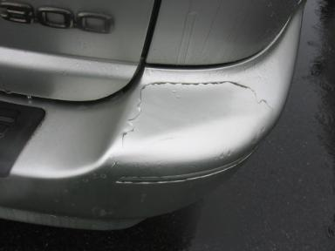 | Rear Bumper | Peeling | GR 12" | 2.00 | 3.60 | .00 | 5.60
 | RR Tire | Flat | None | .00 | .00 | .00 | .00
 | Warning - Engin | On VSC | None | .00 | .00 | .00 | .00
 | Front Bumper | Prev Repair | Acceptable | .00 | .00 | .00 | .00
 | Hood | Prev Repair | Acceptable | .00 | .00 | .00 | .00
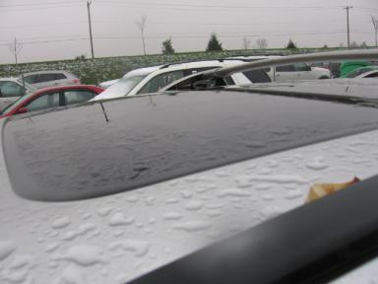 | Sun Roof | Factory | None | .00 | .00 | .00 | .00
 | Lift Gate | Prev Repair | Acceptable | .00 | .00 | .00 | .00
 | Rear Bumper | Prev Repair | Substd Repair | .00 | .00 | .00 | .00
 | RF Door | Ding | PDR/1 | .00 | .00 | .00 | .00
 | RR Door | Ding | PDR/1 | .00 | .00 | .00 | .00
 |  |  | TOTALS | 2.00 | 3.60 | .00 | 5.60



