2006 SUBARU B9 TRIBECA - SILVER
VIN: 4S4WX85C164422816 Work Order #: 7429237
MANHEIM AUTO AUCTION 1190 LANCASTER ROAD
MANHEIM, PA 17545
(717) 665 - 3571

VIN:
  4S4WX85C164422816
  Body Style: | 4SUV - Sun Roof
  Ext Color/Code: | SILVER
  Int Color/Code: | BLK
  Mileage: | 65,669
  ECM Mileage:
  Seller: | R M HOLLENSHEAD AUTO SALES INC
  Certified: | No
  Condition/Grade: | 3.0, Average
  Sale: | 12
  Lane: | 22
  Run: | 96
  Inspection: | DSCHAEFFER 02/18/2009
  Cyberlot: | No
  Drivable: | Yes
  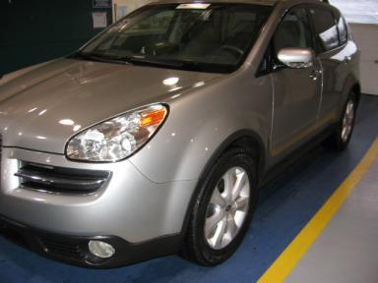 | 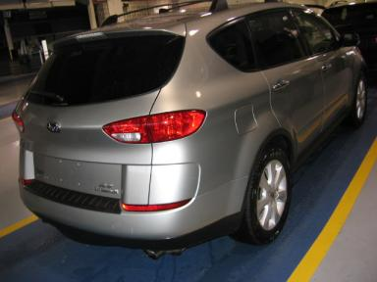
  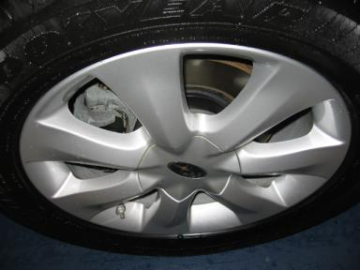 | 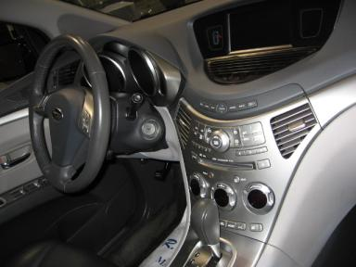
  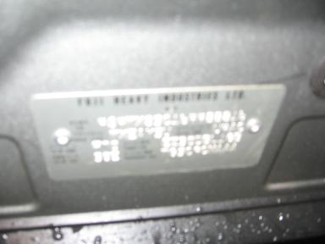

VEHICLE INFORMATION
  MECHANICAL
  6 Cylinder Gas
  Automatic
  AWD
  Pwr Brakes
  3.0 L
  INTERIOR
  Average
  BLK - Leather
  Int Odor: OK
  Regular Dash
  OPTIONS
  Pwr Lock  Pwr Window  Tilt Steering  Cruise Ctl  CD Player  Dual Air Bags  Owner's Manual  Tinted Windows  Fog Lamps  CD Changer - OEM - 6.00  NO Rear Air Conditioning  Third Seat  Floor Mats  Steering Wheel Audio Control  Dual Air Conditioning  Heated Seats  Navigation System |  | Pwr Steering  Pwr Seats - Both  A/C  Rear Defrost  Side Air Bags  Power Mirrors  ABS Brakes  4 Door  Trip Counter  Rear Wiper  Trip Computer  Luggage Rack  Security System  Traction Control  HomeLink  Memory Seat  Parking Distance Control
FLUID LEVELS
Fuel Level: Unknown

  TIRES AND WHEELS
  Tire | Tread Depth | Brand | Size
  Left Front: | 5/32" | GOODYEAR | 255/55R16
  Left Rear: | 5/32" | FALKEN | 255/55R16
  Right Front: | 4/32" | GOODYEAR | 255/55R16
  Right Rear: | 7/32" | FALKEN | 255/55R16
  Spare: | 0/32"
  Tire Condition: Average
  Wheels: Alloy
  KEYS
  Master Key - 2
  Remote Key/Fob - 1

ANNOUNCED CONDITION: T/A
INTERNET REMARKS:
REMARKS/ADDITIONAL DAMAGE:
DISCLOSURES:
NOTES TO CONSIGNOR:
REMARKS:
COMMENTS FOR CONSIGNOR:

2006 SUBARU B9 TRIBECA - SILVER
VIN: 4S4WX85C164422816 Work Order #: 7429237
MANHEIM AUTO AUCTION 1190 LANCASTER ROAD
MANHEIM, PA 17545
(717) 665 - 3571

DAMAGES
 | DESCRIPTION | CONDITION | SEVERITY | REPAIR  HOURS | PAINT  HOURS | PART  HOURS | TOTAL  HOURS
 | LR Door | Dings | PDR/2 | .00 | .00 | .00 | .00
 | L Qtr Panel | Ding | PDR/1 | .00 | .00 | .00 | .00
 | Lift Gate | Dent | 1" to 2" | .00 | .00 | .00 | .00
 | RF Fender | Multiple Dents | 2" to 3" | .00 | .00 | .00 | .00
 | RF Door | Dent/Paint Dmg | 5" to 6" | .00 | .00 | .00 | .00
 | RR Door | Dent/Paint Dmg | 4" to 5" | .00 | .00 | .00 | .00
 | R Qtr Panel | Ding | PDR/1 | .00 | .00 | .00 | .00
 | R Qtr Panel | Prev Repair | Acceptable | .00 | .00 | .00 | .00
 |  |  | TOTALS | .00 | .00 | .00 | .00



