2004 LEXUS GX470 - WHITE
VIN: JTJBT20X340068014 Work Order #: 1063584
MANHEIM MISSISSIPPI 7510 U.S. HIGHWAY 49 N.
HATTIESBURG, MS 39402
(601) 268 - 7550

VIN:
  JTJBT20X340068014
  Body Style: | 4SUV - Sun Roof
  Ext Color/Code: | WHITE
  Int Color/Code: | GRY
  Mileage: | 81,629
  ECM Mileage:
  Seller: | DRIVE FINANCIAL SERVICES
  Title State: | LA
  Certified: | No
  Condition/Grade: | 3.0, Average
  Sale: | 8
  Lane: | 61
  Run: | 60
  Inspection: | SBRYANT 02/10/2009
  Drivable: | Yes
  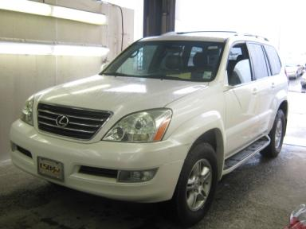 | 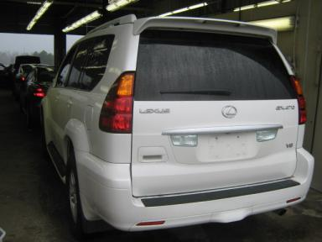
  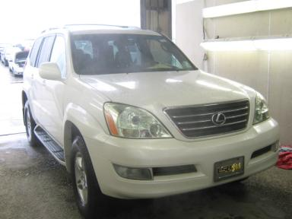 | 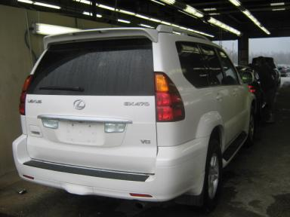
  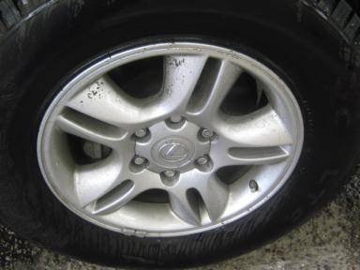 | 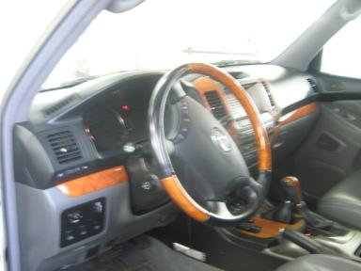
  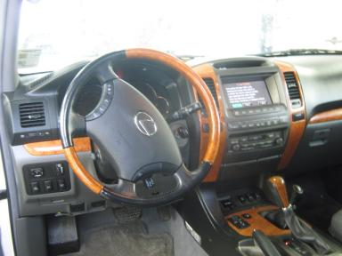 | 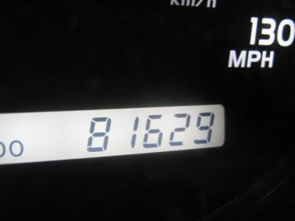
  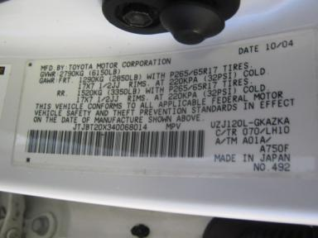 | 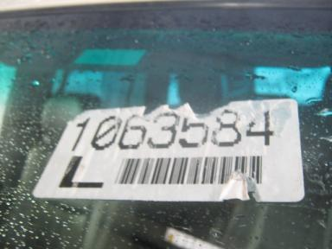
  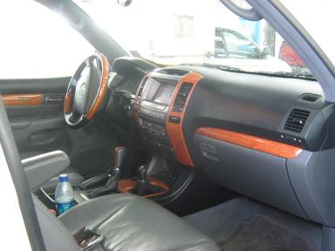

VEHICLE INFORMATION
  MECHANICAL
  8 Cylinder Gas
  Automatic
  4X4
  Pwr Brakes
  4.7 L
  INTERIOR
  Odometer - 5 Digits Digital Operable
  Average
  GRY - Leather
  Int Odor: OK
  Wood Trim Dash
  OPTIONS
  Pwr Lock  Pwr Window  Tilt Steering  Cruise Ctl  Tape/CD  Dual Air Bags  Power Mirrors  ABS Brakes  4 Door  Rear Air Conditioning  Trip Computer  Luggage Rack  Floor Mats  US EPA Label  Steering Wheel Audio Control  HomeLink  Memory Seat  Rear View Camera  Navigation System |  | Pwr Steering  Pwr Seats - Both  A/C  Rear Defrost  Side Air Bags  50 State Emissions  Owner's Manual  Tinted Windows  Trip Counter  Rear Wiper  Third Seat  On-Board Computer  Xenon Headlights  Running Board  Dual Air Conditioning  Heated Seats  DVD with Screen  Power Telescopic Steering
FLUID LEVELS
Fuel Level: Empty

  TIRES AND WHEELS
  Tire | Tread Depth | Brand | Size
  Left Front: | 12/32" | MICHELIN | 265/65R17
  Left Rear: | 12/32" | MICHELIN | 265/65R17
  Right Front: | 12/32" | MICHELIN | 265/65R17
  Right Rear: | 12/32" | MICHELIN | 265/65R17
  Spare: | 12/32" | MICHELIN
  Tire Condition: Average
  Wheels: Alloy
  KEYS
  Combo Key - 1

ANNOUNCED CONDITION: NAVI
INTERNET REMARKS:
REMARKS/ADDITIONAL DAMAGE:
DISCLOSURES:
NOTES TO CONSIGNOR:
REMARKS:
COMMENTS FOR CONSIGNOR:

2004 LEXUS GX470 - WHITE
VIN: JTJBT20X340068014 Work Order #: 1063584
MANHEIM MISSISSIPPI 7510 U.S. HIGHWAY 49 N.
HATTIESBURG, MS 39402
(601) 268 - 7550

DAMAGES
 | DESCRIPTION | CONDITION | SEVERITY | REPAIR  HOURS | PAINT  HOURS | PART  HOURS | TOTAL  HOURS
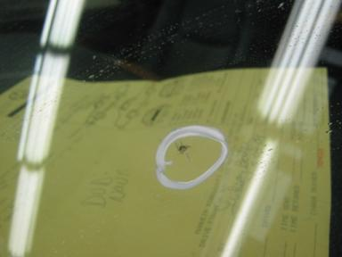 | Windshield | Star in Glass | Less 1" | .00 | .00 | .00 | .00
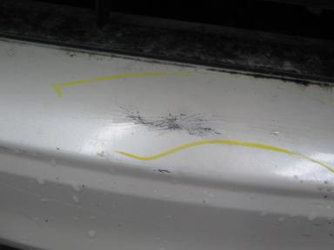 | Front Bumper Co | Dent/Paint Dmg | 2" to 3" | 3.00 | 4.40 | .00 | 7.40
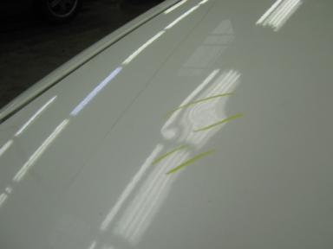 | Hood | Multiple Dents | Less 1" | 4.00 | 4.60 | .00 | 8.60
 | LF Fender | Scuffed | 2" to 3" | .00 | .00 | .00 | .00
 | LF Fender Moldi | Dent/Paint Dmg | 3" to 4" | 2.00 | .00 | .00 | 2.00
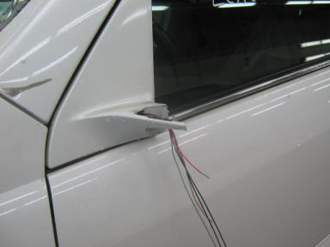 | LF Mirror Housi | Broken | Replacement Req | .00 | .00 | 1.00 | 1.00
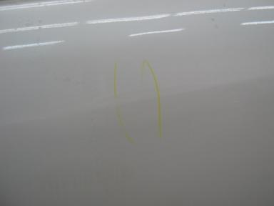 | LR Door | Dent | 2" to 3" | 2.00 | 3.70 | .00 | 5.70
 | R Qtr Panel | Prev Repair | Acceptable | .00 | .00 | .00 | .00
 |  |  | TOTALS | 11.00 | 12.70 | 1.00 | 24.70



