2003 LEXUS GX470 - SILVER
VIN: JTJBT20XX30010934 Work Order #: 6051780
Manheim Orlando 11801 W Colonial Dr
Ocoee, FL 34761-3328
(407) 656-6200

VIN:
  JTJBT20XX30010934
  Body Style: | 4SUV - Sun Roof
  Ext Color/Code: | SILVER
  Int Color/Code: | GRA
  Mileage: | 131,437
  ECM Mileage:
  Seller: | LEXUS FINANCIAL SERVICES/NASHVILLE
  Title State: | FL
  Certified: | No
  Condition/Grade: | 3.0, Average
  Sale: | 11
  Lane: | 20
  Run: | 130
  Inspection: | RBEVILACQU 02/17/2009
  Drivable: | Yes
  Factory Category: | R
  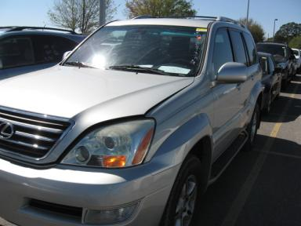 | 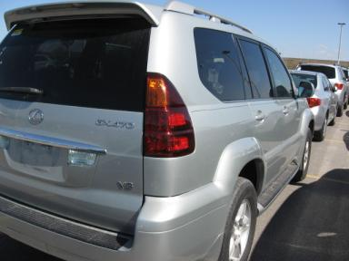
  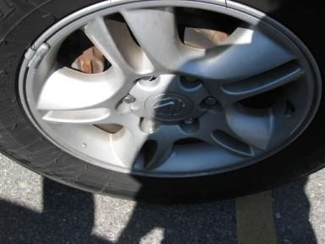 | 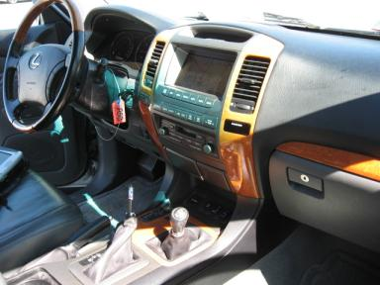
  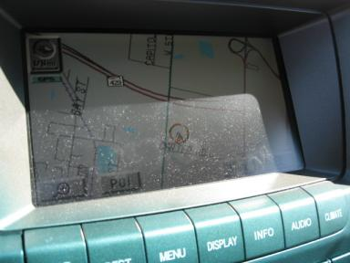 | 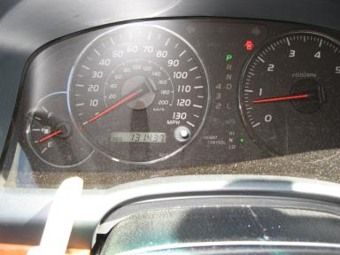
  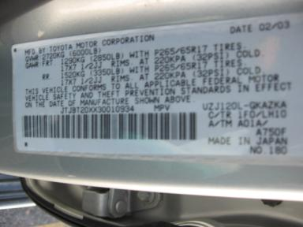

VEHICLE INFORMATION
  MECHANICAL
  8 Cylinder Gas
  Automatic
  4X4
  Pwr Brakes
  4.7 L
  INTERIOR
  Odometer - 6 Digits Digital Operable
  Average
  GRA - Leather
  Int Odor: OK
  Wood Trim Dash
  OPTIONS
  Pwr Lock  Pwr Window  Tilt Steering  Cruise Ctl  Cassette Tape  Dual Air Bags  ABS Brakes  Fog Lamps  Rear Air Conditioning  Third Seat  Floor Mats  Running Board  Auto-Suspension  HomeLink  Wheel Locks  Woodgrain Interior Package  Power Tilt Steering |  | Pwr Steering  Pwr Seats - Both  A/C  Rear Defrost  Side Air Bags  Power Mirrors  Premium Stereo - MARK LEVINSON  Trip Counter  Rear Wiper  Luggage Rack  8 Passenger Seating  Steering Wheel Audio Control  Dual Air Conditioning  Heated Seats  Memory Seat  Power Telescopic Steering  Navigation System
FLUID LEVELS
Fuel Level: 1/4

  TIRES AND WHEELS
  Tire | Tread Depth | Brand | Size
  Left Front: | 5/32" | DUNLOP | 265/65R17
  Left Rear: | 6/32" | DUNLOP | 265/65R17
  Right Front: | 5/32" | DUNLOP | 265/65R17
  Right Rear: | 5/32" | DUNLOP | 265/65R17
  Spare: | 6/32" | DUNLOP
  Tire Condition: Average
  Wheels: Alloy
  KEYS
  Master Key - 1

ANNOUNCED CONDITION: LA,DC,GPS AS-IS OVER 100K MLS
INTERNET REMARKS:
REMARKS/ADDITIONAL DAMAGE:
DISCLOSURES:
NOTES TO CONSIGNOR: *1 MST KNOB **MO
REMARKS: *1 MST KNOB **MO
COMMENTS FOR CONSIGNOR:

2003 LEXUS GX470 - SILVER
VIN: JTJBT20XX30010934 Work Order #: 6051780
Manheim Orlando 11801 W Colonial Dr
Ocoee, FL 34761-3328
(407) 656-6200

DAMAGES
 | DESCRIPTION | CONDITION | SEVERITY | REPAIR  HOURS | PAINT  HOURS | PART  HOURS | TOTAL  HOURS
 | Windshield | Star in Glass | Less 1" | .00 | .00 | .00 | .00
 | Front Bumper | Prev Repair | Vsbl Close Insp | .00 | .00 | .00 | .00
 | Headlights | Faded | Vsbl Close Insp | .00 | .00 | .00 | .00
 | Hood | Multiple Chips | Vsbl Close Insp | .00 | .00 | .00 | .00
 | LF Door Molding | Chipped | Vsbl Close Insp | .00 | .00 | .00 | .00
 | Rear Bumper | Prev Repair | Vsbl Close Insp | .00 | .00 | .00 | .00
 | RF Fender | Dent/Paint Dmg | Less 1" | .00 | .00 | .00 | .00
 | R Qtr Panel | Ding | PDR/1 | .00 | .00 | .00 | .00
 |  |  | TOTALS | .00 | .00 | .00 | .00



