Начало формы
Manheim New Jersey
VEHICLE DETAILS
2005 BMW X5 4.4L
VIN: | 5UXFB53575LV19558 | Body Style: | 4CUV | Top Type: | Panoramic
EXT COLOR/Code: | TITANIUM- 354 | INT COLOR/Code: | BLA | Mileage: | 67,421
Work Order #: | 6632692 | Lane Number: | 14 | Run Number: | 209
Seller: | FINANCIAL SERVICES REMARKETING (LEASE) | Inspector: | EFLUKEY 08/25/2008 | Rcv Date: | 08/25/2008

730 Route 68
Bordentown, NJ 08505-4504
(609) 298-3400

VEHICLE IMAGES
 |  |  | GRADING
  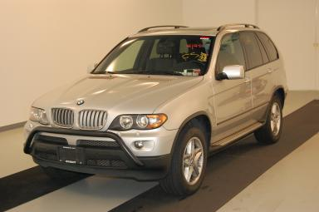 | 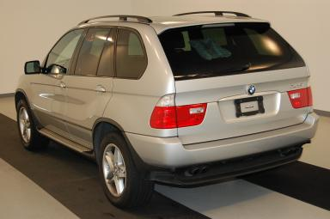
  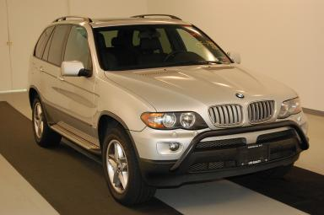 | 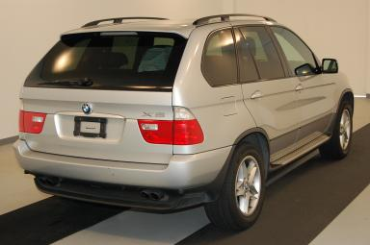
  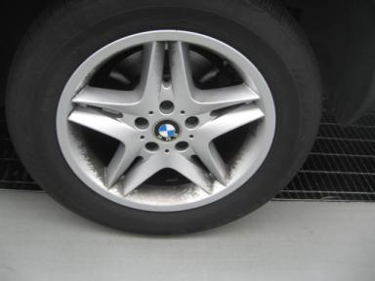 | 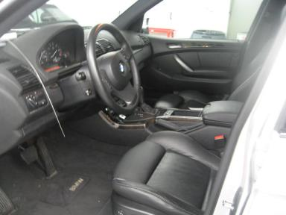
  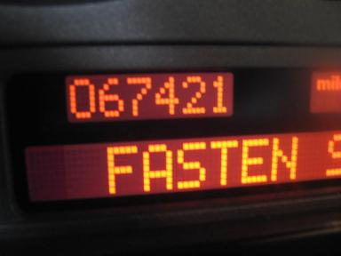 | 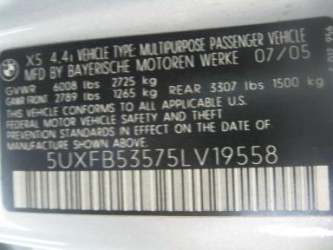
  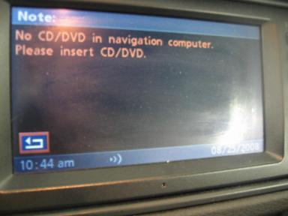
  Grade 4.0 Clean
  Certified - No
  Drivable - Yes

VEHICLE INFORMATION
OPTIONS
Pwr Lock  A/C  Side Air Bags  Owner's Manual  Trip Counter  Cold Weather Package  Floor Mats  Running Board  Panoramic Glass Roof  HomeLink  ST - Steptronic Transmission  Rain Sensor  Power Tilt Steering  Directional Stability Control  Heated Seats - Front |  | Pwr Steering  Cruise Ctl  Dual Air Bags  ABS Brakes  CD Changer - OM - 6.00  Trip Computer  Xenon Headlights  Steering Wheel Audio Control  Dual Air Conditioning  Heated Seats  XL - Xenon Headlights  Tire Pressure Monitor  Heated Steering Wheel  Parking Distance Control  Cell Phone - OEM |  | Pwr Window  Rear Defrost  Power Mirrors  Tinted Windows  Rear Wiper  Luggage Rack  DSC-Dynamic Stability Control  HSW - Heated Steering Wheel  Grille Guard  Cargo Cover  Memory Seat  Power Telescopic Steering  Navigation System  Sunshade - Manual |  | Pwr Seats - Both  Cassette Tape  Power Folding Mirrors  Fog Lamps  Power Trunk/Liftgate  On-Board Computer  Security System  Traction Control  HDC - Hill Descent Control  Sport/Premium Package  Woodgrain Interior Package  Panoramic Glass Roof  Rain Sensor Windshield  Power Seats - Dual

MECHANICAL | INTERIOR
  8 Cylinder Gas
  Steptronic
  AWD
  Pwr Brakes
  4.4 L
  Odometer - 6 Digits Digital - Operable
  Average
  BLA - Leather
  Int Odor: Smoke
  Wood Trim Dash
TIRES AND WHEELS | KEYS
  Tire Condition: | Average | Wheels: | Alloy
  Tire | Tread Depth | Brand | Size
  Left Front: | 7/32" | MICHELIN | 255/55R18
  Left Rear: | 7/32" | MICHELIN | 255/55R18
  Right Front: | 7/32" | MICHELIN | 255/55R18
  Right Rear: | 6/32" | MICHELIN | 255/55R18
  Spare: | 11/32" | MICHELIN | 235/65R17
  Master Key - 2
  Spare Key - 1

ADDITIONAL INFORMATION
*K1,CD,CWP,NAV,PDC,SS,XL,
*RF WINDOW INOP
Common Abbreviations

DAMAGES - SUGGESTED REPAIRS
Suggested repairs are based on Manheim professional inspector's recommendation.
Total labor hours include paint, body or repair estimates.
 | DESCRIPTION | CONDITION | SEVERITY | SUGGESTED  REPAIR | TOTAL  LABOR  HOURS
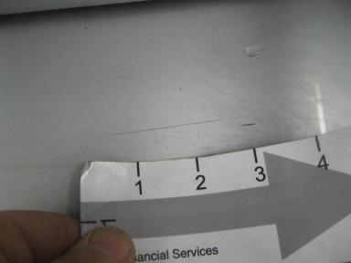 | Rear Bumper | Mult Scratches | 2" to 3" | Repair | 5.20
 | Nav Disc | Missing | Replacement Req | Replace | .00
 | Windshield | Chipped | Vsbl Close Insp | No Action Required | .00
 | Hood | Chipped | Vsbl Close Insp | Touch Up | .50
 | LR Door | Ding | PDR/1 | PDR | .00
 | RF Mirror Housi | Scratch Light | Buffable | Detail | .00
 | Steering Wheel | Scratches | Surface Damage | Touch Up | .50
 |  |  |  | TOTALS | 6.20


Конец формы
VIN: 5UXFB53575LV19558, Work Order #: 6632692

