Начало формы
VEHICLE DETAILS
VEHICLE IMAGES
 |  |  | GRADING
  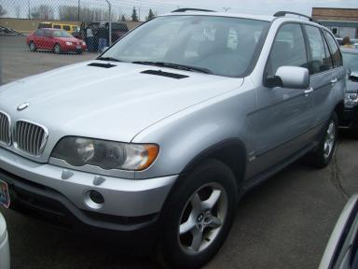 | 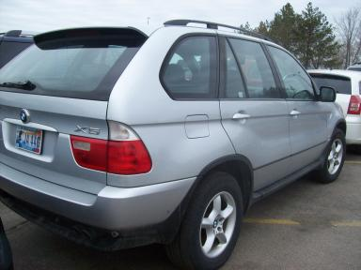
  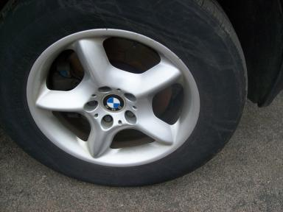 | 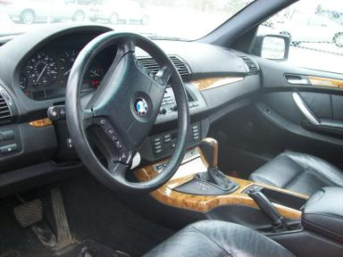
  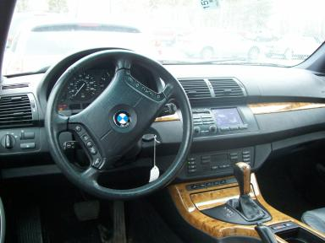 | 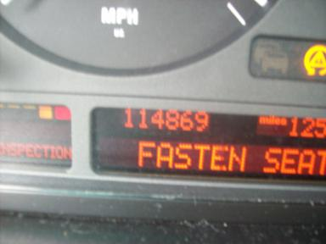
  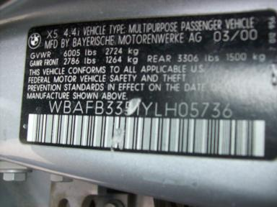
  
  Grade
  More About Auto Grade
  Certified - No
  Drivable - Yes

VEHICLE INFORMATION
OPTIONS
Pwr Lock  Tilt Steering  Cassette Tape  Owner's Manual  Rear Wiper  5 Passenger Seating  Dual Air Conditioning  Woodgrain Interior Package |  | Pwr Steering  A/C  Side Air Bags  ABS Brakes  NO Rear Air Conditioning  US EPA Label  HomeLink |  | Pwr Window  Cruise Ctl  Dual Air Bags  Fog Lamps  Warranty Books  Steering Wheel Audio Control  Heated Seats |  | Pwr Seats - Both  Rear Defrost  Power Mirrors  Trip Counter  NO Third Seat  2 Captain Seats 1 Bench  Memory Seat

MECHANICAL | INTERIOR
  8 Cylinder Gas
  Automatic
  AWD
  Pwr Brakes
  4.4 L
  Dirty
  GRY - Leather
TIRES AND WHEELS | KEYS
  Tire Condition: | Average | Wheels: | Alloy
  Tire | Tread Depth | Brand | Size
  Left Front: | 6/32" | MICHELIN | 235/65R17
  Left Rear: | 6/32" | MICHELIN | 235/65R17
  Right Front: | 6/32" | MICHELIN | 235/65R17
  Right Rear: | 6/32" | MICHELIN | 235/65R17
  Spare: | 10/32" | MICHELIN | 235/65R17
  Master Key - 1

2000 BMW X5 4.4L
VIN: | WBAFB3351YLH05736 | Body Style: | 4CUV | Top Type: | Moon Roof
EXT COLOR/Code: | SILVER | INT COLOR/Code: | GRY | Mileage: | 114,869
Work Order #: | 1529660 | Lane Number: | 20 | Run Number: | 40
Seller: | UNITED EDUCATORS CREDIT UNION | Inspector: | LDICK 03/30/2009 | Rcv Date: | 03/27/2009

ADDITIONAL INFORMATION
AS IS MILES OVER AWD
Common Abbreviations

DAMAGES - SUGGESTED REPAIRS
Suggested repairs are based on Manheim professional inspector's recommendation.
Total labor hours include paint, body or repair estimates.
 | DESCRIPTION | CONDITION | SEVERITY | SUGGESTED  REPAIR | TOTAL  LABOR  HOURS
 | Front Bumper | Chipped | 1 | Paint Chip Repair | .00
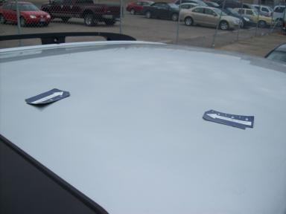 | Roof | Hail Dmg Heavy | Less 1" | Repair | 12.30
 | LF Door | Multiple Chips | 2 | Paint Chip Repair | .00
 | LF Door | Multiple Dents | PDR/2 | PDR | .00
 | Rear Bumper | Multiple Dents | 1" to 2" | Partial Repair | .00
 | Gas | Low Fluid | None | Replace | .00
 | L Qtr Panel | Dent | Less 1" | Repair | 4.10
 | RF Door | Prev Repair | Acceptable | No Action Required | .00
 | RR Door | Prev Repair | Acceptable | No Action Required | .00
 | R Qtr Panel | Prev Repair | Acceptable | No Action Required | .00
 |  |  |  | TOTALS | 16.40


Конец формы
VIN: WBAFB3351YLH05736, Work Order #: 1529660

