2005 LEXUS RX330 - SILVER
VIN: JTJHA31U150074535 Work Order #: 3326294
Manheim San Francisco Bay 29900 Auction Ct
Hayward, CA 94544-6914
(510) 786-4500

VIN:
  JTJHA31U150074535
  Body Style: | 4CUV - Moon Roof
  Ext Color/Code: | SILVER - 6T1
  Int Color/Code: | GRY - LA11
  Mileage: | 96,826
  ECM Mileage:
  Seller: | LEXUS FINANCIAL SERVICES/TORRANCE
  Title State: | CA
  Certified: | No
  Condition/Grade: | 3.0, Average
  Sale: | 18
  Lane: | 17
  Run: | 138
  Inspection: | DHENSING 04/02/2009
  Cyberlot: | No
  Drivable: | Yes
  Factory Category: | L
  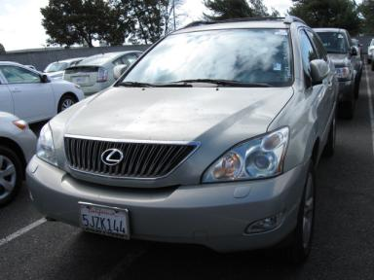 | 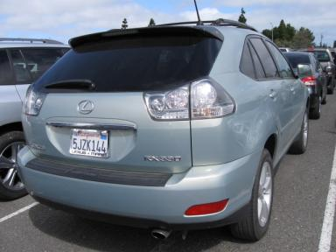
  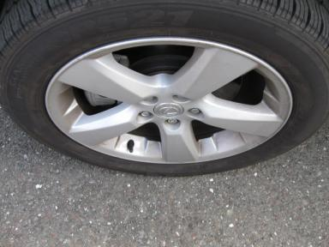 | 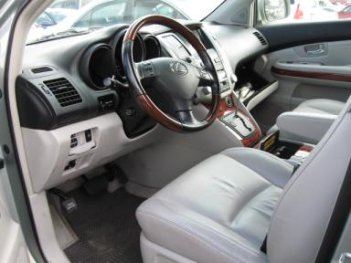

VEHICLE INFORMATION
  MECHANICAL
  6 Cylinder Gas
  Automatic
  AWD
  Pwr Brakes
  3.3 L
  INTERIOR
  Odometer - 6 Digits Digital Operable
  Average
  GRY - Leather
  Int Odor: OK
  Regular Dash
  OPTIONS
  Pwr Lock  Pwr Window  A/C  Rear Defrost  Side Air Bags  50 State Emissions  Owner's Manual  4 Door  Luggage Rack  Steering Wheel Audio Control  Cargo Cover |  | Pwr Steering  Tilt Steering  Cruise Ctl  Tape/CD  Dual Air Bags  Power Mirrors  ABS Brakes  Fog Lamps  US EPA Label  Heated Seats
FLUID LEVELS
Fuel Level: Unknown

  TIRES AND WHEELS
  Tire | Tread Depth | Brand | Size
  Left Front: | 8/32" | NEXEN | 235/55R18
  Left Rear: | 5/32" | MICHELIN | 235/55R18
  Right Front: | 5/32" | MICHELIN | 235/55R18
  Right Rear: | 5/32" | MICHELIN | 235/55R18
  Spare: | 5/32" | MICHELIN
  Tire Condition: Poor
  KEYS
  Valet Key - 1
  Combo Key - 1

ANNOUNCED CONDITION: LEASE/DMV$BP, Navigation CD Present, Shift Knob Present, GSK/MASTER KEY/NAV CD IN F/L
INTERNET REMARKS:
REMARKS/ADDITIONAL DAMAGE:
DISCLOSURES:
NOTES TO CONSIGNOR:
REMARKS:
COMMENTS FOR CONSIGNOR:

2005 LEXUS RX330 - SILVER
VIN: JTJHA31U150074535 Work Order #: 3326294
Manheim San Francisco Bay 29900 Auction Ct
Hayward, CA 94544-6914
(510) 786-4500

DAMAGES
 | DESCRIPTION | CONDITION | SEVERITY | REPAIR  HOURS | PAINT  HOURS | PART  HOURS | TOTAL  HOURS
 | LF Door | Multiple Dents | Less 1" | .00 | .00 | .00 | .00
 | LR Tire | Worn | Replacement Req | .00 | .00 | .00 | .00
 | Rear Bumper Cov | Dent/Paint Dmg | 1" to 2" | 1.00 | 3.60 | .00 | 4.60
 | Spare Tire | Worn | Replacement Req | .00 | .00 | .30 | .30
 | RF Tire | Worn | Replacement Req | .00 | .00 | .00 | .00
 | RF Door | Multiple Dents | 1" to 2" | .00 | .00 | .00 | .00
 | R Qtr Panel | Dent | 1" to 2" | .00 | .00 | .00 | .00
 | RR Tire | Worn | Replacement Req | .00 | .00 | .00 | .00
 | RR Wheel | Scratched | 3" to 4" | .00 | .00 | .00 | .00
 |  |  | TOTALS | 1.00 | 3.60 | .30 | 4.90



