Начало формы
VEHICLE DETAILS
VEHICLE IMAGES
 |  |  | GRADING
  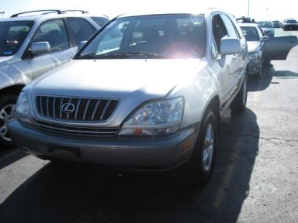 | 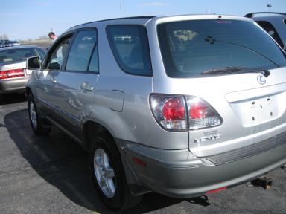
  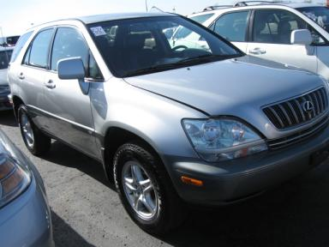 | 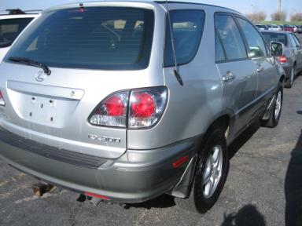
  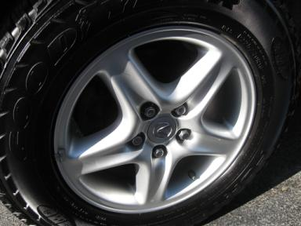 | 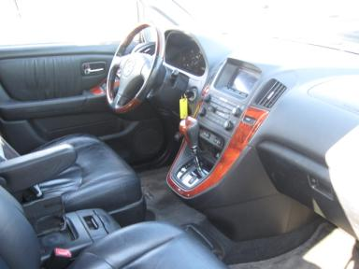
  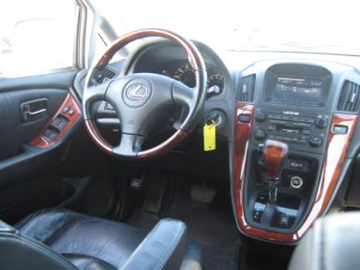 | 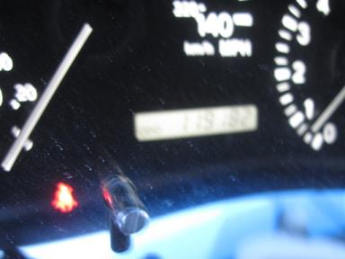
  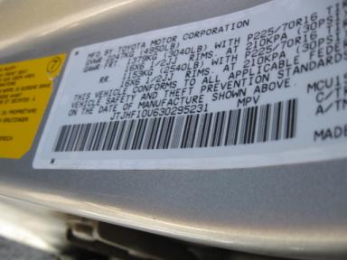 | 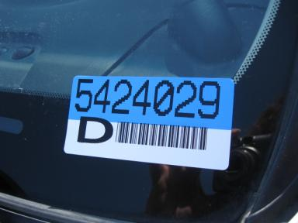
  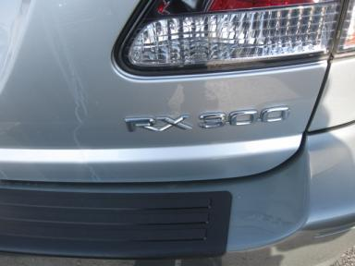
  
  Grade 3.3 Average
  More About Auto Grade
  Certified - No
  Drivable - Yes

VEHICLE INFORMATION
OPTIONS
Pwr Lock  Tilt Steering  Tape/CD  ABS Brakes  Rear Wiper  Trailer Hitch  Heated Seats |  | Pwr Steering  A/C  Dual Air Bags  Tinted Windows  Trip Computer  Traction Control  Woodgrain Interior Package |  | Pwr Window  Cruise Ctl  Power Mirrors  Fog Lamps  Floor Mats  Trailer Plug  Hand Tool Kit |  | Pwr Seats - Both  Rear Defrost  Owner's Manual  Rear Air Conditioning  Security System  HomeLink

MECHANICAL | INTERIOR
  6 Cylinder Gas
  Automatic
  AWD
  Pwr Brakes
  3.0 L
  BLK - Leather
  Wood Trim Dash
TIRES AND WHEELS | KEYS
  Tire Condition: |  | Wheels:
  Tire | Tread Depth | Brand | Size
  Left Front: | 7/32" | GOODYEAR | 225/70R16
  Left Rear: | 7/32" | GOODYEAR | 225/70R16
  Right Front: | 7/32" | GOODYEAR | 225/70R16
  Right Rear: | 7/32" | GOODYEAR | 225/70R16
  Spare: | 0/32" | GOODYEAR | 225/70R16
  Combo Key - 1

2003 LEXUS RX300
VIN: | JTJHF10U630295231 | Body Style: | 4CUV | Top Type: | Sun Roof
EXT COLOR/Code: | SLVR | INT COLOR/Code: | BLK | Mileage: | 119,182
Work Order #: | 5424029 | Lane Number: | 2 | Run Number: | 17
Seller: | SUPERIOR LEXUS | Inspector: | LCOLLINS2 04/21/2009 | Rcv Date: | 04/21/2009

ADDITIONAL INFORMATION
MI OVER LT AS IS
Common Abbreviations

DAMAGES - SUGGESTED REPAIRS
Suggested repairs are based on Manheim professional inspector's recommendation.
Total labor hours include paint, body or repair estimates.
 | DESCRIPTION | CONDITION | SEVERITY | SUGGESTED  REPAIR | TOTAL  LABOR  HOURS
 | LR Door | Dent/No Paint Dmg | PDR/2 | PDR | .00
 | RR Door | Dent/No Paint Dmg | PDR/3 | PDR | .00
 | Windshield | Chipped | Vsbl Close Insp | No Action Required | .00
 | Front Bumper Co | Chipped | Surface Damage | Brush Touch | .00
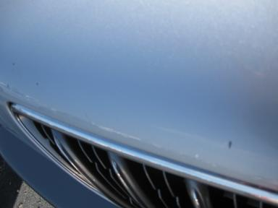 | Hood | Multiple Chips | Surface Damage | Refinish | 3.80
 | LF Fender | Chipped | Surface Damage | Brush Touch | .00
 | LF Door | Scratched | Surface Damage | Wet Sand | .00
 | LR Door | Scratched | Surface Damage | Wet Sand | .00
 | L Qtr Panel | Chipped | Surface Damage | Brush Touch | .00
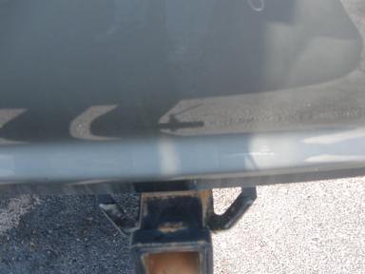 | Rear Bumper Cov | Scratched | Body Damage | Repair | 3.60
 | RF Fender | Scratched | Surface Damage | Wet Sand | .00
 | RF Door | Scratched | Surface Damage | Wet Sand | .00
 | RR Door | Scratched | Surface Damage | Wet Sand | .00
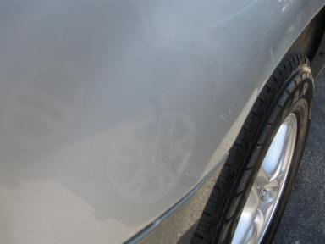 | R Qtr Panel | Dent/Paint Dmg | Body Damage | Repair | 5.30
 |  |  |  | TOTALS | 12.70


Конец формы
VIN: JTJHF10U630295231, Work Order #: 5424029

