Начало формы
VEHICLE DETAILS
VEHICLE IMAGES
 |  |  | GRADING
  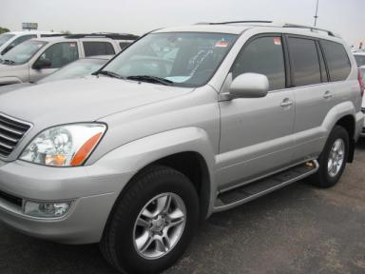 | 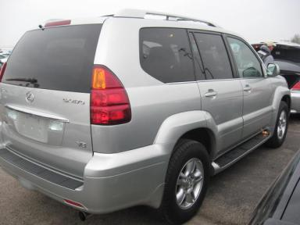
  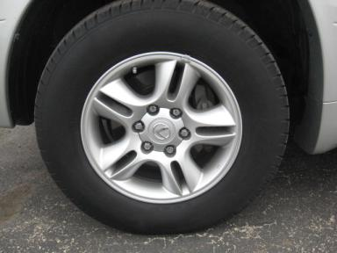 | 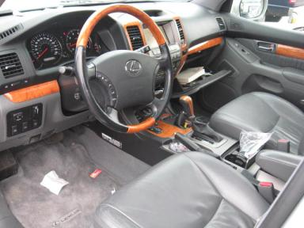
  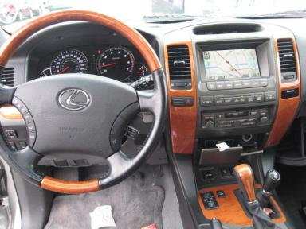 | 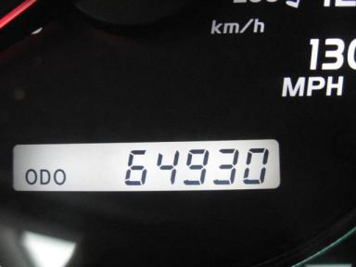
  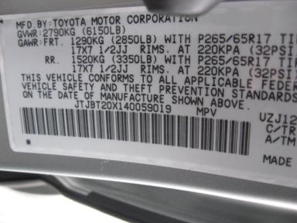
  
  Grade 4.2 Clean
  More About Auto Grade
  Certified - No
  Drivable - Yes

VEHICLE INFORMATION
OPTIONS
Pwr Lock  Tilt Steering  Cassette Tape  Owner's Manual  Fog Lamps  Third Seat  Running Board  Heated Seats  Power Tilt Steering |  | Pwr Steering  A/C  Side Air Bags  ABS Brakes  Trip Counter  Luggage Rack  Steering Wheel Audio Control  Memory Seat  Navigation System |  | Pwr Window  Cruise Ctl  Dual Air Bags  Tinted Windows  Rear Air Conditioning  Floor Mats  Traction Control  Rear View Camera |  | Memory Seats  Rear Defrost  Power Mirrors  4 Door  Rear Wiper  Security System  Dual Air Conditioning  Woodgrain Interior Package

MECHANICAL | INTERIOR
  8 Cylinder Gas
  Automatic
  4X4
  Pwr Brakes
  4.7 L
  Odometer - 6 Digits Analog - Operable
  Clean
  Leather
  Int Odor: OK
  Wood Trim Dash
TIRES AND WHEELS | KEYS
  Tire Condition: | Good | Wheels: | Alloy
  Tire | Tread Depth | Brand | Size
  Left Front: | 7/32" | MICHELIN | 265/65R17
  Left Rear: | 7/32" | MICHELIN | 265/65R17
  Right Front: | 7/32" | MICHELIN | 265/65R17
  Right Rear: | 8/32" | MICHELIN | 265/65R17
  Spare: | 0/32" | MICHELIN | 265/65R17
  Master Key - 2
  Spare Key - 1

2004 LEXUS GX470
VIN: | JTJBT20X140059019 | Body Style: | 4SUV | Top Type: | Moon Roof
EXT COLOR/Code: | SILVER | Mileage: | 64,930
Work Order #: | 1155339 | Lane Number: | 9 | Run Number: | 246
Seller: | UNION LEASING EXCHANGE LLC | Inspector: | JAGUILAR 05/06/2009 | Rcv Date: | 05/05/2009

ADDITIONAL INFORMATION
HAS NAV/NO NAV DISCS TA SG
*HAS NAV/NO NAV DISCS
Common Abbreviations

DAMAGES - SUGGESTED REPAIRS
Suggested repairs are based on Manheim professional inspector's recommendation.
Total labor hours include paint, body or repair estimates.
 | DESCRIPTION | CONDITION | SEVERITY | SUGGESTED  REPAIR | TOTAL  LABOR  HOURS
 | Hood | Multiple Chips | 5" to 6" | Refinish | 3.80
 | Lift Gate | Dent/No Paint Dmg | PDR/1 | PDR | .00
 | R Qtr Panel | Scratch Light | 1" to 2" | Wet Sand | .00
 | Keyless Remote | Missing | Replacement Req | Replace | .00
 | Front Bumper Co | Chipped | 1" to 2" | No Action Required | .00
 | L Qtr Panel Mol | Dent/Paint Dmg | 1" to 2" | No Action Required | .00
 | R Qtr Panel Mol | Chipped | 1" to 2" | No Action Required | .00
 |  |  |  | TOTALS | 3.80


Конец формы
VIN: JTJBT20X140059019, Work Order #: 1155339

