Начало формы
VEHICLE DETAILS
VEHICLE IMAGES
 |  |  | GRADING
  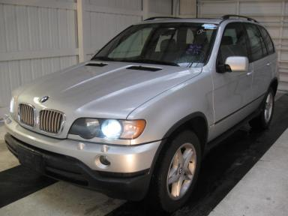 | 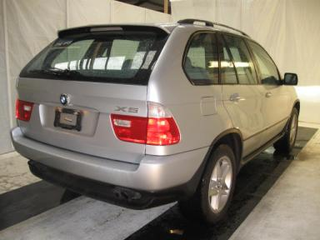
  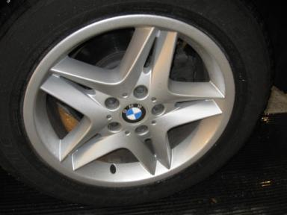 | 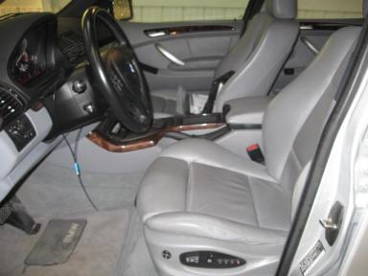
  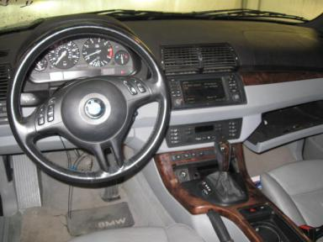 | 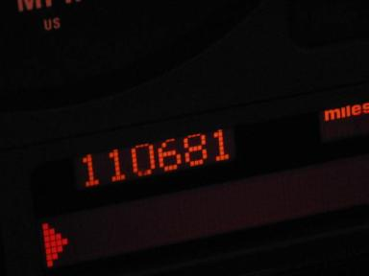
  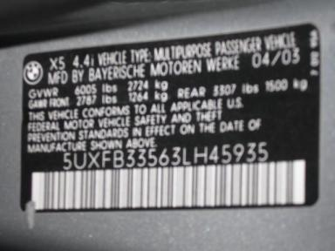
  
  Grade 3.4 Average
  More About Auto Grade
  Certified - No
  Drivable - Yes

VEHICLE INFORMATION
OPTIONS
Pwr Lock  Tilt Steering  Cassette Tape  Power Folding Mirrors  Trip Counter  Cold Weather Package  Security System  HomeLink  ST - Steptronic Transmission  Tire Pressure Monitor  Power Seats - Dual |  | Pwr Steering  A/C  Side Air Bags  Owner's Manual  CD Changer - 6.00  On-Board Computer  Steering Wheel Audio Control  Premium Package  Memory Seat  Power Telescopic Steering  Heated Seats - Front |  | Pwr Window  Cruise Ctl  Dual Air Bags  Premium Stereo - DSP  Rear Wiper  US EPA Label  Dual Air Conditioning  Sport Package  Woodgrain Interior Package  Navigation System |  | Pwr Seats - Both  Rear Defrost  Power Mirrors  Fog Lamps  Power Trunk/Liftgate  DSC-Dynamic Stability Control  HDC - Hill Descent Control  Heated Seats  Rain Sensor  Directional Stability Control

MECHANICAL | INTERIOR
  8 Cylinder Gas
  Automatic
  AWD
  Pwr Brakes
  4.4 L
  Odometer - 6 Digits Digital - Operable
  Clean
  GRY - Leather
  Int Odor: OK
  Wood Trim Dash
TIRES AND WHEELS | KEYS
  Tire Condition: | Average | Wheels: | Alloy
  Tire | Tread Depth | Brand | Size
  Left Front: | 6/32" | MICHELIN | 255/55R18
  Left Rear: | 5/32" | MICHELIN | 255/55R18
  Right Front: | 8/32" | MICHELIN | 255/55R18
  Right Rear: | 4/32" | MICHELIN | 255/55R18
  Spare: | 0/32" | MICHELIN | 255/55R18
  Master Key - 1

2003 BMW X5 4.4L
VIN: | 5UXFB33563LH45935 | Body Style: | 4CUV | Top Type: | Moon Roof
EXT COLOR/Code: | TITANIUM | INT COLOR/Code: | GRY | Mileage: | 110,681
Work Order #: | 1521124 | Lane Number: | 34 | Run Number: | 289
Seller: | FINANCIAL SERVICES REMARKETING (LEASE) | Inspector: | JBROWN2 05/06/2009 | Rcv Date: | 05/06/2009

ADDITIONAL INFORMATION
SPT/PREM,DSP,HS,NAV,WT,CWP,
*BK, AS-IS CLEAN CARFAX 5/28/09
Common Abbreviations

DAMAGES - SUGGESTED REPAIRS
Suggested repairs are based on Manheim professional inspector's recommendation.
Total labor hours include paint, body or repair estimates.
 | DESCRIPTION | CONDITION | SEVERITY | SUGGESTED  REPAIR | TOTAL  LABOR  HOURS
 | Front Bumper | Mult Scratches | 1" to 2" | Airbrush | 1.00
 | Hood | Prev Repair | Acceptable | No Action Required | .00
 | LF Fender | Prev Repair | Acceptable | No Action Required | .00
 | LF Door | Dent/No Paint Dmg | PDR/1 | PDR | .00
 | LR Door | Dent/No Paint Dmg | PDR/1 | PDR | .00
 | Lift Gate | Dent/No Paint Dmg | PDR/1 | PDR | .00
 | RF Fender | Prev Repair | Acceptable | No Action Required | .00
 | RF Wheel | Mult Scratches | 1" to 2" | Repair | 2.00
 | RF Door | Dent/No Paint Dmg | PDR/1 | PDR | .00
 |  |  |  | TOTALS | 3.00


Конец формы
VIN: 5UXFB33563LH45935, Work Order #: 1521124

