2004 TOYOTA 4 RUNNER 4X4 SR5 - SILV
VIN: JTEBU14R640024140 Work Order #: 1522897
Manheim Ohio 3905 Jackson Pike
Grove City, OH 43123-9300
(614) 871-2771

VIN:
  JTEBU14R640024140
  Body Style: | 4SUV - Hard Top
  Ext Color/Code: | SILV
  Int Color/Code: | GRY
  Mileage: | 110,321
  ECM Mileage:
  Seller: | USB DEALER SERVICES
  Title State: | MI
  Certified: | No
  Condition/Grade: | 4.5 , Clean
  Sale: | 25
  Lane: | 8
  Run: | 14
  Inspection: | BWEST4 06/13/2009
  Drivable: | Yes
  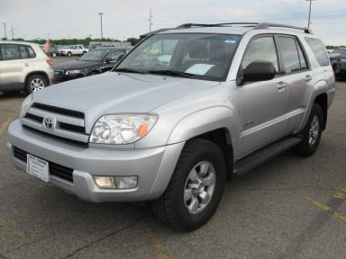 | 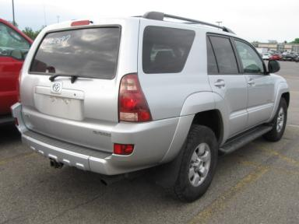
  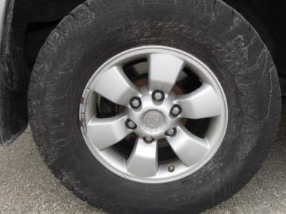 | 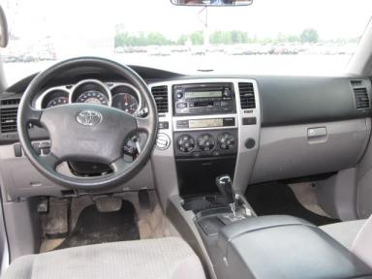
  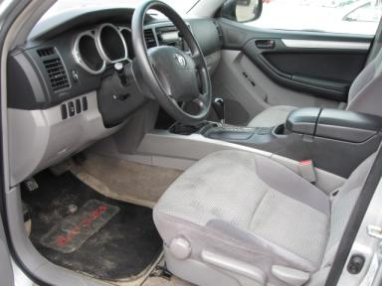 | 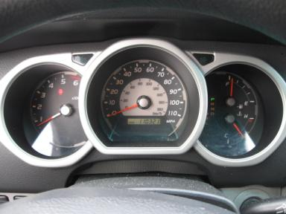
  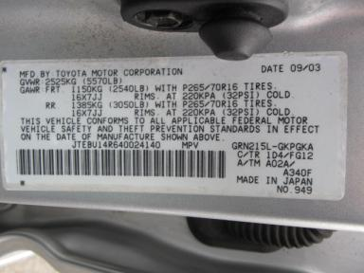

VEHICLE INFORMATION
  MECHANICAL
  6 Cylinder Gas
  Automatic
  4X4
  Pwr Brakes
  4.0 L
  INTERIOR
  Average
  GRY - Cloth
  Int Odor: OK
  Regular Dash
  OPTIONS
  Pwr Lock  Pwr Window  A/C  Rear Defrost  Dual Air Bags  Power Mirrors  Tinted Windows  Fog Lamps  NO Rear Air Conditioning  Trip Computer  NO Third Seat  Floor Mats  Running Board  2 Captain Seats 1 Bench  Power Rear Sliding Glass |  | Pwr Steering  Tilt Steering  Cruise Ctl  Tape/CD  50 State Emissions  ABS Brakes  4 Door  Rear Wiper  Warranty Books  Luggage Rack  5 Passenger Seating  US EPA Label  Trailer Hitch  Trailer Plug
FLUID LEVELS
Fuel Level: Empty

  TIRES AND WHEELS
  Tire | Tread Depth | Brand | Size
  Left Front: | 6/32" | GENERIC | 255/70D16
  Left Rear: | 7/32" | GENERIC | 255/70D16
  Right Front: | 6/32" | GENERIC | 255/70D16
  Right Rear: | 5/32" | GENERIC | 255/70D16
  Spare: | 6/32" | MICHELIN
  Tire Condition: Average
  Wheels: Alloy
  KEYS
  Master Key - 1
  Remote Key/Fob - 1

ANNOUNCED CONDITION: SELL UNDER ACCT# 65126 AG
INTERNET REMARKS:
REMARKS/ADDITIONAL DAMAGE:
DISCLOSURES:
NOTES TO CONSIGNOR:
REMARKS:
COMMENTS FOR CONSIGNOR:

2004 TOYOTA 4 RUNNER 4X4 SR5 - SILV
VIN: JTEBU14R640024140 Work Order #: 1522897
Manheim Ohio 3905 Jackson Pike
Grove City, OH 43123-9300
(614) 871-2771

DAMAGES
 | DESCRIPTION | CONDITION | SEVERITY | REPAIR  HOURS | PAINT  HOURS | PART  HOURS | TOTAL  HOURS
 | Front Bumper | Mult Scratches | Less 1" | .00 | .00 | .00 | .00
 | LF Door | Scratch Light | 6" to 7" | .50 | .00 | .00 | .50
 | Rear Bumper | Scratched | 2" to 3" | .00 | 2.20 | .00 | 2.20
 | RF Door | Dent/No Paint Dmg | PDR/1 | .00 | .00 | .00 | .00
 | R Qtr Panel | Scratch Light | 8" to 9" | .50 | .00 | .00 | .50
 | Owners manuals | Missing | Unacceptable | .00 | .00 | .00 | .00
 |  |  | TOTALS | 1.00 | 2.20 | .00 | 3.20



