Manheim Baltimore-Washington
7120 Dorsey Run Rd
Elkridge, MD 21075
(410) 796-8899

VEHICLE DETAILS
2001 TOYOTA RAV-4 AWD L
VIN: | JTEHH20VX10103765 | Body Style: | 4CUV | Top Type: | Hard Top
EXT COLOR/Code: | SILVER | INT COLOR/Code: | GRY | Mileage: | 139,015
Work Order #: | 8906480 | Lane Number: | 1 | Run Number: | 37
Seller: | DARCARS TOYOTA OF FREDERICK | Inspector: | SDAVID 06/16/2009 | Rcv Date: | 06/15/2009

VEHICLE IMAGES
 |  |  | GRADING
  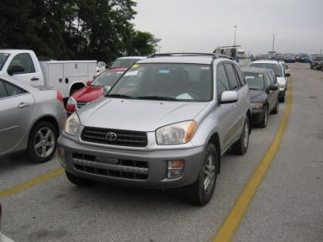 | 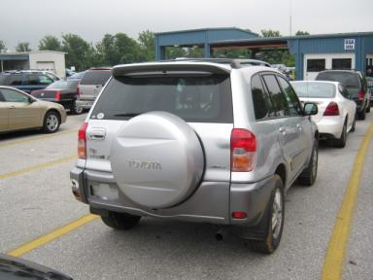
  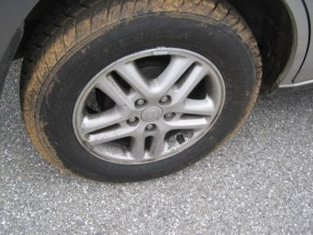 | 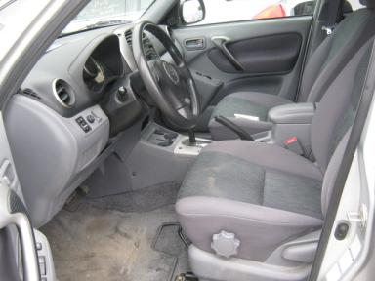
  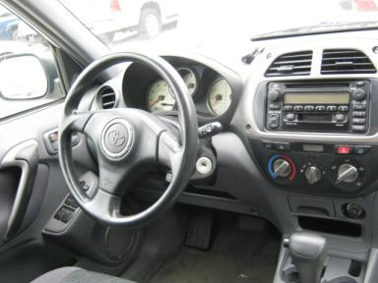 | 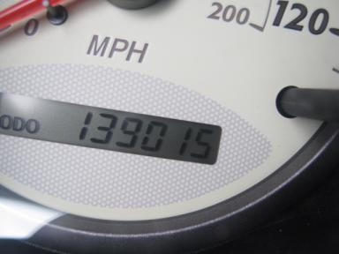
  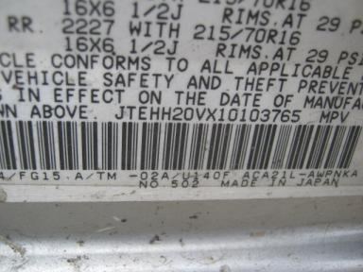
  
  Grade 4.0 Clean
  More About Auto Grade
  Certified - No
  Drivable - Yes

VEHICLE INFORMATION
OPTIONS
Pwr Lock  Rear Defrost  ABS Brakes  NO Rear Air Conditioning  5 Passenger Seating  2 Captain Seats 1 Bench |  | Pwr Steering  Tape/CD  Fog Lamps  Trip Computer  Floor Mats |  | Pwr Window  Dual Air Bags  Trip Counter  Luggage Rack  US EPA Label |  | A/C  Power Mirrors  Rear Wiper  NO Third Seat  Security System

MECHANICAL | INTERIOR
  4 Cylinder Gas
  Automatic
  AWD
  Pwr Brakes
  2.0 L
  Odometer - 6 Digits Digital - Operable
  Dirty
  GRY - Cloth
  Int Odor: OK
  Regular Dash
TIRES AND WHEELS | KEYS
  Tire Condition: | Average | Wheels: | Alloy
  Tire | Tread Depth | Brand | Size
  Left Front: | 6/32" | COOPER | 215/70R16
  Left Rear: | 6/32" | COOPER | 215/70R16
  Right Front: | 6/32" | COOPER | 215/70R16
  Right Rear: | 6/32" | COOPER | 215/70R16
  Spare: | 0/32"
  Master Key - 2
  Remote Key/Fob - 2

ADDITIONAL INFORMATION
OV1K
Common Abbreviations

DAMAGES - SUGGESTED REPAIRS
Suggested repairs are based on Manheim professional inspector's recommendation.
Total labor hours include paint, body or repair estimates.
 | DESCRIPTION | CONDITION | SEVERITY | SUGGESTED  REPAIR | TOTAL  LABOR  HOURS
 | Header Panel | Multiple Chips | 6 | Paint Chip Repair | .00
 | Hood | Multiple Chips | 6 | Paint Chip Repair | .00
 | LF Fender | Dent/No Paint Dmg | PDR/7 | PDR | .00
 | LF Door | Dent/No Paint Dmg | PDR/7 | PDR | .00
 | LR Door | Mult Scratches | 2" to 3" | Refinish | 2.80
 | LR Wheel | Mult Scratches | 1" to 2" | Repair | .00
 | RF Door | Dent/No Paint Dmg | PDR/7 | PDR | .00
 | Interior | Soiled | Needs Cleaning | Detail | .00
 | Warranty Books | Missing | Replacement Req | Replace | .00
 | Owners manuals | Missing | Replacement Req | Replace | .00
 |  |  |  | TOTALS | 2.80

