2004 LEXUS LX470 - 4R2/CRM
VIN: JTJHT00W043541789 Work Order #: 8093895
Manheim Milwaukee 561 27th St
Caledonia, WI 53108
(262) 835-4436

VIN:
  JTJHT00W043541789
  Body Style: | 4SUV - Moon Roof
  Ext Color/Code: | 4R2/CRM - 4R2
  Int Color/Code: | TAN - LG00
  Mileage: | 115,054
  ECM Mileage:
  Seller: | LEXUS FINANCIAL SERVICES/CEDAR RAPIDS
  Title State: | OH
  Certified: | No
  Condition/Grade: | 3.0, Average
  Sale: | 26
  Lane: | 13
  Run: | 86
  Inspection: | RADZIMA 06/02/2009
  Drivable: | Yes
  Factory Category: | C
  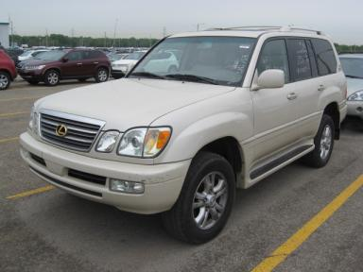 | 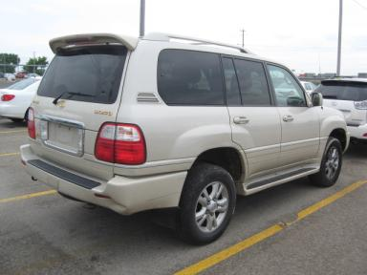
  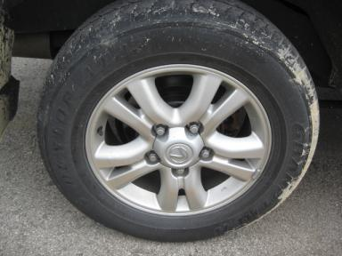 | 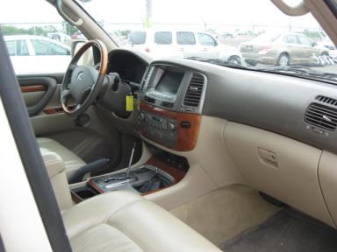
  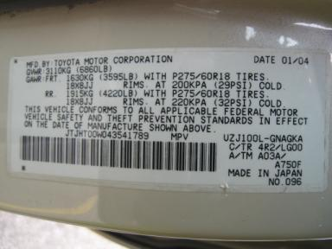 | 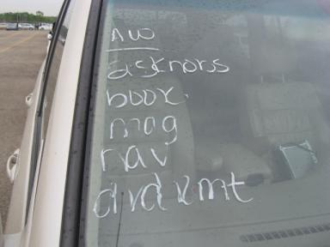
  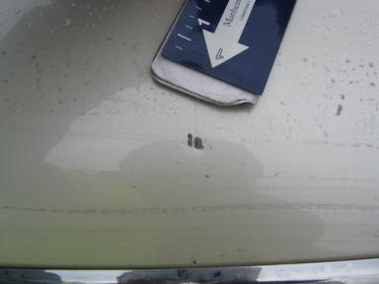 | 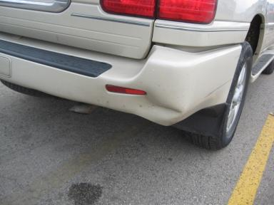
  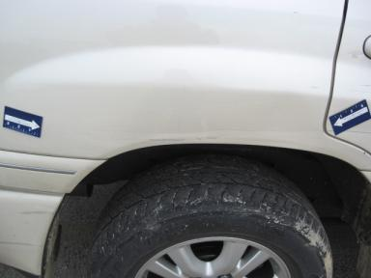 | 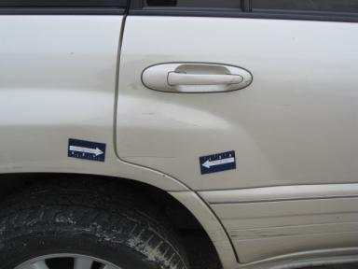

VEHICLE INFORMATION
  MECHANICAL
  8 Cylinder Gas
  Automatic
  4X4
  Pwr Brakes
  4.7 L
  INTERIOR
  Odometer - 6 Digits Digital Operable
  Average
  TAN - Leather
  Int Odor: OK
  Wood Trim Dash
  OPTIONS
  Pwr Lock  Pwr Window  A/C  Rear Defrost  Side Air Bags  50 State Emissions  Power Folding Mirrors  ABS Brakes  4 Door  Trip Counter  Rear Wiper  Luggage Rack  Spoiler  Power Vent Windows  Running Board  Power Antenna  HomeLink  Memory Seat  Rear View Camera  Power Tilt Steering  Cell Phone - OEM |  | Pwr Steering  Pwr Seats - Both  Cruise Ctl  Tape/CD  Dual Air Bags  Power Mirrors  Owner's Manual  Tinted Windows  Fog Lamps  CD Changer - OEM - 6.00  Trip Computer  Floor Mats  US EPA Label  Step Bumper  Steering Wheel Audio Control  Auto-Suspension  Heated Seats  Gold Package  Power Telescopic Steering  Navigation System
FLUID LEVELS
Fuel Level: Unknown

  TIRES AND WHEELS
  Tire | Tread Depth | Brand | Size
  Left Front: | 4/32" | DUNLOP | 275/60R18
  Left Rear: | 7/32" | DUNLOP | 275/60R18
  Right Front: | 4/32" | DUNLOP | 275/60R18
  Right Rear: | 7/32" | DUNLOP | 275/60R18
  Spare: | 7/32" | DUNLOP
  Tire Condition: Average
  Wheels: Alloy
  KEYS
  Master Key - 1

ANNOUNCED CONDITION: 4X4-AS IS MILES OVER, KNOBS NAV DISC MAG DVD RMT BOOKS IN GLOVE, Navigation CD Present, Shift Knob Present, Buyer Fee includes a $10 TFS/LFS Administrative Fee.
INTERNET REMARKS:
REMARKS/ADDITIONAL DAMAGE:
DISCLOSURES:
NOTES TO CONSIGNOR: *PD
REMARKS: *PD
COMMENTS FOR CONSIGNOR: RAINING

2004 LEXUS LX470 - 4R2/CRM
VIN: JTJHT00W043541789 Work Order #: 8093895
Manheim Milwaukee 561 27th St
Caledonia, WI 53108
(262) 835-4436

DAMAGES
 | DESCRIPTION | CONDITION | SEVERITY | REPAIR  HOURS | PAINT  HOURS | PART  HOURS | TOTAL  HOURS
 | Front Bumper Co | Mult Scratches | 7" to 8" | 1.50 | 3.70 | .00 | 5.20
 | Hood | Dent/Paint Dmg | Less 1" | 1.00 | 5.10 | .00 | 6.10
 | LR Door Molding | Mult Scratches | 3" to 4" | 1.00 | .00 | .00 | 1.00
 | Half Liftgate | Mult Scratches | 2" to 3" | 1.00 | .00 | .00 | 1.00
 | Rear Bumper Cov | Dent/Paint Dmg | Replacement Req | .00 | 3.70 | 1.50 | 5.20
 | RR Door | Dent/Paint Dmg | 4" to 5" | 3.00 | 3.40 | .00 | 6.40
 | R Qtr Panel | Dent/Paint Dmg | GR 12" | 5.00 | 3.70 | .00 | 8.70
 | R Qtr Panel Mol | Mult Scratches | 3" to 4" | 1.50 | .00 | .00 | 1.50
 | Warning - Maint | On | Unknown | 1.00 | .00 | .00 | 1.00
 | LF Carpet | Burn Hole | Repair Required | .00 | .00 | .00 | .00
 | Hood | Chipped | 4 | .00 | .00 | .00 | .00
 | Hood | Scratch Light | 4" to 5" | .00 | .00 | .00 | .00
 | LF Fender | Dent/No Paint Dmg | PDR/1 | .00 | .00 | .00 | .00
 | LF Fender | Scratch Light | 4" to 5" | .00 | .00 | .00 | .00
 | LF Door | Edge Chipped | 4 | .00 | .00 | .00 | .00
 | LF Door | Scratch Light | 1" to 2" | .00 | .00 | .00 | .00
 | LR Door | Scratch Light | 2" to 3" | .00 | .00 | .00 | .00
 | RF Fender | Scratch Light | 1" to 2" | .00 | .00 | .00 | .00
 | RF Door | Edge Chipped | 1 | .00 | .00 | .00 | .00
 | RF Door | Scratch Light | 1" to 2" | .00 | .00 | .00 | .00
 | RR Door | Mult Scratches | 5" to 6" | .00 | .00 | .00 | .00
 |  |  | TOTALS | 15.00 | 19.60 | 1.50 | 36.10



