2005 BMW X5 4.4L - BLACK
VIN: 5UXFB53595LV16886 Work Order #: 131656
Manheim Atlanta 4900 Buffington Rd
Atlanta, GA 30349
(404) 762-9211

VIN:
  5UXFB53595LV16886
  Body Style: | 4CUV - Moon Roof
  Ext Color/Code: | BLACK
  Int Color/Code: | BLK
  Mileage: | 108,735
  ECM Mileage:
  Seller: | WELLS FARGO FINANCIAL ACCEPTANCE
  Title State: | GA
  Certified: | No
  Condition/Grade: | 3.0, Average
  Sale: | 26
  Lane: | 12
  Run: | 139
  Inspection: | JUBROWN 06/19/2009
  Drivable: | Yes
  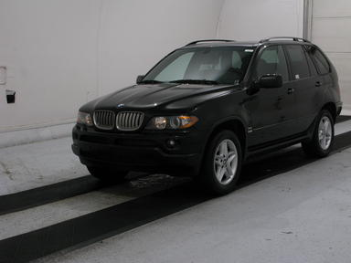 | 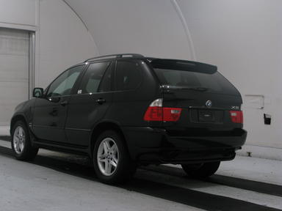
  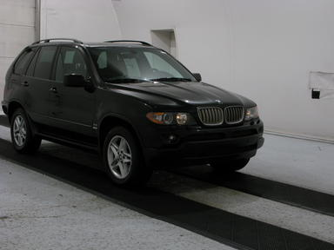 | 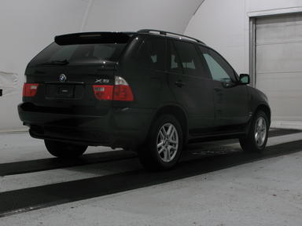
  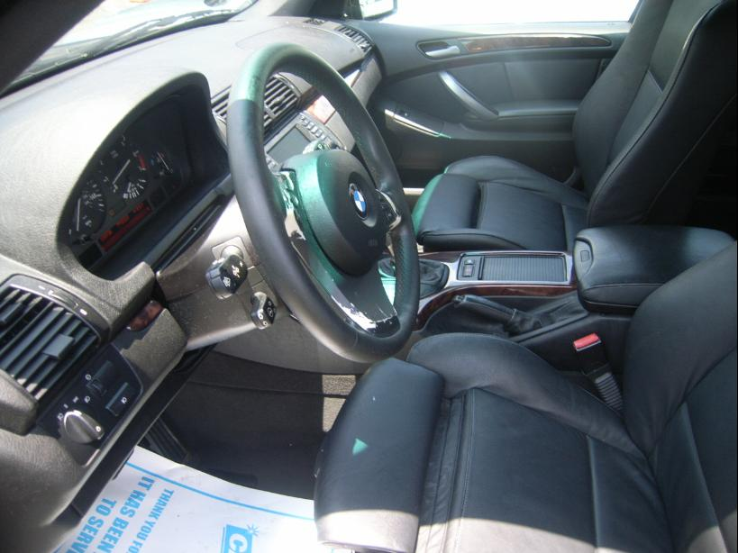 | 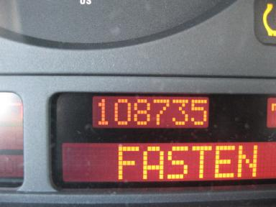
  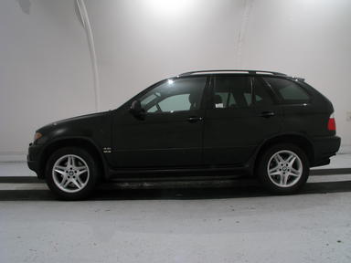 | 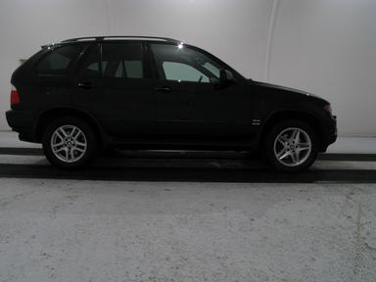

VEHICLE INFORMATION
  MECHANICAL
  8 Cylinder Gas
  Automatic
  AWD
  Pwr Brakes
  4.4 L
  INTERIOR
  Dirty
  BLK - Vinyl
  Int Odor: OK
  OPTIONS
  Pwr Lock  Pwr Window  Tilt Steering  Cruise Ctl  Cassette Tape  Power Mirrors  Warranty Books  Heated Seats  Woodgrain Interior Package  Power Tilt Steering  Navigation System  Sunshade - Manual |  | Pwr Steering  Pwr Seats - Both  A/C  Rear Defrost  Dual Air Bags  Owner's Manual  Trip Computer  Memory Seat  Power Telescopic Steering  Heated Steering Wheel  Parking Distance Control
FLUID LEVELS
Fuel Level: Unknown

  TIRES AND WHEELS
  Tire | Tread Depth | Brand | Size
  Left Front: | 5/32" | MICHELIN | 255/55R18
  Left Rear: | 6/32" | MICHELIN | 255/55R18
  Right Front: | 5/32" | MICHELIN | 255/55R18
  Right Rear: | 6/32" | MICHELIN | 255/55R18
  Spare: | 0/32" | MICHELIN
  KEYS
  Master Key - 1

ANNOUNCED CONDITION: MILES OVER/ASIS
INTERNET REMARKS:
REMARKS/ADDITIONAL DAMAGE:
DISCLOSURES:
NOTES TO CONSIGNOR: *NO CURRENT TAG
REMARKS: *NO CURRENT TAG
COMMENTS FOR CONSIGNOR:

2005 BMW X5 4.4L - BLACK
VIN: 5UXFB53595LV16886 Work Order #: 131656
Manheim Atlanta 4900 Buffington Rd
Atlanta, GA 30349
(404) 762-9211

DAMAGES
 | DESCRIPTION | CONDITION | SEVERITY | REPAIR  HOURS | PAINT  HOURS | PART  HOURS | TOTAL  HOURS
 | LF Fender | Scratch Light | GR 12" | .00 | .00 | .00 | .00
 | LF Door | Dent/No Paint Dmg | 1" to 2" | .00 | .00 | .00 | .00
 | LF Door | Scratch Light | 3" to 4" | .00 | .00 | .00 | .00
 | LR Door | Dent/No Paint Dmg | 1" to 2" | .00 | .00 | .00 | .00
 | LR Tire | Add'l Damage SCREW IN TIRE | None | .00 | .00 | .00 | .00
 | RF Door | Dent/No Paint Dmg | 1" to 2" | .00 | .00 | .00 | .00
 | R Qtr Panel | Dent/No Paint Dmg | 1" to 2" | .00 | .00 | .00 | .00
 | Warning - Engin | On | Unknown | 1.00 | .00 | .00 | 1.00
 | Warning - Tire | On | Unknown | 1.00 | .00 | .00 | 1.00
 | Windshield | Multiple Chips | Less 1" | .00 | .00 | .00 | .00
 | Hood | Scratch Light | Buffable | .00 | .00 | .00 | .00
 | LR Door | Scratch Light | Buffable | .00 | .00 | .00 | .00
 | L Qtr Panel | Scratch Light | Buffable | .00 | .00 | .00 | .00
 | RF Door | Scratch Light | Buffable | .00 | .00 | .00 | .00
 | RR Door | Scratch Light | Buffable | .00 | .00 | .00 | .00
 |  |  | TOTALS | 2.00 | .00 | .00 | 2.00



