2005 LEXUS GX470 - SILV PIN
VIN: JTJBT20X550085687 Work Order #: 7700738
Manheim Nashville 8400 Eastgate Blvd
Mt. Juliet, TN 37122
(615) 773-3800

VIN:
  JTJBT20X550085687
  Body Style: | 4SUV - Sun Roof
  Ext Color/Code: | SILV PIN - LF0
  Int Color/Code: | GRY - LH10
  Mileage: | 80,191
  ECM Mileage:
  Seller: | LEXUS FINANCIAL SERVICES/CEDAR RAPIDS
  Title State: | MO
  Certified: | No
  Condition/Grade: | 3.0, Average
  Sale: | 28
  Lane: | 77
  Run: | 51
  Inspection: | JWORD 06/22/2009
  Drivable: | Yes
  Factory Category: | L
  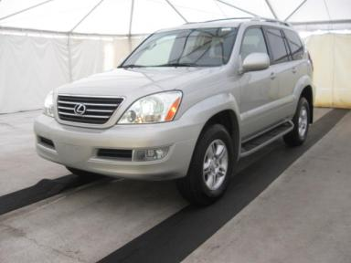 | 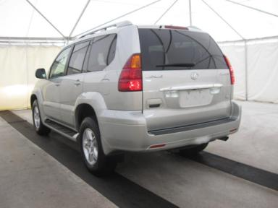
  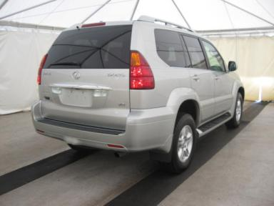 | 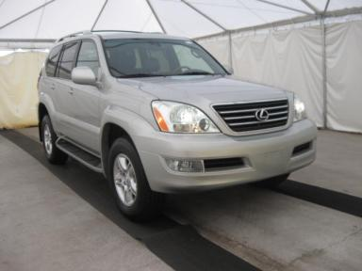
  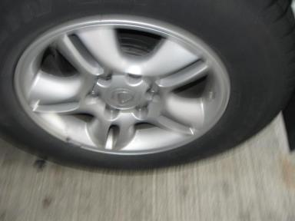 | 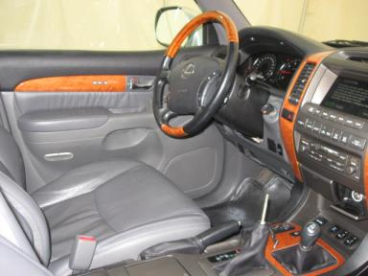
  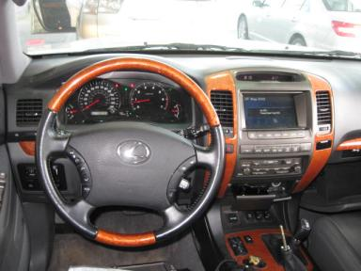 | 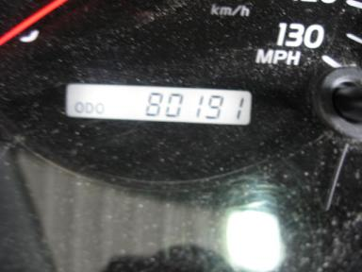
  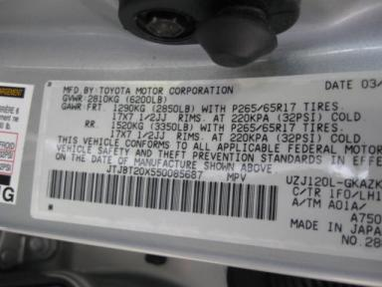

VEHICLE INFORMATION
  MECHANICAL
  8 Cylinder Gas
  Automatic
  4X4
  Pwr Brakes
  4.7 L
  INTERIOR
  Average
  GRY - Leather
  Int Odor: OK
  Wood Trim Dash
  OPTIONS
  Pwr Lock  Pwr Window  Tilt Steering  Cruise Ctl  CD Player  Dual Air Bags  Power Mirrors  Owner's Manual  Premium Stereo - MARKLEVINSON  Fog Lamps  Rear Air Conditioning  Rear Wiper  Third Seat  Floor Mats  Security System  Dual Air Conditioning  Heated Seats  Memory Seat  Woodgrain Interior Package  Power Telescopic Steering  Navigation System  Hand Tool Kit  Bluetooth |  | Pwr Steering  Pwr Seats - Both  A/C  Rear Defrost  Side Air Bags  50 State Emissions  Heated Mirrors  ABS Brakes  Tinted Windows  Trip Counter  CD Changer - OEM - 6.00  Warranty Books  Luggage Rack  US EPA Label  Steering Wheel Audio Control  HomeLink  Wheel Locks  Rear View Camera  Telescopic Steering Wheel  Power Tilt Steering  Rain Sensor Windshield  First Aid Kit
FLUID LEVELS
Fuel Level: 1/2

  TIRES AND WHEELS
  Tire | Tread Depth | Brand | Size
  Left Front: | 10/32" | MICHELIN | 265/65R17
  Left Rear: | 10/32" | MICHELIN | 265/65R17
  Right Front: | 10/32" | MICHELIN | 265/65R17
  Right Rear: | 10/32" | MICHELIN | 265/65R17
  Spare: | 10/32" | MICHELIN
  Tire Condition: Good
  Wheels: Alloy
  KEYS
  Master Key - 2

ANNOUNCED CONDITION: 4X4;LA;DC;HEATED SEATS;MO, Navigation CD Present, Shift Knob Present, 1ST AID KIT;BOOKS;NAV DISK;KNOB;1 M KEY IN OFFICE, Buyer Fee includes a $10 TFS/LFS Administrative Fee.
INTERNET REMARKS:
REMARKS/ADDITIONAL DAMAGE:
DISCLOSURES:
NOTES TO CONSIGNOR:
REMARKS:
COMMENTS FOR CONSIGNOR:

2005 LEXUS GX470 - SILV PIN
VIN: JTJBT20X550085687 Work Order #: 7700738
Manheim Nashville 8400 Eastgate Blvd
Mt. Juliet, TN 37122
(615) 773-3800

DAMAGES
 | DESCRIPTION | CONDITION | SEVERITY | REPAIR  HOURS | PAINT  HOURS | PART  HOURS | TOTAL  HOURS
 | Front Bumper | Scratches | 2" to 3" | .00 | 3.60 | .00 | 3.60
 | Rear Bumper Tow | Multiple Dents | 5" to 6" | 1.50 | 1.50 | .00 | 3.00
 | Hood | Multiple Chips | 5 | .00 | .00 | .00 | .00
 | Roof | Dent/No Paint Dmg | PDR/5 | .00 | .00 | .00 | .00
 | LF Door | Dent/No Paint Dmg | PDR/2 | .00 | .00 | .00 | .00
 | LF Door | Scratch Light | Less 1" | .00 | .00 | .00 | .00
 | LR Door | Dent/No Paint Dmg | PDR/2 | .00 | .00 | .00 | .00
 | L Qtr Panel | Dent/No Paint Dmg | PDR/1 | .00 | .00 | .00 | .00
 | Tailgate | Scratch Light | 5" to 6" | .00 | .00 | .00 | .00
 | RF Fender | Scratch Light | 6" to 7" | .00 | .00 | .00 | .00
 | RF Door | Dent/No Paint Dmg | PDR/1 | .00 | .00 | .00 | .00
 | RF Door | Scratch Light | 6" to 7" | .00 | .00 | .00 | .00
 | RR Door | Dent/No Paint Dmg | PDR/1 | .00 | .00 | .00 | .00
 | RR Door | Scratch Light | 6" to 7" | .00 | .00 | .00 | .00
 |  |  | TOTALS | 1.50 | 5.10 | .00 | 6.60



