Начало формы
VEHICLE DETAILS
VEHICLE IMAGES
 |  |  | GRADING
  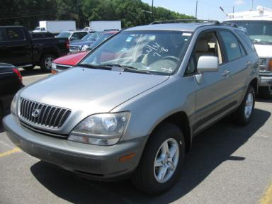 | 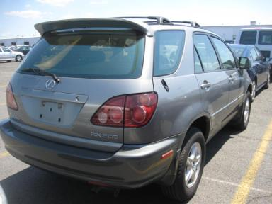
  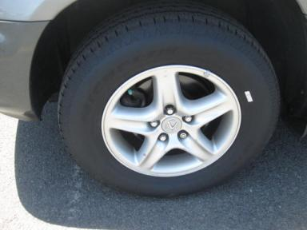 | 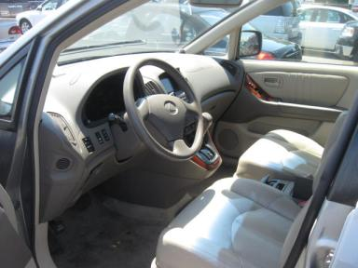
  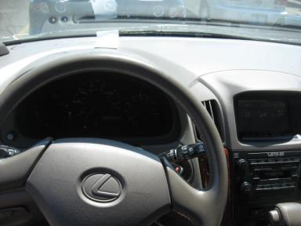 | 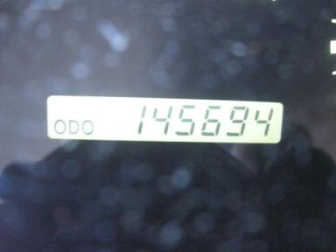
  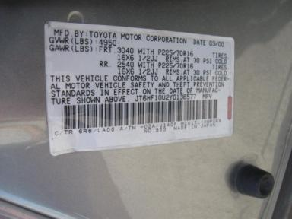
  
  Grade 4.4 Clean
  More About Auto Grade
  Certified - No
  Drivable - Yes

VEHICLE INFORMATION
OPTIONS
Pwr Lock  Tilt Steering  Cassette Tape  Owner's Manual  Trip Counter  Luggage Rack  Power Antenna |  | Pwr Steering  A/C  Side Air Bags  ABS Brakes  CD Changer - 6.00  Floor Mats  Traction Control |  | Pwr Window  Cruise Ctl  Dual Air Bags  Fog Lamps  Rear Wiper  US EPA Label  HomeLink |  | Pwr Seats - Both  Rear Defrost  Power Mirrors  Maintenance Records  Warranty Books  Security System  Heated Seats

MECHANICAL | INTERIOR
  6 Cylinder Gas
  Automatic
  AWD
  Pwr Brakes
  3.0 L
  Average
  BEI - Leather
  Int Odor: OK
  Wood Trim Dash
TIRES AND WHEELS | KEYS
  Tire Condition: | Good | Wheels: | Alloy
  Tire | Tread Depth | Brand | Size
  Left Front: | 8/32" | MICHELIN | 225/70R16
  Left Rear: | 7/32" | MICHELIN | 225/70R16
  Right Front: | 8/32" | MICHELIN | 225/70R16
  Right Rear: | 8/32" | MICHELIN | 225/70R16
  Spare: | 9/32" | BRIDGESTONE | 225/70R16
  Master Key - 1

2000 LEXUS RX300
VIN: | JT6HF10U2Y0136577 | Body Style: | 4CUV | Top Type: | Moon Roof
EXT COLOR/Code: | SILVER | INT COLOR/Code: | BEI | Mileage: | 145,694
Work Order #: | 9073394 | Lane Number: | 13 | Run Number: | 74
Seller: | AUTOLENDERS | Inspector: | ASMITH5 07/06/2009 | Rcv Date: | 07/06/2009

ADDITIONAL INFORMATION
OV 100
Common Abbreviations

DAMAGES - SUGGESTED REPAIRS
Suggested repairs are based on Manheim professional inspector's recommendation.
Total labor hours include paint, body or repair estimates.
 | DESCRIPTION | CONDITION | SEVERITY | SUGGESTED  REPAIR | TOTAL  LABOR  HOURS
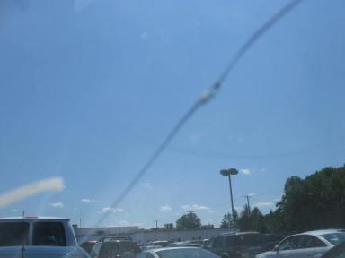 | Windshield | Cracked | 8" to 9" | Replace | .00
 | Front Bumper | Chipped | 1 | Paint Chip Repair | .00
 | Hood | Multiple Chips | 2 | Brush Touch | .00
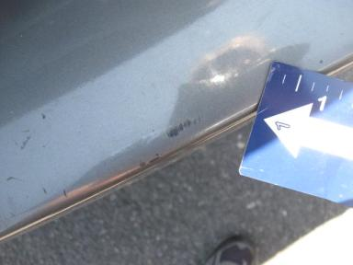 | Rear Bumper | Mult Scratches | 2" to 3" | Repair | 2.00
 | R Qtr Panel | Dent/No Paint Dmg | PDR/1 | PDR | .00
 |  |  |  | TOTALS | 2.00


Конец формы
VIN: JT6HF10U2Y0136577, Work Order #: 9073394

